**Java Script**

1. **why we need java script?**

Developers use JavaScript in web development to add interactivity and features to [improve the user experience](https://blog.hubspot.com/website/usability-vs-user-experience?__hstc=45788219.f59dd9dc41b459e719c5b4cd9a768a27.1646249529534.1646249529534.1646249529534.1&__hssc=45788219.1.1646249529535&__hsfp=1603130137&_ga=2.168554793.901349043.1646249529-1254543002.1646249529&hubs_content=blog.hubspot.com/website/what-is-javascript&hubs_content-cta=improve%20the%20user%20experience) and make the internet much more enjoyable.

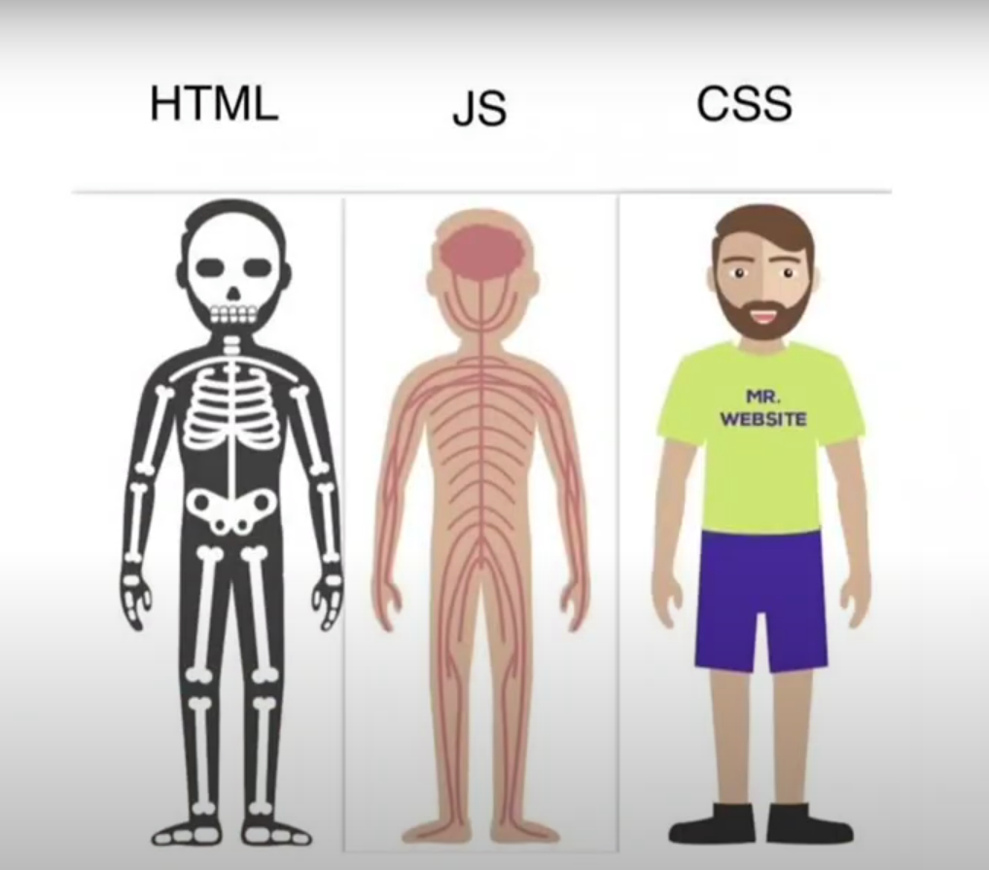

1. **History of java script?**

**Netscape programmer** named **Brendan Eich** developed a new scripting language in just **10 days**. It was originally called **Mocha**, but quickly became known as **LiveScript** and, later, **JavaScript**.

**What Is ECMAScript?**

When JavaScript was first introduced by Netscape, there was a war going on between all the browser vendors on the market at the time. Microsoft and several other browser vendors implemented their own versions of JavaScript (with different names and syntax) in their respective browsers. This created a huge headache for developers, as code that worked fine on one browser was a total waste on another. This went on for a while till they all agreed to use the same language (JavaScript) in their browsers.

As a result, Netscape submitted JavaScript to the [European Computer Manufacturers Association](https://www.ecma-international.org/) (ECMA) for standardization in order to ensure proper maintenance and support of the language. Since JavaScript was standardized by ECMA, it was officially named ECMAScript.

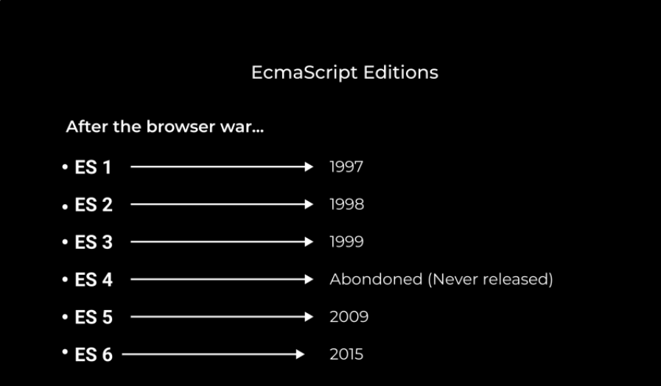

Originally, the name ECMAScript was just the formalization of JavaScript, but now languages like JScript and ActionScript are also based on the ECMAScript standard.

1. **What is java script?**

Java Script is a High level Programing Language that is primarly used to enhance the interactivity and dynamic behaviour of web sites

Java Script is also a light weight, cross platforms, Single threaded and High level Interpreted compiled programming language. It is knowns as Scripting Languages for websites.

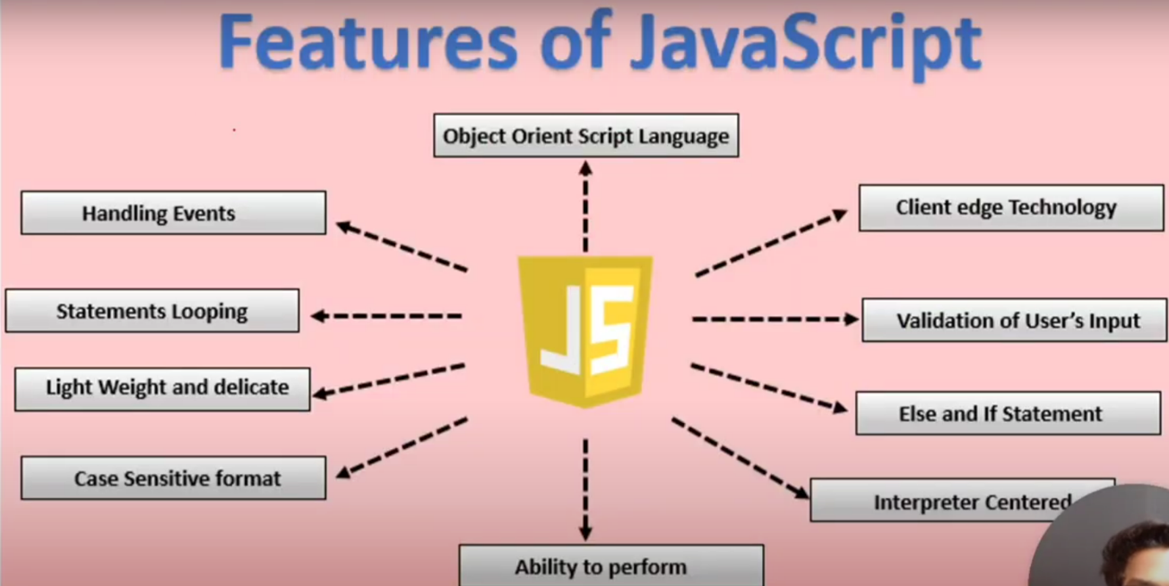

* **High-Level Language**

High-level languages are programming languages that are used for writing programs or software that can be understood by humans and computers. High-level languages are easier to understand for humans because they use a lot of symbols letters phrases to represent logic and instructions in a program. It contains a high level of abstraction compared to low-level languages.

* **Cross-platform**

It is a software or applications that can operate on multiple operating system

* **Single-theaded**

It is the only programming language that can run natively in a browser, making it an instrumental part of web development. However, one critical feature of JavaScript is that it is single-threaded. This means that it can only execute one task at a time.

* **Asynchronous**

how it can be used to effectively handle potential blocking operations, such as fetching resources from a server.

* **Synchronous**

Synchronous means the code runs in a particular sequence of instructions given in the program. Each instruction waits for the previous instruction to complete its execution.

* **Obeject Oriented**

It provides an overview of the basic concepts of OOP.

* **Scripting**

Scripting is used to automate tasks on a website. It can respond to any specific event, like button clicks, scrolling, and form submission. It can also be used to generate dynamic content. and JavaScript is a widely used scripting language.

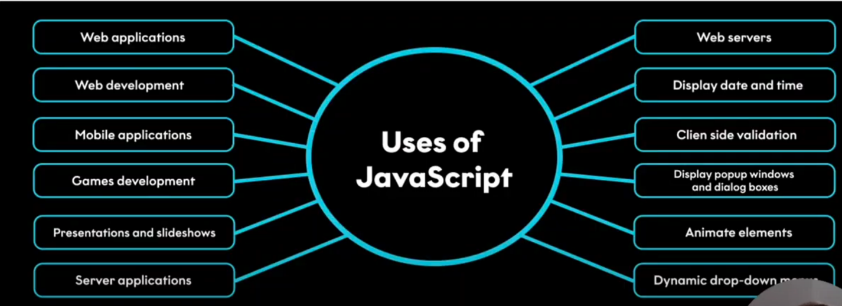

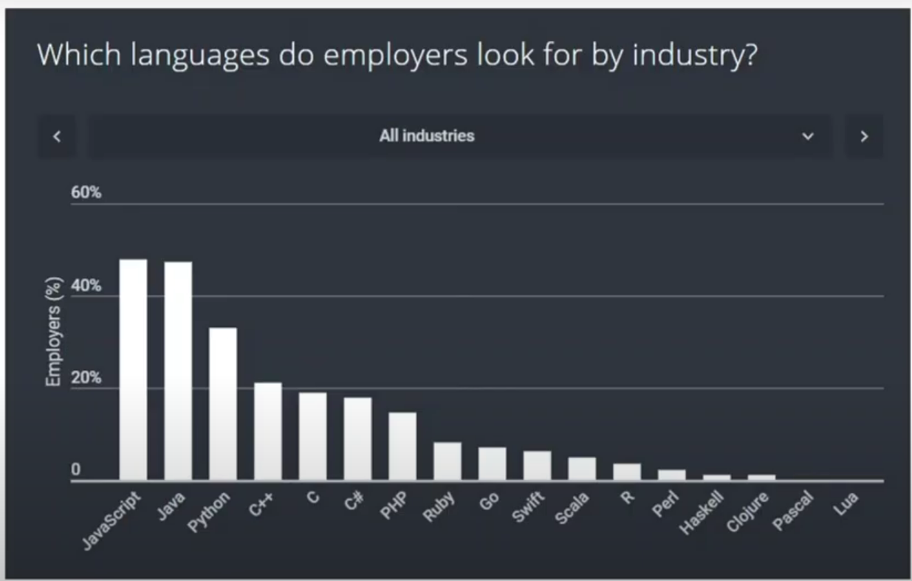

1. **What is Vanilla JavaScript**

The term vanilla script is used to refer to the pure JavaScript (or we can say plain JavaScript) without any type of additional library. Sometimes people often used it as a joke"nowadays several things can also be done without using any additional JavaScript libraries".

The vanilla script is one of the lightest weight frameworks ever. It is very basic and straightforward to learn as well as to use. You can create significant and influential applications as well as websites using the vanilla script.

The team of developers that created the vanilla JavaScript is continuously working on it to improve it and make it more useful for the web-developers.

1. **why JavaScript programming language?**

It supplies objects relevant to running JavaScript on a server. For if the server-side extensions allow an application to communicate with a database, and provide continuity of information from one invocation to another of the application, or perform file manipulations on a server. The useful framework which is the most famous these days is [**node.js**](https://www.geeksforgeeks.org/introduction-to-nodejs/).

1. **What is a JavaScript Engine?**

A JavaScript engine is a program that compiles JavaScript code and executes it. It is a software that runs inside a web browser or on a server that interprets JavaScript code and executes it. The engine is responsible for parsing the JavaScript code, compiling it into machine code, and executing it.

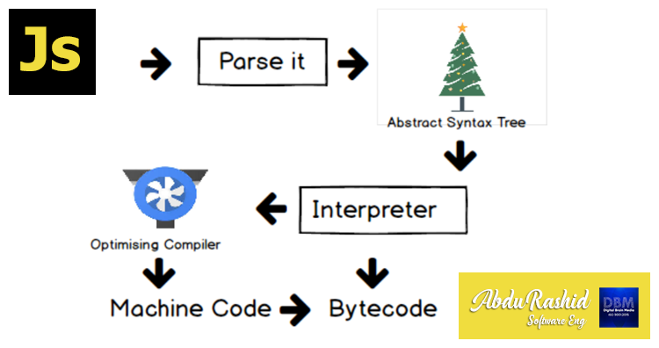

**Parsing**

The first stage of a JavaScript engine is parsing. It is the process of breaking down the source code into its individual components, such as keywords, variables, and operators. The parser creates a tree structure called the Abstract Syntax Tree (AST), which represents the structure of the code.

**Compilation**

The next stage is compilation. The compiler takes the AST and converts it into machine code. The machine code is optimized to run efficiently on the target platform. The compilation process includes several optimizations, such as inlining, loop unrolling, and dead code elimination.

**Execution**

The final stage is execution. The compiled code is executed by the JavaScript engine. The engine executes the code line by line, keeping track of variables and function calls. It also manages memory allocation and deallocation.

1. **Java script Run time environment?**

JavaScript works on a environment called **JavaScript Runtime Environment**. To use JavaScript you basically install this environment and than you can simply use JavaScript.

So in order to use JavaScript you install a **Browser** or **NodeJS** both of which are JavaScript Runtime Environment.

**call stack:**

The call stack is used to store information about function calls, including local variables, parameters, and the point of execution.

**Heap:**

The heap is a region of memory used for dynamic memory allocation. It stores objects, arrays, and other complex data structures that are created and managed at runtime.

**Web API:**

A Web API (Application Programming Interface) is a set of rules and tools that allows different software applications to communicate with each other over the web. It acts as an intermediary, enabling one application to interact with another application's data or functionality using standard web protocols, usually HTTP.

**Event loop:**

The event loop is a fundamental concept in asynchronous programming, especially in environments like JavaScript. It enables non-blocking operations, allowing code to execute asynchronously while ensuring that tasks are handled in an orderly manner. Here's a closer look at how synchronous and asynchronous operations interact with the event loop:

**Synchronous vs. Asynchronous**

1. **Synchronous:**

Synchronous operations are executed sequentially, one after the other. Each operation must complete before the next one begins.

1. **Asynchronous:**

Asynchronous operations allow code to execute without waiting for previous operations to complete. This is useful for tasks that involve waiting, such as network requests or timers.

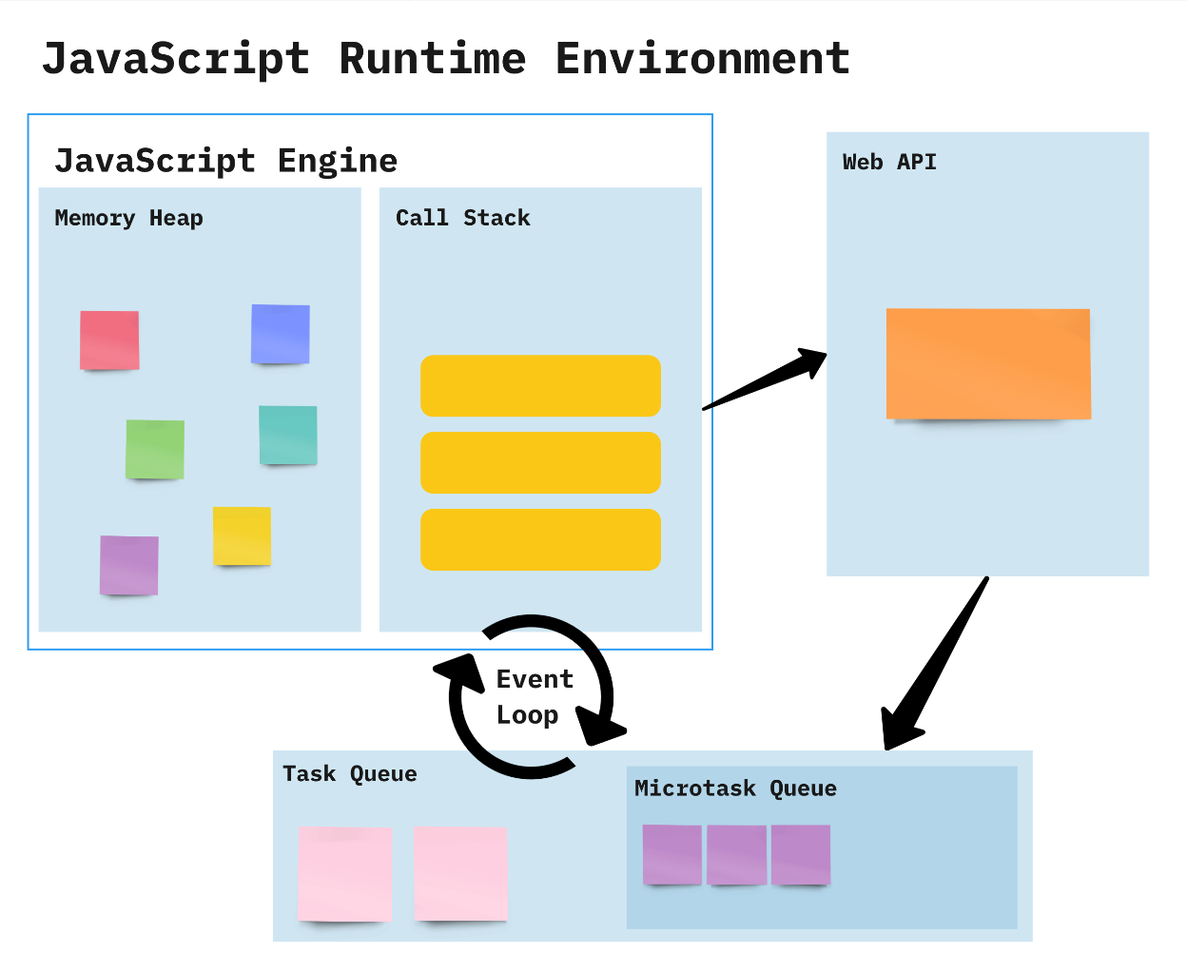

**How it Works:**

* Constantly checks whether or not the call stack is empty
* When the call stack is empty, all queued up Microtasks from Microtask Queue are popped onto the callstack
* If both the call stack and Microtask Queue are empty, the event loop dequeues tasks from the Task Queue and calls them
* Starved event loop

**Difference Between Compiler and Interpreter**

| **Compiler** | **Interpreter** |
| --- | --- |
| **Steps of Programming:**   * Program Creation. * Analysis of language by the compiler and throws errors in case of any incorrect statement. * In case of no error, the Compiler converts the source code to Machine Code. * Linking of various code files into a runnable program. * Finally runs a Program. | **Steps of Programming:**   * Program Creation. * Linking of files or generation of Machine Code is not required by Interpreter. * Execution of source statements one by one. |
| The compiler saves the Machine Language in form of Machine Code on disks. | The Interpreter does not save the Machine Language. |
| Compiled codes run faster than Interpreter. | Interpreted codes run slower than Compiler. |
| The compiler generates an output in the form of (.exe). | The interpreter does not generate any output. |
| Errors are displayed in Compiler after Compiling together at the current time. | Errors are displayed in every single line. |

**How Many Ways To Insert JS**

JavaScript, also known as JS, is one of the scripting (client-side scripting) languages, that is usually used in web development to create modern and interactive web-pages. The term "script" is used to refer to the languages that are not standalone in nature and here it refers to JavaScript which run on the client machine.

1. **internal JS:**

By using script tag at the bottom of the document

**Syntax:**

<body>

<script>

Console.log(“hello world”);

</script>

</body>

1. **inline JS:**

we can apply inline js within the element.

**Syntax:**

<body>

<button onclick=”alert(‘hello world’)”>click</button>

</body>

1. **external JS:**

By creating a js file with .js extention we can insert js file into the html document. That js file is linked in the script tag.

**Syntax:**

<body>

<script src=”js file with .js extention”></script>

</body>

**Variables:**

Variables are used to store data in JavaScript. Variables are used to store reusable values. The values of the variables are allocated using the assignment operator(“=”).

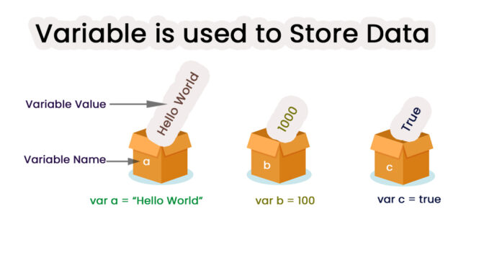

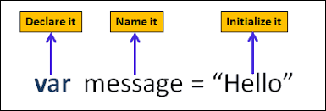

JavaScript Variables can be declared in 4 ways:

* **Automatically**
* **Using var**
* **Using let**
* **Using const**

Example:

a=10;

Var b=20;

let c=5;

Const d=15;

console.log(a); //10

console.log(a); //20

console.log(a); //5

console.log(a); //15

**Rules for Identifiers:**

* Names can contain letters, digits, underscores, and dollar signs
* Identifier should not start with number
* Names must begin with a letter or _ or $
* Names are case-sensitive
* Reserved words cannot be used as Identifier.

**Terms:**

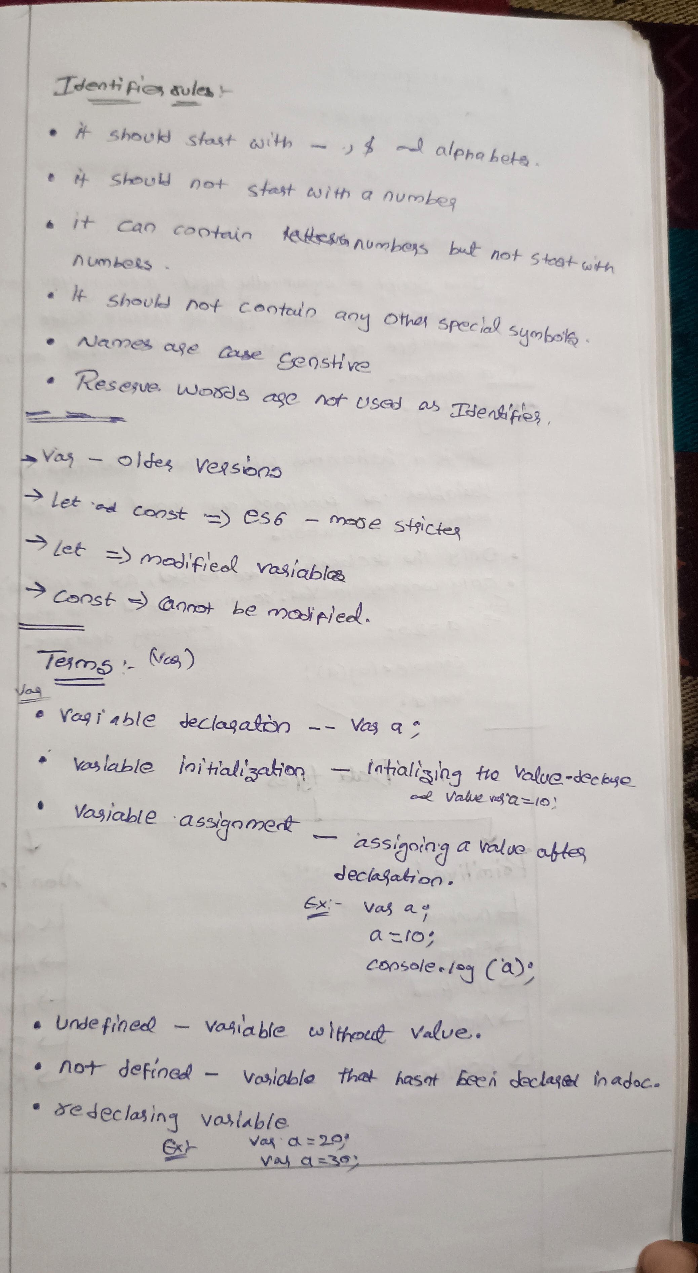

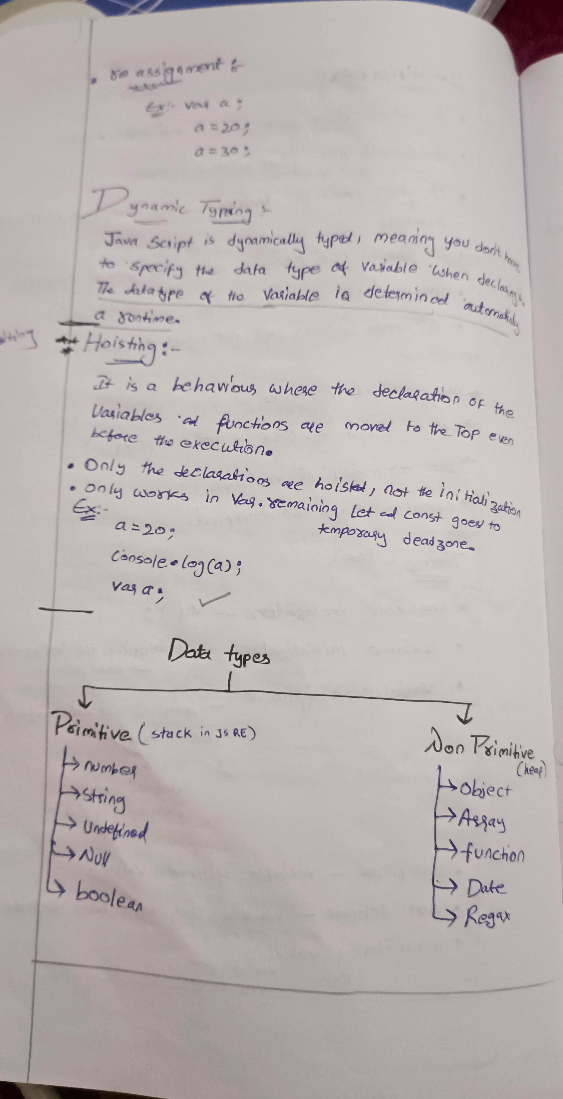

**Dynamic typing:**

Js is a dynamically typed, meaning you do not have to specify the datatype of the variable when declared. The Data type of the variable is determined automatically in a runtime.

**Hoisting**

* It is a behaviour where the declaration of the variable and functions are moved to the top even before the execution.
* Only Declaration is hoisted not the Initialization
* Only works in **var** remaining **let** and **const** goes to temporary deadzone

Example:

a=20;

Console.lob(a); //20

var a;

**Data types**

JavaScript provides different **data types** to hold different types of values. There are two types of data types in JavaScript.

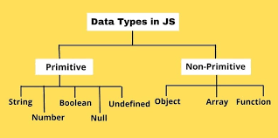

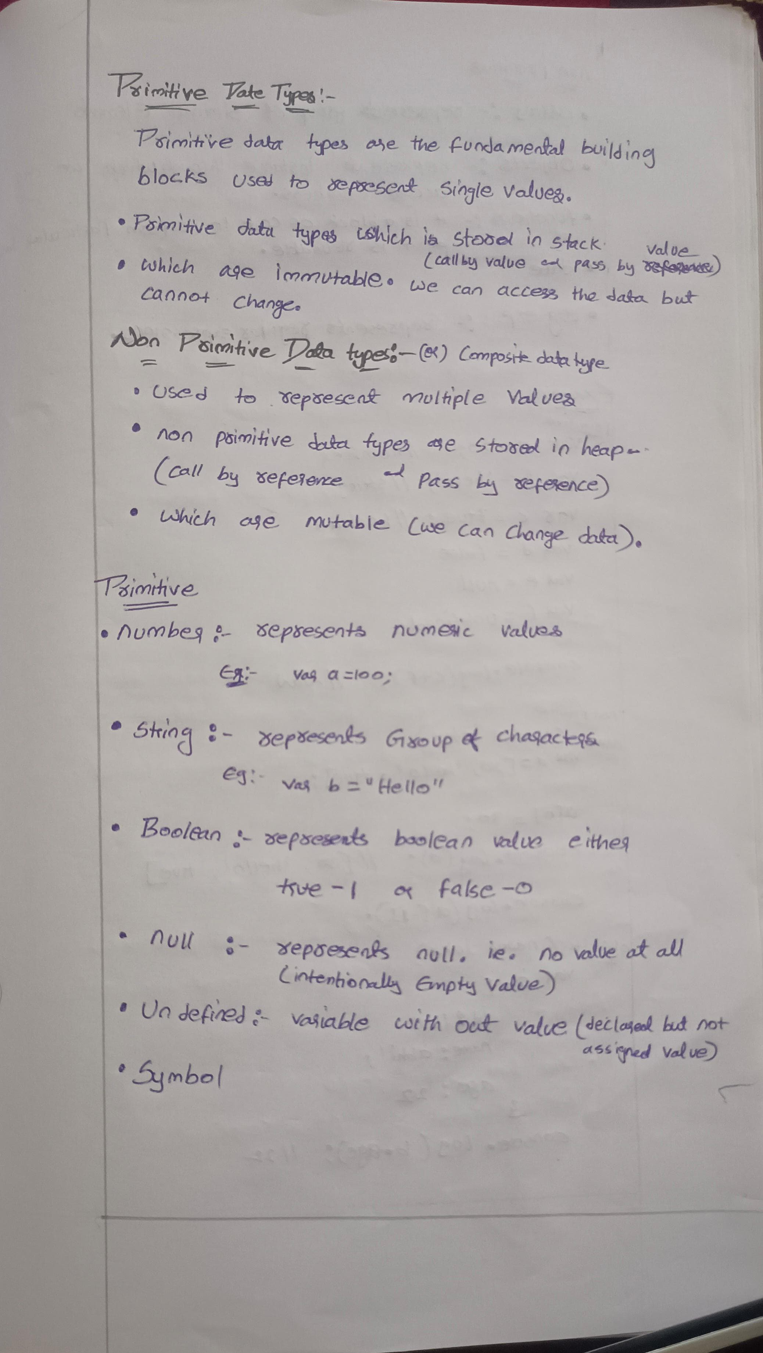

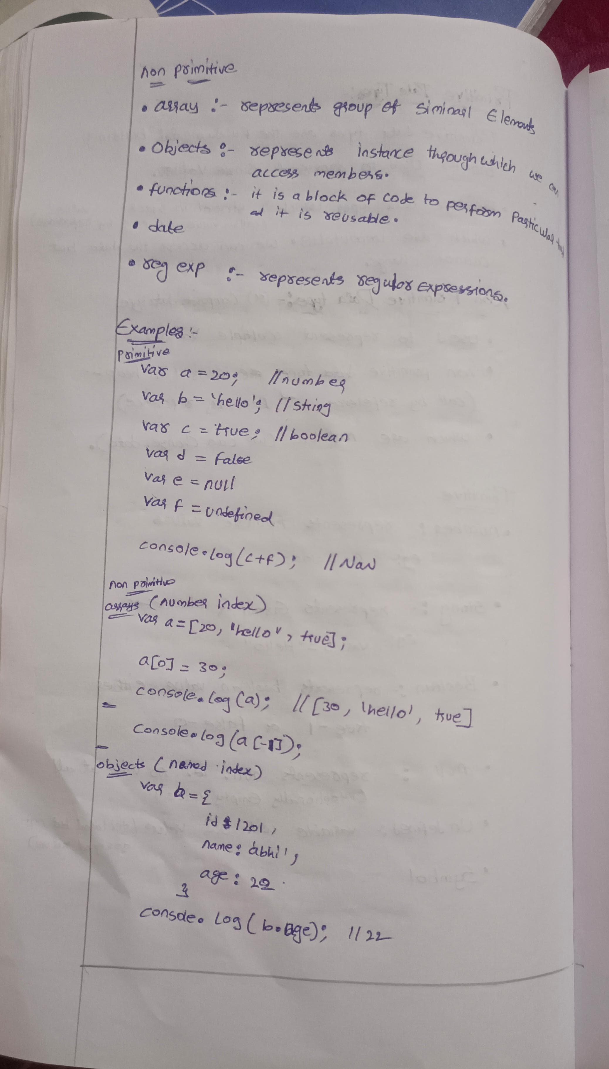

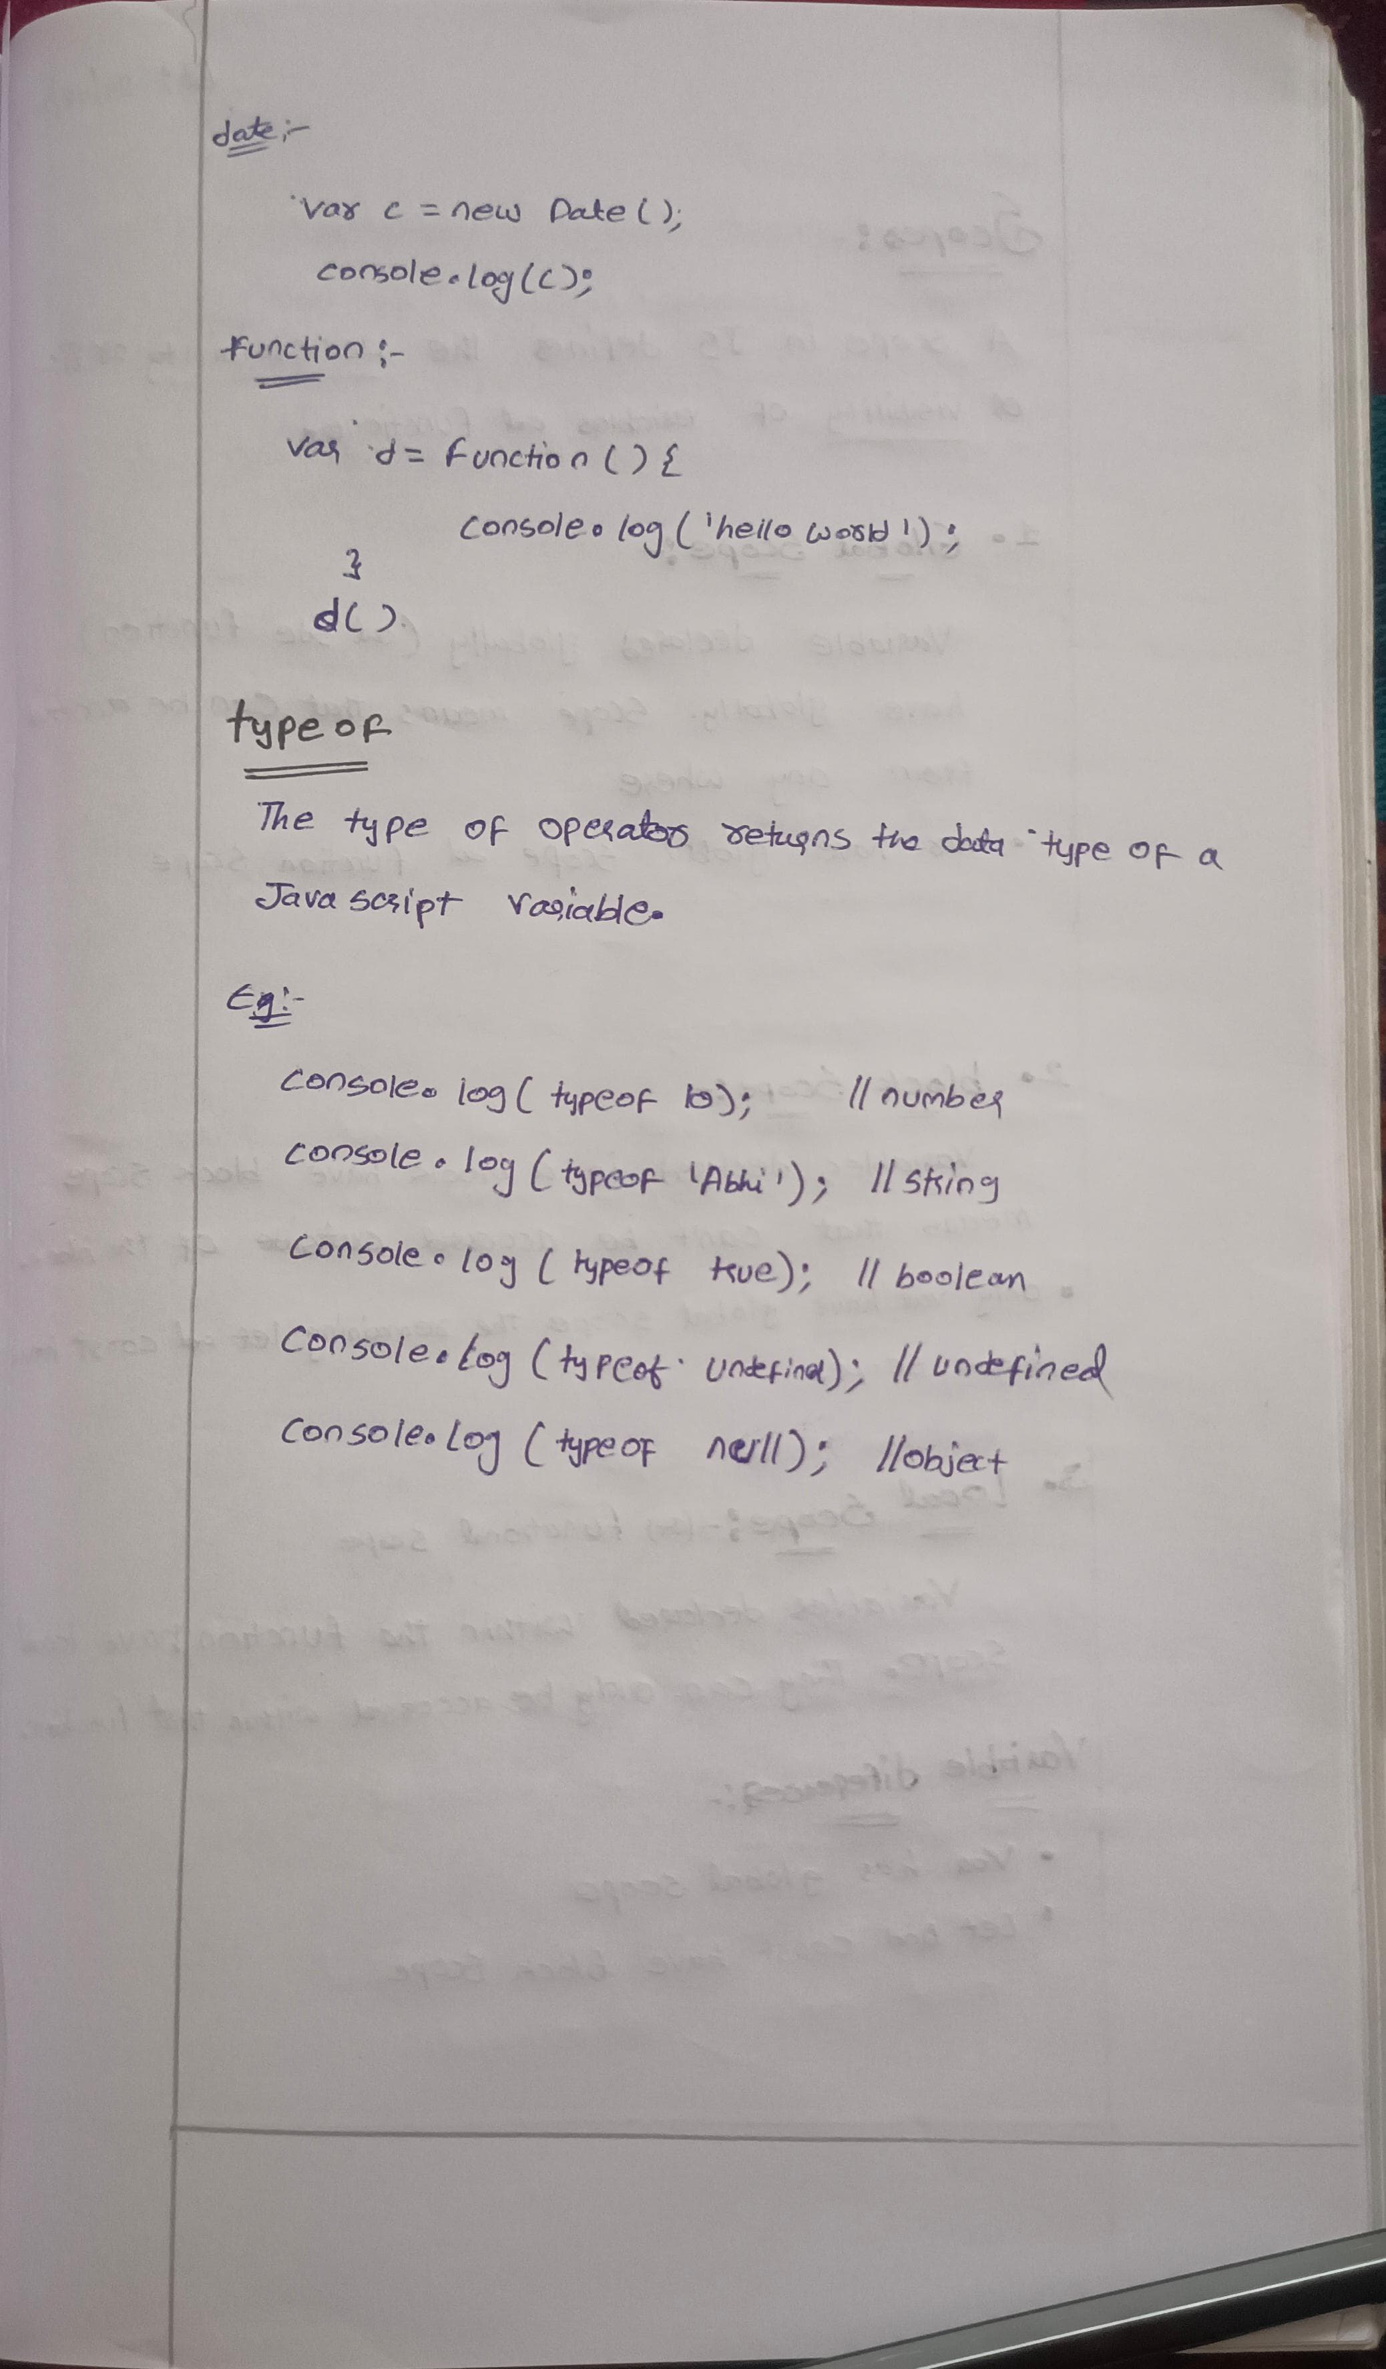

**Typeof:**  
The typeof operator returns the data type of a variable.

The JavaScript typeof operator returns the data type of a variable or expression. It’s a unary operator placed before its operand and returns a string indicating the data type, such as “number”, “string”, “boolean”, “object”, “undefined”, “function”, or “symbol”.

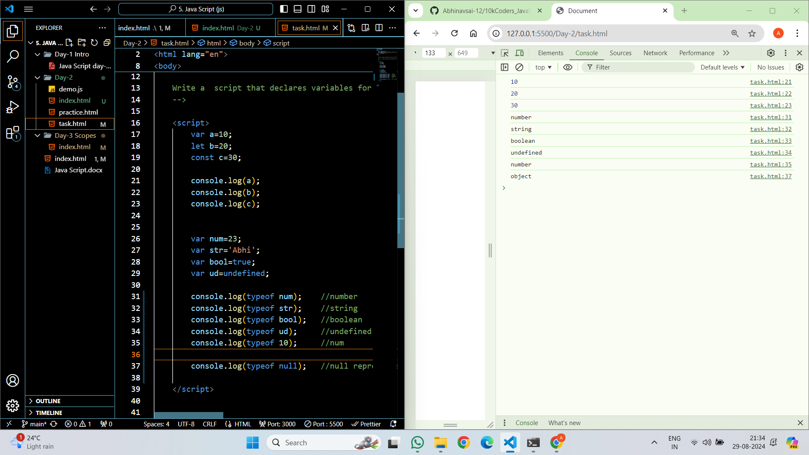

**Scopes**

A Scope in JS defines the Accessibility or life or Visibility of Variables and Functions.

* 1. Global Scope:

Variable declared globally (out side function) have globally. Scope means can be access from any where.

Var have global Scope and Function Scope.

* 1. Block Scope:

Variables declared in a block have block scope means that can’t be accessed outside of the block.

Only var have global scope the remaining let and const have block scope.

* 1. Local Scope:

Variables declared within the function have local scope. They can only be accessed with in the function.

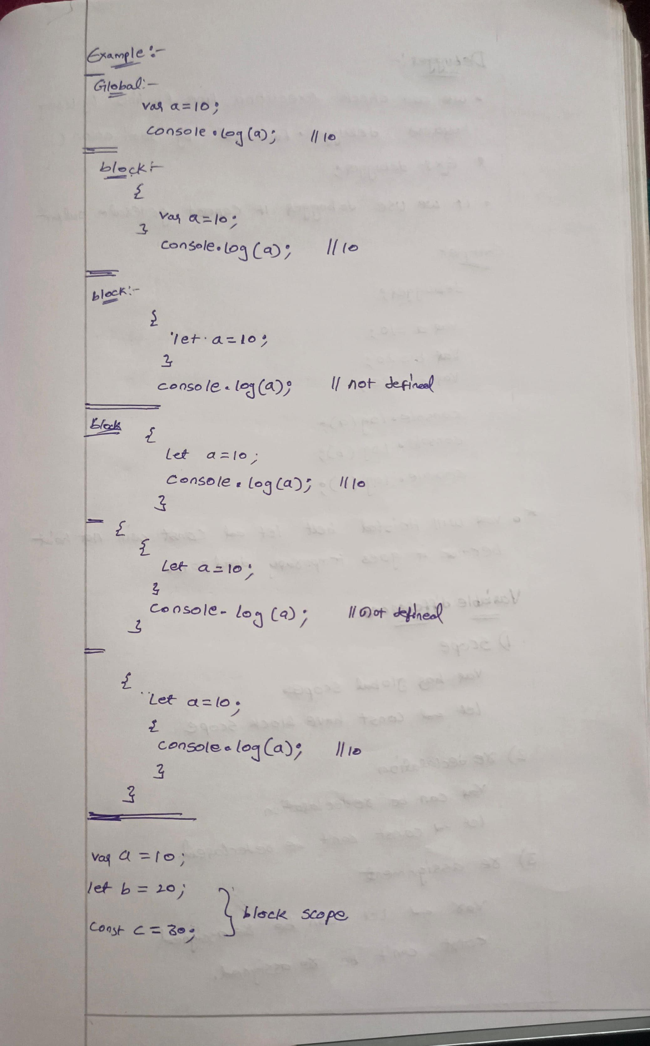

**Debugger**

We can check Execution line by line by using keyword debugger followed by semi colon (:)

**syntax:**

debugger;

**Example:**

    <script>

debugger;

        var a=10;

        let b=20;

        const c=30;

        console.log(a);

        console.log(b);

        console.log(c);

    </script>

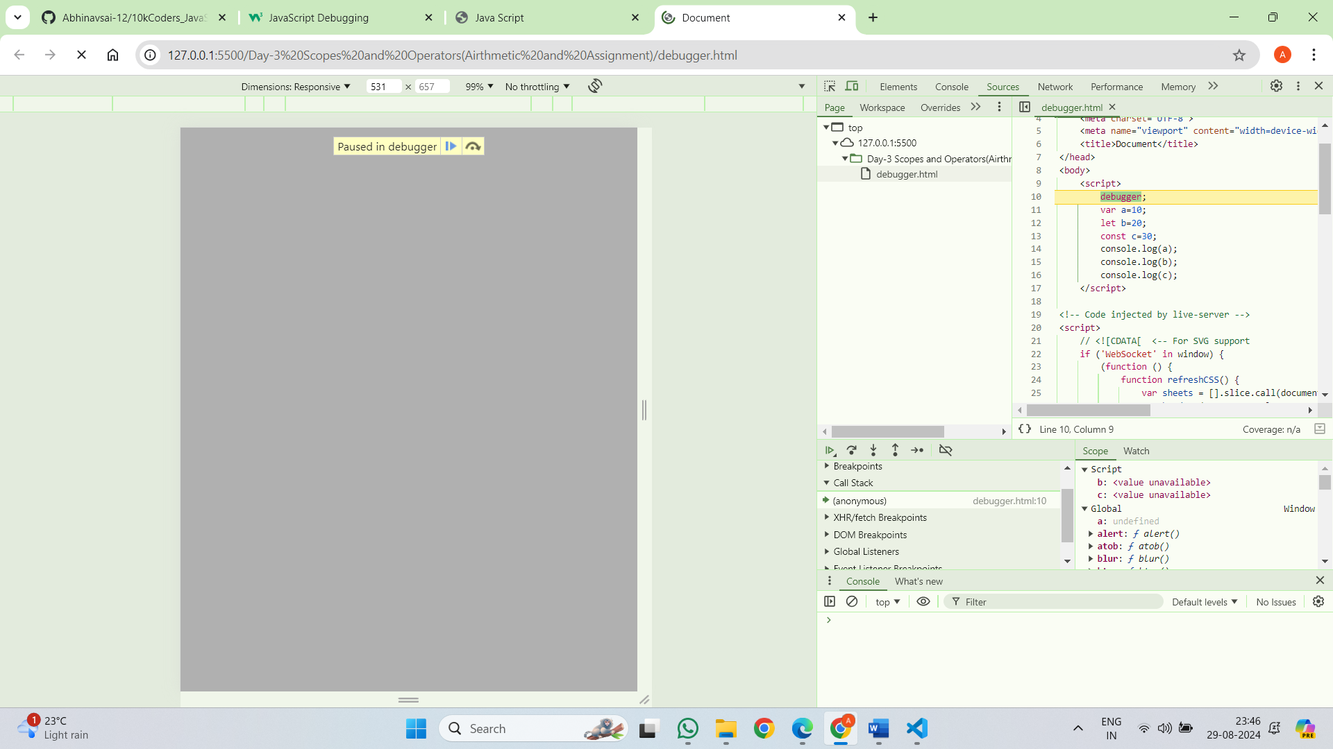

**Variable Difference:**

1. Scope  
   var has global scope

Let and const have block scope

1. Re declaration

Var can be re declared

Let and const can’t be re declared

1. Re assignment

Var and let can be re assigned

Const can’t be re assigned

**Operators**

Javascript operators are used to perform different types of mathematical and logical computations.

(or)

In JavaScript, an **operator** is a symbol that performs an operation on one or more operands, such as variables or values, and returns a result. Let us take a simple expression **4 + 5** is equal to 9. Here 4 and 5 are called **operands**, and ‘+’ is called the **operator**.

Types:

1. Airthmetic Operators
2. Assignment Operator
3. Comparision Operator
4. Logical Operator
5. Ternary Operator
6. Bitwise Oberator
7. String Operator
8. Typeof Operator

**Arithmetic operators**

Arithmetic operators are used to perform **arithmetic operations** between variables or values.

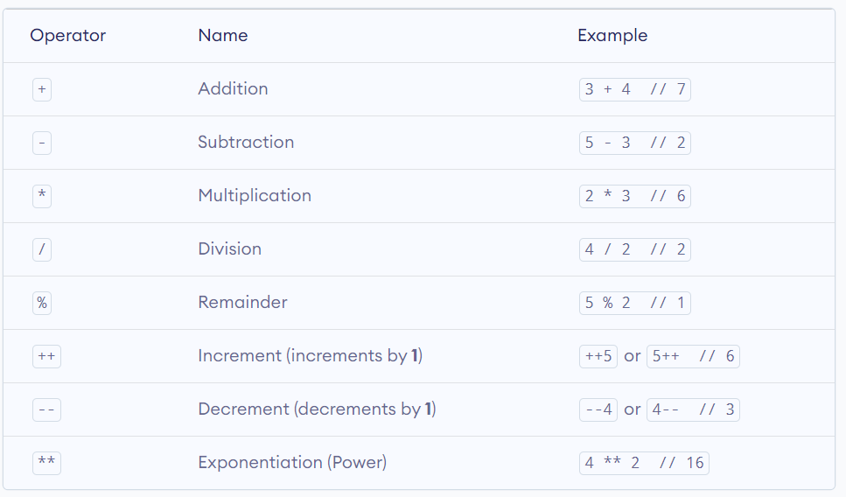

**Example:**

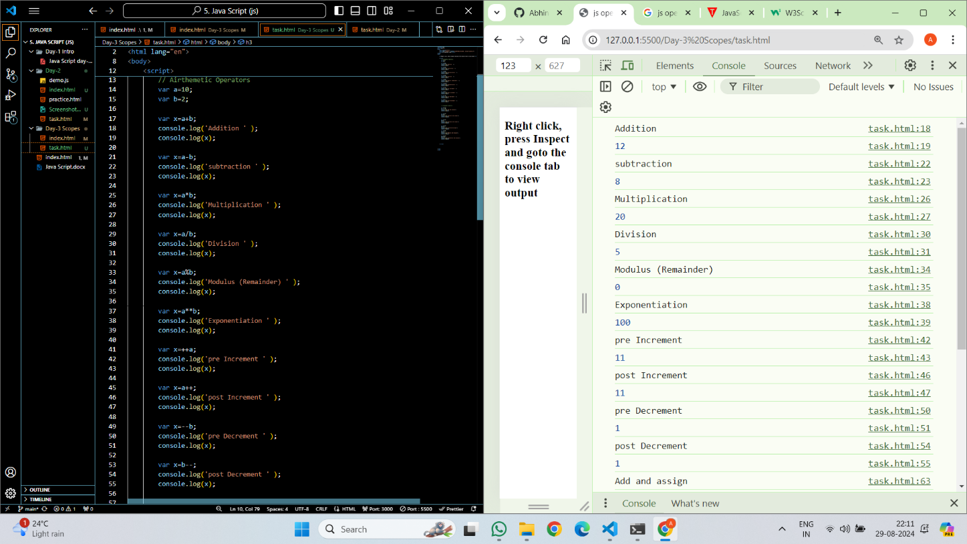

**Assignment Operators:**

We use assignment operators to **assign** values to variables.

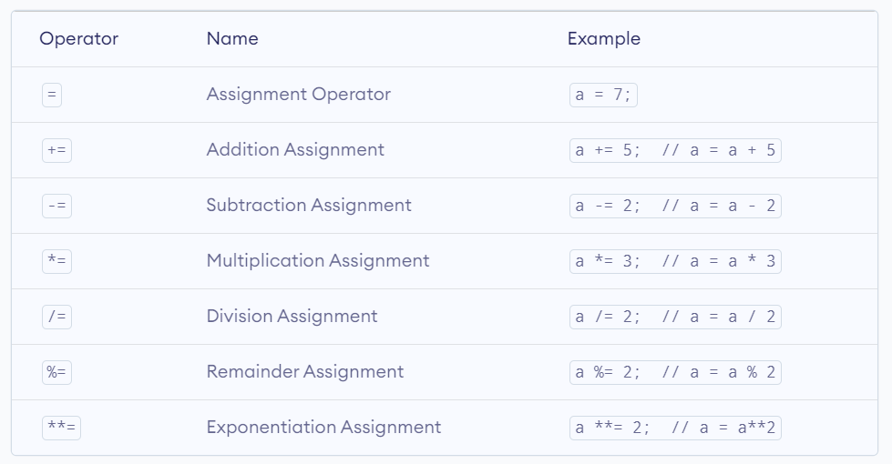

**Example:**

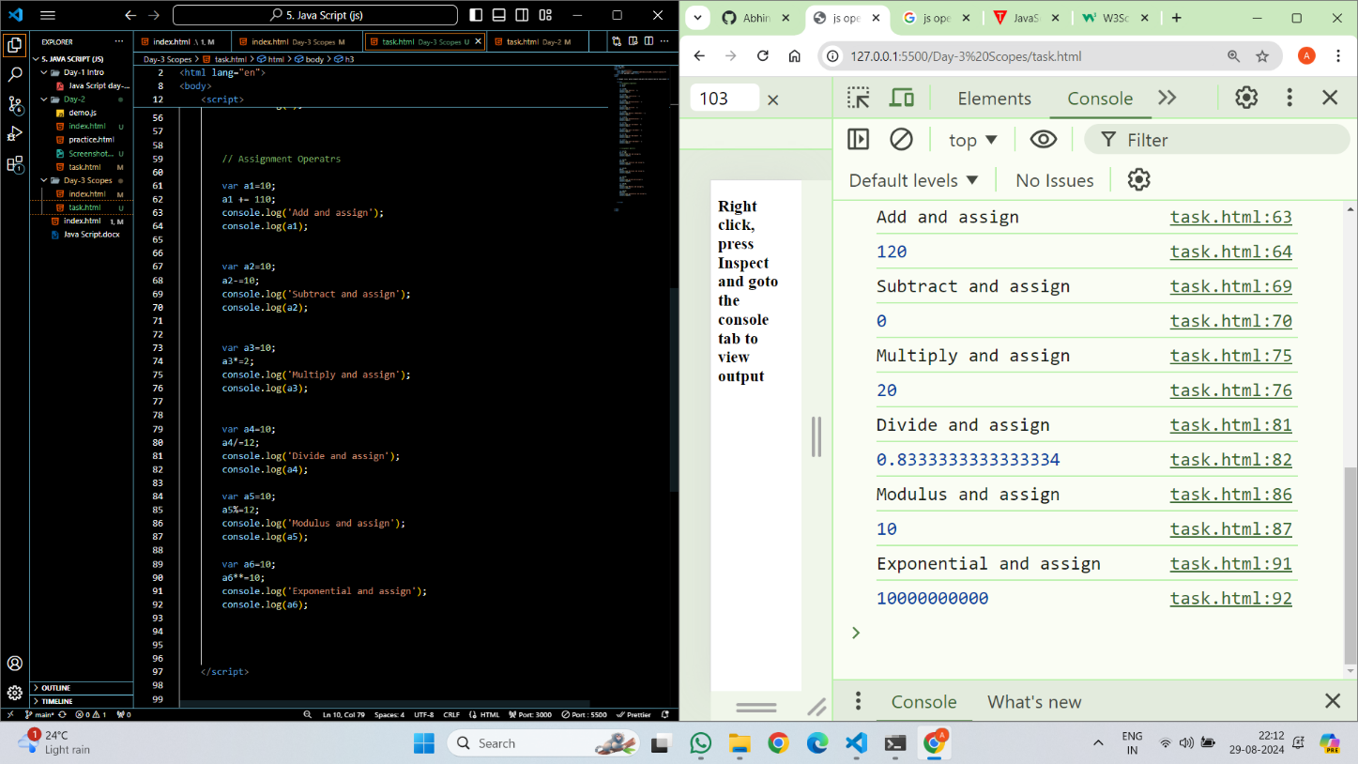

**Comparision Operators**

Comparison operators are used in logical statements to determine equality or difference between variables or values.

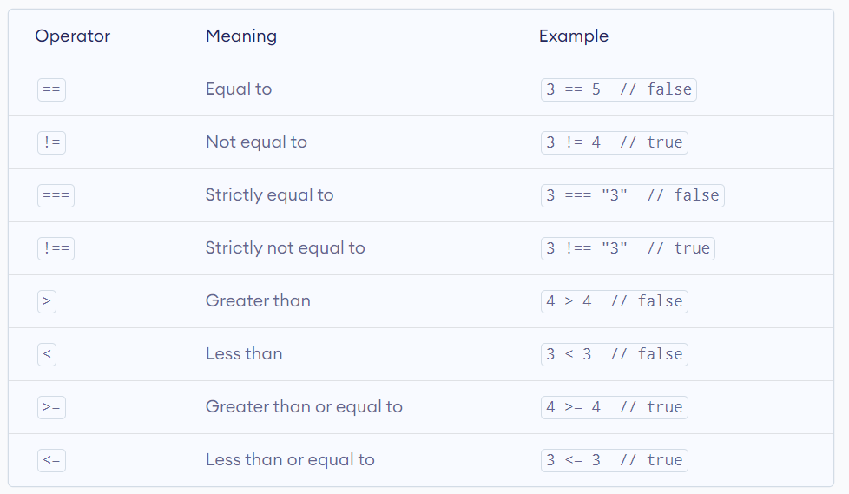

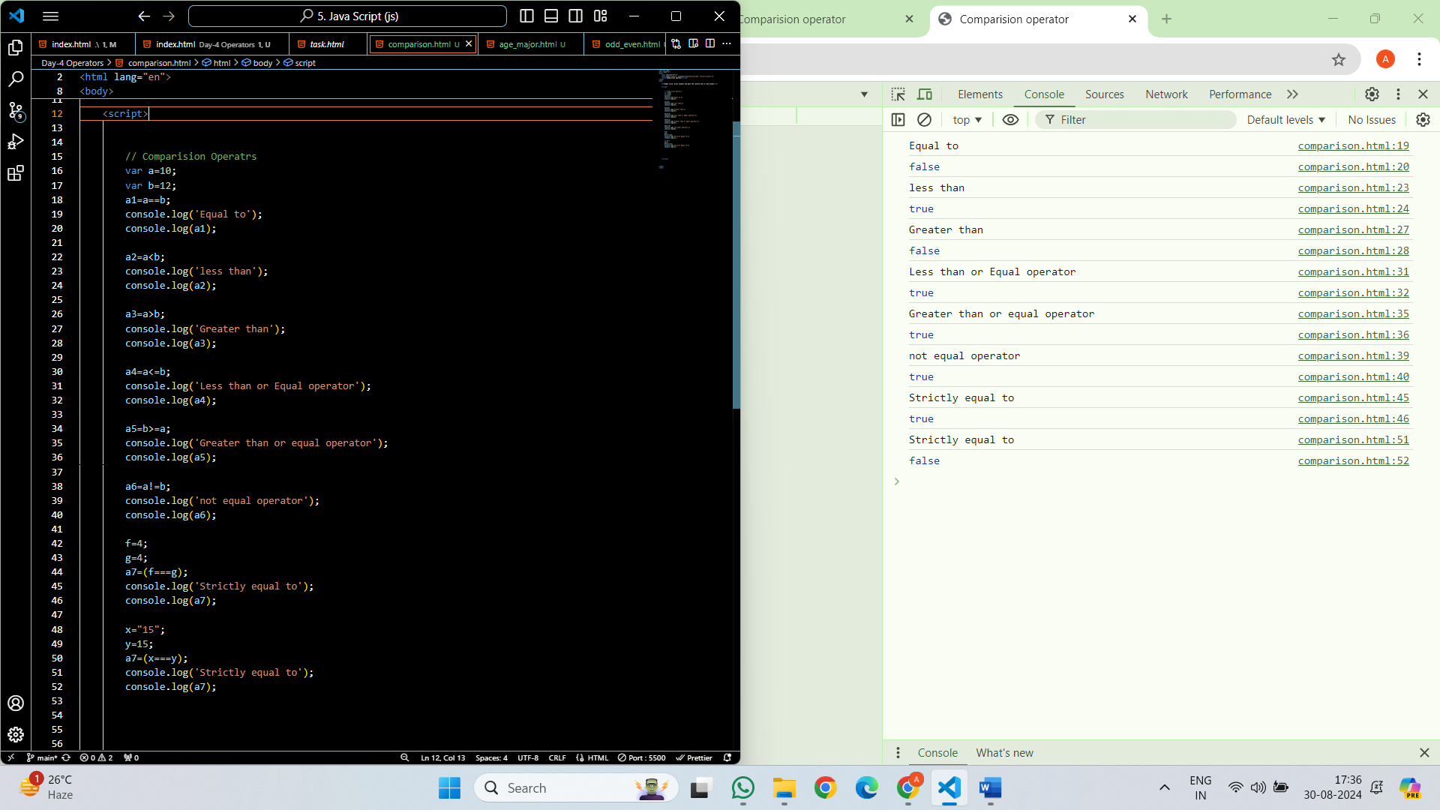

**Logical Operator:**

Logical operators return a boolean value by evaluating boolean expressions.

1. Logical And Operator: The **logical AND** operator **&&** returns true if both the expressions are true.
2. Logical OR Operator: The logical OR operator **||** returns true if at least one expression is true.
3. Logical Not Operator: The logical NOT operator **!** returns true if the specified expression is false and vice versa.

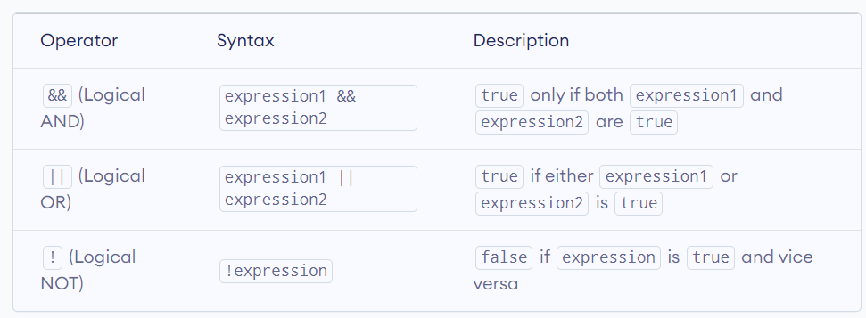

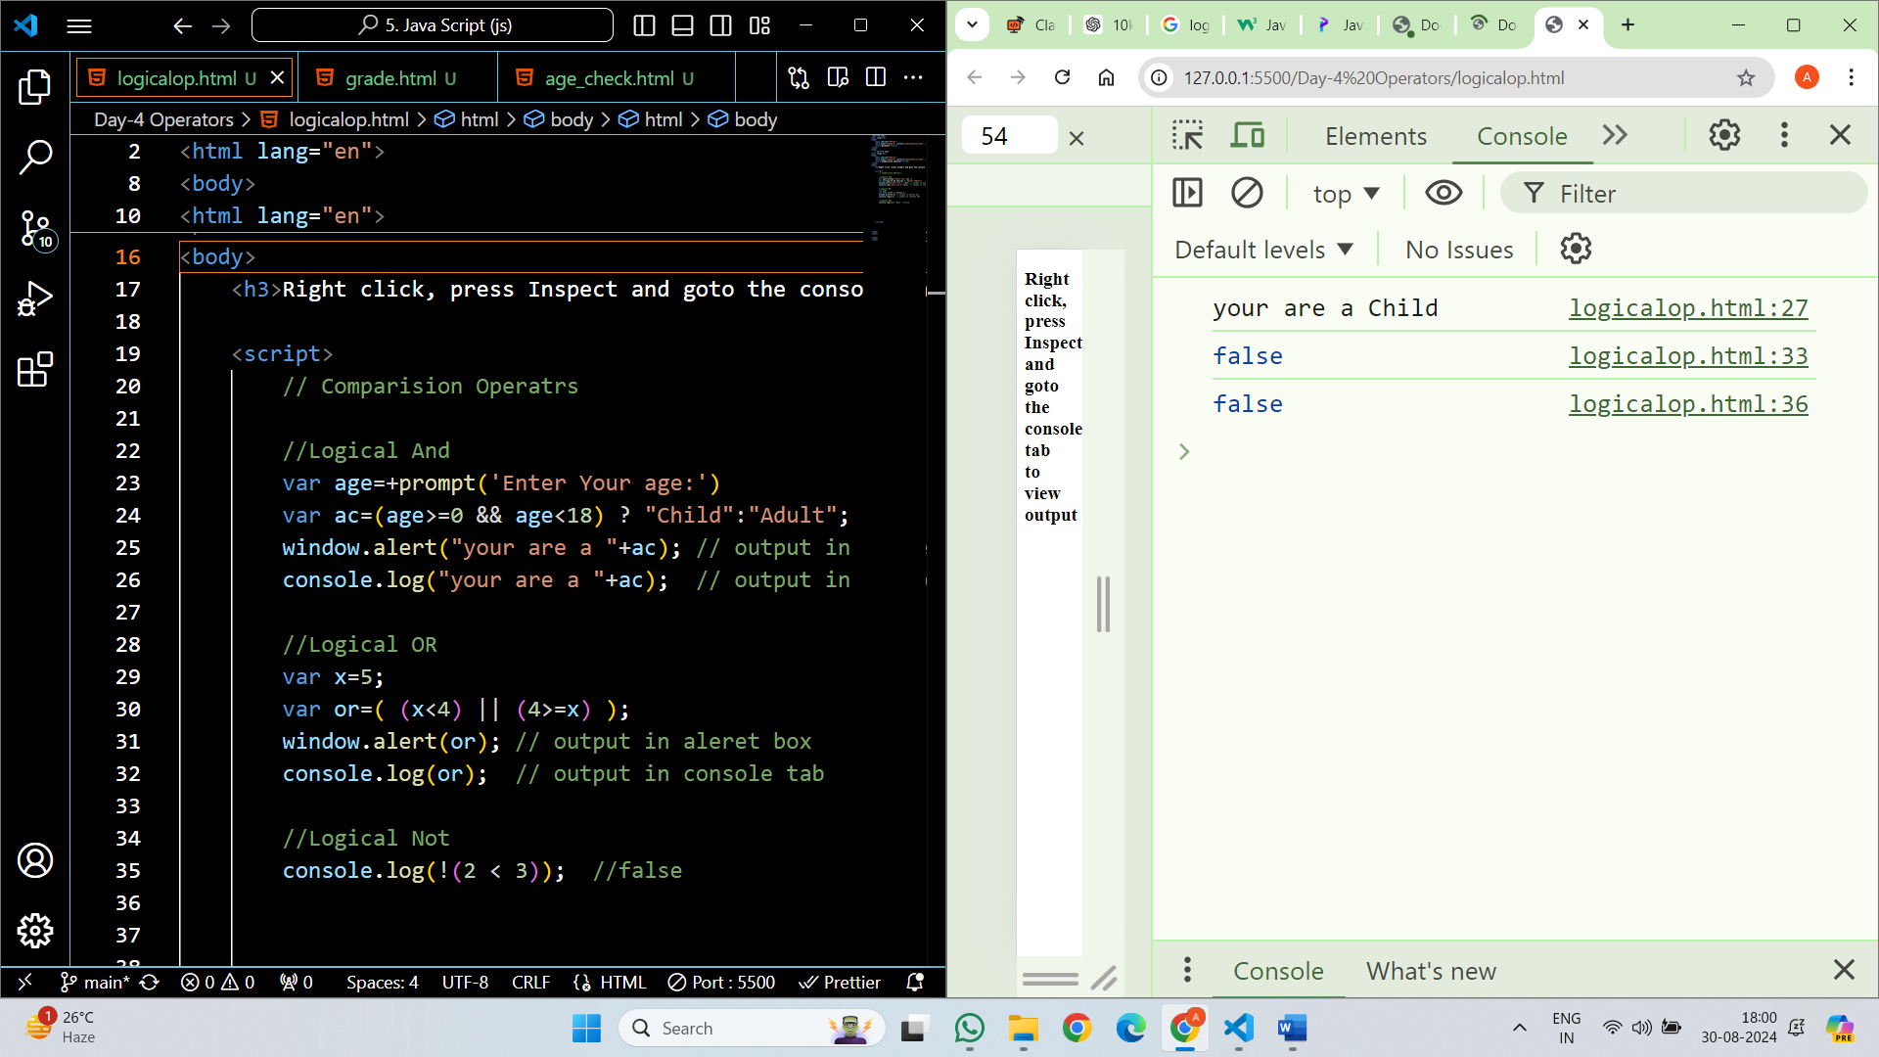

**Ternary operator:**

The Ternary Operator in JavaScript is a shortcut for writing simple if-else statements. It’s also known as the Conditional Operator because it works based on a condition. The ternary operator allows you to quickly decide between two values depending on whether a condition is true or false.

**Syntax:**

condition ? trueExpression : falseExpression

**Example:**

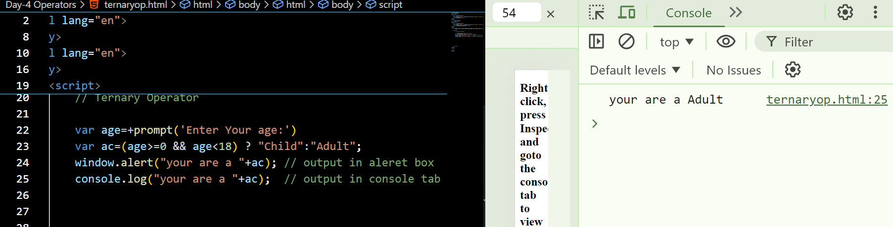

**Nullish coalescing operator (??)**

is a logical operator that returns its right-hand side operand when its left-hand side operand is null or undefined, and otherwise returns its left-hand side operand. It’s commonly used to provide default values for variables.

**Example:**

<script>

        //Nulish Coalescing Operator

         var a=null;

         var b=a ?? "Some Content";

         console.log(b); // Some Content

    </script>

**Unary Operator:**

* Unary operators in JavaScript are unique operators that consider a single input and carry out all possible operations.
* The Unary plus, unary minus, prefix increments, postfix increments, postfix decrements, and prefix decrements are examples of these operators. These operators are either put before or after the operand.
* The unary operators are more effective in executing functions than JavaScript; they are more popular. Unary operators are flexible and versatile since they cannot be overridden.

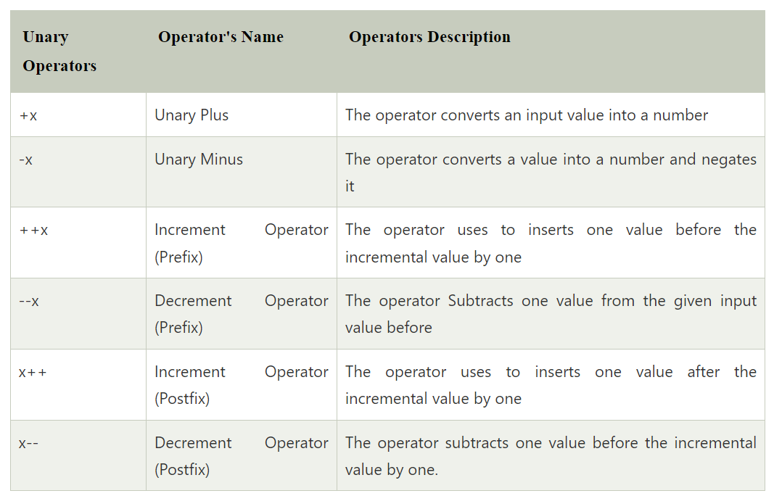

Example:

    <script>

            // Using unary plus to convert string to number

            let str1 = "12";

            let num = +str1;

            console.log(num);

            console.log(typeof (num))  // Here we are using typeof operator

            // "Abhinav" cannot be converted to a number

            let str2 = +"Abhinav";

            console.log(str2);

            console.log(typeof (str2))

            let s1='2'

            let n1 = -s1;

            console.log(n1);

            console.log(typeof (n1))

            let s2='3'

            let n2 = ++s2;

            console.log(n2);

            console.log(typeof (n2))

            let s3='5'

            let n3 = s3++;

            console.log(n3);

            console.log(typeof (n3))

    </script>

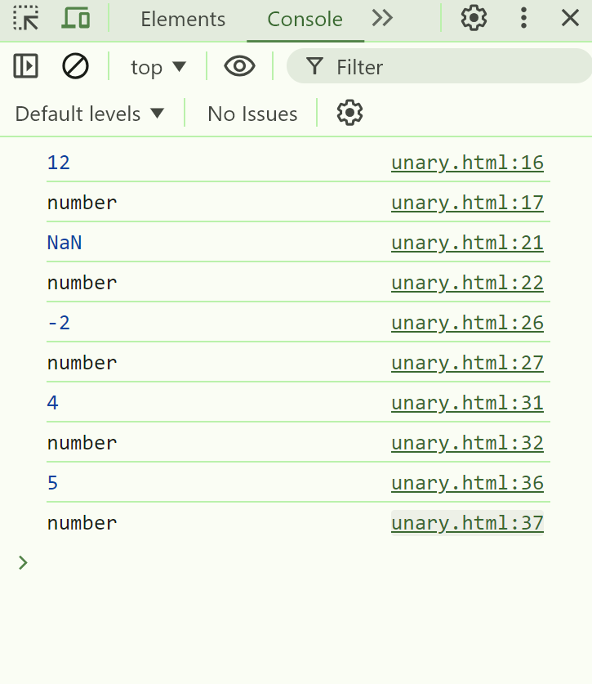

**Type Coercion**

Type coercion refers to the automatic or implicit conversion of values from one data type to another.

In programming, type conversion is the process of converting data of one [type](https://www.programiz.com/javascript/data-types) to another. For example, converting [string](https://www.programiz.com/javascript/string) data to [number](https://www.programiz.com/javascript/numbers).

There are two types of type conversion in JavaScript:

* **Implicit Conversion** - Automatic type conversion.
* **Explicit Conversion** - Manual type conversion.

**Explicit Type Conversion**

JavaScript type conversion, allowing you to convert values from one data type to another.

1.   **String()**: Converts a value to a string.

let num = 123;

let str = String(num);

console.log(str);

// Output: "123"

2.   **Number()**: Converts a value to a number.

let str = "123";

let num = Number(str);

console.log(num); // Output: 123

3. **Boolean()**: Converts a value to a boolean.

let num = 0;

let bool = Boolean(num);

console.log(bool); // Output: false

Example:

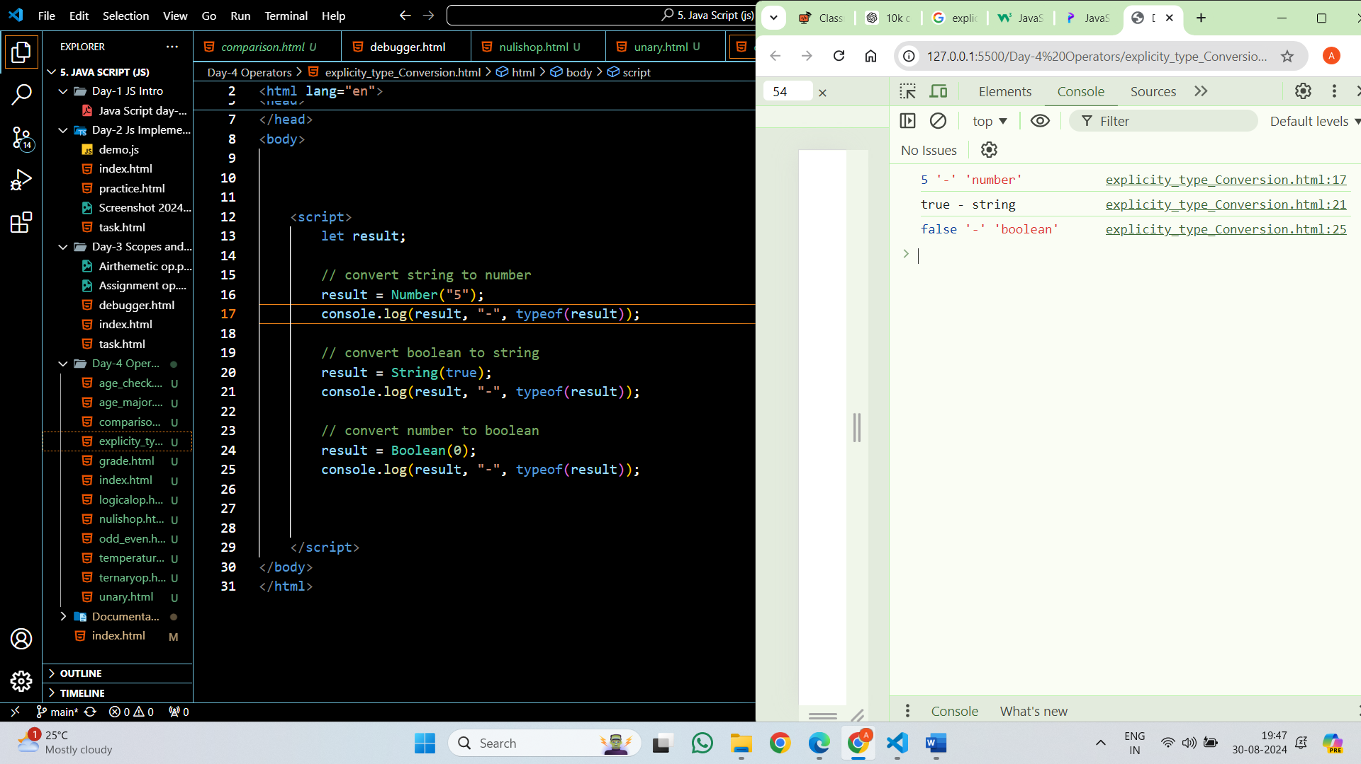

**How to take or get input from Users:**

Var a= +prompt(‘Enter Your Data’);

**In JavaScript, values are categorized as either "truthy" or "falsy"**

**Falsy Values:**

1.   **false**: The boolean value false itself.

2.   **0**: The number zero.

3.   **""**: Empty string.

4.   **null**: The absence of any value.

5.   **undefined**: A variable that has not been assigned a value or a property that does not exist.

6.   **NaN**: Not-a-Number.

**Truthy Values:**

1.   **true**: The boolean value true itself.

2.   **Non-zero numbers**: Any number other than 0 (including negative numbers and decimals).

3.   **Non-empty strings**: Any string with at least one character.

4.   **Non-empty arrays**: Arrays with at least one element.

5.   **Objects**: Any object (including functions and arrays) is truthy, even if it's empty.

6.   **Functions**: Any function is truthy, even if it doesn't return anything.

**Check Truthy, Falsy values using ternary operator:**

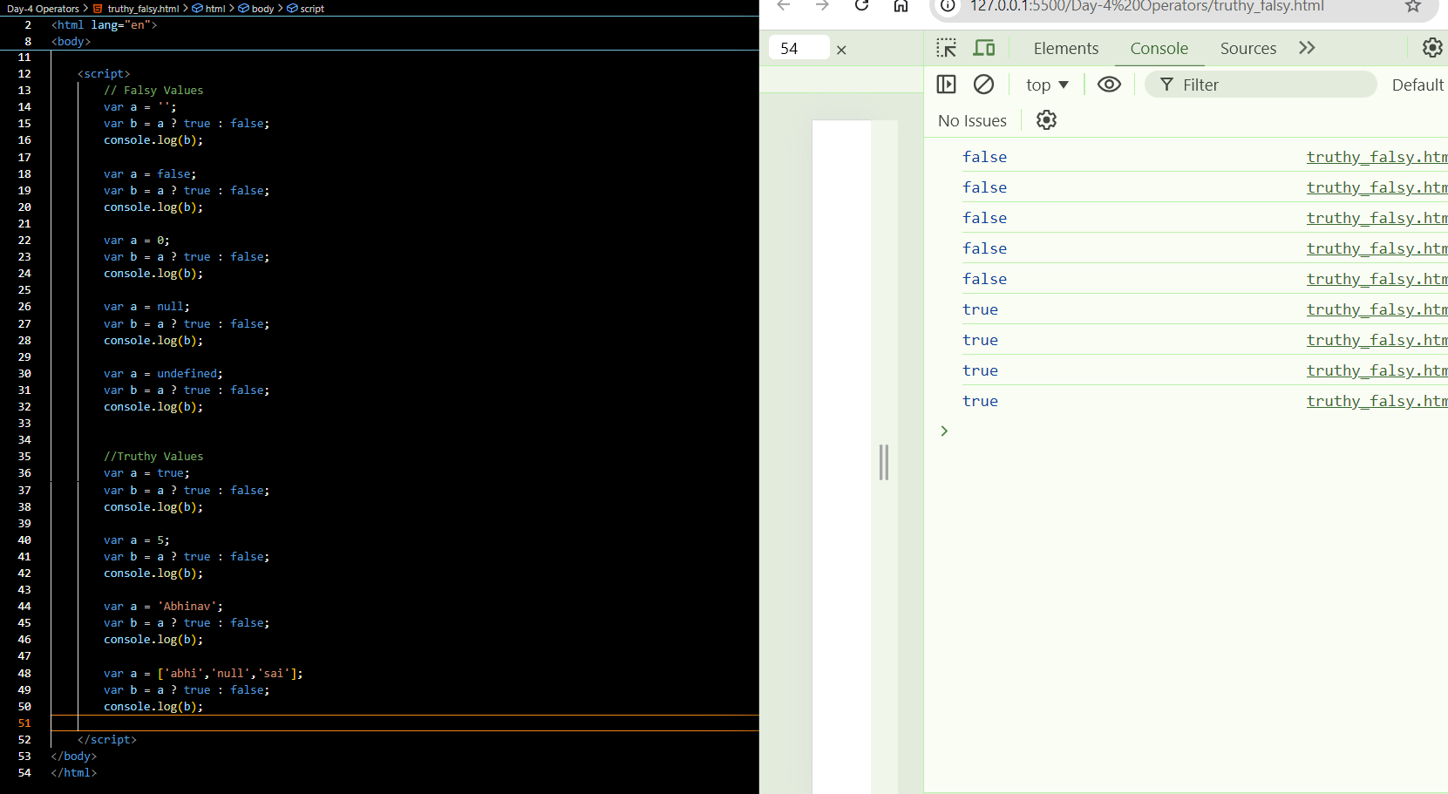

**Tasks:**

1. Write a JavaScript script that compares two variables using different comparison operators (==, ===, !=, !==, >, <, >=, <=) and prints the results.

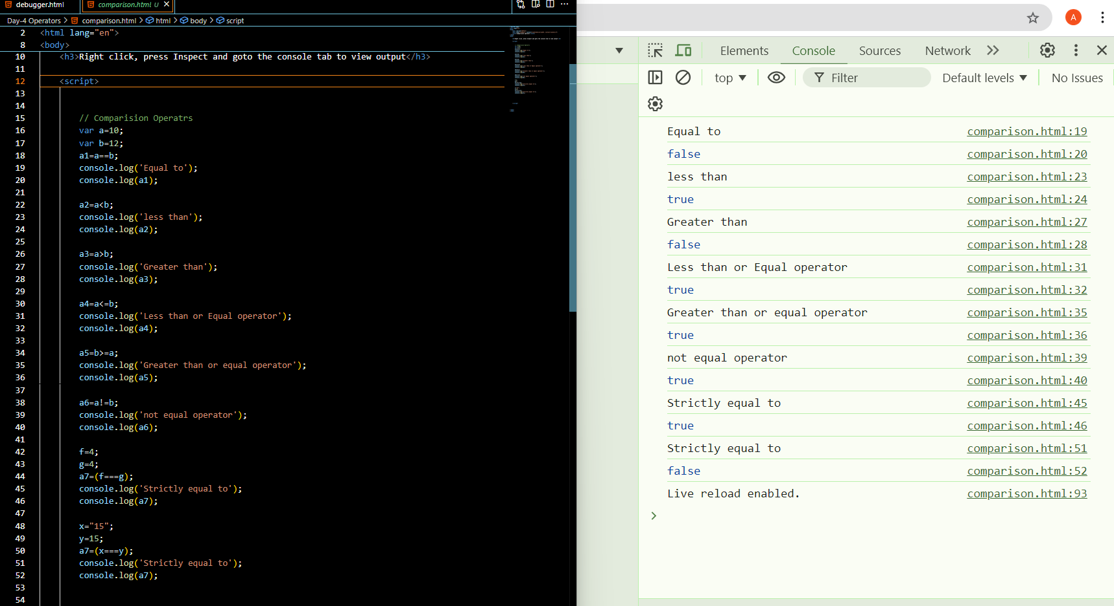

1. Write a JavaScript script that uses the ternary operator to determine if a number is even or odd.

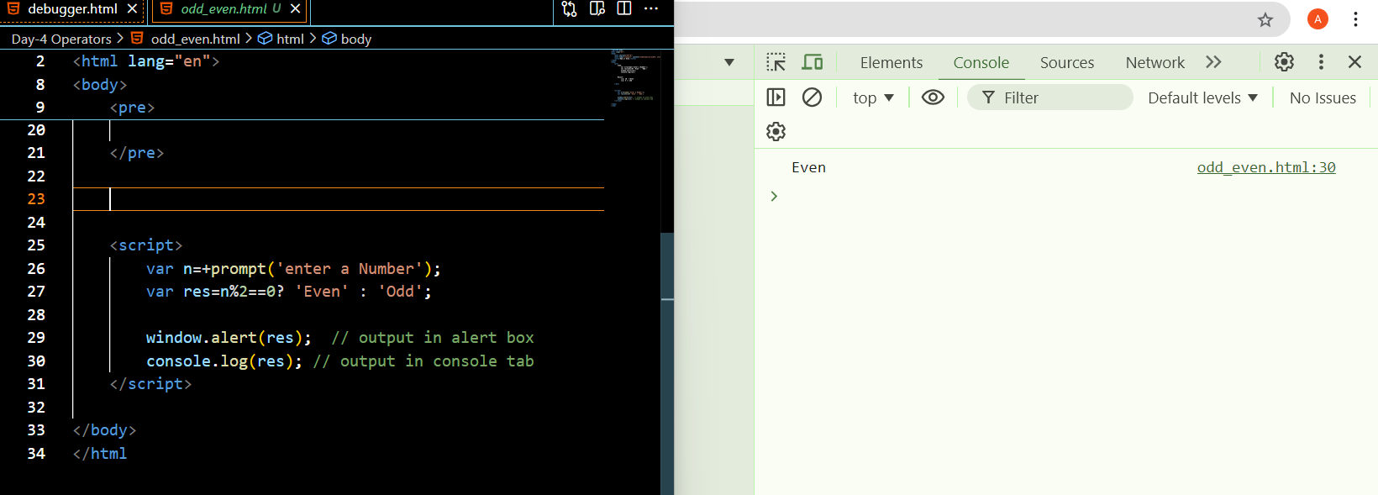

1. Expand the script to include a ternary operation that checks if a user is an adult (18+) or a minor.

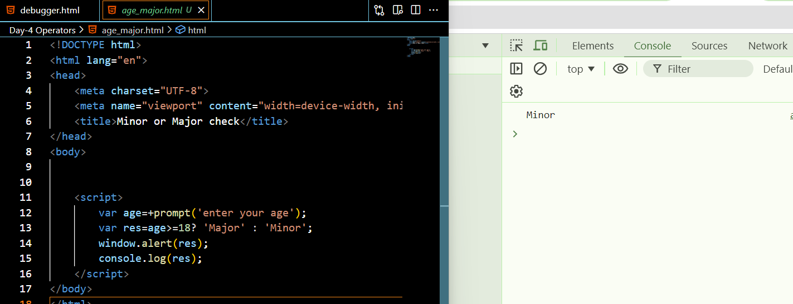

1. Grade Classification: Declare a variable score and set it to a value between 0 and 100. Use nested ternary operators to classify the score into grades: A (>= 90), B (>= 75), C (>= 60), D (>= 45), and F (below 45). Log the grade.

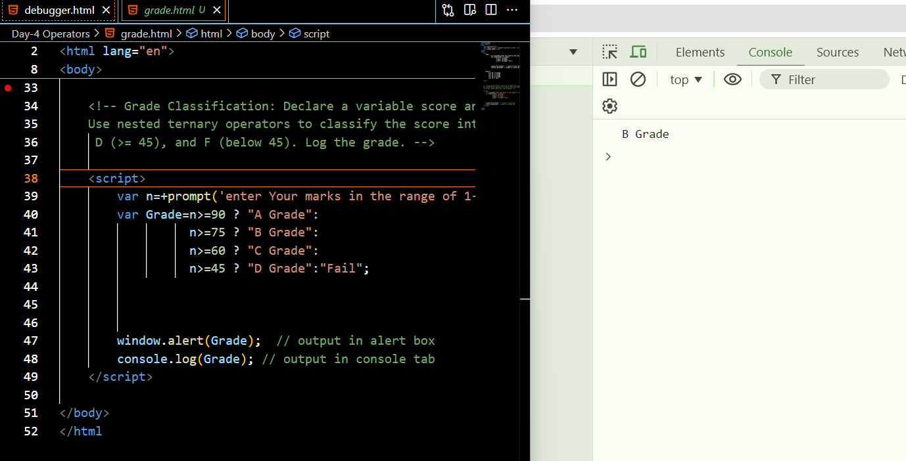

1. Temperature Check: Declare a variable temperature and use nested ternary operators to categorize it as "Hot" (above 30), "Warm" (20-30), "Cool" (10-19), and "Cold" (below 10). Log the result.

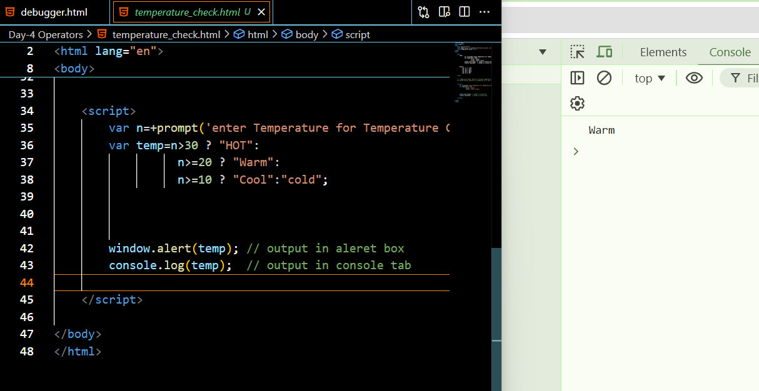

1. Age Group: Declare a variable age and use the ternary operator to classify the age into "Child" (0-12), "Teen" (13-19), "Adult" (20-64), and "Senior" (65 and above). Log the result.

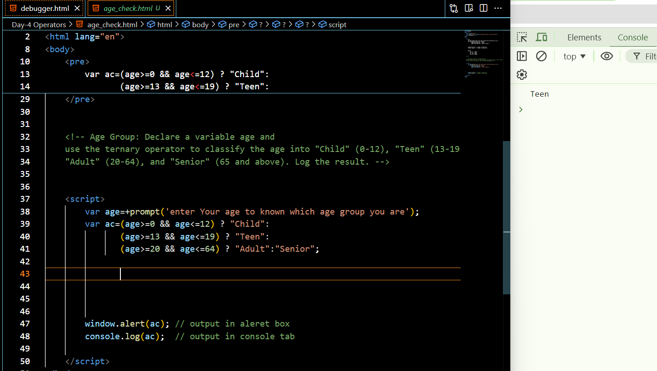

**Conditional Statements**

Conditional statements in programming are used to**control the flow of a program** based on certain conditions. These statements allow the execution of different code blocks depending on whether a specified condition evaluates to true or false, providing a fundamental mechanism for**decision-making**in algorithms. In this article, we will learn about the basics of Conditional Statements along with their different types.



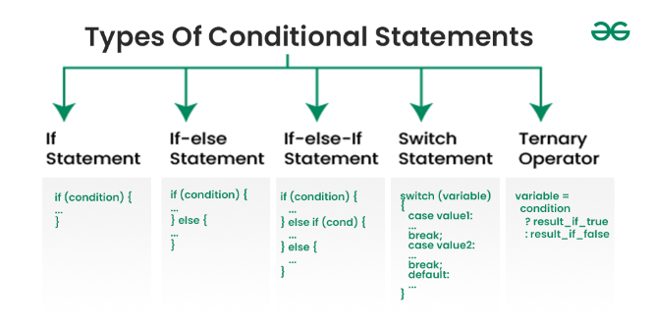

**1. if Statement:**

The **if** statement executes a block of code if a specified condition is true.

**Syntax:**

**if (condition) {**

**// Code to execute if condition is true**

**}**

**Example:**

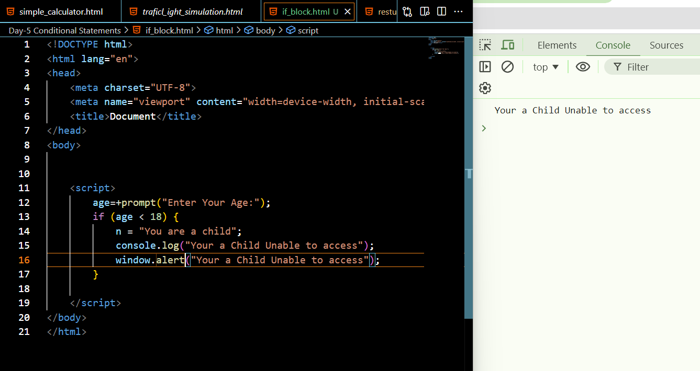

**2. if...else Statement:**

The **if...else** statement executes one block of code if a specified condition is true and another block if the condition is false.

**Syntax:**

**if (condition) {**

**// Code to execute if condition is true**

**} else {**

**// Code to execute if condition is false**

**}**

**Example:**

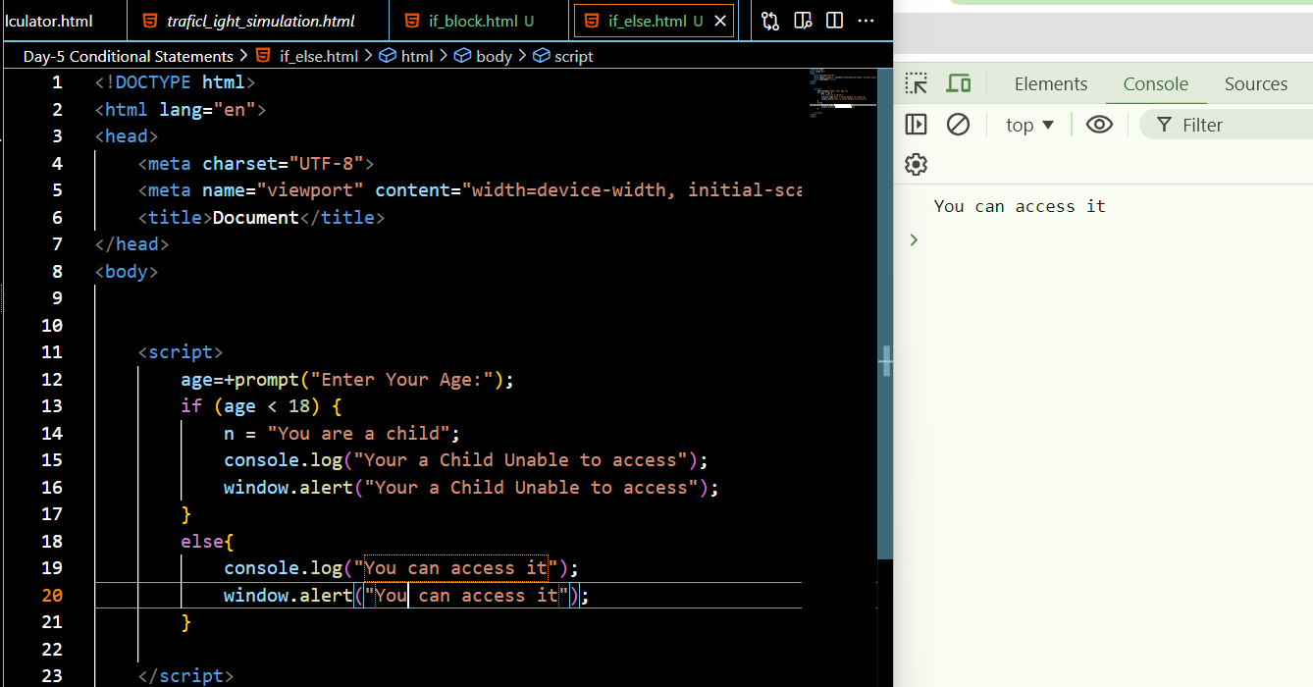

**3)if...else if...else Statement:**

The **if...else if...else** statement allows you to specify multiple conditions and execute different code blocks based on the outcome of those conditions.

**Syntax:**

if (condition1) {

    // Code to execute if condition1 is true

} else if (condition2) {

    // Code to execute if condition2 is true

} else {

    // Code to execute if none of the conditions are true

}

**Example:**

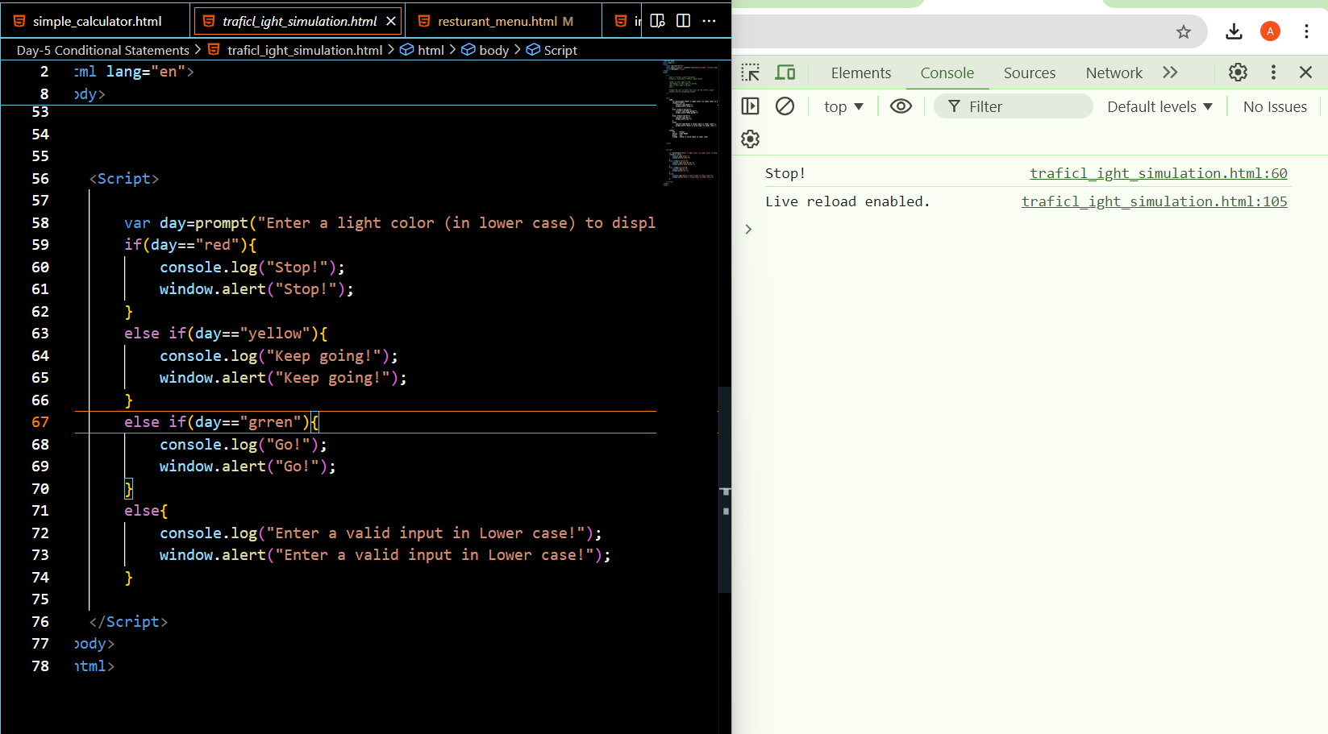

**4)Nested if:**

You can have if statements inside if statements, this is called a nested if.

Syntax

**if *condition1* {  
  *// code to be executed if condition1 is true*  
  if *condition2*{  
    *// code to be executed if both condition1 and condition2 are true*  
  }  
}**

**Example:**

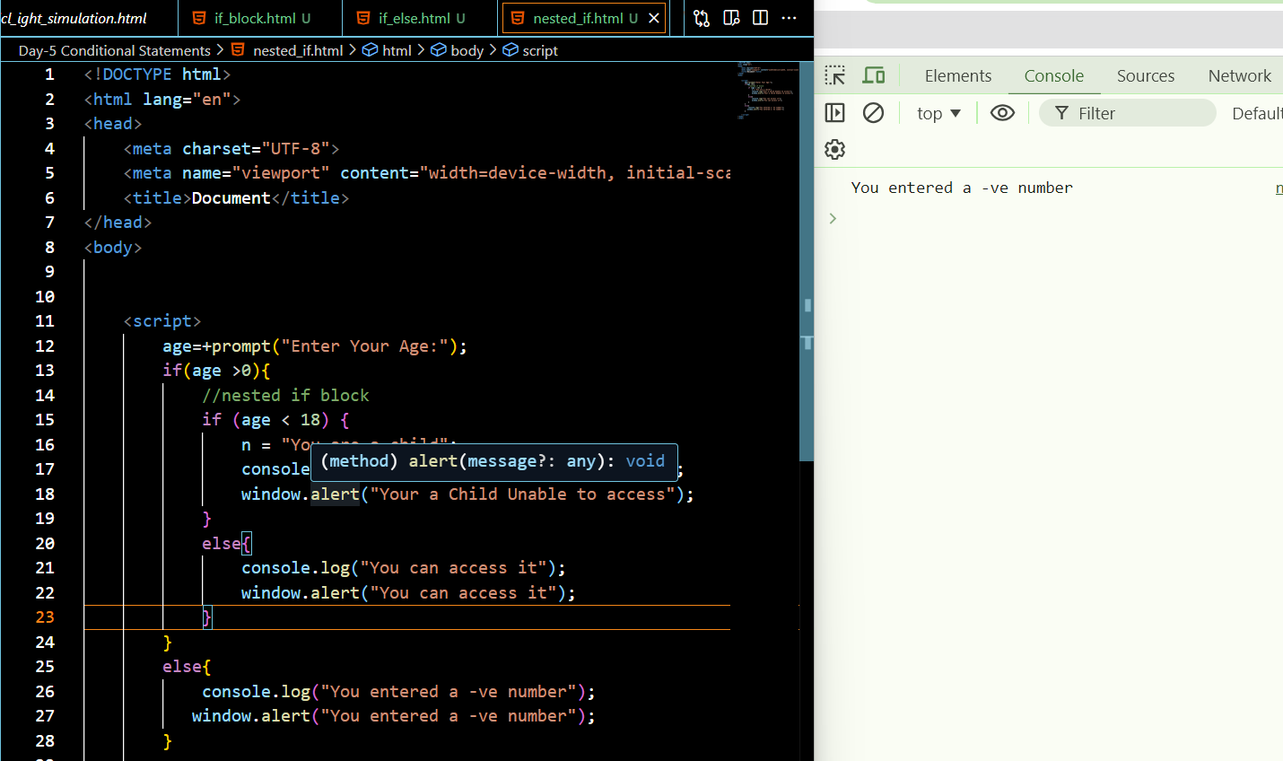

**Switch statements**

A switch statement in JavaScript is a control flow statement that allows you to execute a block of code among many options based on the value of an expression.

**Key Points**

1.   **Expression Evaluation**: The **expression** inside the switch statement is evaluated once.

2.   **Case Matching**: The result of the expression is compared with the values specified in each **case** clause using strict equality (**===**).

3.   **Code Execution**: If a match is found, the code block associated with that **case** is executed.

4.   **Break Statement**: The **break** statement is used to terminate the switch statement. If omitted, execution will continue to the next **case** clause (fall-through behavior).

5.   **Default Case**: The **default** clause is optional and executes if no matching **case** is found. It acts like the **else** in an if-else structure.

**Syntax:**

**switch (expression) {**

**case value1:**

**// Code to run if expression === value1**

**break;**

**case value2:**

**// Code to run if expression === value2**

**break;**

**// More cases...**

**default:**

**// Code to run if no case matches**

**}**

Example:

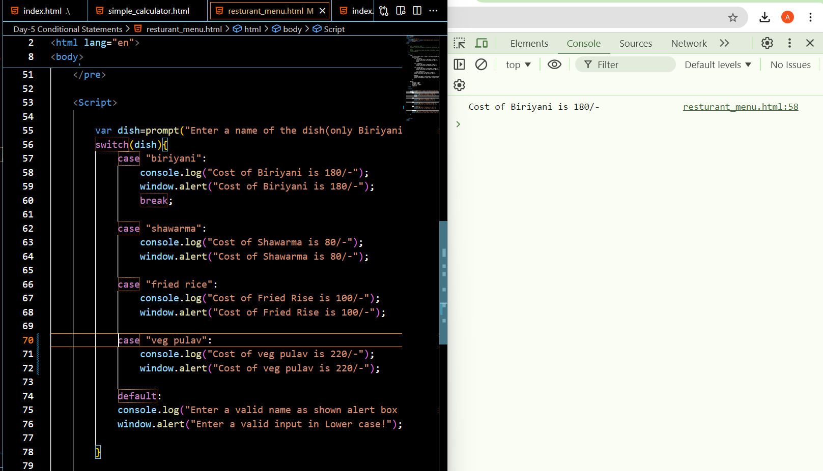

**TASKS**

**Task 1: Day of the Week Message**

Scenario: Develop a webpage that displays a special message based on the current day of the week.

“Start your week strong!” for Monday.

“Keep going!” for Tuesday.

“Halfway there!” for Wednesday.

“Almost the weekend!” for Thursday.

“Happy Friday!” for Friday.

“Enjoy your weekend!” for Saturday and Sunday.

**Task:**

Get the current day of the week.

Display the corresponding message.

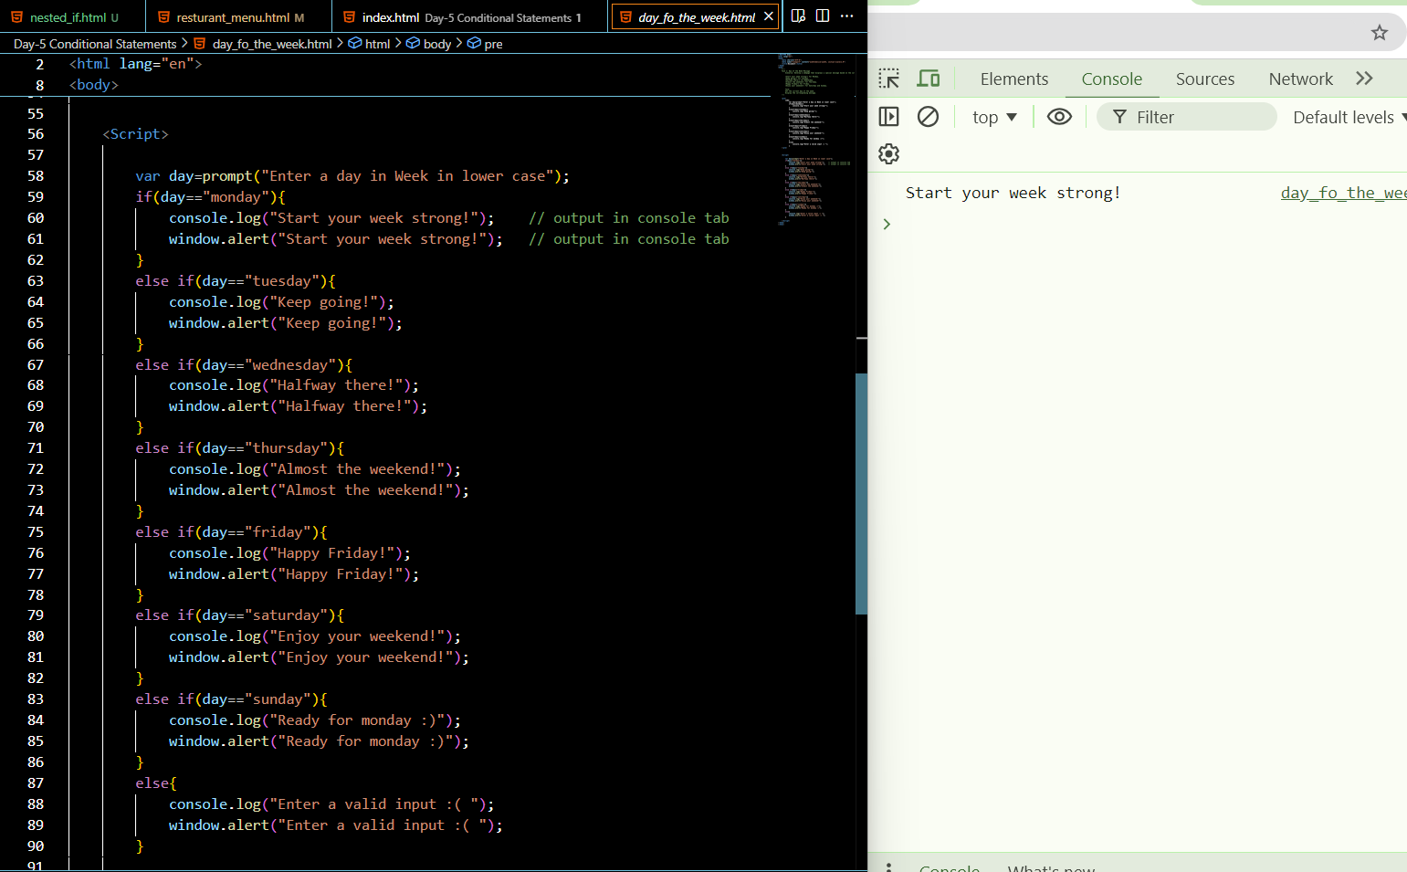

**Task 2: Traffic Light Simulation**

Scenario: Simulate a traffic light system.

“Stop” if the light is red.

“Get Ready” if the light is yellow.

“Go” if the light is green.

**Task:**

Prompt the user to enter the color of the traffic light.

Display the corresponding action.



**Task 3: Discount Calculator**

Scenario: Calculate the discount based on the total purchase amount.

“No discount” if the amount is less than $50.

“5% discount” if the amount is between $50 and $100.

“10% discount” if the amount is between $101 and $200.

“15% discount” if the amount is above $200.

**Task:**

Prompt the user to enter the total purchase amount.

Display the discount percentage.

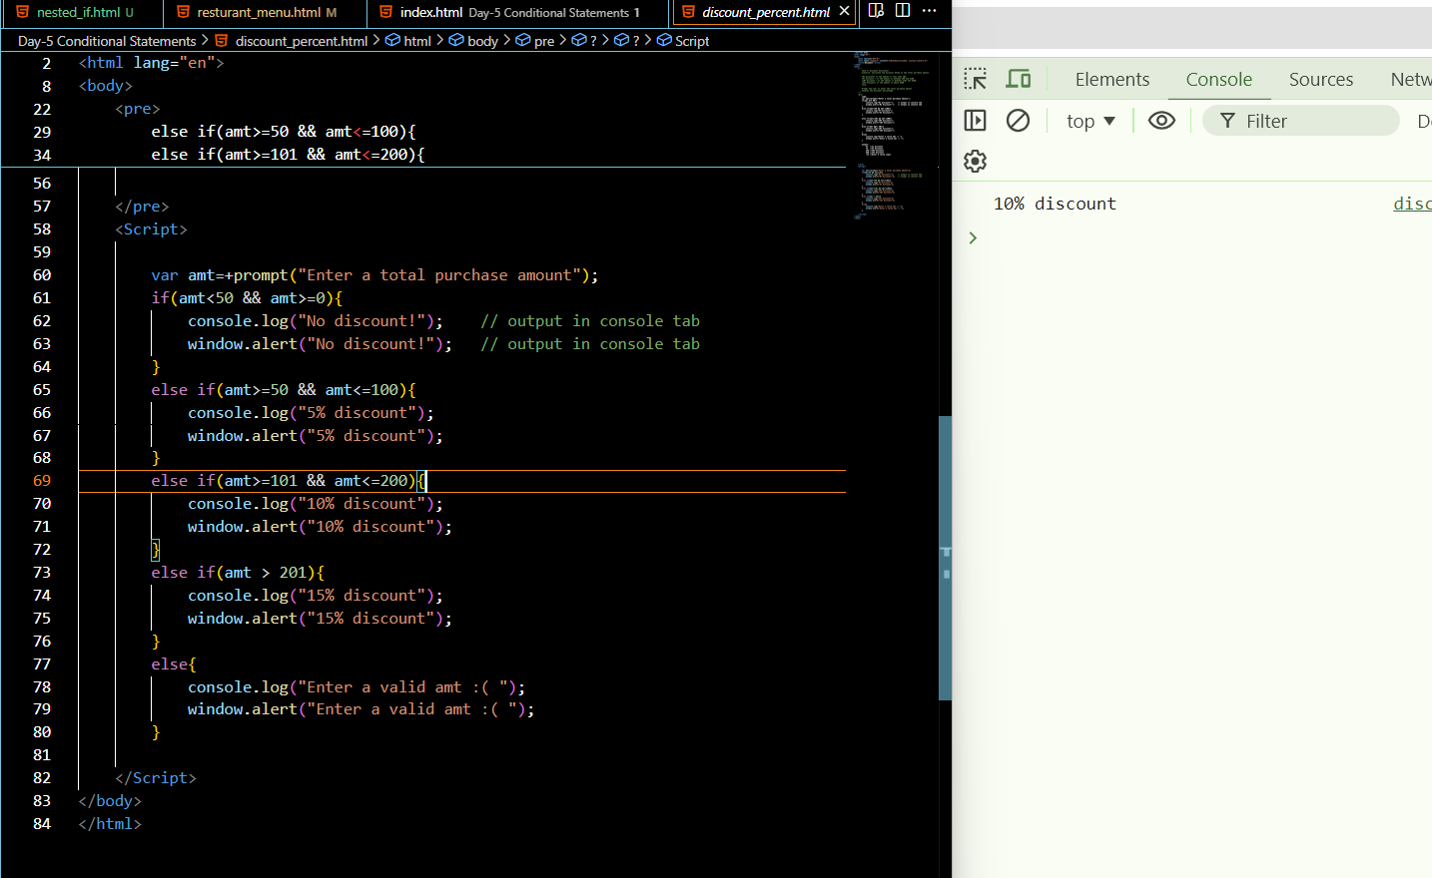

**Task 4: Restaurant Menu**

Scenario: You are developing a restaurant menu system that provides the price of a dish based on the dish name.

**Task:**

Assume a variable dish holds the name of the dish as a string (e.g., "Biriyani", "shawarma", "Fried rice", "veg pula").

Print the price.

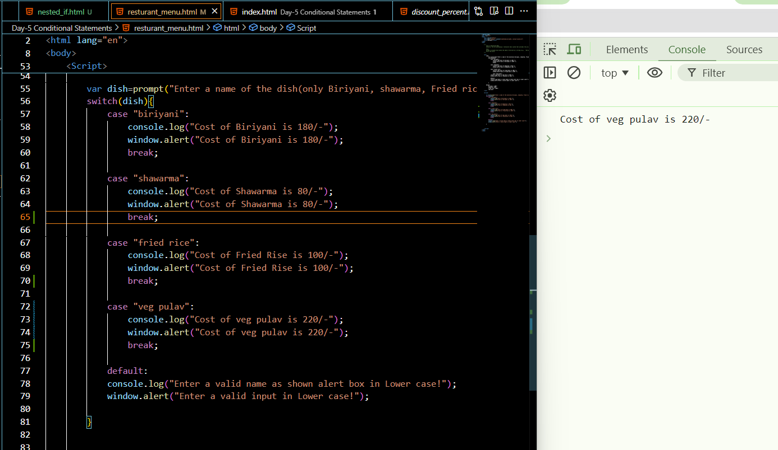

**Task 5: Simple Calculator**

Scenario: You are developing a simple calculator that performs basic arithmetic operations.

**Task:**

Assume variables num1 and num2 hold two numbers, and operator holds the arithmetic operator as a string (e.g., “+”).

Use a switch case statement to perform the operation and store the result in a variable result.

Print the result.

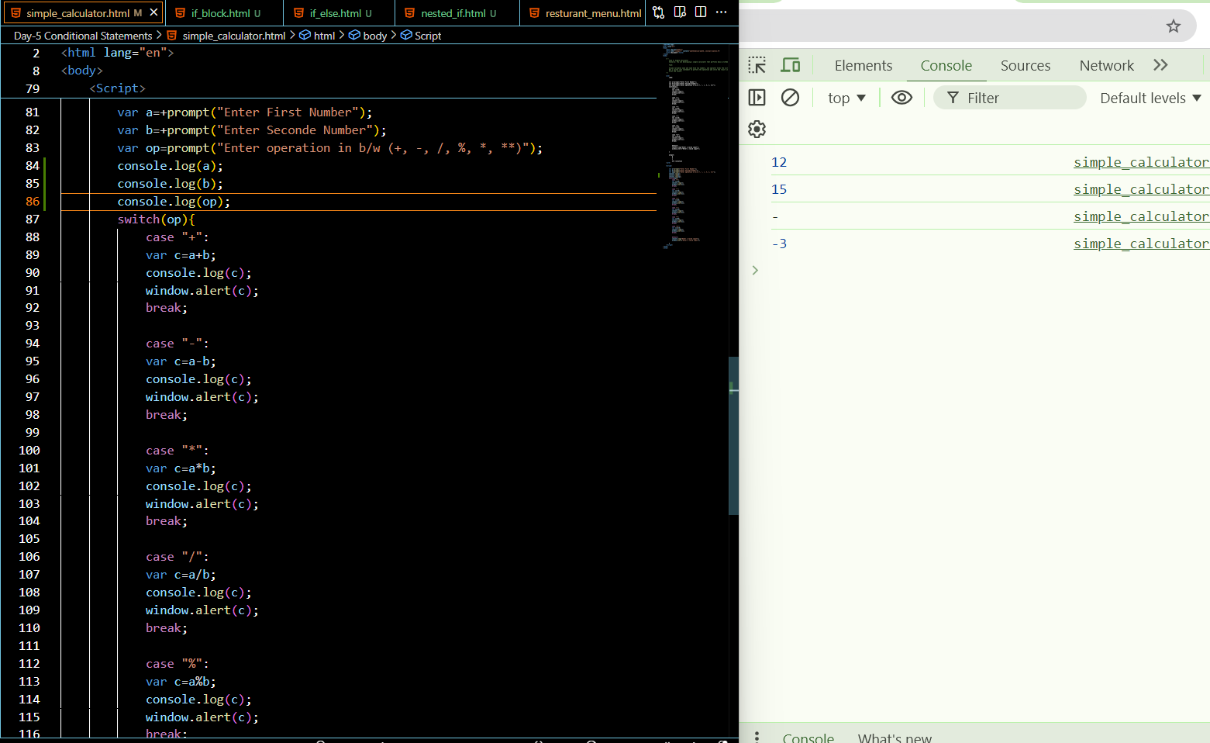

**LOOPS**

**Loops:**

In JavaScript, the for loop is used for iterating over a block of code a certain number of times, or to iterate over the elements of an [array](https://www.programiz.com/javascript/array).

**For loop:**

The **JavaScript for loop** *iterates the elements for the fixed number of times*. It should be used if number of iteration is known. The syntax of for loop is given below.

**Syntax:**

for (initialization; condition; increment)

{

    code to be executed

}

**Example:**

**<script>**

for (i=1; i**<**=5; i++)

{

document.write(i + "**<br/>**")

}

**</script>**

**Output:**

1  
2  
3  
4  
5

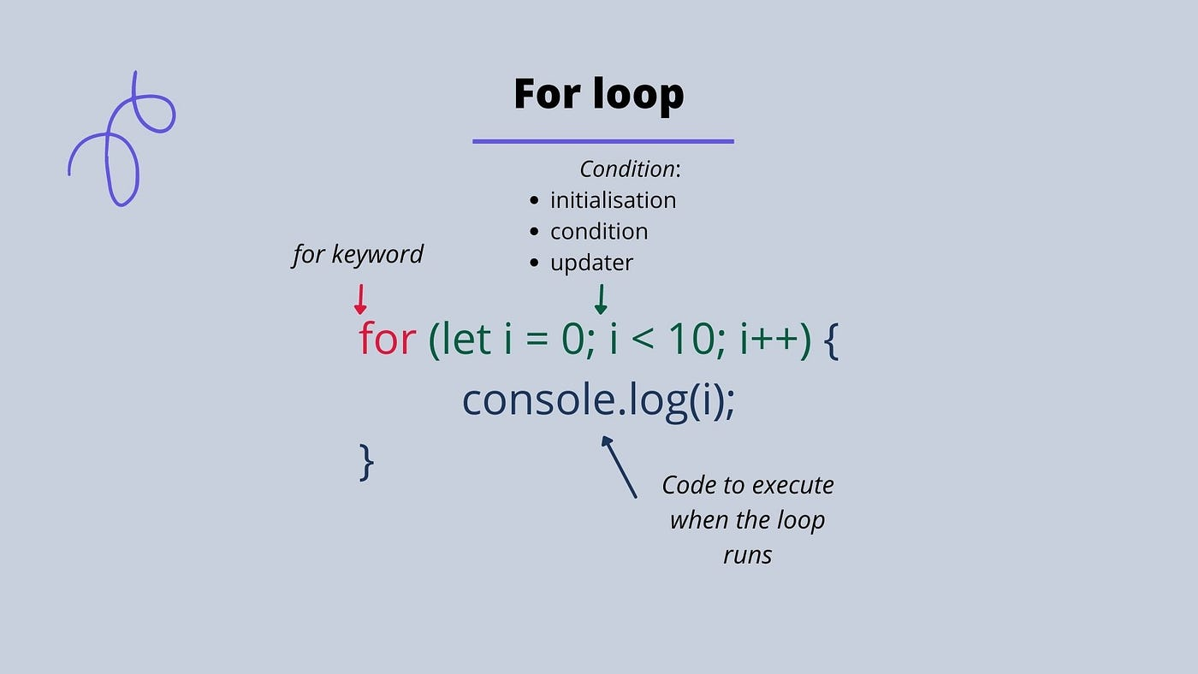

**Nested For loop:**

If we have loop inside loop, this is called a nested loop.

**Example:**

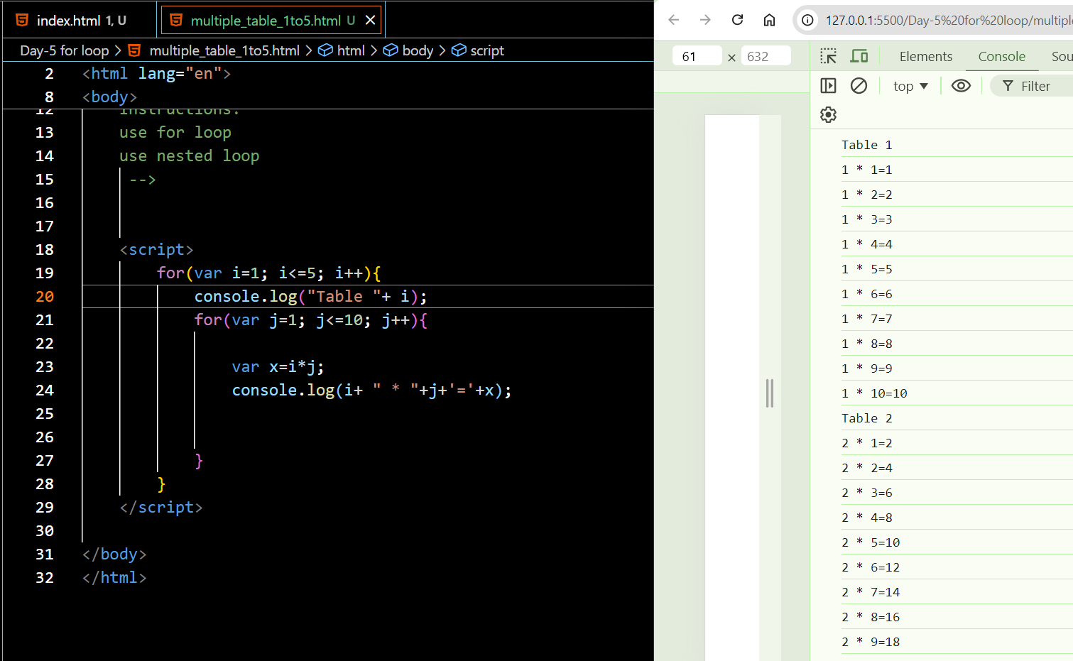

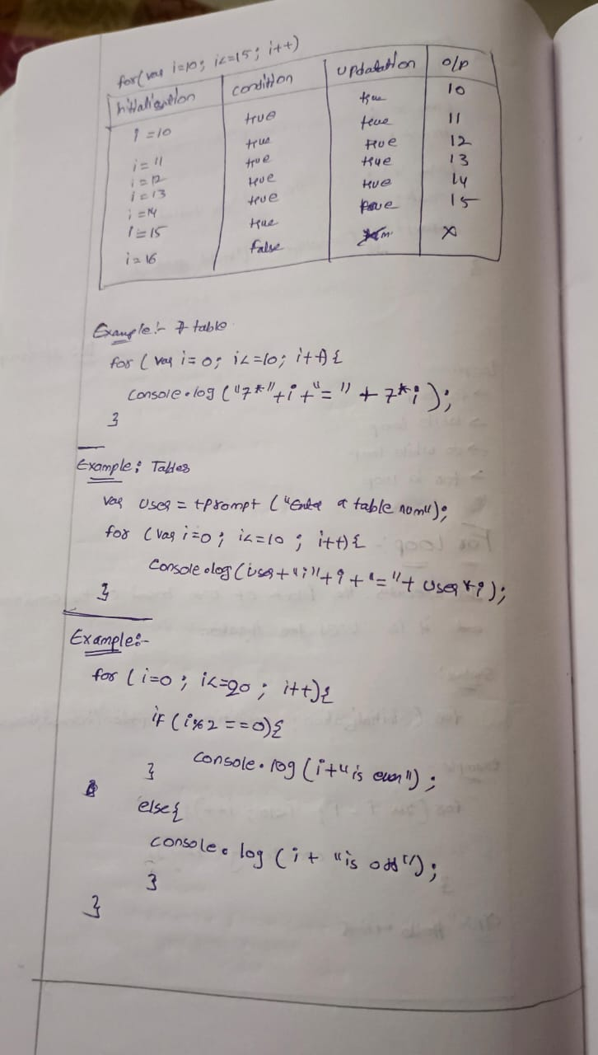

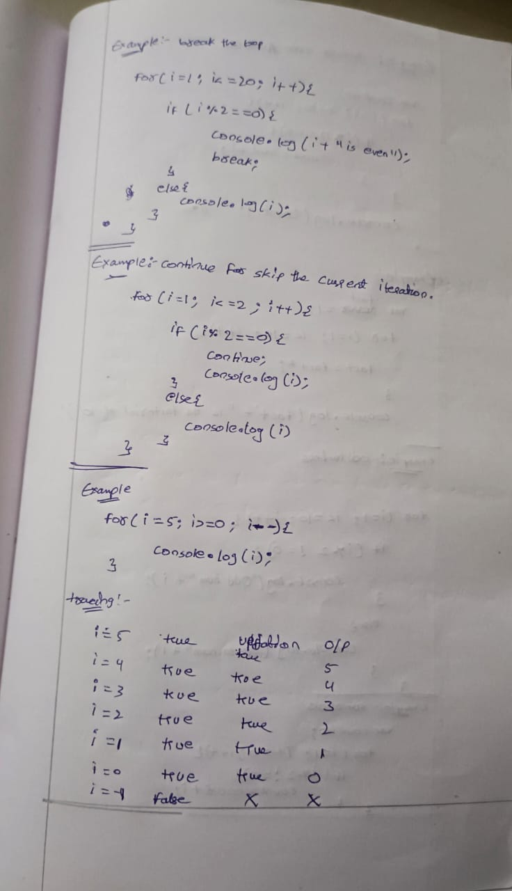

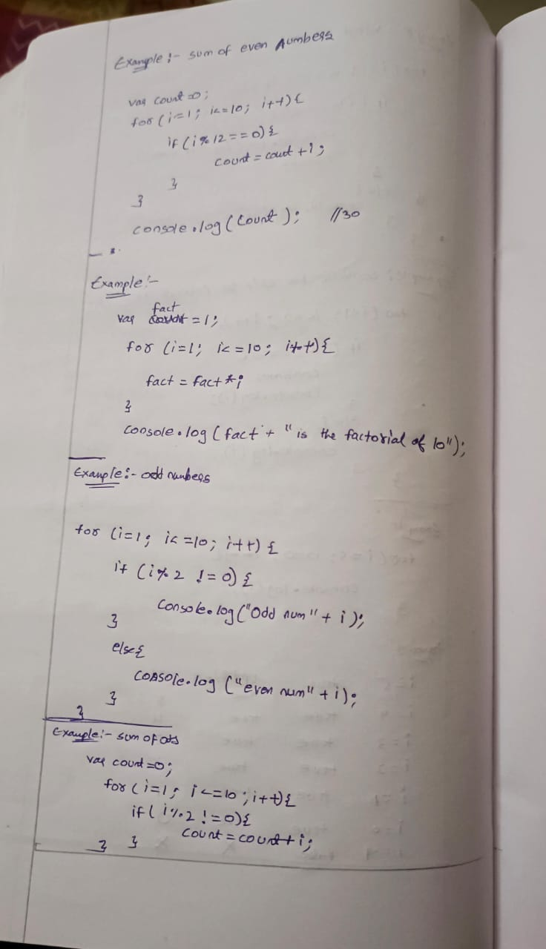

**Tasks:**

**Task 1: Print Numbers from 1 to 10**

Instructions:

Use a for loop to print numbers from 1 to 10.

Display the numbers in the console.

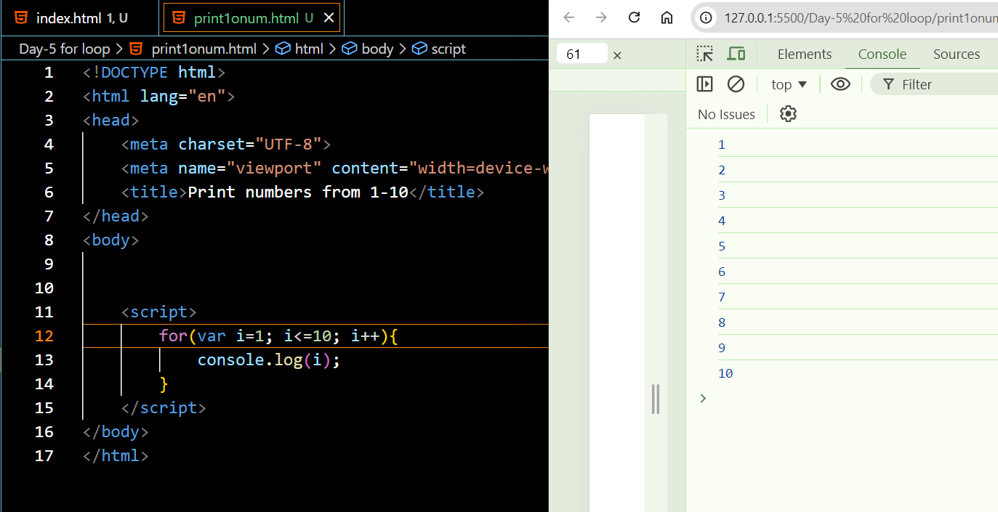

**Task 2: Print Even Numbers from 1 to 20**

Scenario: Write JavaScript code that prints all even numbers from 1 to 20.

Instructions:

Use a for loop to iterate from 1 to 20.

Use an if statement to check if a number is even and print it.

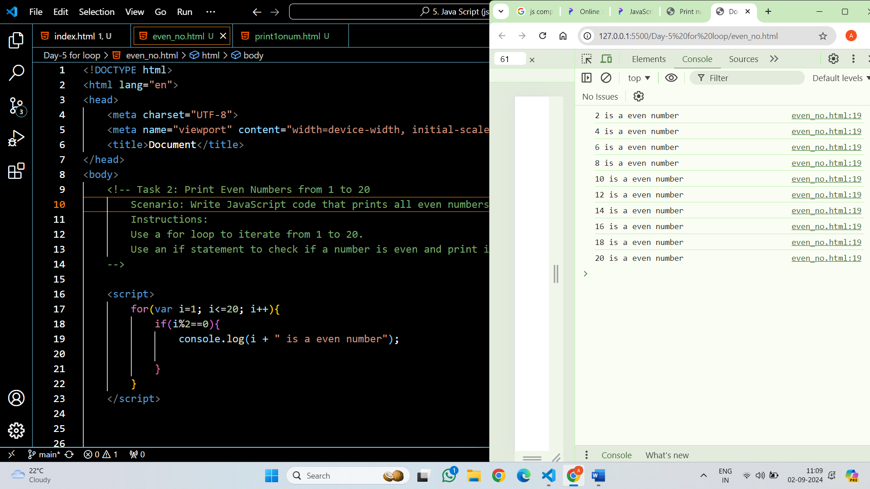

**Task 3: Print Multiples of 5 up to 50**

Scenario: Write JavaScript code that prints all multiples of 5 up to 50.

Instructions:

Use a for loop to iterate from 1 to 50.

Use an if statement to check if a number is a multiple of 5 and print it.

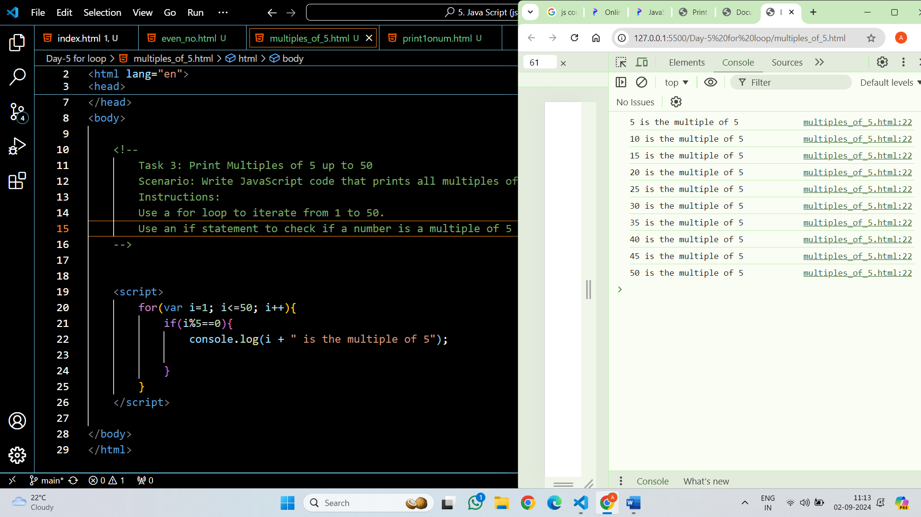

**Task 4: Sum of Numbers from 1 to 100**

Scenario: Write JavaScript code that calculates the sum of numbers from 1 to 100.

Instructions:

Use a for loop to iterate from 1 to 100.

Add each number to a sum variable and print the total sum.

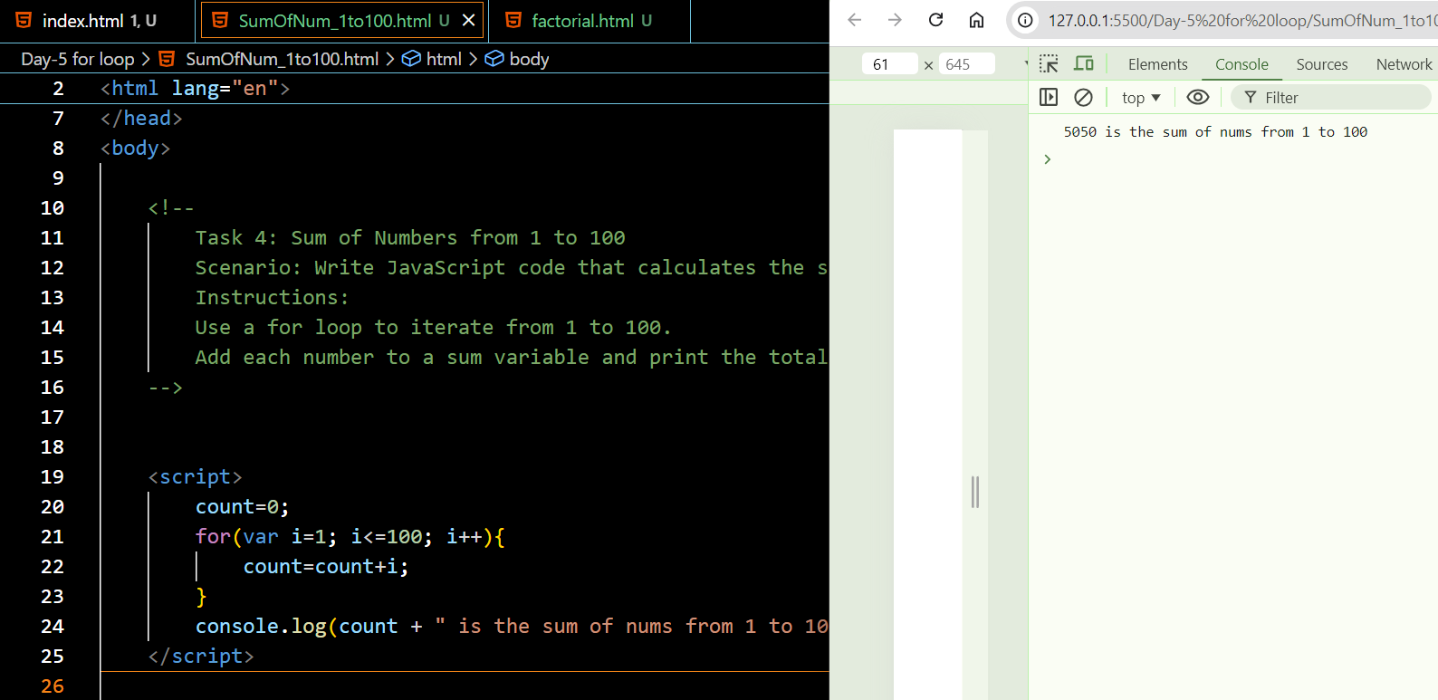

**Task 5: Create a JavaScript program that calculates the factorial of a given number using a for loop.**

**Instructions:**

Use a for loop to multiplication the given

Take prompt from the user

hint: take count value as 1;

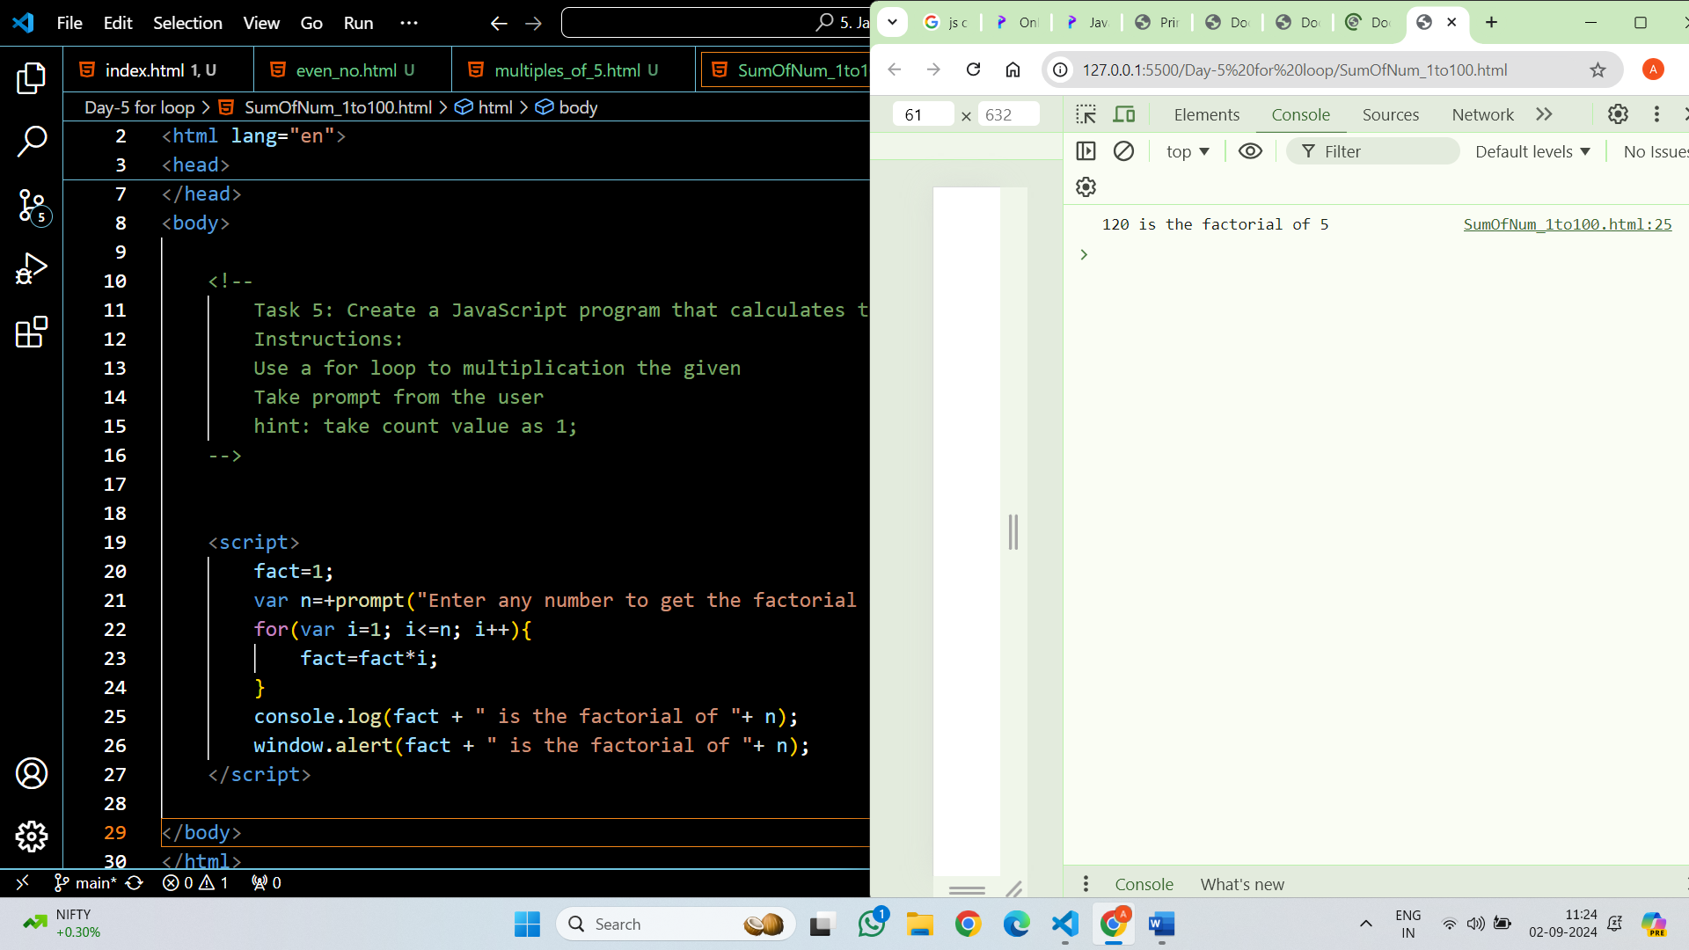

**Task 6: Print Numbers in Reverse Order**

Scenario: Write JavaScript code that prints numbers from 10 to 1 in reverse order.

Instructions:

Use a for loop to count down from 10 to 1.

Display the numbers in the console.

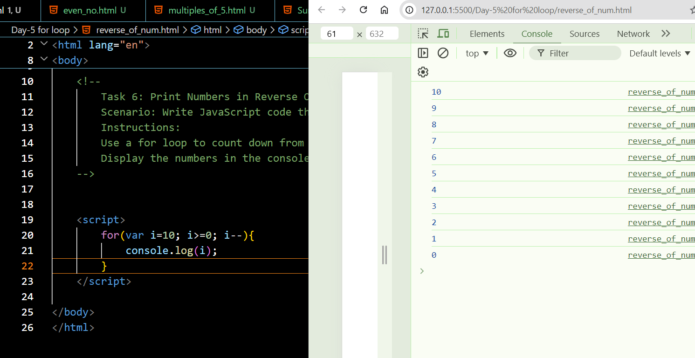

(optional)

**Task 7: Print the Alphabet**

Scenario: Write JavaScript code that prints the alphabet from A to Z.

Instructions:

Use a for loop to iterate through the ASCII values of the letters A to Z.

Convert the ASCII values to characters and print them.

Hint - console.log(String.fromCharCode(i));

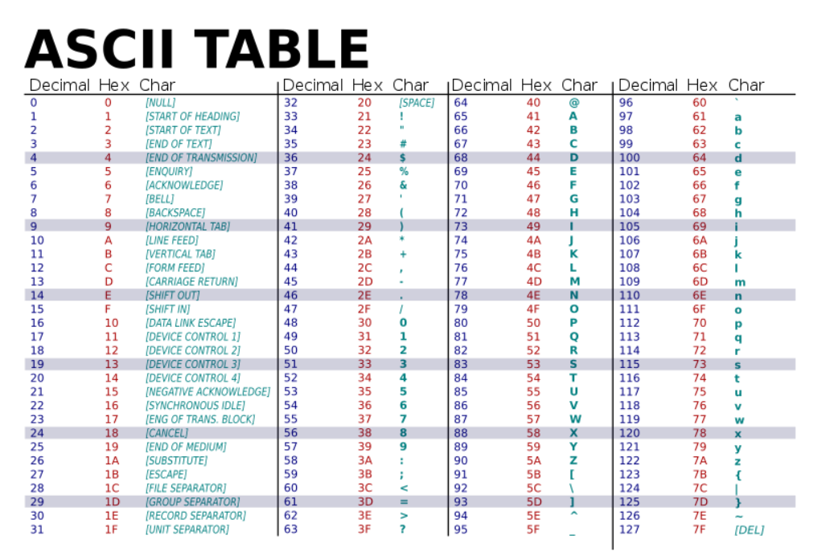

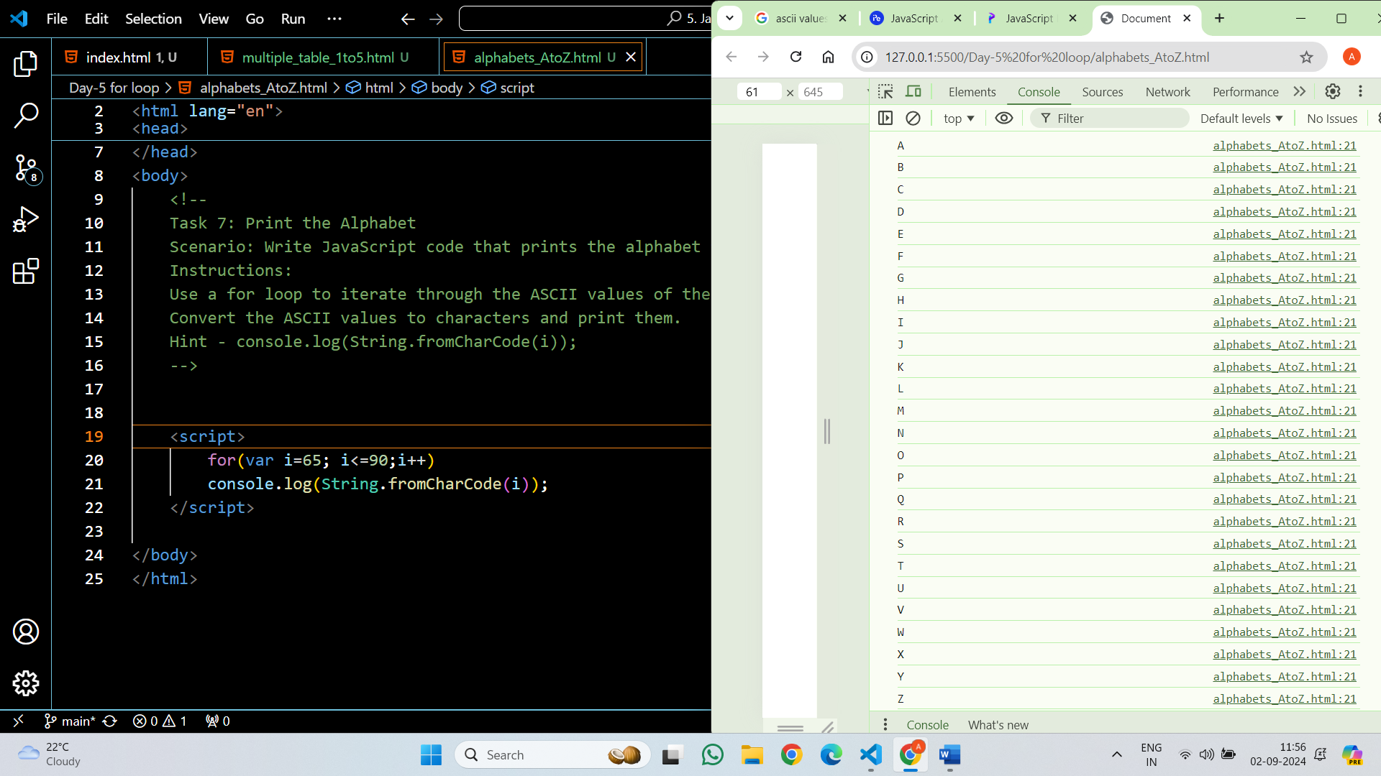

**Task 8:Write a JavaScript script that uses nested loops to**

print a multiplication table for numbers 1 through 5.

Instructions:

use for loop

use nested loop



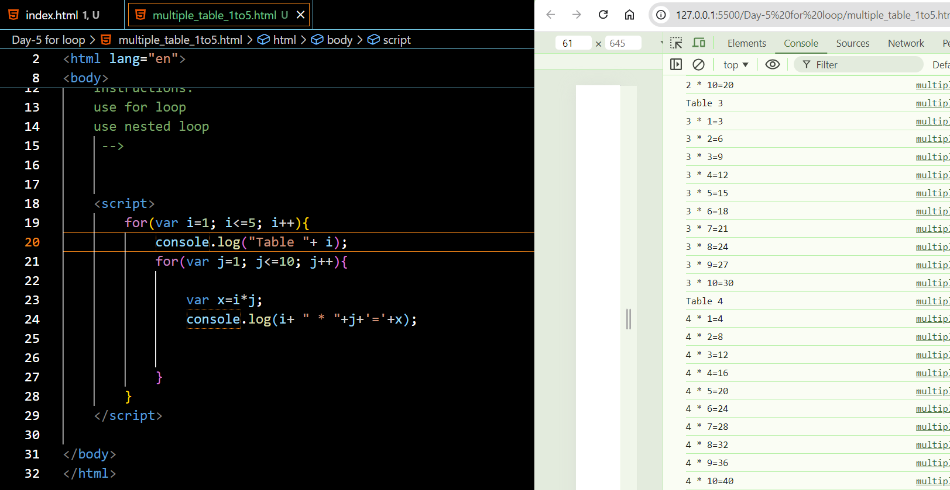

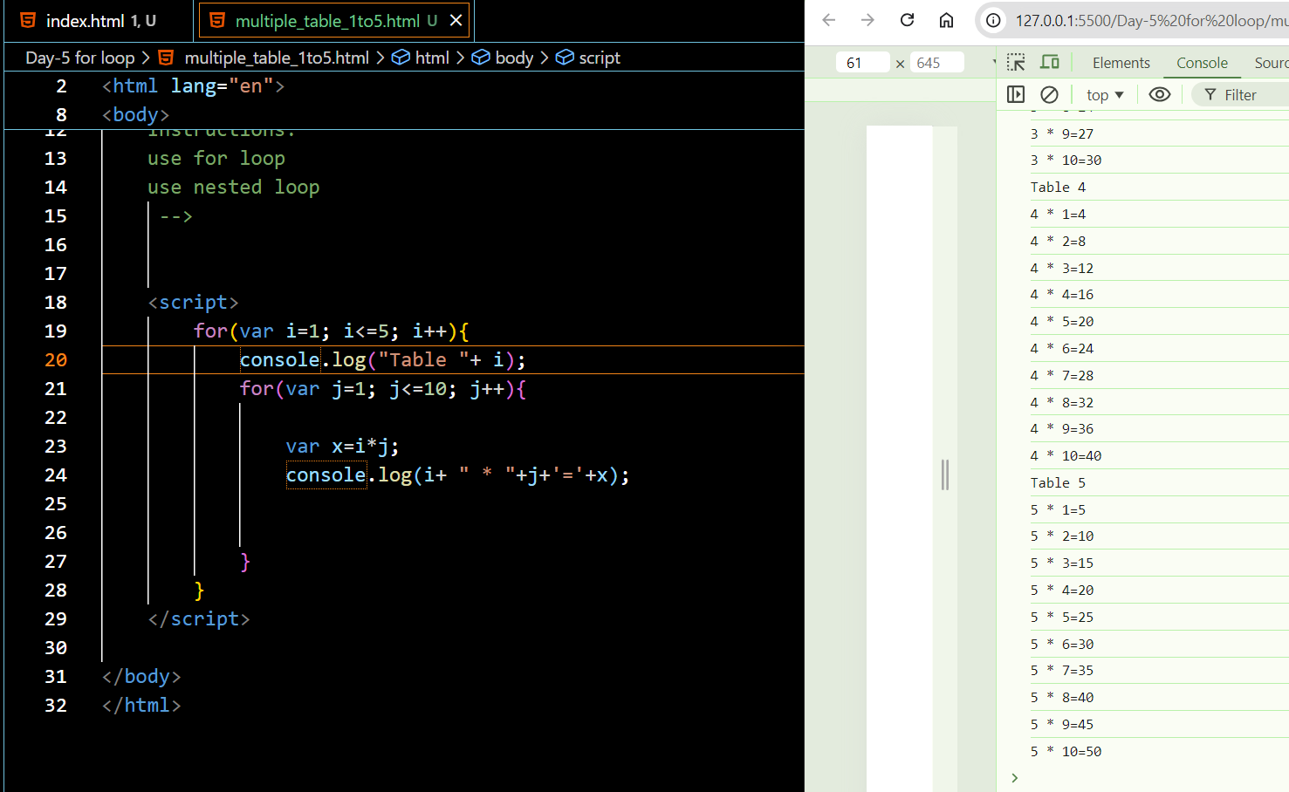

**While Loop:**

A **while** loop repeats a block of code while a specified condition is true.

The condition is evaluated before each iteration. If it returns true, the loop continues; otherwise, it stops.

**Syntax:**

while (condition) {

// code to be executed

}

**Example:**

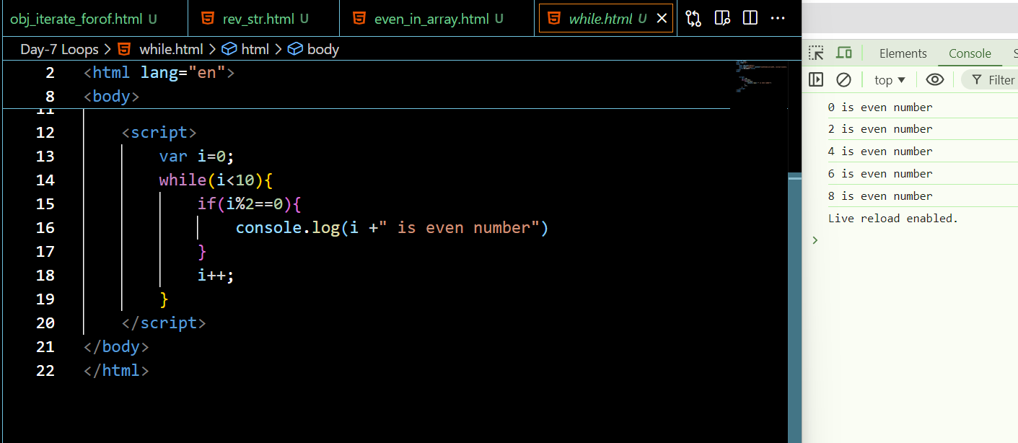

**Do While:**

Similar to the **while** loop, but it always executes its block of code at least once, even if the condition evaluates to false.

The block of code is executed first, then the condition is evaluated. If true, the loop continues; if false, it stops.

**Syntax:**

do {

// code to be executed

}

while (condition);

**Example:**

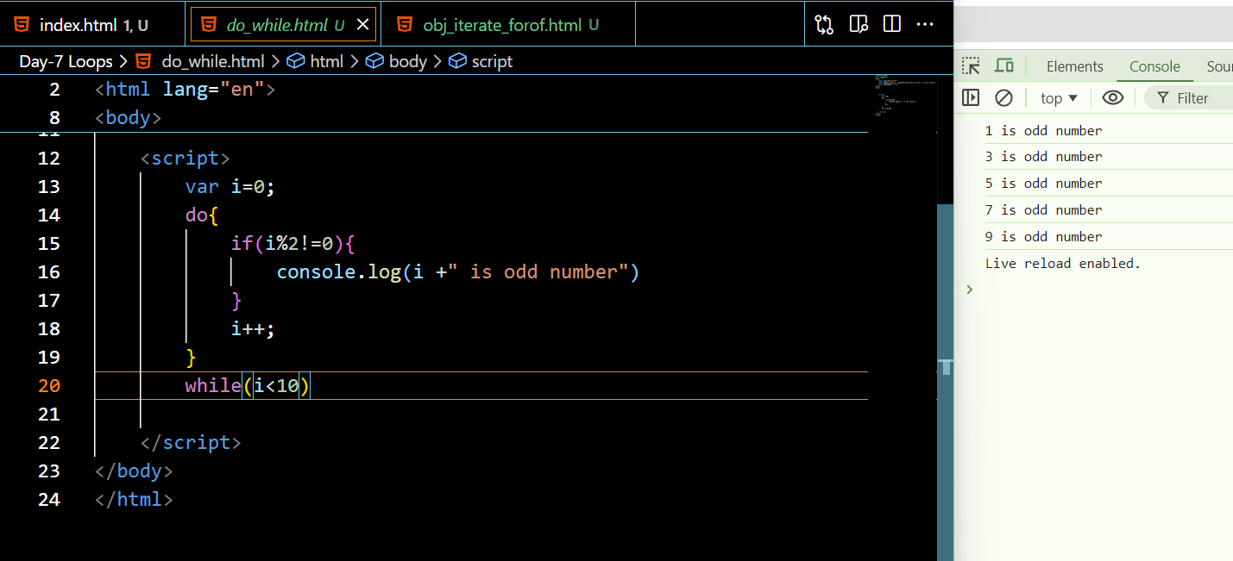

**For in loop:**

Used to iterate over the properties of an object,array, string. It iterates over enumerable properties of an object, in an arbitrary order.

We can access index and values.

**Syntax:**

for (ref in strname){

        console.log(ref);//indexes

      }

**Example:**

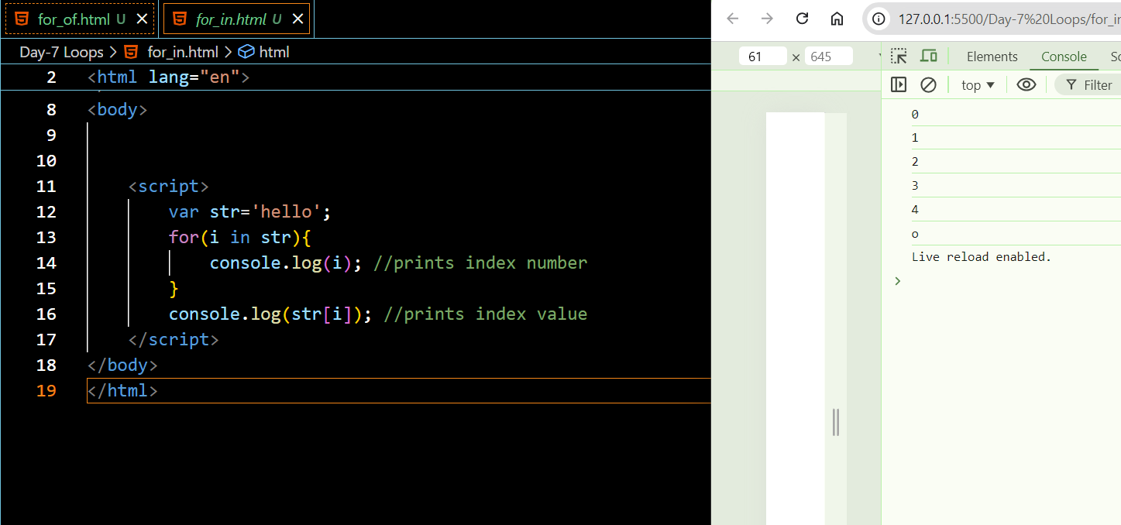

1)  **Iterates over Properties**:

* The for...in loop iterates over all enumerable properties of an object.

 2) **Order Not Guaranteed**:

* The order of iteration is not guaranteed. It's generally the order in which properties were defined, but this can vary.

3)  **Use with Objects**:

* Typically used for objects, not arrays, because it iterates over property names (keys) rather than values.

**For of Loop:**

Introduced in ES6, it iterates over iterable objects such as arrays, strings, maps, sets, etc.

**Syntax:**

 for (ref of strname){

        console.log(ref);//values

      }

========================

for (variable of iterable) {

// code to be executed

}

* It provides a more concise syntax compared to the traditional **for** loop for iterating over arrays and other iterable objects.

1)   **Iterates over Values**:

* The for...of loop iterates over the values of an iterable object.
* This loop does not work with objects unless they implement the iterable protocol.

2)  **Use with Arrays and Other Iterables**:

* Commonly used with arrays, strings, maps, sets, and other iterable objects.

**Example:**

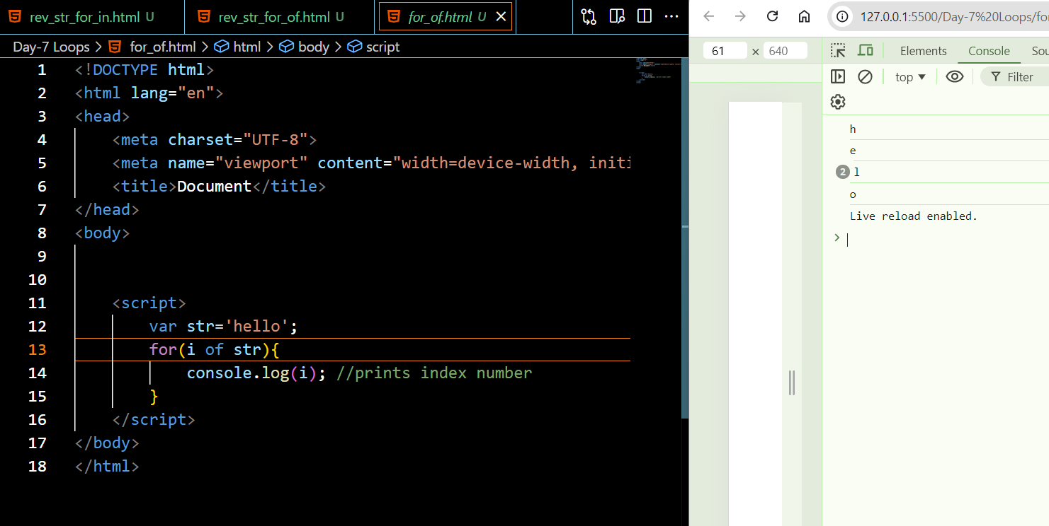

**TASK :**

1. Reverse a string Input : hello output : olleh

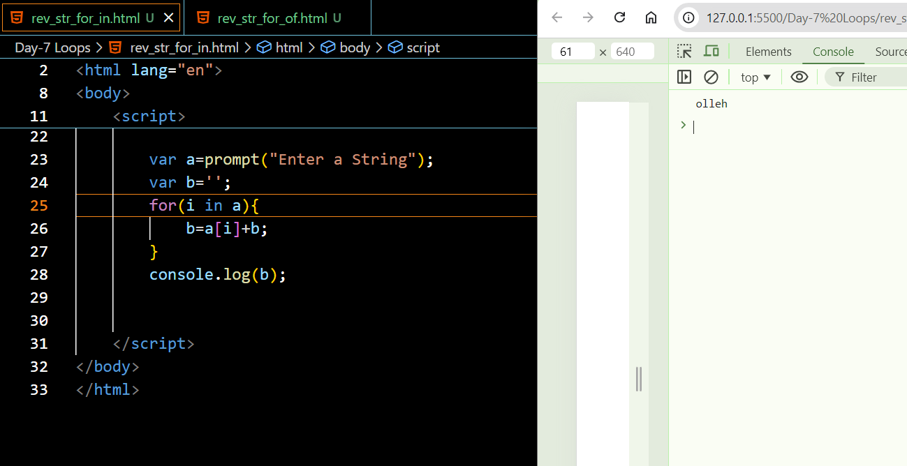

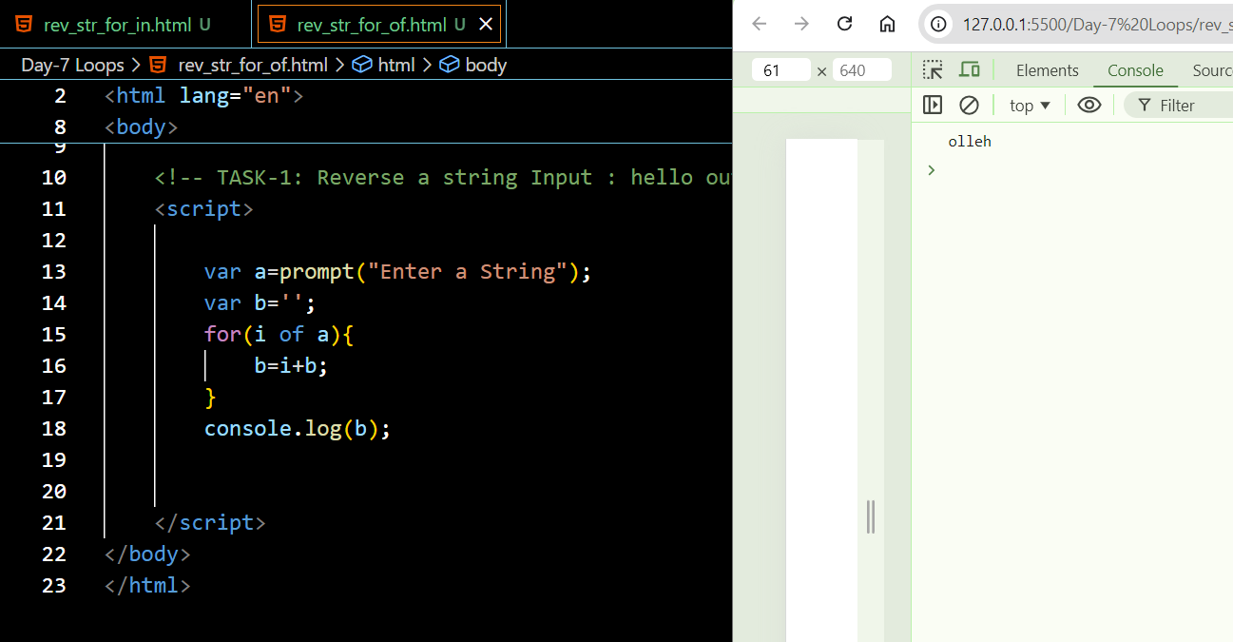

1. Find the even numbers in the array - [ 23,54,67,64.45,95,98].

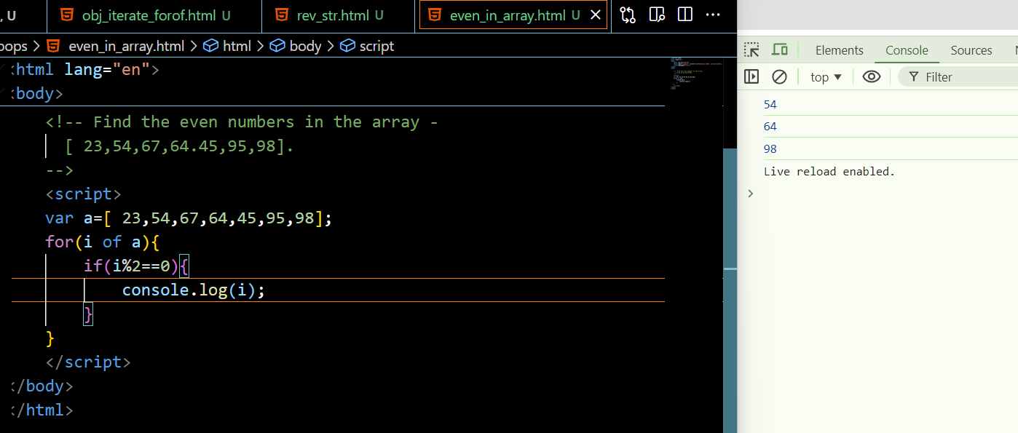

        3. Iterate an object values & keys using a for of loop.

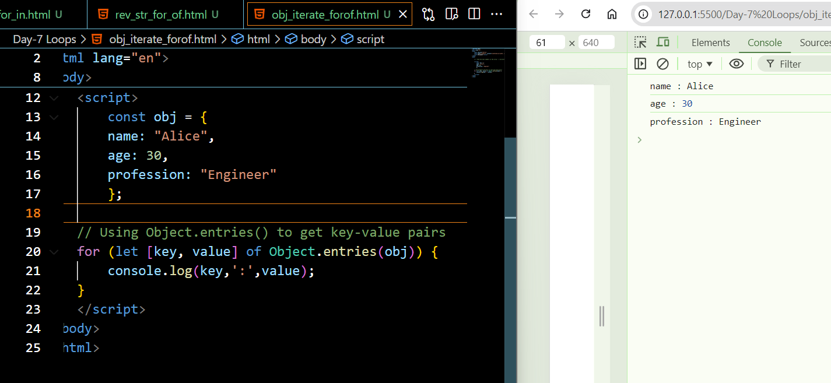

**Functions**

**A function is a reusable block of code that is used to perform a specific task when something invokes it.**

A JavaScript function is defined with the function keyword, followed by a name, followed by parentheses ().The code to be executed, by the function, is placed inside curly brackets: {}

Function parameters are listed inside the parentheses () in the function definition. Function arguments are the values received by the function when it is invoked. Inside the function, the arguments (the parameters) behave as local variables.

Named functions can be hoisted

**Syntax:**

function name(params) {

//code to be executed

        }

**Example:**

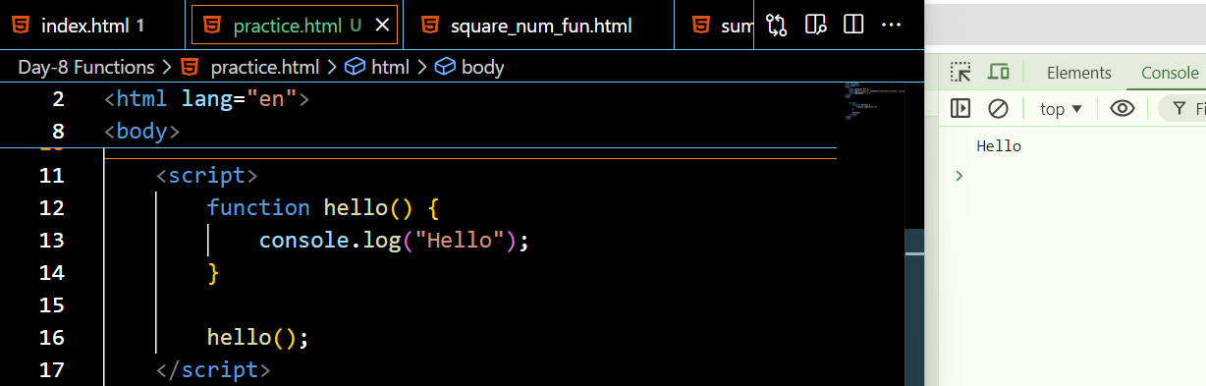

**Example: adding two numbers**

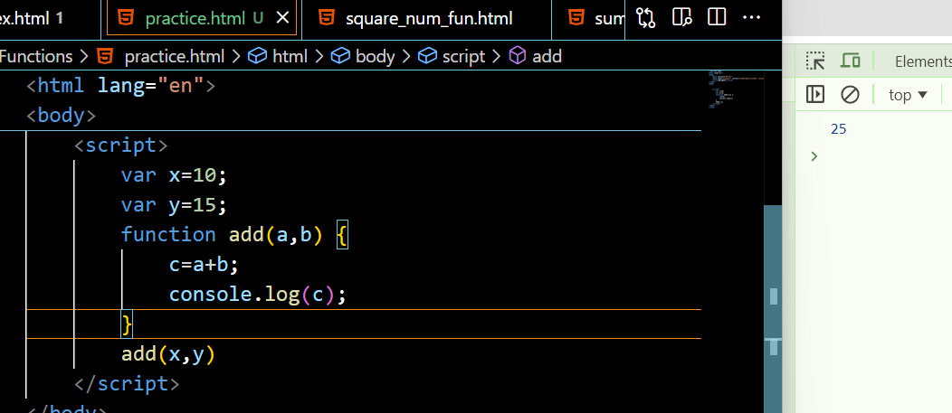

**Example:** even numbers in range

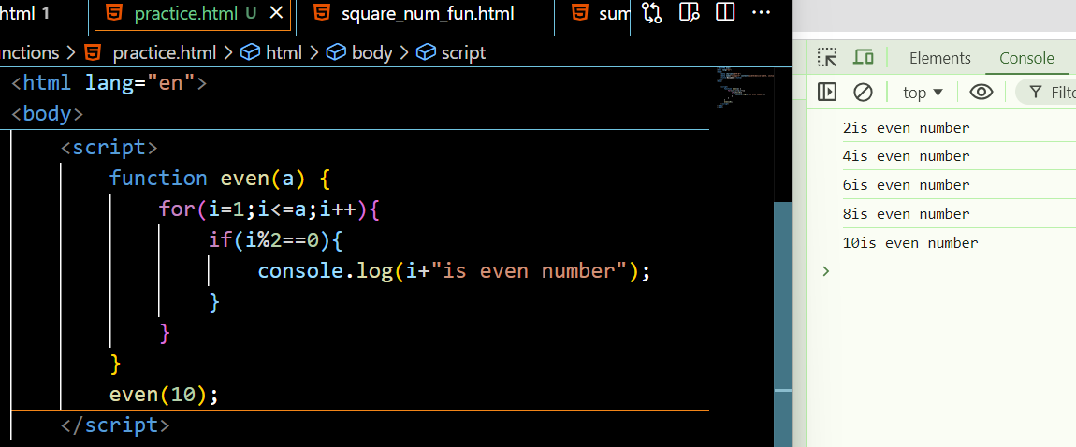

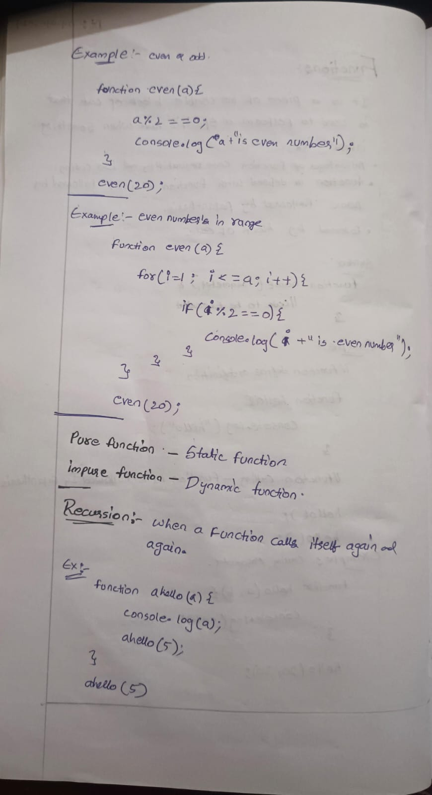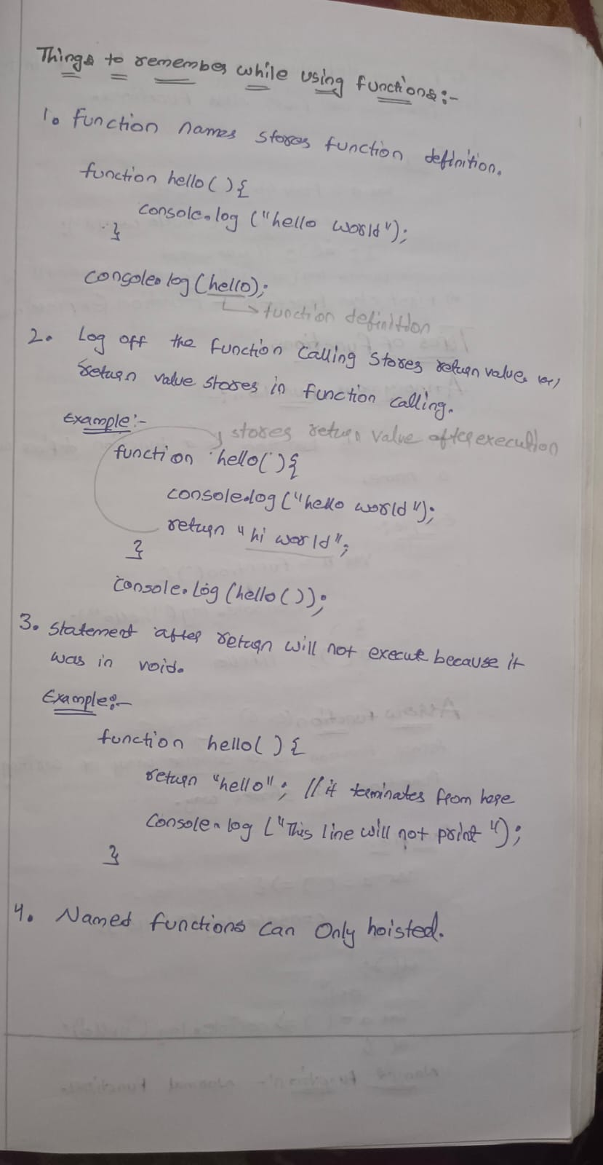



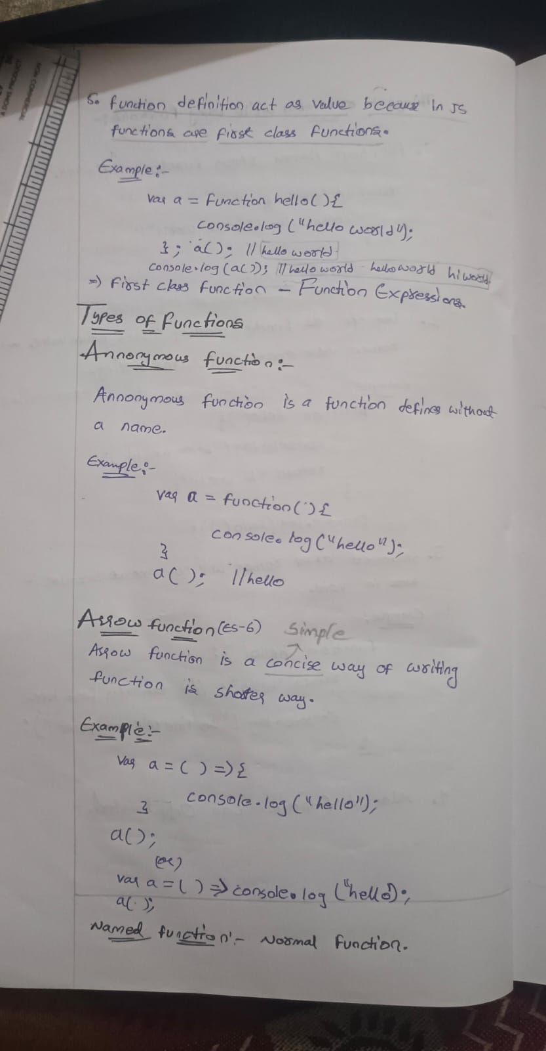



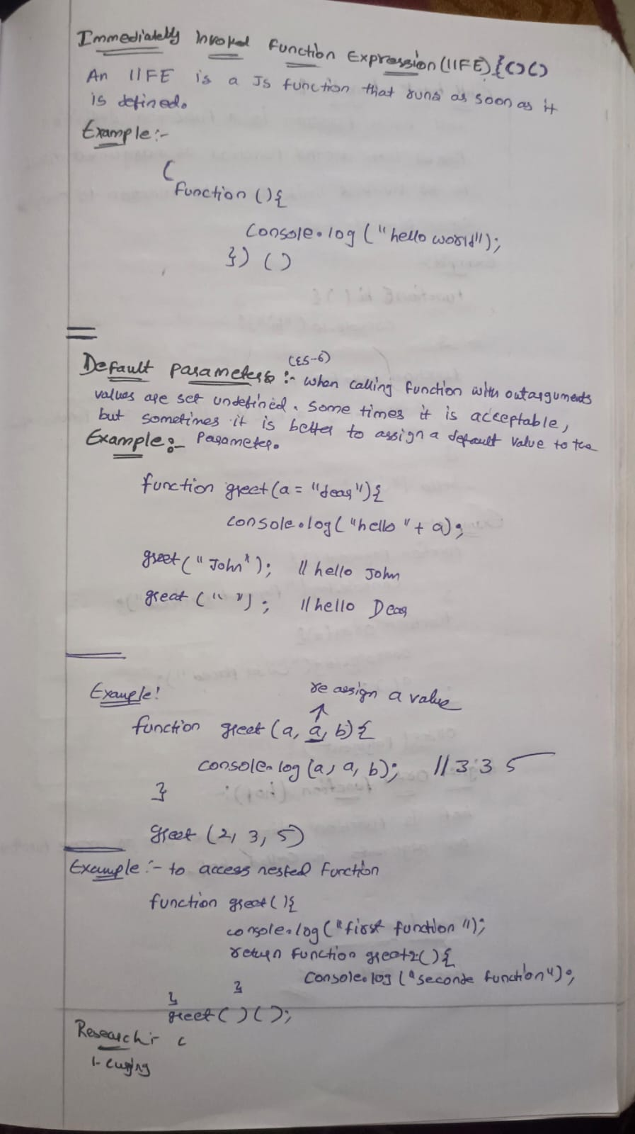

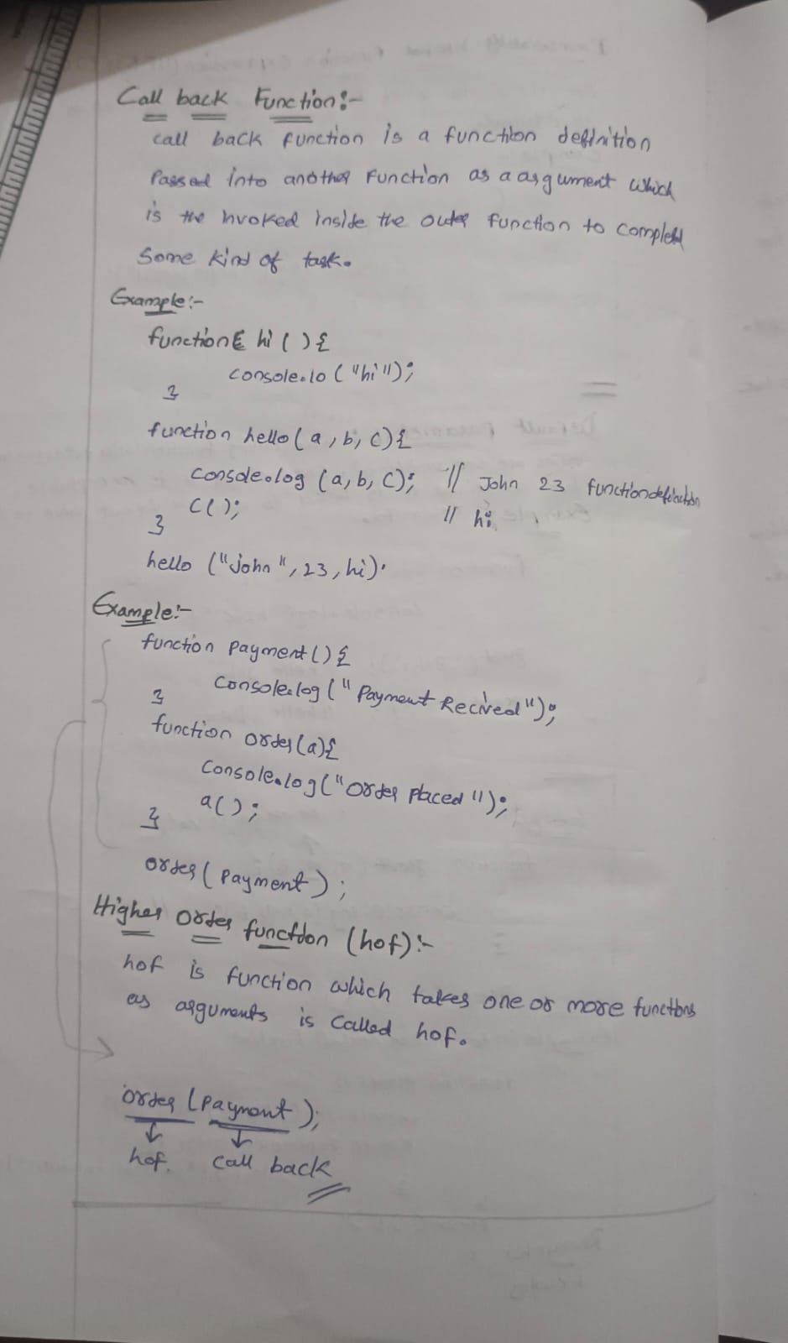

**Tasks**

**Task 1: Greeting Function**

Scenario: Create a function that takes a name as an argument and returns a greeting message.

Task:

Define a function greet that takes one parameter name.

The function should print a greeting message like “Hello, [name]!”.

Call the function with different names and print the results.

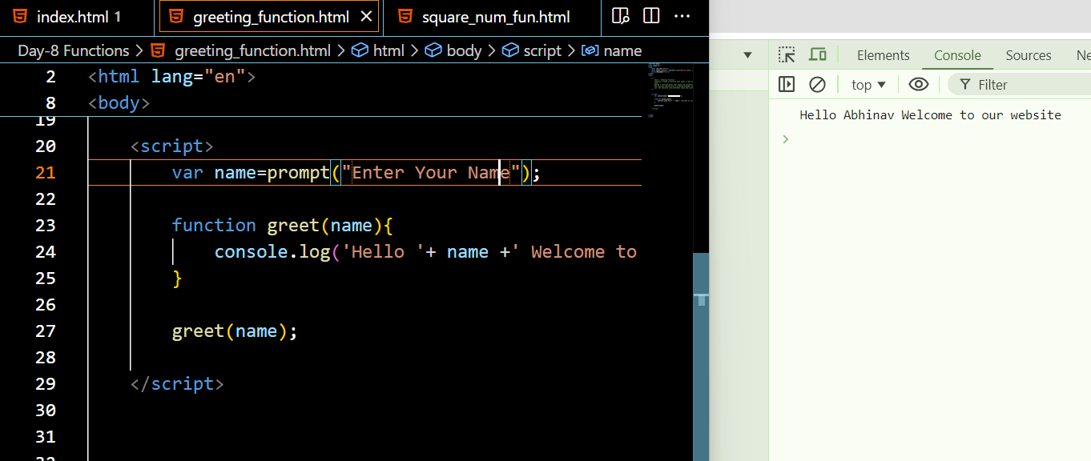

**Task 2: Sum Function**

Scenario: Create a function that takes two numbers as arguments and returns their sum.

Task:

Define a function sum that takes two parameters a and b.

The function should return the sum of a and b.

Call the function with different numbers and print the results.

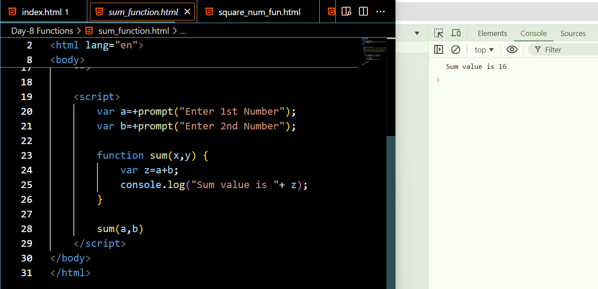

**Task 3: Square Function**

Scenario: Create a function that takes a number as an argument and returns its square.

Task:

Define a function square that takes one parameter num.

The function should return the square of num.

Call the function with different numbers and print the results.

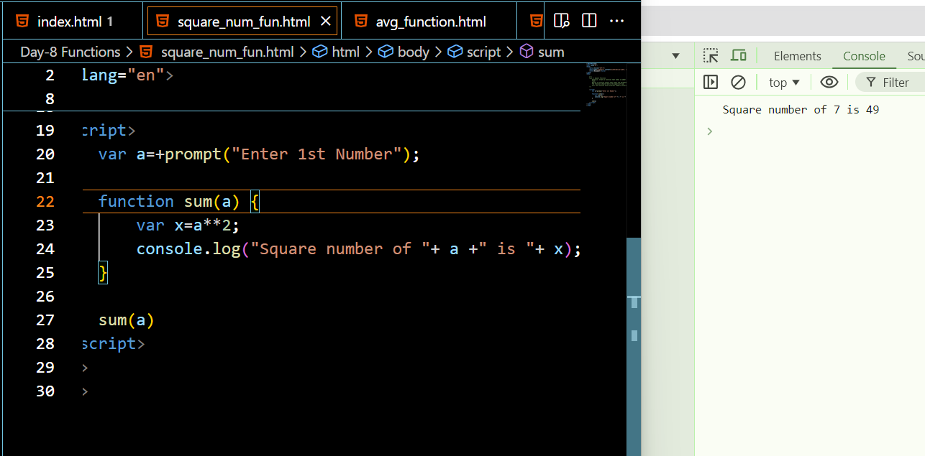

**Task 4: Average Function**

Scenario: Create a function that takes an array of numbers as an argument and returns the average.

Task:

hint:[2,5,2] =9/3=3

Define a function average that takes one parameter arr.

The function should return the average of the numbers in arr.

Call the function with different arrays and print the results.

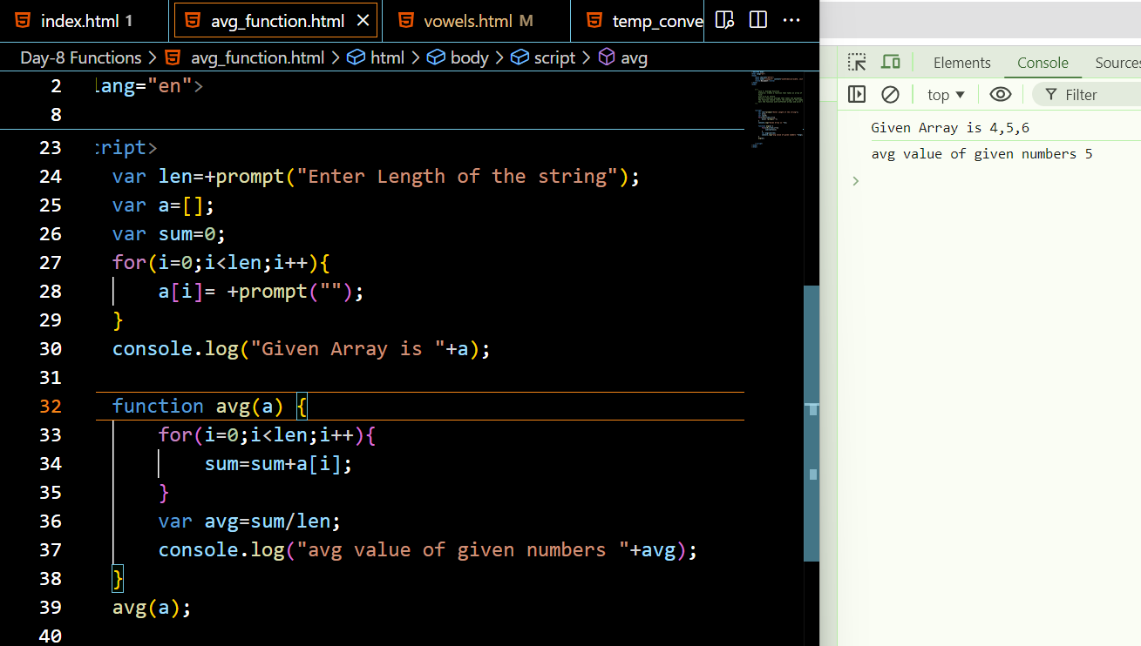

Task 5: Vowels Function

Scenario: Create a function that takes a string as an argument and returns weather the strings contains vowels or not .

Task:

Define a function that takes one parameter str.

The function should return whether string contains vowels or not.

use loops and if conditions

Call the function with different strings and print the results.

hello --a,e ,i ,o,u---it contains vowels

hll---it doesnt contains vowels

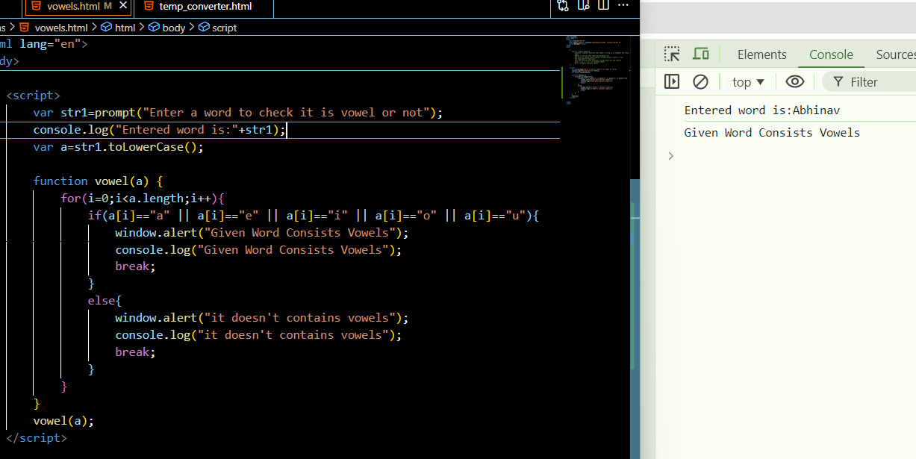

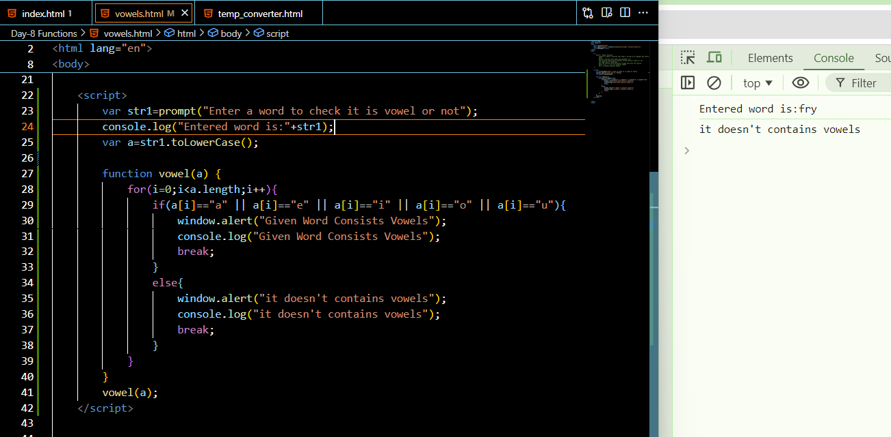

Task 6: Temperature Converter

Scenario: Create a function that converts temperatures between Celsius and Fahrenheit.

Task:

Define a function convertTemperature that takes two parameters: temp (the temperature) and scale (the scale to convert to, either “C” or “F”).

The function should return the converted temperature.

Test the function with different temperatures and scales and print the results.

Hints:-

formula for celscious (temp - 32) * 5/9

formula for fahrehnheit (temp * 9/5) + 32

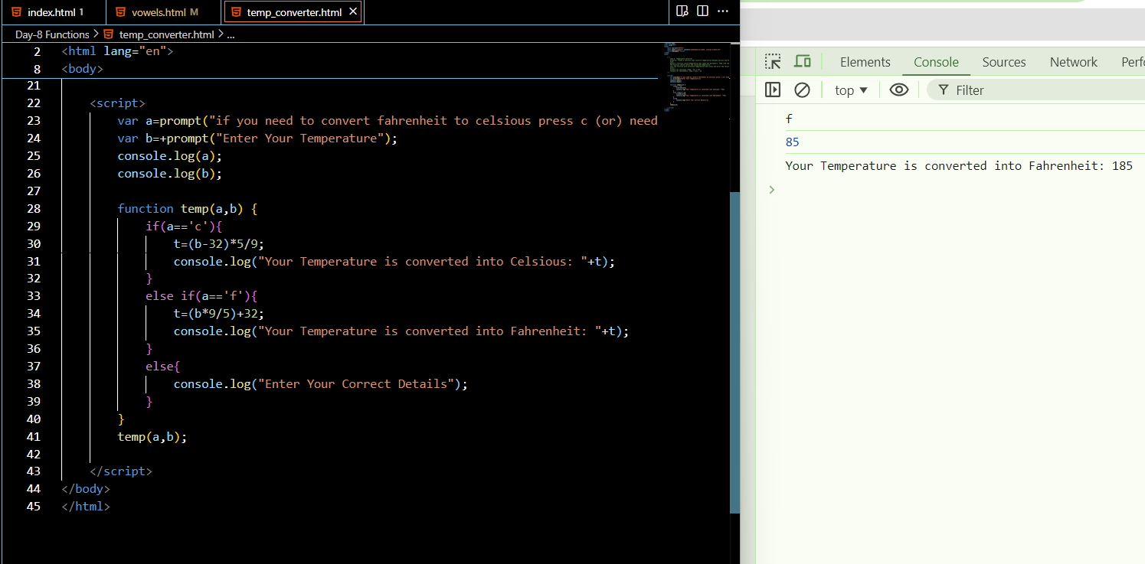

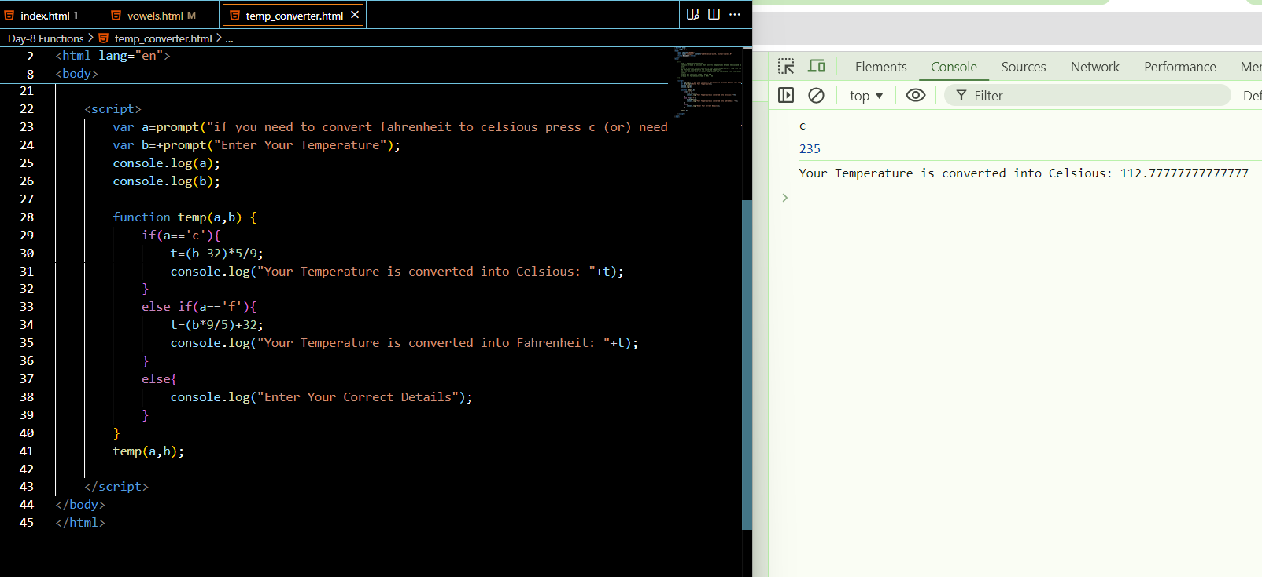

**Global Execution Context**

**Global execution context:**

Global Execution Context is the first context that gets created when the JavaScript engine starts executing code.

**Key Components**

**1. Memory Allocation (Creation Phase)**:

* During this phase, the engine sets up the memory for variables and functions.
* **Variables** declared with **var** are hoisted and initialized with **undefined**.
* **Function declarations** are hoisted and their definitions are stored in memory.
* Variables declared with **let** and **const** are also hoisted but are not initialized. They remain in a temporal dead zone until they are assigned a value

**2. Code Execution (Execution Phase)**:

·         The JavaScript engine executes the code line by line.

·         Variables declared with **var** are assigned their values.

·         Functions are available to be called.

·         Variables declared with **let** and **const** are assigned values when their declaration is encountered in the code.

**How it works on the functions**

When a function is invoked, a new **Execution Context(function execution context)** is created specifically for that function. This context is separate from the Global Execution Context but follows similar principles.

* Each function invocation creates a new execution context.
* Variables declared inside a function are local to that function and are not accessible outside it.
* The scope chain allows inner functions to access variables from their parent functions and the global context.

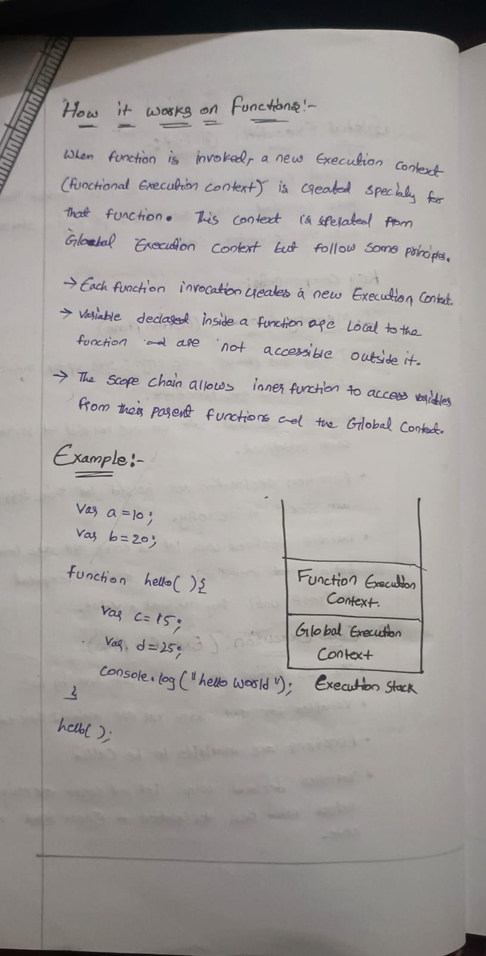

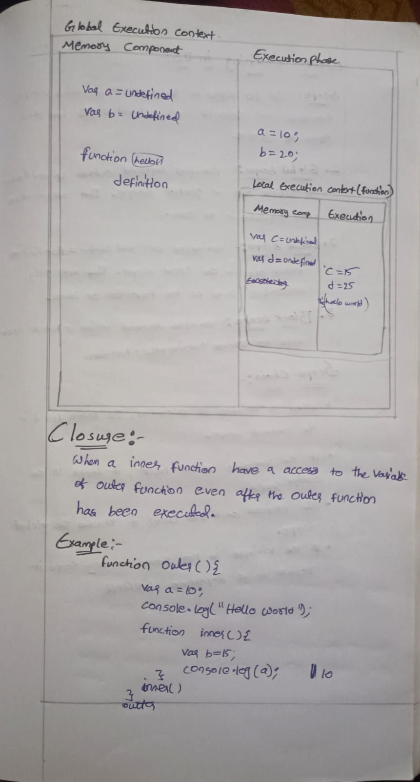

**Closures**

A closure is a function that has access to its own scope, the scope of the outer function, and the global scope. This means a closure can remember and access variables from its outer function even after that function has finished executing.

(Or)

When a inner function have a access to the variable of outer function even after the outer function has been executed.

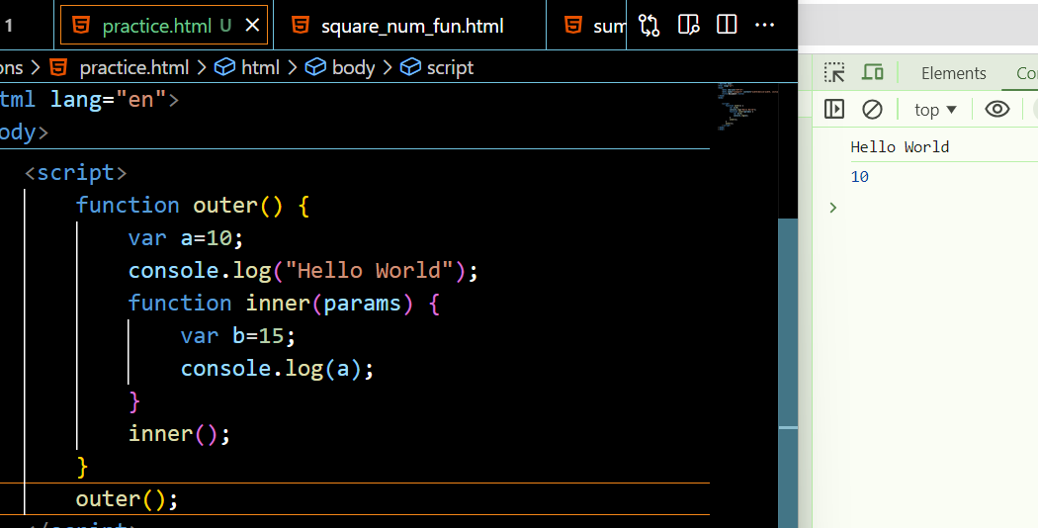

**Scope Chaining in JavaScript**

**Scope** in JavaScript refers to the context in which variables, functions, and objects are accessible. JavaScript has three types of scope:

1.   **Global Scope:** Variables declared outside of any function or block are in the global scope. They are accessible from anywhere in the code.

2.   **Local Scope:** Variables declared within a function or block are in the local scope. They are only accessible within that function or block.

3.   **Block Scope:** Variables declared inside a block can’t able to access outside of the function

**Scope Chain**:

* When a variable is accessed, JavaScript looks for it in the current scope.
* If the variable is not found, it looks in the outer scope.
* This process continues until it reaches the global scope.
* If the variable is not found in any scope, it results in a ReferenceError

Example:

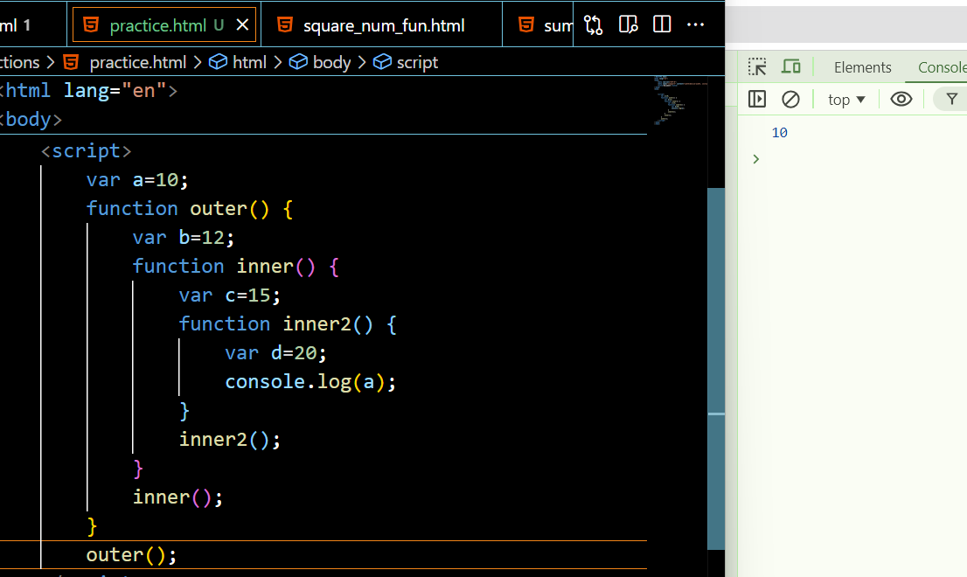

**Lexical Scoping:**

* JavaScript uses lexical scoping, meaning that the scope of a variable is determined by its position in the source code.
* Inner functions have access to variables declared in their outer functions (but not vice versa).

**DOM- Document Object Model**

DOM is a standard object model that allows programs and scripts to dynamically access and update the content, structure, and style of a document

Document Object Model (DOM) connects web pages to scripts languages by representing the structure of a document

The DOM represents a document with a logical tree. Each branch of the tree ends in a node, and each node contains objects. DOM methods allow programmatic access to the tree. With them, you can change the document's structure, style, or content.

**Main Object:**

Here's a breakdown of some key concepts related to the JavaScript DOM:

⦁ Document: The top-level object in the DOM hierarchy, representing the entire HTML document. It serves as an entry point to access and manipulate the document's content.

 console.log(document);

Logging document to the console in JavaScript will display the entire Document Object Model (DOM) of the current HTML page.

**Methods for Accessing Elements:**(Get methods using dom)

**1)document.getElementById():** Retrieves an element by its unique ID

**Example:**

<div id="demo">Content1</div>

var a=document.getElementById("demo");

console.log(a);

**2)document.getElementsByClassName():** Retrieves elements by their class name.

**Example:**

  <p class="myClass">Paragraph 1</p>

  <p class="myClass">Paragraph 2</p>

var a=document.getElementsByClassName("myClass");

console.log(a);

//here the point to note is classnames are always in collections

You can get the element by their index numbers

Var a= document.getElementsByClassName(“myClass”)[0]

3) **document.getElementsByTagName():** Retrieves elements by their tag name.

  <h1>Heading</h1>

  <p>Paragraph 1</p>

  <p>Paragraph 2</p>

  var a= document.getElementsByTagName("p");

  console.log(a);

//here the point to note is tagnames are always in collections

You can get the element by their index numbers

Var elementsByTagName= document.getElementByTagName(“p”)[0]

 4)**Accessing Elements by CSS Selector:**

**Example:**

  <div class="container">

    <p class="para">Paragraph 1</p>

    <p class="para">Paragraph 2</p>

</div>

**querySelector()** method allows you to select the first element in the document

**Example:**

var elementBySelector = document.querySelector(".para");//selects by classname

var myDiv = document.querySelector("#myDiv");//select by id

var elselector = document.querySelector("div");//select by element name

**querySelectorAll** -iIt operates similarly to querySelector(), but instead of returning only the first matching element, it returns a list of all matching elements.

**Example:**

var paragraphs = document.querySelectorAll(".para");//select all elements by class names

var divs = document.querySelectorAll("div");//select all div elements in a collections

**Get content of the html**

innerText and innerHTML are properties of DOM elements in JavaScript that deal with the content of HTML elements

**innerText:**

⦁ innerText is a property that represents the visible text content of an element.

⦁ It retrieves the text content of the element, excluding any HTML tags.

**innerHTML:**

⦁ innerHTML is a property that represents the HTML content of an element.

⦁ It retrieves or sets the HTML markup within the element, including any nested elements and tags.

⦁ It can be used to dynamically change the structure and content of an element.

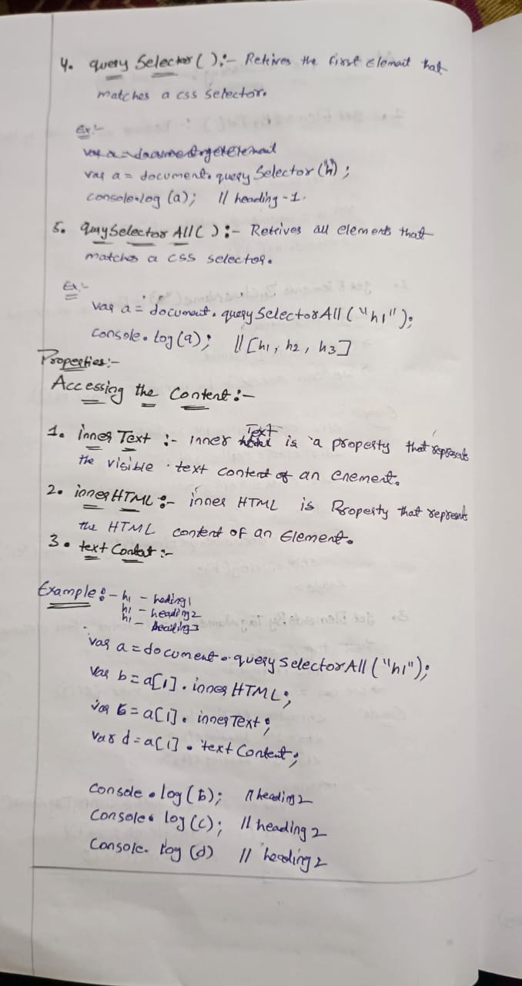

**How to modify existing content**

    // Select the element by its ID

    var paragraph = document.getElementById("myParagraph");

    // Update the text content using innerText

    paragraph.innerText = "Updated text!";

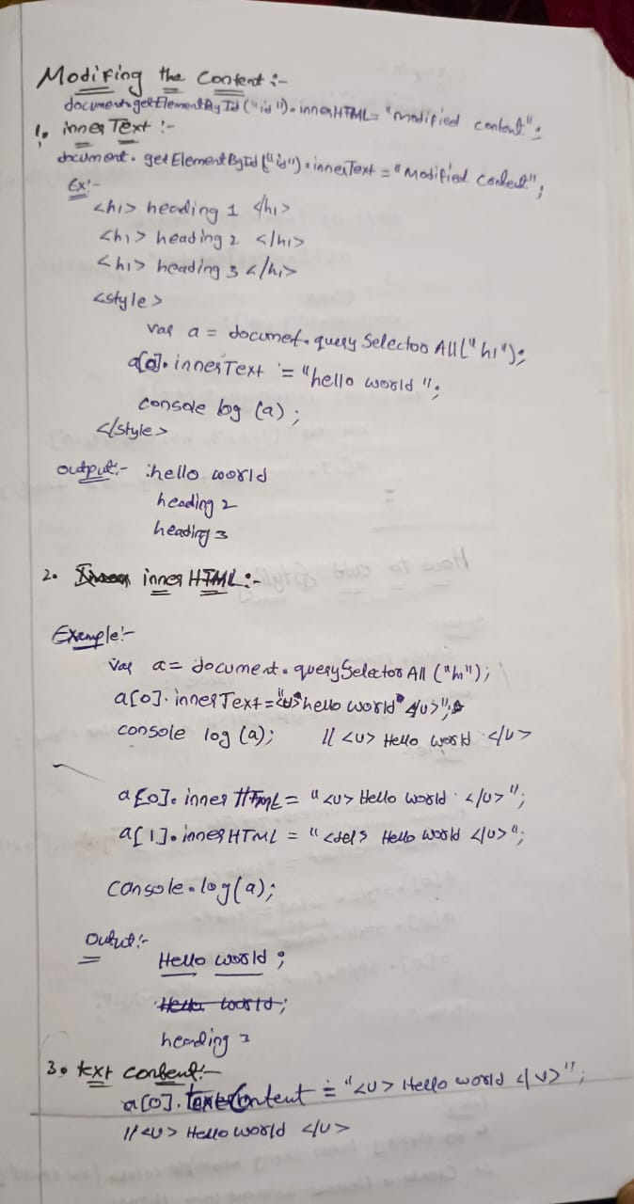

**How to apply styles using dom**

Step 1: Access the element where you want to append the text node

Step 2: Apply styles

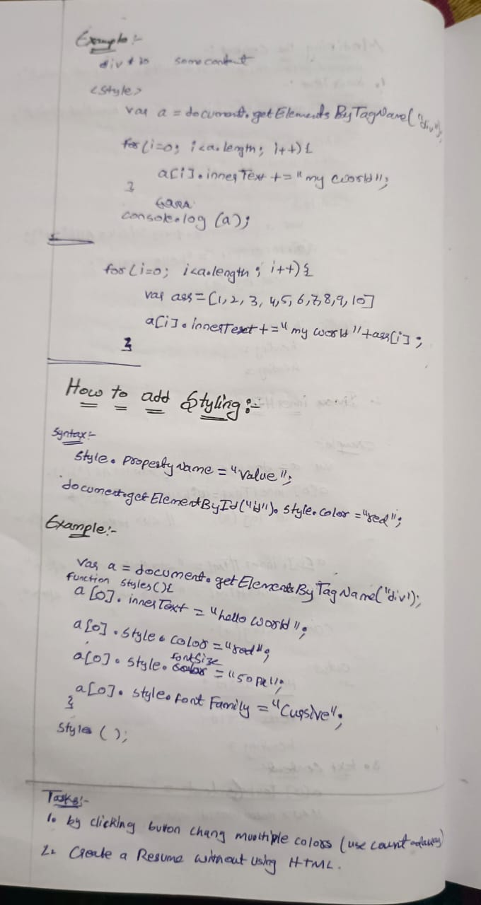

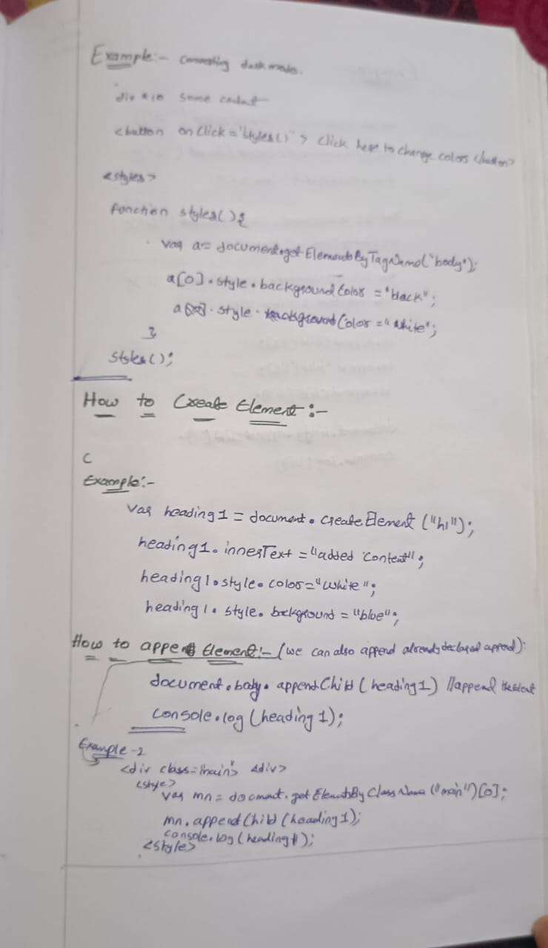

**How to change attribute values by using setAttribute**

<div id="myDiv">This is some text and have id myDiv but it will changed to demo</div>

 var a=document.getElementById("myDiv").setAttribute("id","demo");

console.log(document)//can inspect and check weather it was changed or not

we can change the attribute by using .setAttribute.(“attribute name”,”attribute value”) //output

**How to create element and how to append element in dom**

**Creating element**

* A new paragraph element is created using document.createElement("p").
* The innerText property of the newly created paragraph element is set to "This is a dynamically created paragraph."
* The paragraph element is appended to the document body using **document.body.appendChild(newParagraph).**

**Appendchild and Append**

Append and appendChild methods are used in JavaScript to add nodes to the DOM, but they have some differences in terms of usage, accepted parameters, and behavior:

**appendChild syntax:**

parentNode.appendChild(newChild);

**Parameters:**

newChild: A single node (an element, text node, or any other node) that will be appended as the last child of parentNode

**Behavior:**

If the newChild is already in the DOM, it will be removed from its current position and moved to the new position.

**Only accepts a single node**.

**Append syntax:**

parentNode.append(node1, node2, node3);

**Parameters:**

nodes: One or more nodes or strings that will be appended as the last children of parentNode.

**Behavior:**

Can append multiple nodes and/or strings at once.

If a string is provided, it will be added as a text node.

Allows appending a combination of nodes and text.

**How to create textNode**

 // **Step 1: Access the element where you want to append the text node**

 var myDiv = document.getElementById("myDiv");

// **Step 2: Create a text node**

var textNode = document.createTextNode("This is a dynamically created text node.");

// **Step 3: Append the text node to the element**

myDiv.appendChild(textNode);

⦁ Access the element where you want to append the text node.

⦁ Create a text node using document.createTextNode().

⦁ Append the text node to the desired element.

**Example:**

// **Create a new paragraph element**

    var newParagraph= document.createElement("p");

    // **Set innertext or other properties if needed**

    newParagraph.innerText = "This is a dynamically created paragraph.";

    // **Append the paragraph to the document body**

    document.body.appendChild(newParagraph);

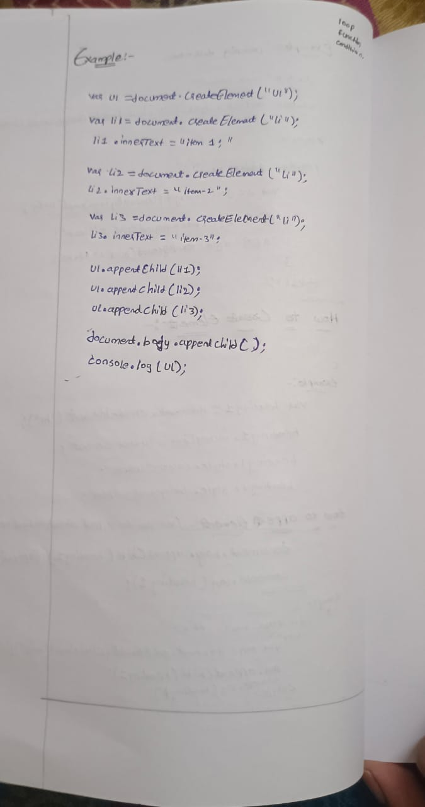

**Tasks:**

1. **Color Genrator:** By clicking button change multiple colors (use count and arrays)

**Code:**

    <script>

        var body=document.getElementsByTagName("body")[0];

        body.style.display="flex";

        body.style.flexDirection="column";

        body.style.width="98vw";

        body.style.height="98vh";

        body.style.justifyContent="center";

        body.style.alignItems="center";

        body.style.gap="10px";

        var head1=document.createElement("h1");

        head1.innerText="Color Genrator";

        head1.style.fontSize="28px";

        document.body.appendChild(head1);

        var area=document.createElement("div");

        area.style.width="50%";

        area.style.height="50vh";

        area.style.border="3px solid black";

        area.style.color="white";

        document.body.appendChild(area);

        var btn=document.createElement("button");

        btn.innerText="Click Here to Change Color";

        btn.style.fontSize="15px";

        btn.addEventListener("click", cg);

        document.body.appendChild(btn);

        var count=0;

        var arr=['black','skyblue','lightgreen','grey','blue'];

        function cg(){

            area.style.backgroundColor=arr[count];

            count++;

            if(count>=arr.length){

                count=0;

            }

        }

    </script>

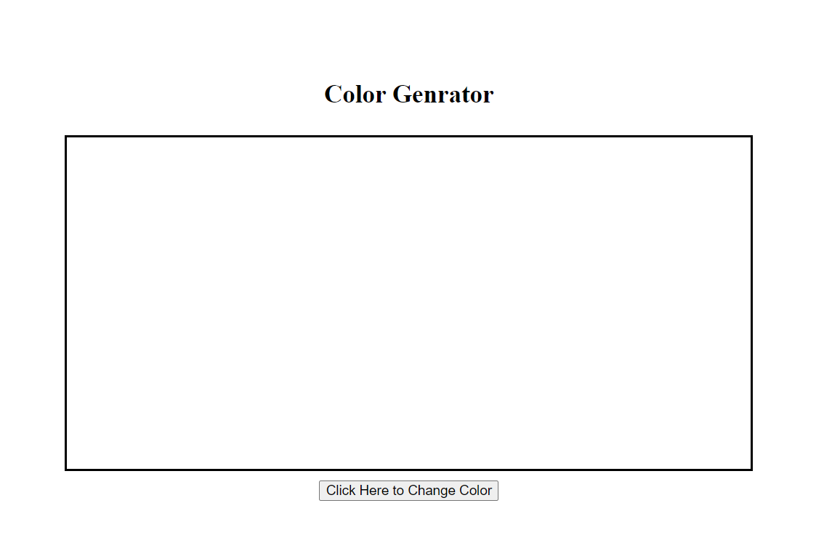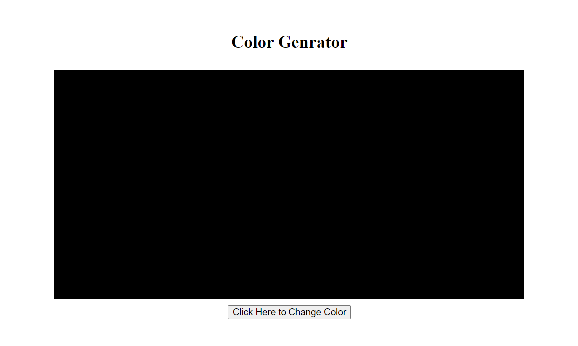

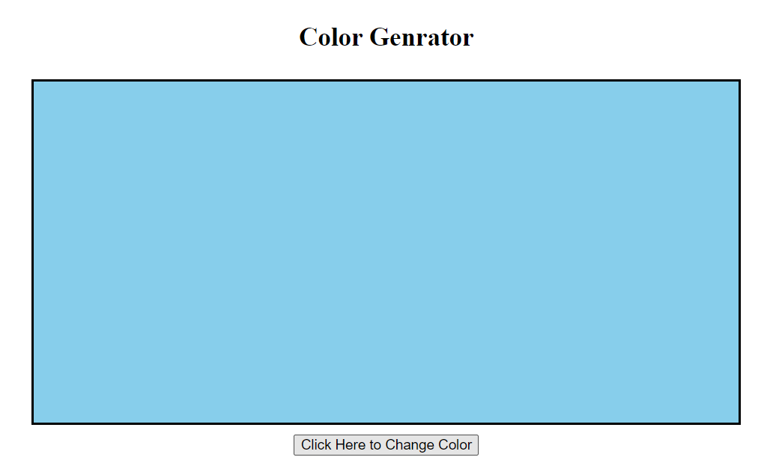 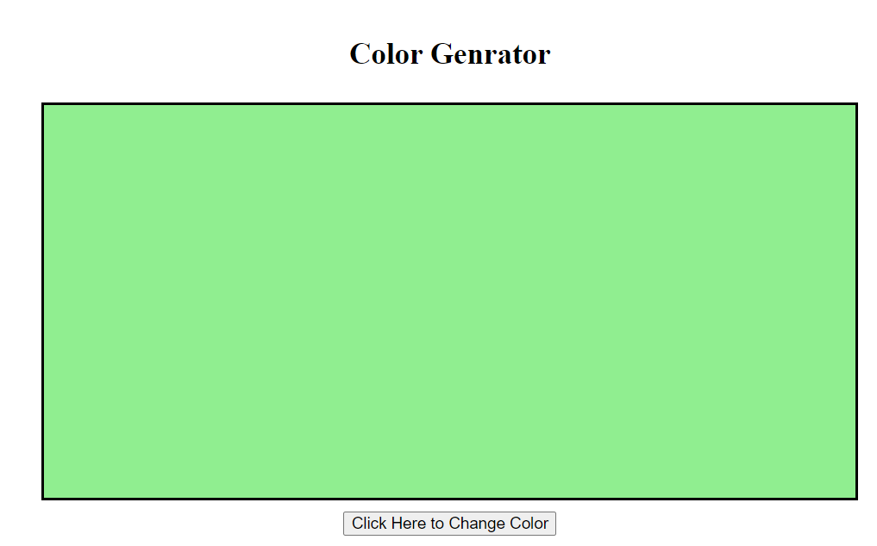 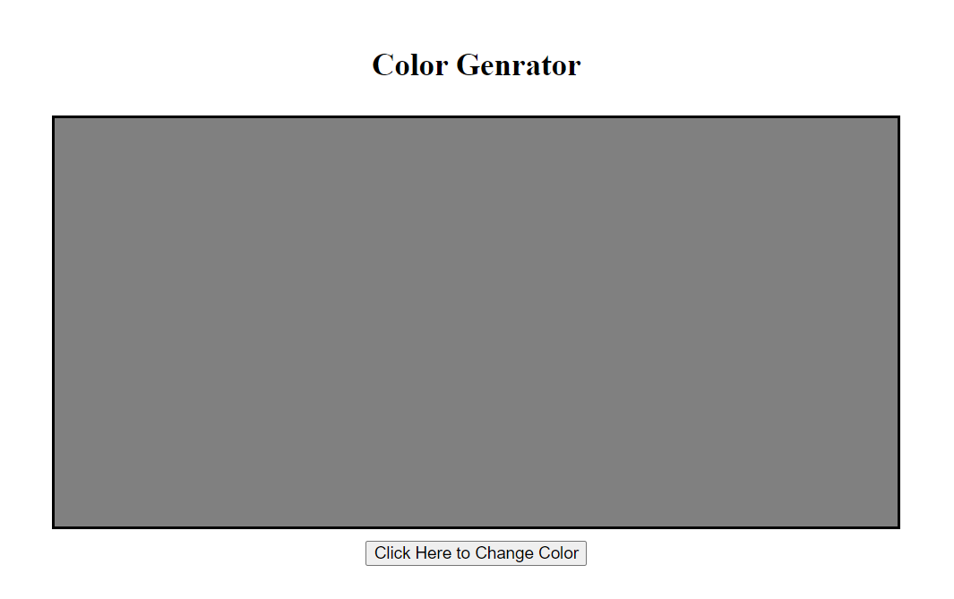 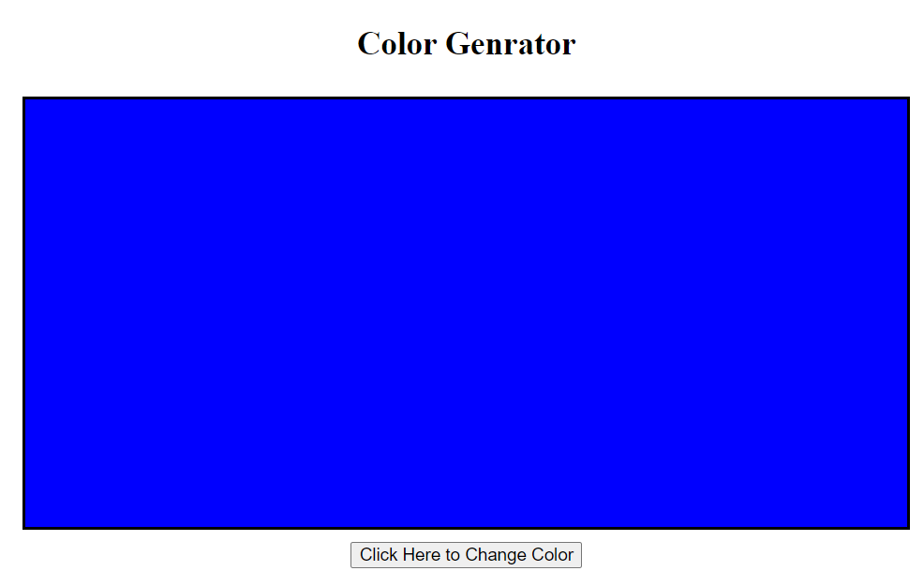

1. **Resume:** create a Resume without using HTML

        var body=document.getElementsByTagName("body")[0];

        body.style.width="48vw";

        body.style.height="auto";

        body.style.border="3px solid black";

        // Name

        var head1=document.createElement("h1");

        head1.innerText="ABHINAV SAI ";

        head1.style.textAlign="center";

        // head1.style.paddingLeft="25px";

        head1.style.color="green";

        head1.style.fontSize="40px";

        document.body.appendChild(head1);

        // CAREER OBJECTIVE

        var sh1=document.createElement("h3");

        sh1.innerText="CAREER OBJECTIVE";

        sh1.style.paddingLeft="25px";

        sh1.style.color="red";

        sh1.style.fontSize="26px";

        document.body.appendChild(sh1);

        // CAREER OBJECTIVE statement

        var co=document.createElement("p");

        co.innerText="Responsible and motivated student ready to apply education in the workplace. Offers excellent technical abilities with software and applications, ability to handle challenging work, and excellent time management skills.";

        co.style.paddingLeft="25px";

        document.body.appendChild(co);

        // Technical Skills

        var sh2=document.createElement("h3");

        sh2.innerText="Technical Skills";

        sh2.style.paddingLeft="25px";

        sh2.style.color="red";

        sh2.style.textAlign="left";

        sh2.style.fontSize="26px";

        document.body.appendChild(sh2);

        var ts=document.createElement("ul");

        var li1=document.createElement("li");

        var li2=document.createElement("li");

        var li3=document.createElement("li");

        var li4=document.createElement("li");

        var li5=document.createElement("li");

        ts.style.listStyleType="none";

        li1.innerText="Java";

        li2.innerText="Python";

        li3.innerText="HTML";

        li4.innerText="CSS";

        li5.innerText="Java Script";

        ts.appendChild(li1);

        ts.appendChild(li2);

        ts.appendChild(li3);

        ts.appendChild(li4);

        ts.appendChild(li5);

        document.body.appendChild(ts);

        // Soft Skills

        var sh3=document.createElement("h3");

        sh3.innerText="Soft Skills";

        sh3.style.paddingLeft="25px";

        sh3.style.color="red";

        sh3.style.textAlign="left";

        sh3.style.fontSize="26px";

        document.body.appendChild(sh3);

        var ts=document.createElement("ul");

        var li1=document.createElement("li");

        var li2=document.createElement("li");

        var li3=document.createElement("li");

        var li4=document.createElement("li");

        ts.style.listStyleType="none";

        li1.innerText="Adaptapility";

        li2.innerText="Self Motivation";

        li3.innerText="Self Confidence";

        li4.innerText="Team Work";

        ts.appendChild(li1);

        ts.appendChild(li2);

        ts.appendChild(li3);

        ts.appendChild(li4);

        document.body.appendChild(ts);

        //Hobbies.

        var sh4=document.createElement("h3");

        sh4.innerText="Soft Skills";

        sh4.style.paddingLeft="25px";

        sh4.style.color="red";

        sh4.style.textAlign="left";

        sh4.style.fontSize="26px";

        document.body.appendChild(sh4);

        var hob=document.createElement("ul");

        hob.style.listStyleType="none";

        hobbies=["playing Cricket","Listening Music","watching Movies"];

        for(var i=0;i<hobbies.length;i++){

            var li=document.createElement("li");

            li.innerText=hobbies[i];

            li.style.color="green";

            li.style.fontSize="16px";

            hob.appendChild(li);

        }

        document.body.appendChild(hob);

        // Declaration

        var sh5=document.createElement("h3");

        sh5.innerText="Declaration";

        sh5.style.paddingLeft="25px";

        sh5.style.color="red";

        sh5.style.textAlign="left";

        sh5.style.fontSize="26px";

        document.body.appendChild(sh5);

        // Declaration Statement

        var ds=document.createElement("p");

        ds.innerText="I hereby declare that the information furnished above is genuine to the best of my belief and I hold the responsibility of their authenticity and correctness.";

        ds.style.paddingLeft="25px";

        document.body.appendChild(ds);

        // sign

        var sign=document.createElement("p");

        sign.innerText="-Abhinav Sai";

        sign.style.paddingLeft="600px";

        document.body.appendChild(sign);

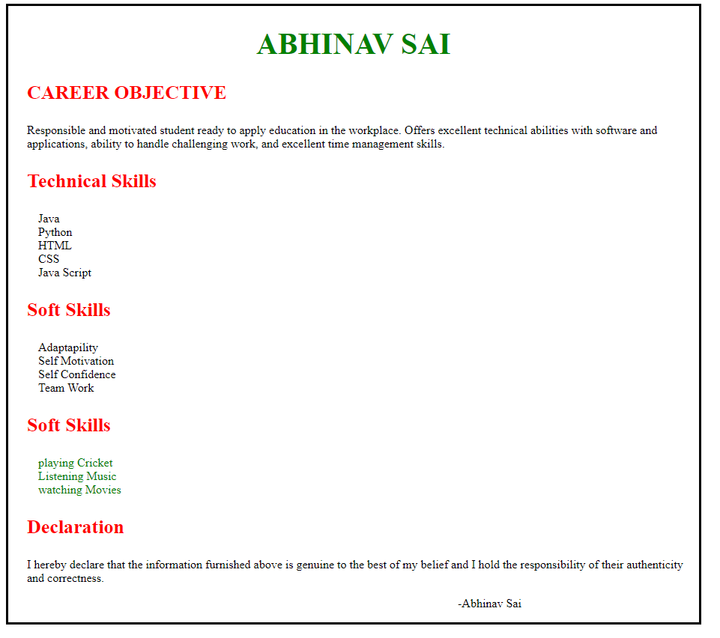

**DOM**

It is a object model used to manipulate the document and there are two ways to  create document object

1) Field Names – document level object creation

2) Methods – element level object creation

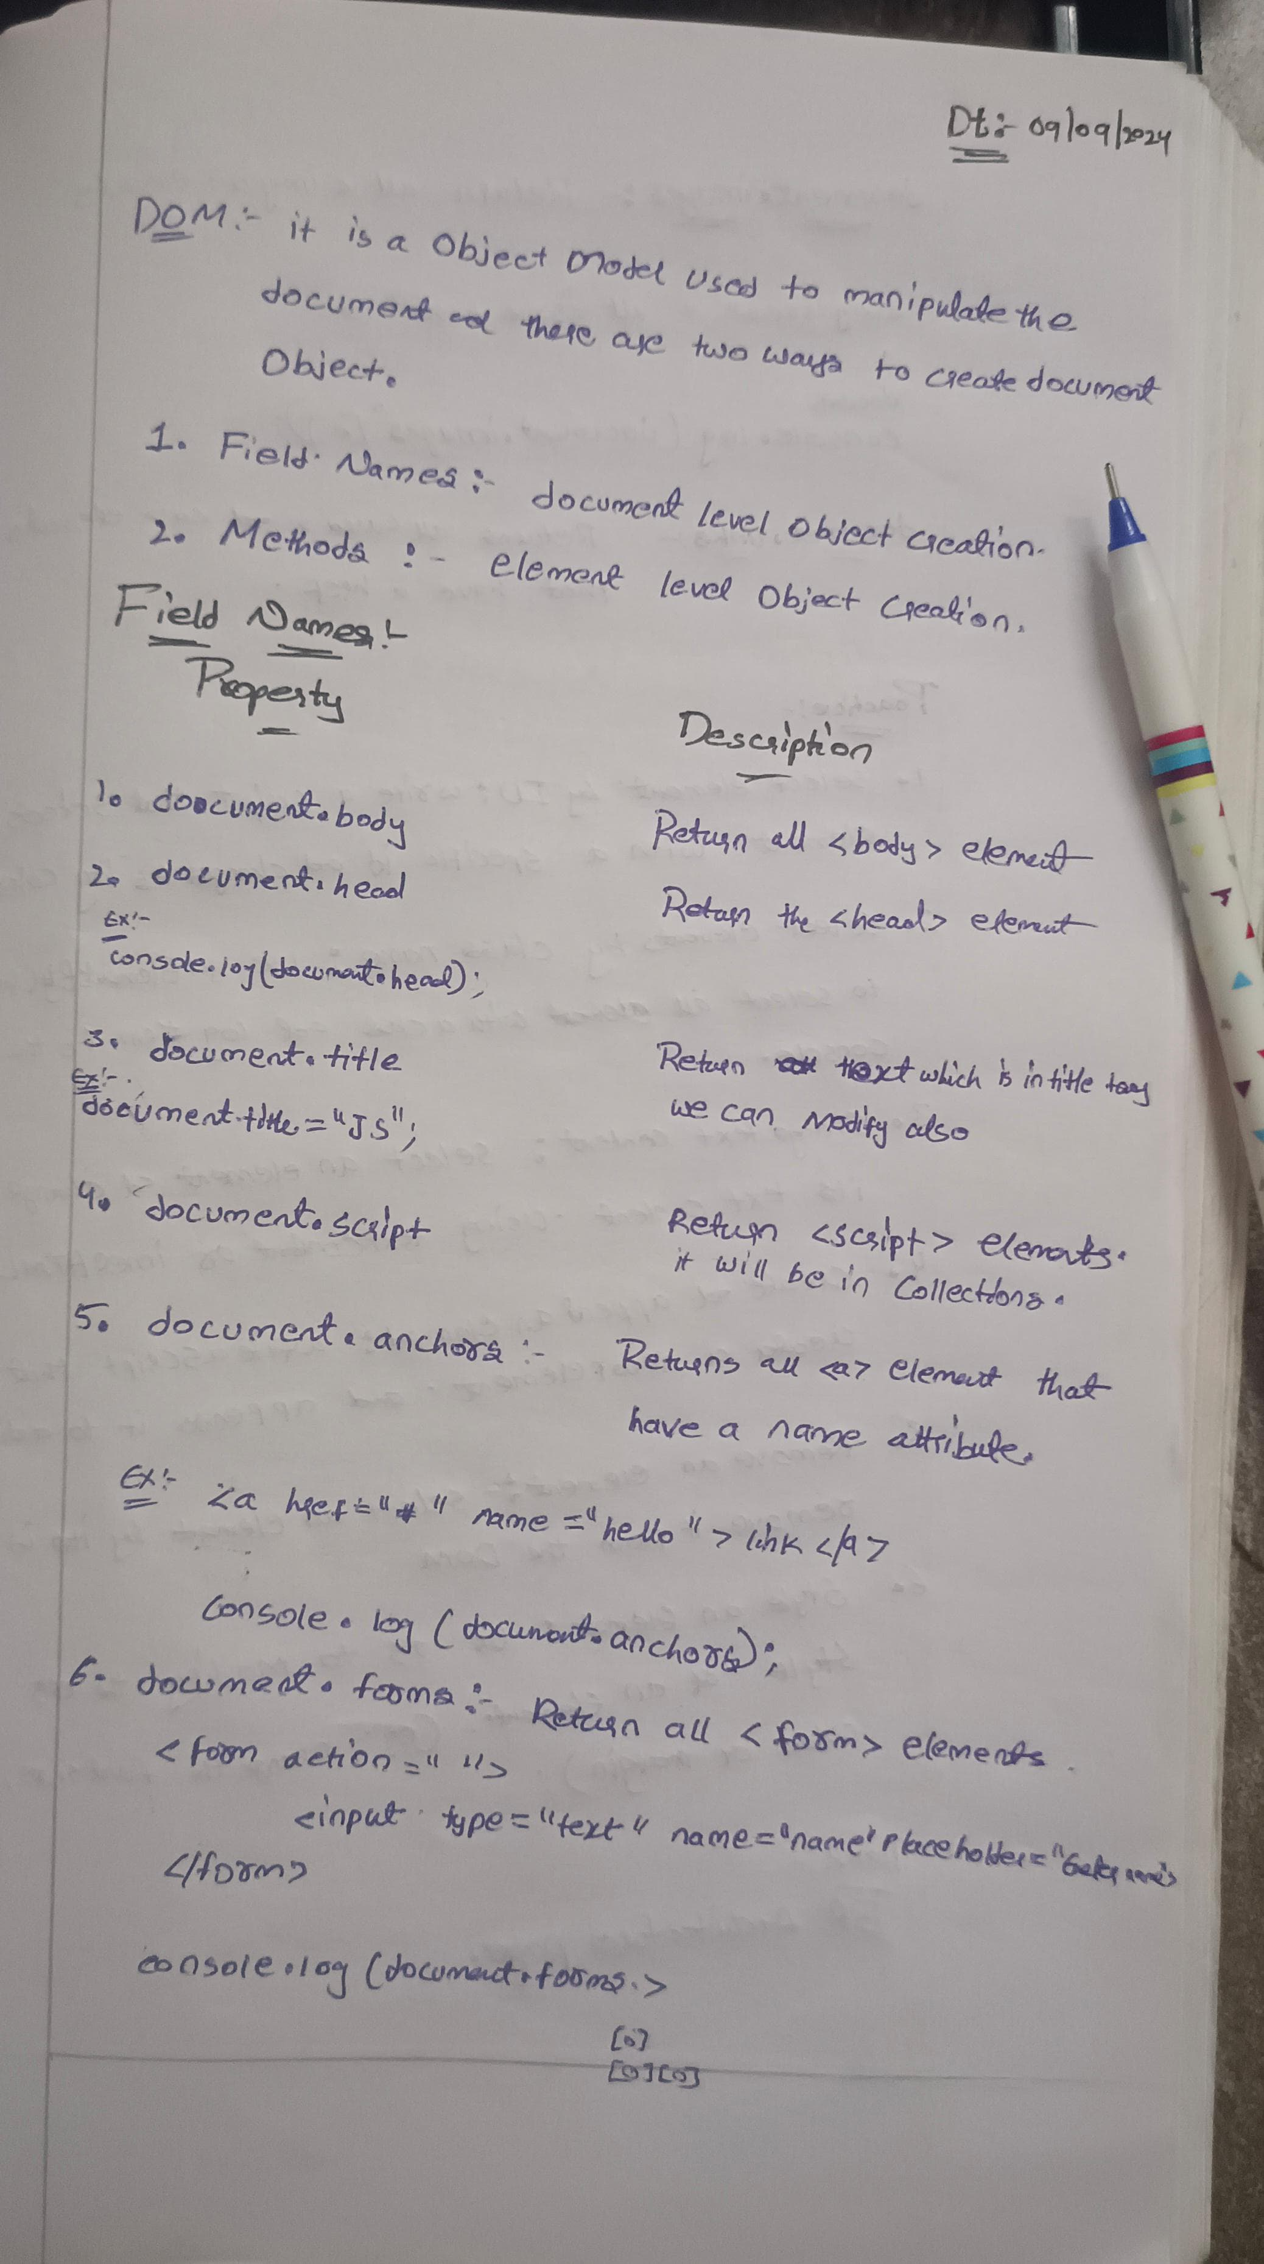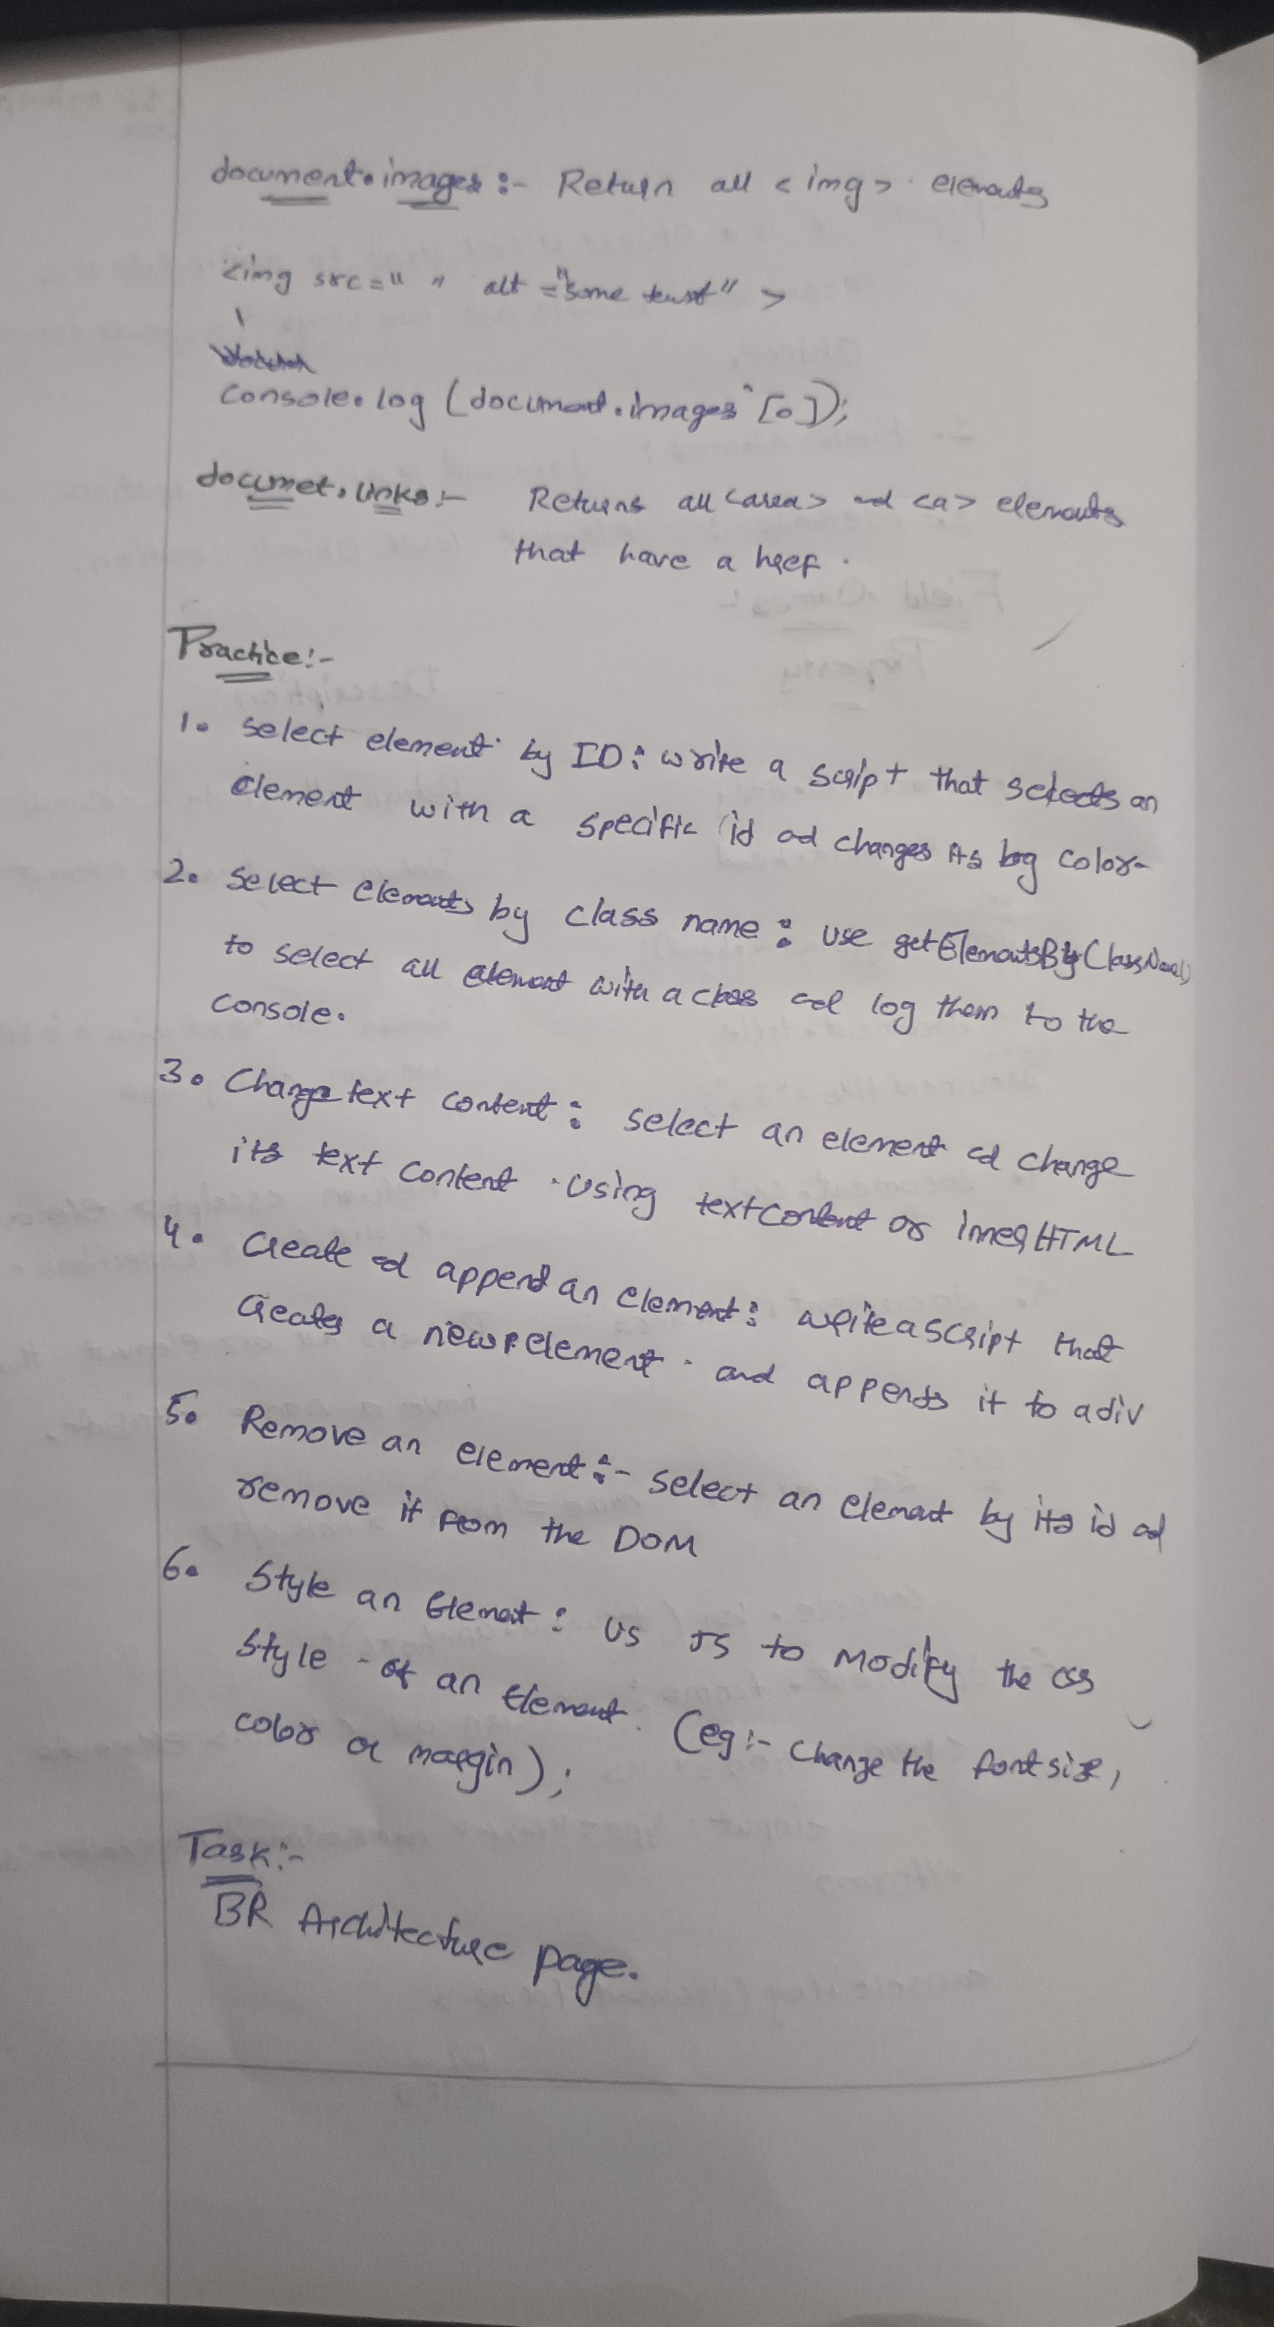



//1. Changing bg color

        var a=document.getElementById("p1");

        a.style.backgroundColor="navy";

        a.style.color="White";

        console.log(a);

        //2. select elements by class name

        var b=document.getElementsByClassName("p2");

        console.log(b);

        //3. changing Text

        var c=document.querySelector("h3");

        c.innerHTML="Changed text";

        console.log(c);

        //4. create and append

        var d1=document.querySelector(".app");

        var d=document.createElement("h2");

        d.innerText="h2 is created";

        d1.appendChild(d);

        //5. Remove an Element

        var e=document.getElementById("id1");

        id1.remove();

        // 6. Style an element

        var f=document.getElementsByTagName("h2");

        f[0].style.backgroundColor="navy";

        f[0].style.color="white";

**EXAMPLE: Br Architecture Houses**

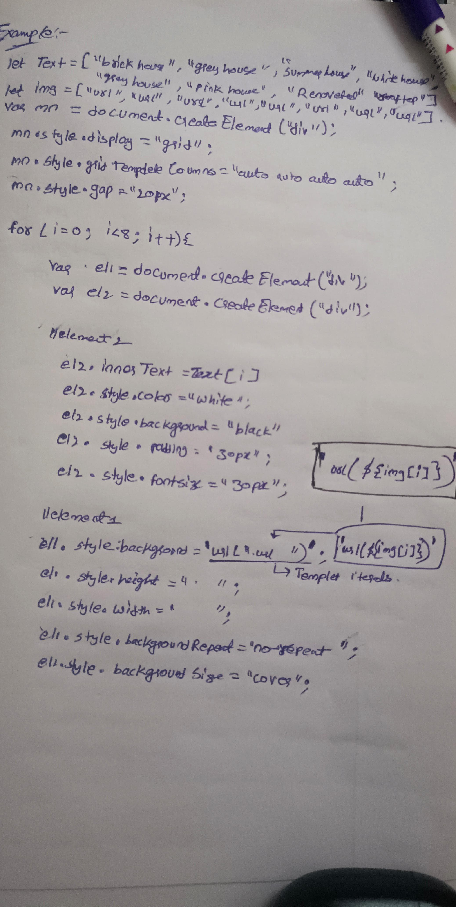

**Task:**

var nav=document.createElement("div");

        nav.style.display="flex";

        nav.style.justifyContent="space-between";

        nav.style.padding="5px";

        nav.style.height="8vh";

        nav.style.width="98vw";

        nav.style.position="relative";

        var nav1=document.createElement("div");

        nav1.style.paddingTop="10px";

        var br=document.createElement("a");

        br.innerText="BR Architecture";

        br.style.fontSize="32px";

        br.style.color="black";

        br.setAttribute("href","#");

        br.style.textDecoration="none";

        nav1.appendChild(br);

        nav.appendChild(nav1);

        var nav2=document.createElement("div");

        nav2.style.paddingRight="20px";

        nav2.style.paddingTop="15px";

        var about1=document.createElement("a");

        about1.innerText="About us";

        about1.style.padding="15px";

        about1.setAttribute("href","#");

        about1.style.color="black";

        about1.style.textDecoration="none";

        about1.style.fontSize="20px";

        nav2.appendChild(about1);

        var menu1=document.createElement("a");

        menu1.innerText="Menu";

        menu1.style.padding="15px";

        menu1.setAttribute("href","#");

        menu1.style.textDecoration="none";

        menu1.style.color="black";

        menu1.style.fontSize="20px";

        nav2.appendChild(menu1);

        var contact1=document.createElement("a");

        contact1.innerText="Contact Us";

        contact1.style.padding="15px";

        contact1.setAttribute("href","#");

        contact1.style.textDecoration="none";

        contact1.style.color="black";

        contact1.style.fontSize="20px";

        nav2.appendChild(contact1);

        nav.appendChild(nav2);

        document.body.appendChild(nav);

        console.log(nav);

        //home section

        var homee=document.createElement("div");

        var home=document.createElement("div");

        home.style.background=`url("architect.jpg")`;

        home.style.backgroundRepeat="no-repeat";

        home.style.backgroundSize="cover";

        home.style.height="95vh";

        home.style.width="98.8vw";

        homee.appendChild(home);

        document.body.appendChild(homee);

        // Houses

        let text=["Summer House","Brick House" ,"Renovated House","Barn House","Brick House","Summer House","Barn House","Renovated House"];

        let img=["https://www.w3schools.com/w3images/house5.jpg","https://www.w3schools.com/w3images/house2.jpg","https://www.w3schools.com/w3images/house3.jpg","https://www.w3schools.com/w3images/house4.jpg","https://www.w3schools.com/w3images/house2.jpg","https://www.w3schools.com/w3images/house5.jpg","https://www.w3schools.com/w3images/house4.jpg","https://www.w3schools.com/w3images/house3.jpg"];

        var hs=document.createElement("div");

        hs.style.height="100vh";

        hs.style.width="98px";

        var h1=document.createElement("h1");

        h1.innerText="Projects";

        h1.style.color="black";

        h1.style.fontSize="38px";

        h1.style.padding="50px 10px 60px 20px";

        hs.appendChild(h1);

        var houses=document.createElement("div");

        houses.style.display="grid";

        houses.style.gridTemplateColumns="auto auto auto auto";

        houses.style.justifyContent= "space-around" ;

        houses.style.paddingLeft="45px";

        houses.style.gap="35px";

        for(var i=0;i<8; i++){

            var hs1=document.createElement("div");

            var hs2=document.createElement("div");

            // element-2

            hs1.innerHTML=text[i];

            hs1.style.color="white";

            hs1.style.background="black";

            hs1.style.width="45%";

            hs1.style.padding="10px";

            hs1.style.fontSize="16px";

            //element-1

            hs2.style.background=`url(${img[i]})`;

            hs2.style.height="220px";

            hs2.style.width="325px";

            hs2.style.backgroundRepeat="no-repeat";

            hs2.style.backgroundSize="cover";

            hs2.appendChild(hs1);

            houses.appendChild(hs2);

            hs.appendChild(houses);

            document.body.appendChild(hs);

        }

**OUTPUT:**



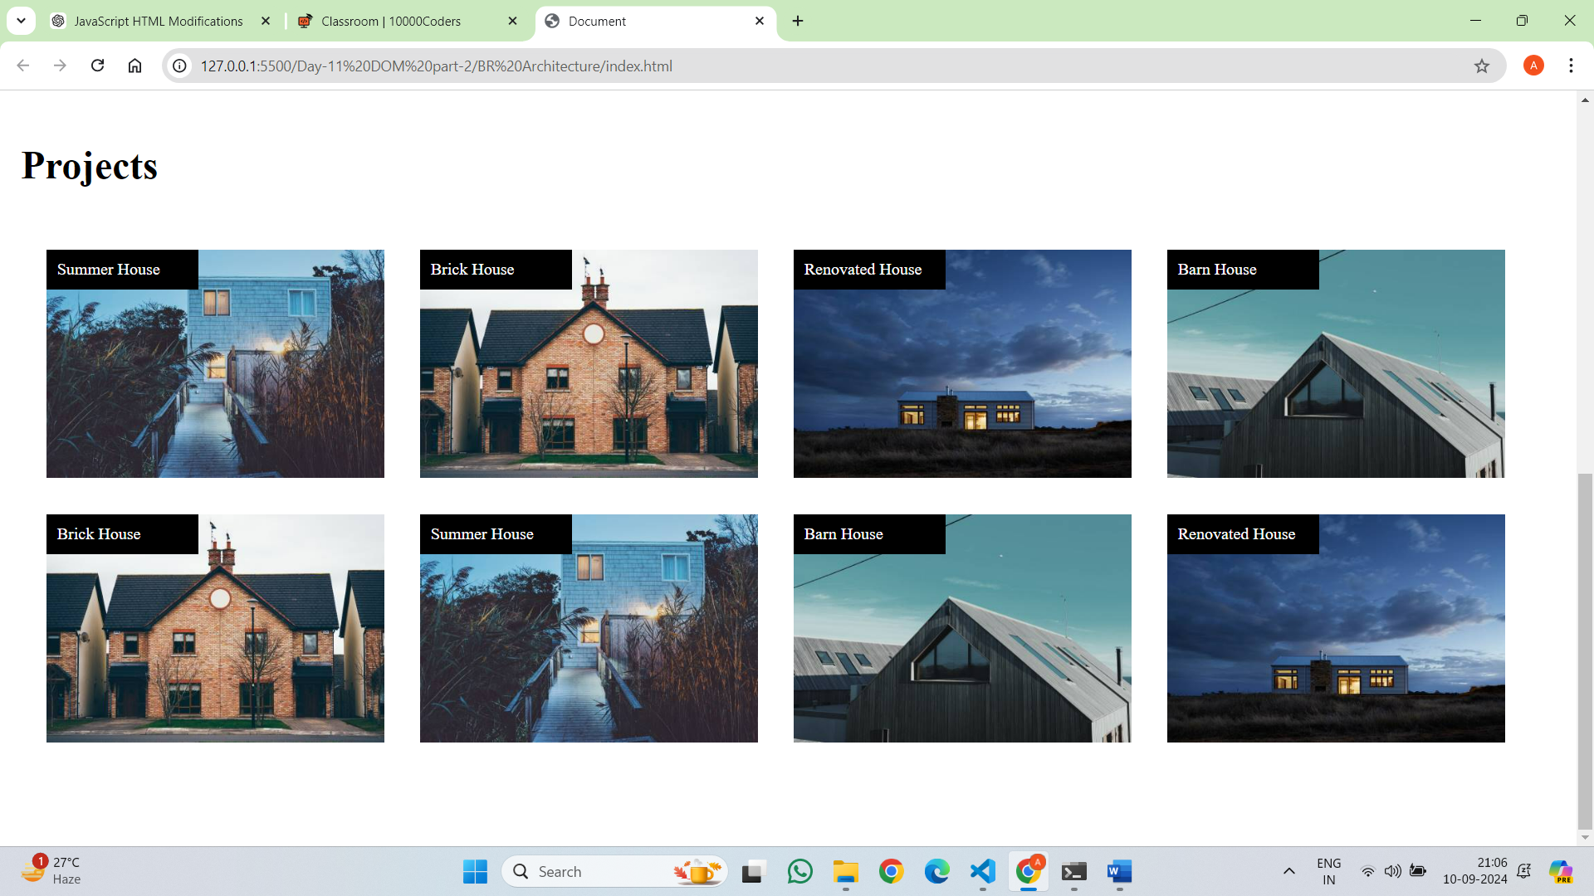

Topic:  Dom – setAttribute, getAttribute, classlist, event listeners and event handlers

**How to change attribute values by using setAttribute**

**Syntax:**

<div id="myDiv">This is some text and have id myDiv but it will changed to demo</div>

 var a=document.getElementById("myDiv").**setAttribute**("id","demo");

console.log(document)//can inspect and check weather it was changed or not

we can change the attribute by using .setAttribute.(“attribute name”,”attribute value”)

//output

**Example-1:**

var a=document.createElement("form");

        var b=document.createElement("input");

        b.setAttribute("type","password");

        b.setAttribute("placeholder","Enter Password");

        a.appendChild(b);

        document.body.appendChild(a);

**Output:**

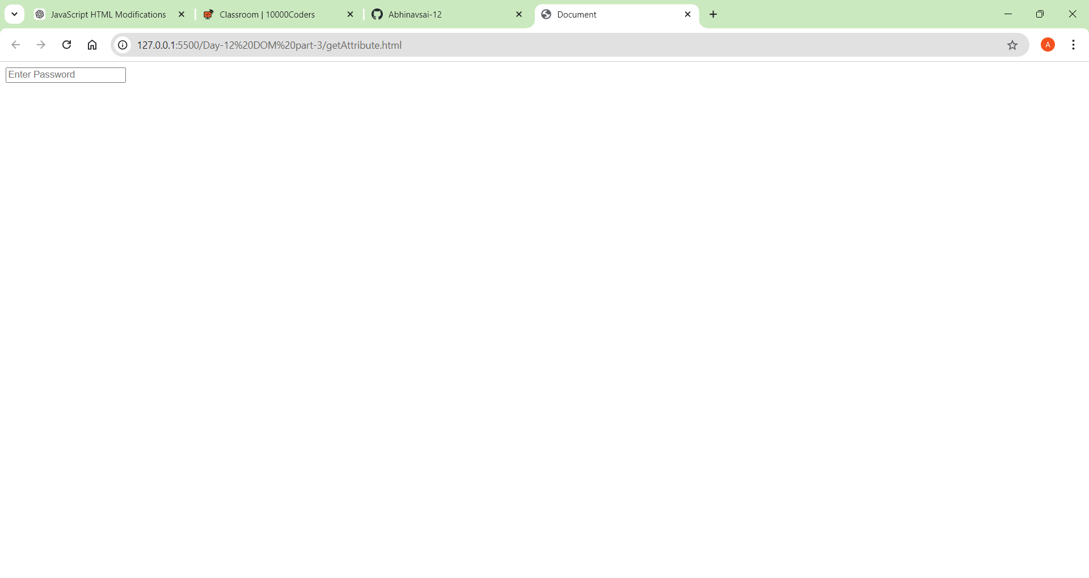

**Example-2:** img

var a=document.createElement("img");

        img.setAttribute("src","a1.jpge");

        document.body.appendChild(a);

**Example-3:** How to set class name by using setAtribute and use css of class name

<style>

        .adder{

            background-color:blue;

            color: white;

            font-size:2em;

            padding:20px;

        }

    </style>

</head>

<body>

    <script>

        var a=document.createElement("div");

        a.innerHTML="Content Added";

        a.setAttribute("class","adder");

        document.body.appendChild(a);

    </script>

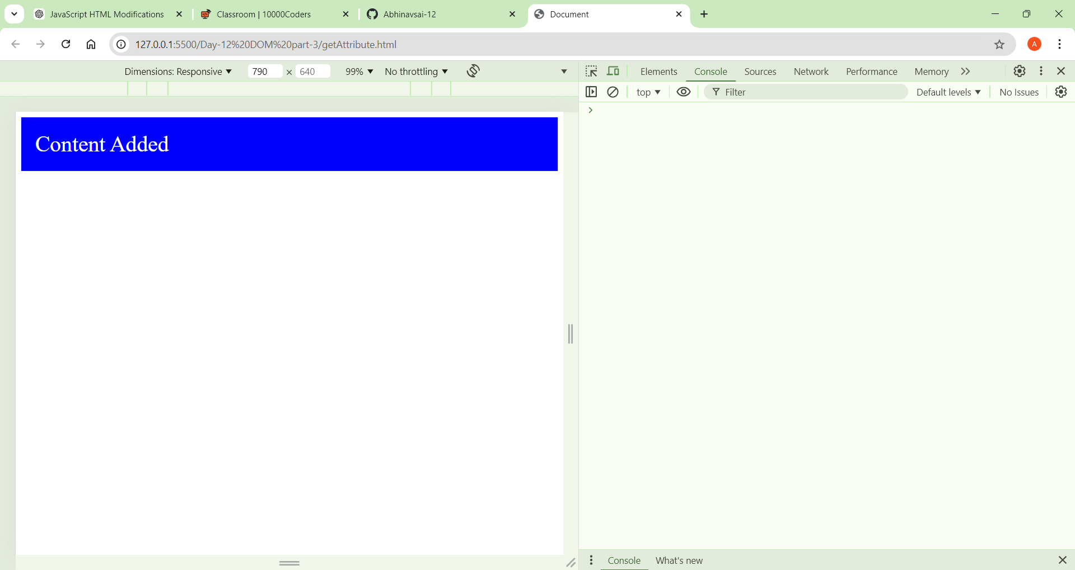

**Example-4:**

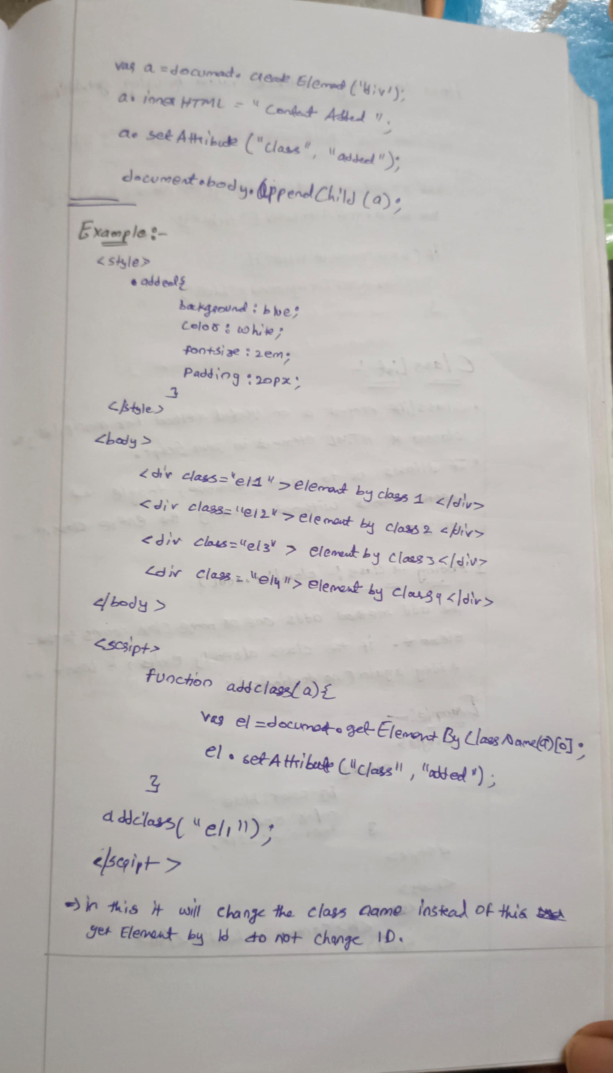

**How to get attribute**

We can get the element attribute  by using get attribute method in dom

**Example:**

    <div class="el1" title="ct">Content Added</div>

    <script>

        var a=document.getElementsByClassName("el1")[0];

        var b=a.getAttribute("title");

        if(b=="ct"){

            a.style.background="blue";

        }

    </script>

**Classlist add and remove**

* The classList property is an incredibly useful method for manipulating the classes of HTML elements in JavaScript.
* It allows you to add, remove, toggle, and check classes without altering the entire className string. Here's an in-depth explanation of how classList.add() and classList.remove() work.

1. **What is classList?**

⦁ classList is a property that returns a live DOMTokenList collection of the classes of an element.

⦁ You can think of classList as a way to interact with the classes applied to an HTML element, allowing you to add, remove, or toggle CSS classes dynamically.

**2. Syntax:** The syntax for accessing classList is as follows:

element.classList

classList methods include:

.add(), .remove(), .toggle()

3. **Adding a Class: classList.add()**

The add() method adds one or more class names to the element. If the class already exists, it won't be added again (no duplicates).

**Syntax**: element.classList.add(className1, className2, ..., classNameN);

**Example:**

<style>

        .added{

            background-color:blue;

            color: white;

            font-size:2em;

            padding:20px;

        }

    </style>

</head>

<body>

    <div>

        <h1>Content in heading</h1>

    </div>

    <button onclick="fun()">click here</button>

    <script>

        function fun(){

            var div=document.querySelector("div");

**div.classList.add("added");**

        }

    </script>

</body>

4. **Removing a Class: classList.remove()**

The remove() method removes one or more class names from the element. If the class does not exist, nothing happens.

**Syntax:** element.classList.remove(className1, className2, ..., classNameN);

**Example-1:**

function fun(){

            var div=document.querySelector("div");

**div.classList.remove("added");**

        }

**Example-2:**

var count=true;

        function fun(){

            var div=document.querySelector("div");

            if(count){

                div.classList.add("added");

                count=false;

            }

            else{

**div.classList.remove("added");**

                count=true;

            }

        }

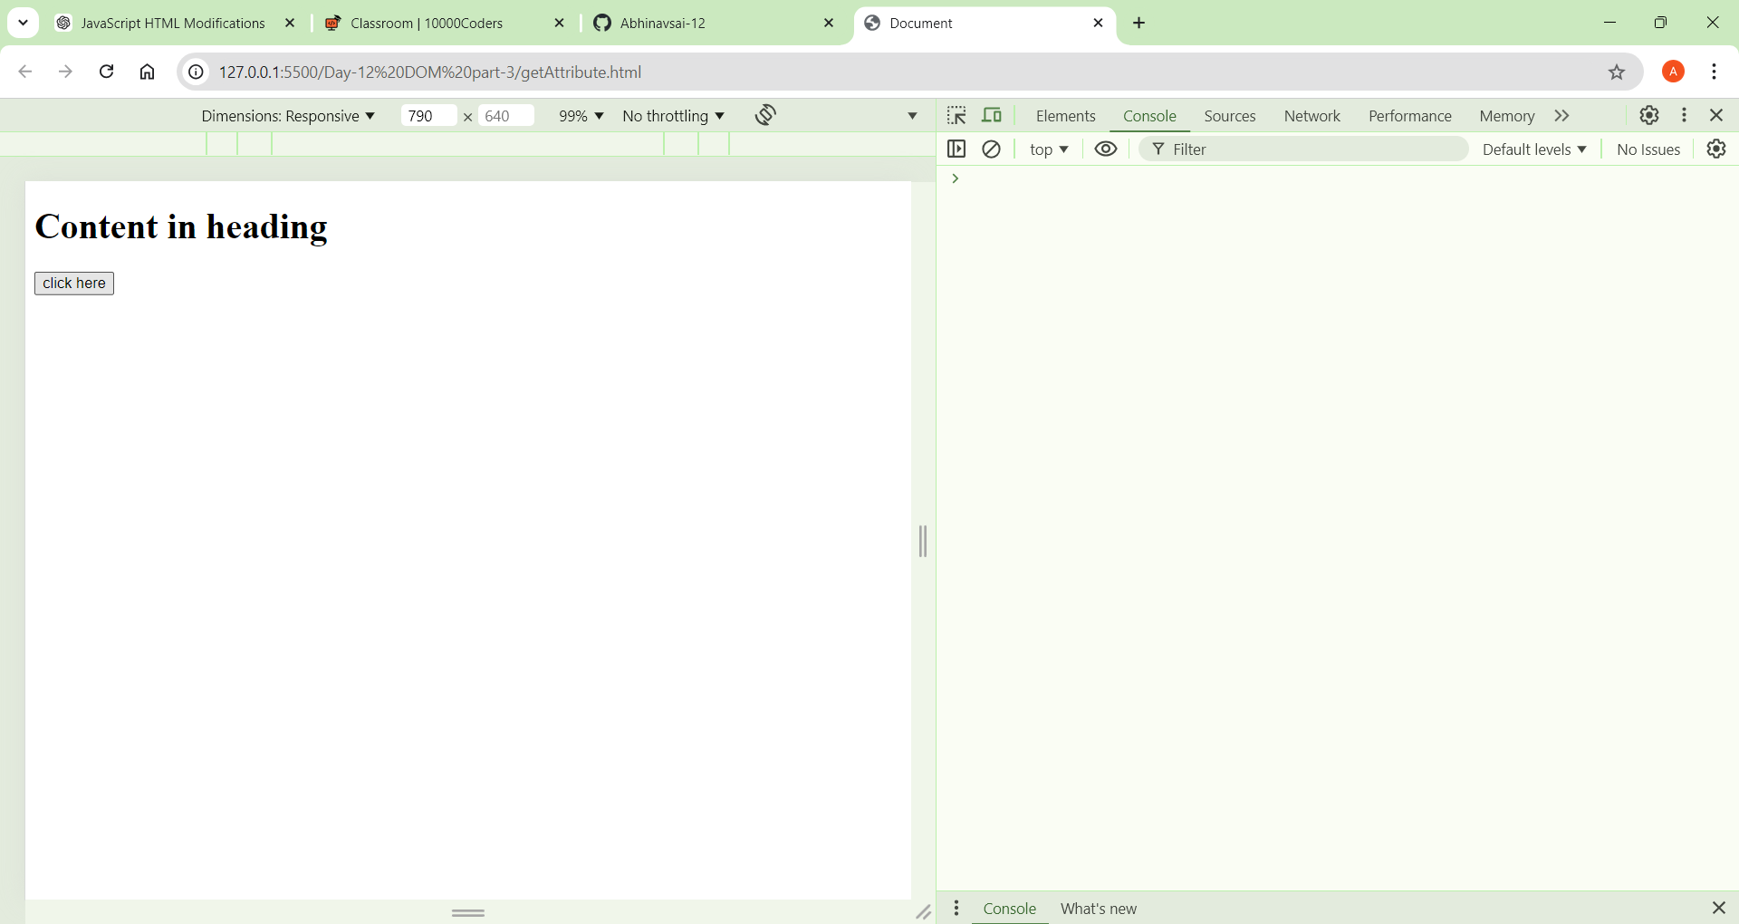

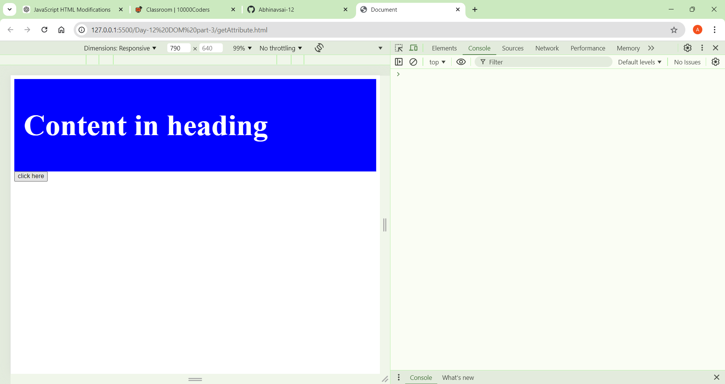



5. **Common Use Cases**

**A. Toggling Classes (With classList.toggle())**

⦁ Sometimes, you may want to add a class if it’s not present or remove it if it is. This can be done with the toggle() method.

**Syntax:** element.classList.toggle('className');

**Example:**

<div>

        <h1>Content in heading</h1>

    </div>

    <button onclick="fun()">click here</button>

    <script>

        var count=true;

        function fun(){

            var div=document.querySelector("div");

            div.classList.toggle("added");

        }

**B. Checking If an Element Has a Class (classList.contains())**

⦁ To check if an element has a certain class, use the contains() method.

**Syntax:** if (element.classList.contains('className')) { // do something }

**Types of Events**

**Mouse Events:**

**click:** Occurs when a mouse button is clicked.

**dblclick:** Occurs when a mouse button is double-clicked.

**mouseover:** Occurs when the mouse pointer enters the area of an element.

**mouseout:** Occurs when the mouse pointer leaves the area of an element.

**mousemove:** Occurs when the mouse pointer is moved over an element.

**Keyboard Events:**

**keydown:** Occurs when a keyboard key is pressed down.

**Keyup:** Occurs when a keyboard key is released.

**keypress:** Occurs when a keyboard key is pressed and released.

**Form Events:**

**submit:** Occurs when a form is submitted.

**change:** Occurs when the value of an input element changes.

**focus:** Occurs when an element receives focus.

**blur:** Occurs when an element loses focus.

**Window Events:**

**load:** Occurs when a resource and its dependent resources have finished loading.

**resize:** Occurs when the browser window is resized.

**scroll:** Occurs when the user scrolls through a webpage.

**Event handlers**:

Event handlers are functions in JavaScript that are responsible for handling specific types of events. They define what should happen when a particular event occurs. Event handlers are associated with HTML elements and are triggered when the corresponding event takes place.

**1.Inline Event Handlers:** Inline event handlers are defined directly within the HTML markup using the on attribute followed by the event name.

**<button onclick="myFunction()">Click me</button>**

**Example:**

<div>

        <h1>Content in heading</h1>

    </div>

    <button onclick="fun()">click here</button>

    <script>

        var count=true;

        function fun(){

            var div=document.querySelector("div");

            div.classList.toggle("added")

        }

    </script>

**2.DOM Event Handlers:** DOM event handlers are assigned to HTML elements using JavaScript code.

You can attach event handlers using methods like addEventListener()

const button = document.getElementById('myButton');

button.addEventListener('click', myFunction);

**Event listeners:**

Event listeners in JavaScript are functions that wait for a specific event to occur and then execute code in response to that event.

**Using addEventListener() Method:** The addEventListener() method attaches an event listener to an HTML element.

**It takes three parameters:** the event name, the function to be executed when the event occurs, and an optional boolean value indicating whether to use capturing or bubbling (default is false, indicating bubbling).

const button = document.getElementById('myButton');

button.addEventListener('click', function() {

    console.log('Button clicked!');

});

**Removing Event Listeners:** You can remove event listeners using the removeEventListener() method. It requires the same parameters as addEventListener().

function handleClick() {

    console.log('Button clicked!');

}

const button = document.getElementById('myButton');

button.addEventListener('click', handleClick);

// Later, if you want to remove the event listener

button.removeEventListener('click', handleClick);

=============================================================================

**Mouse Events Examples:**

**1. click:** Occurs when a mouse button is clicked.

<div>

<h1>Content in heading</h1>

</div>

<button>click here</button>

<script>

var btn=document.querySelector("button");

var div=document.querySelector("div");

btn.addEventListener("click",fun);

function fun(){

var div=document.querySelector("div");

div.style.color="red";

div.style.background="blue";

}

<script>

2. **dblclick:** Occurs when a mouse button is double-clicked.

<div>

<h1>Content in heading</h1>

</div>

<button>click here</button>

<script>

var btn=document.querySelector("button");

var div=document.querySelector("div");

btn.addEventListener("dblclick",fun2);

// dblclick

function fun2(){

var div=document.querySelector("div");

div.style.color="white";

div.style.background="blue";

}

<script>

3. **mouseover:** Occurs when the mouse pointer enters the area of an element.

<div>

<h1>Content in heading</h1>

</div>

<button>click here</button>

<script>

var btn=document.querySelector("button");

var div=document.querySelector("div");

div.addEventListener("mouseover",fun3);

// mouseover

function fun3(){

var div=document.querySelector("div");

div.style.color="white";

div.style.background="red";

}

<script>

**4. mousemove:**  Occurs when the mouse pointer is moved over an element.

<div>

<h1>Content in heading</h1>

</div>

<button>click here</button>

<script>

var btn=document.querySelector("button");

var div=document.querySelector("div");

div.addEventListener("mousemove",fun4);

//mousemove

function fun4(){

var div=document.querySelector("div");

div.style.color="red";

div.style.background="green";

}

</script>

**5. mouseout:** Occurs when the mouse pointer leaves the area of an element.

<div>

<h1>Content in heading</h1>

</div>

<button>click here</button>

<script>

var btn=document.querySelector("button");

var div=document.querySelector("div");

div.addEventListener("mouseout",fun5);

// mouseout

function fun5(){

var div=document.querySelector("div");

div.style.color="red";

div.style.background="grey";

}

</script>

**Keyboard Events:**

**1. keydown:** Occurs when a keyboard key is pressed down.

<script>

document.addEventListener("keydown",function(event){

console.log(event.key);

})

</script>

**2. Keyup:**Occurs when a keyboard key is released.

<script>

document.addEventListener("keyup",function(event){

console.log(event.key);

})

</script>

**3. keypress:** Occurs when a keyboard key is pressed and released.

<script>

document.addEventListener("keypress",function(event){

console.log(event.key);

})

</script>

**Tasks:**

1. **Modify element attributes: Select an image element and change its src and alt attributes.**

**Code:**

<img id="js" src="https://training.epam.com/static/news/496/JavaScriptforatestautomationengineerfeaturesadvantagestools_014111.png" alt="myimg" height="350px" width="350px">

    <script>

        var img=document.getElementById("js");

        img.src="https://miro.medium.com/v2/resize:fit:800/1*PEzOBf4AkvDoE4VME4kq4Q.jpeg";

        img.alt="new js img";

        console.log(img);

    </script>

1. **Event handling:** Write a script that adds a click event listener to a button that changes the text of a paragraph when clicked.

**Code:**

    <p>Event handling: Write a script that adds a click event listener

        to a button that changes the text of a paragraph when clicked.

    </p>

    <button>click here</button>

    <script>

        var btn=document.querySelector("button");

        btn.addEventListener("click",fun);

    function fun(){

            var p=document.querySelector("p");

            p.innerText="Responsible and motivated student ready to apply education in the workplace. Offers excellent technical abilities with software and applications, ability to handle challenging work, and excellent time management skills.";

            p.style.background="grey";

            p.style.padding="20px";

            p.style.border="2px solid black";

        }

    </script>

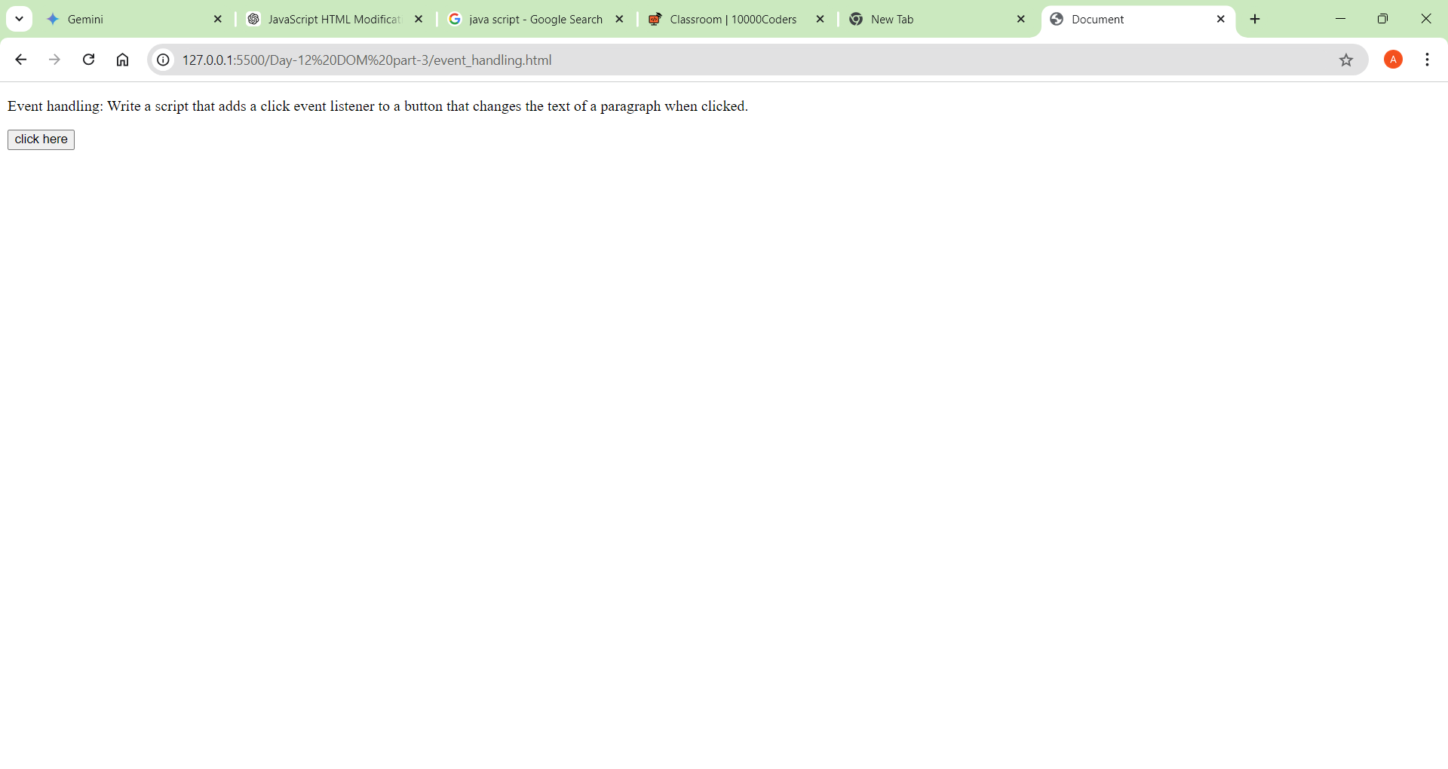

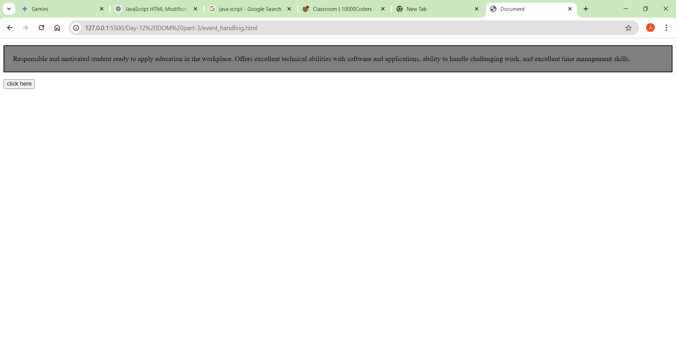

1. Dynamic class manipulation: Write a function that adds or removes a class from an element when a button is clicked.

**Code:**

<style>

        .div11{

            background-color:blueviolet;

            color: white;

            padding:20px;

            height:40vh;

            width: 40vw;

        }

        .adder{

            background-color: rgb(240, 185, 112);

            color: black;

            padding:20px;

            height:40vh;

            width: 40vw;

        }

        button{

            margin: 20px;

        }

    </style>

</head>

<body>

    <!--

        Dynamic class manipulation: Write a function that adds or removes

        a class from an element when a button is clicked.

    -->

    <div id="div11" class="div11">

        <p>Dynamic class manipulation: Write a function that adds or removes

            a class from an element when a button is clicked.

        </p>

        <p>Lorem ipsum dolor sit amet consectetur adipisicing elit. Accusantium

           pariatur quaerat numquam consequatur natus. Totam illum fuga eveniet

           maiores laudantium labore delectus repellat modi ratione, corrupti doloremque voluptates ad! Odio.

        </p>

    </div>

    <button onclick="fun()">click Here</button>

    <script>

        function fun(){

            var div=document.getElementById("div11");

            div.classList.toggle('adder');

        }

    </script>

</body>

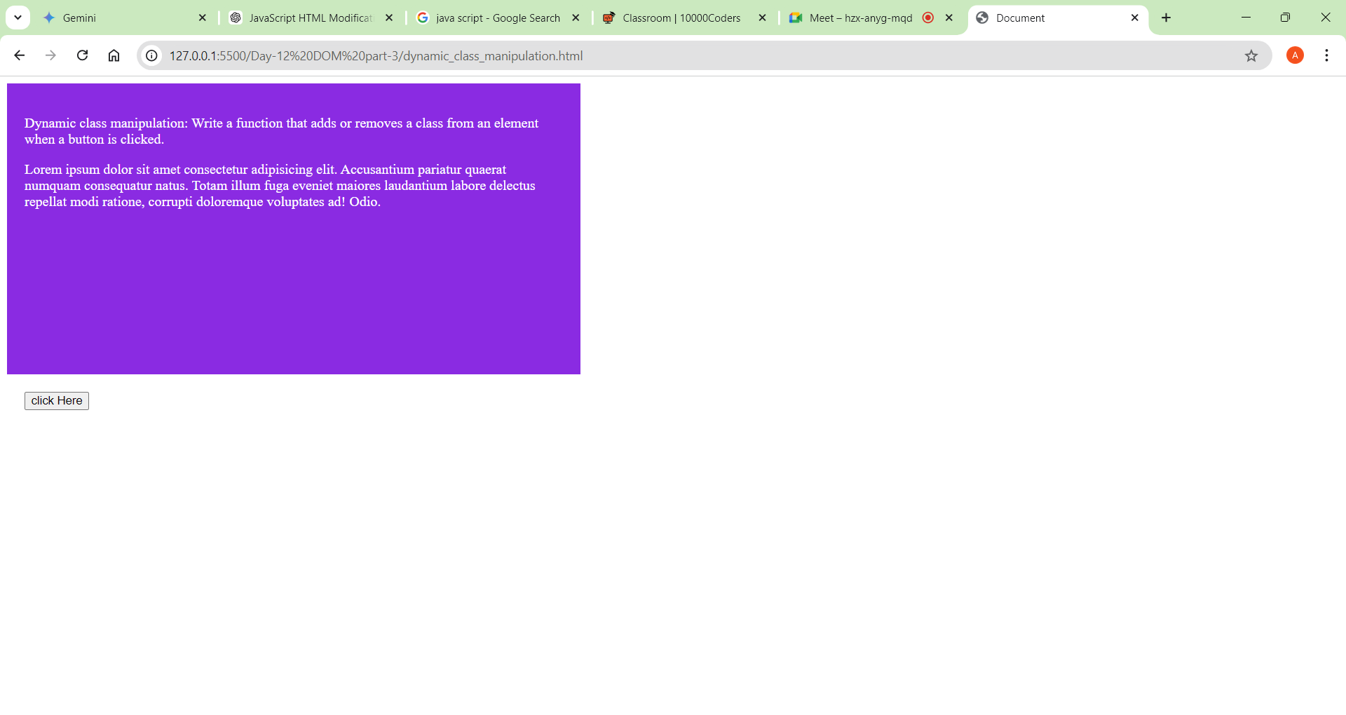

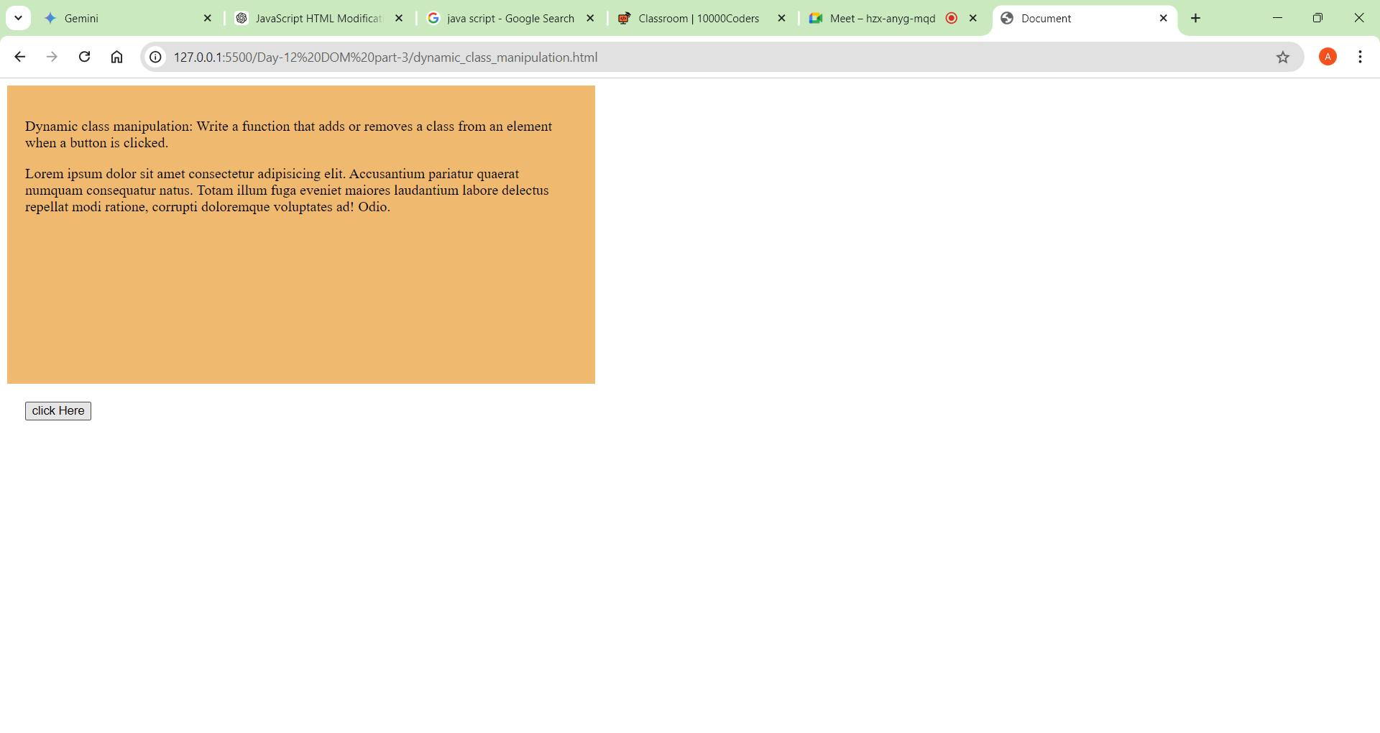

1. Toggle visibility: Create a button that toggles the visibility of an element by showing/hiding it on each click.

**Code**:

<style>

        .div1{

            background-color:blueviolet;

            color: white;

            padding:20px;

            height:10vh;

            width: 40vw;

        }

        .adder{

        display: none;

        }

        button{

            margin: 20px;

        }

    </style>

</head>

<body>

    <div id="div1" class="div1">

        <p>Toggle visibility: Create a button that toggles the visibility of

            an element by showing/hiding it on each click.

        </p>

    </div>

    <button onclick="fun()">click Here</button>

    <script>

        function fun(){

            var div=document.getElementById("div1");

            div.classList.toggle('adder');

        }

    </script>

</body>

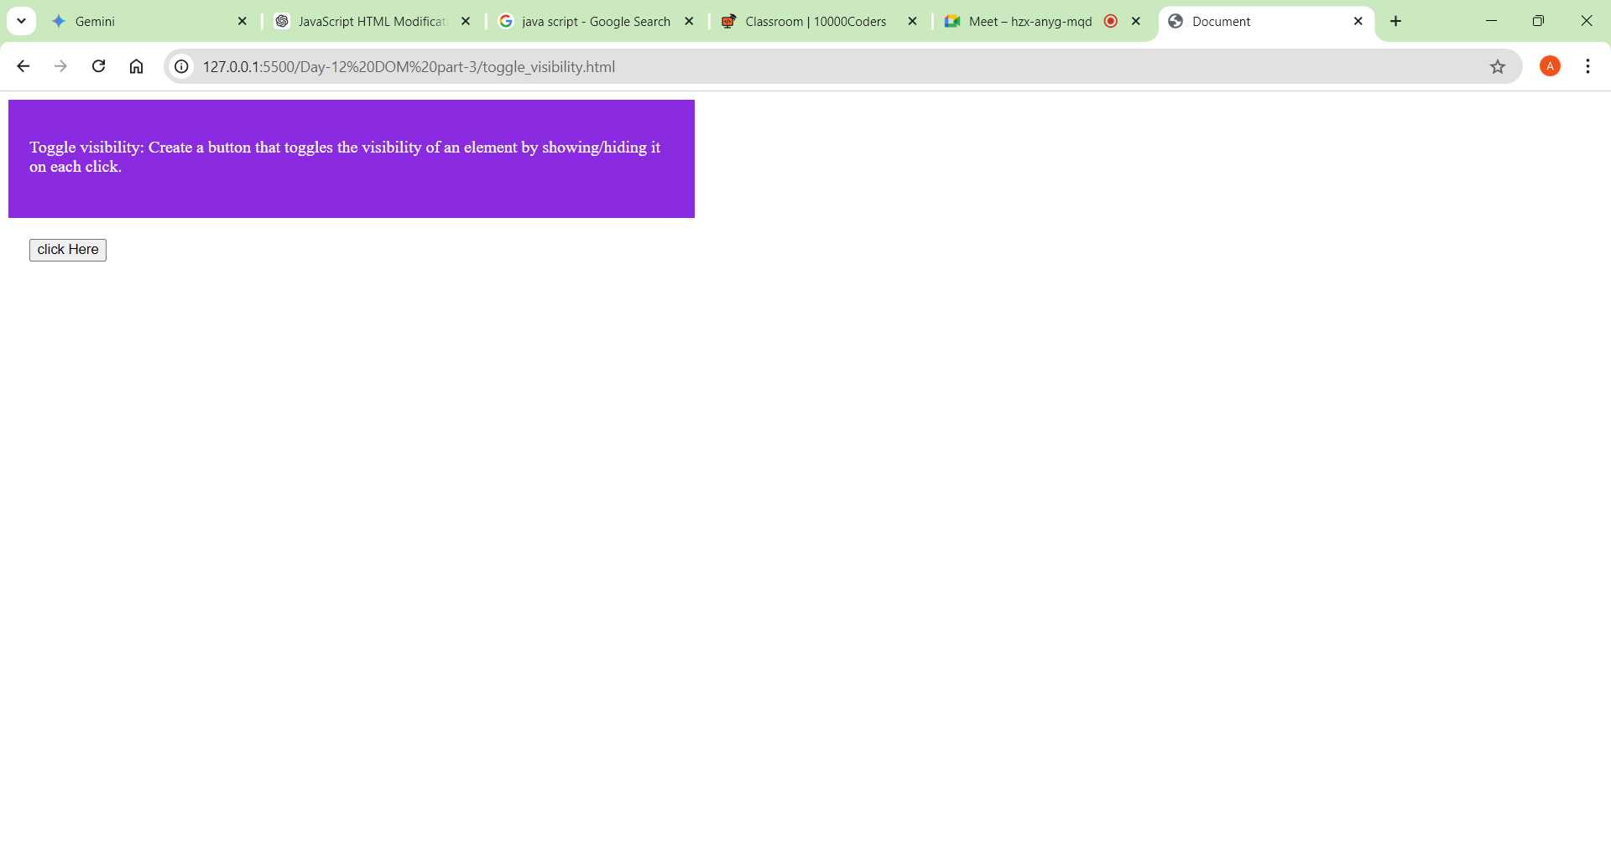

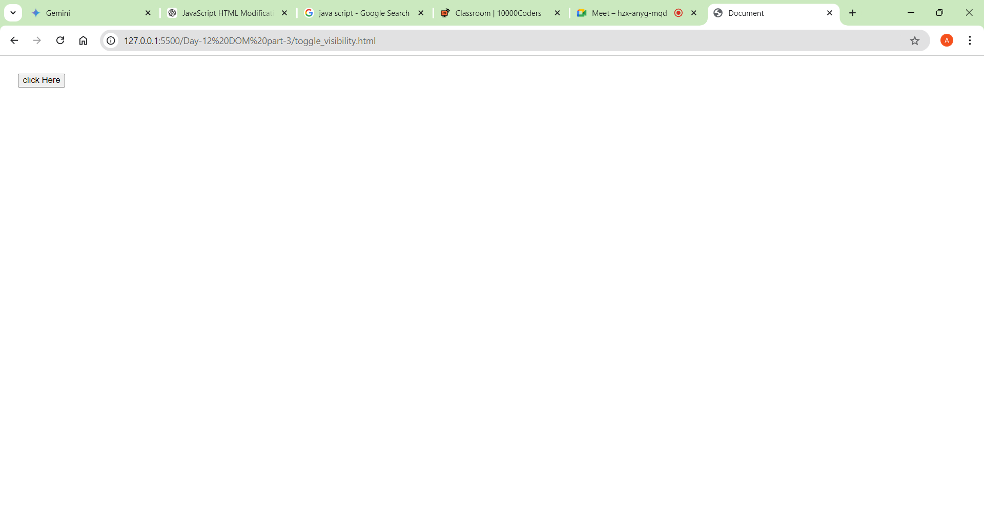

1. Task:5 => by clicking the button display an image

**Code:**

<!DOCTYPE html>

<html lang="en">

<head>

    <meta charset="UTF-8">

    <meta name="viewport" content="width=device-width, initial-scale=1.0">

    <title>Document</title>

    <style>

        .div1{

            background-color:blueviolet;

            color: white;

            padding:20px;

            height:40vh;

            width: 40vw;

        }

        .html{

            background-image: url("https://media.licdn.com/dms/image/D4D12AQEaTK5_cv5Fmg/article-cover_image-shrink_720_1280/0/1677082453584?e=2147483647&v=beta&t=hy4wcIl2vOpp5lr5k74obYVN63IT-U4lydNOIo3hHGo");

            background-repeat: no-repeat;

            background-size: cover;

            color: white;

            padding:20px;

            height:40vh;

            width: 40vw;

        }

        .css{

            background-image: url("https://ksra.eu/wp-content/uploads/2021/05/Vp9WvV7YKdH4k8sKRePcE8-1200-80.jpeg");

            background-repeat: no-repeat;

            background-size: cover;

            color: white;

            padding:20px;

            height:40vh;

            width: 40vw;

        }

        .boot{

            background-image: url("https://www.drupal.org/files/project-images/b5-new-logo.png");

            background-repeat: no-repeat;

            background-size: cover;

            color: white;

            padding:20px;

            height:40vh;

            width: 40vw;

        }

        .js{

            background-image: url("https://cyberhoot.com/wp-content/uploads/2020/07/Free-Courses-to-learn-JavaScript-1024x576.jpg");

            background-repeat: no-repeat;

            background-size: cover;

            color: white;

            padding:20px;

            height:40vh;

            width: 40vw;

        }

        button{

            margin: 20px;

            margin-left:60px;

        }

    </style>

</head>

<body>

    <div id="div1" class="div1">

    </div>

    <button onclick="html()">HTML</button>

    <button onclick="css()">CSS</button>

    <button onclick="boot()">Bootstrap</button>

    <button onclick="js()">Java Script</button>

    <script>

        function html(){

            var div=document.getElementById("div1");

            div.classList.toggle('html');

        }

        function css(){

            var div=document.getElementById("div1");

            div.classList.toggle('css');

        }

        function boot(){

            var div=document.getElementById("div1");

            div.classList.toggle('boot');

        }

        function js(){

            var div=document.getElementById("div1");

            div.classList.toggle('js');

        }

    </script>

</body>

</html>

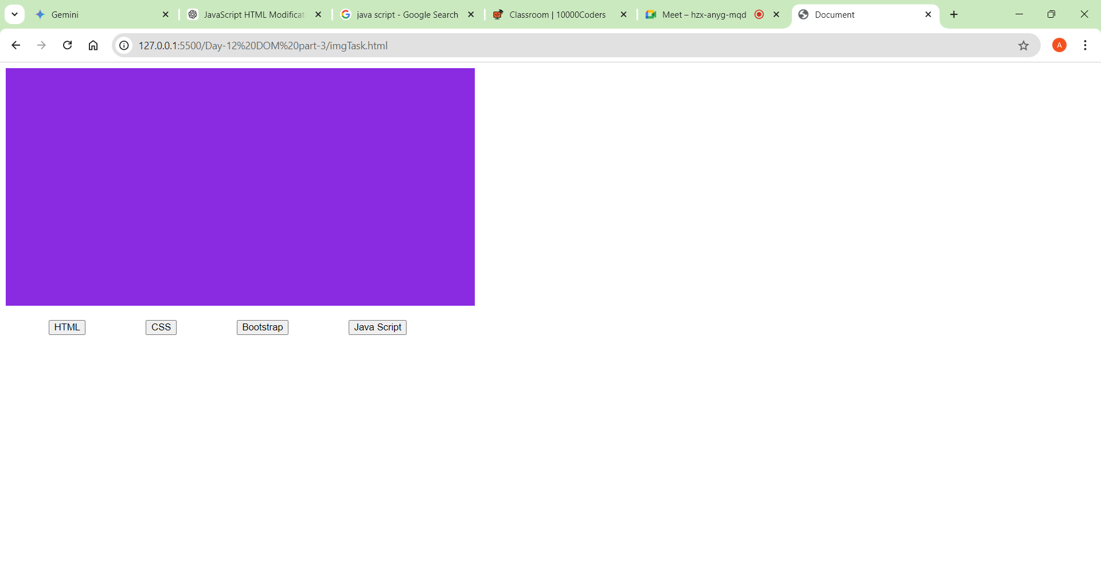

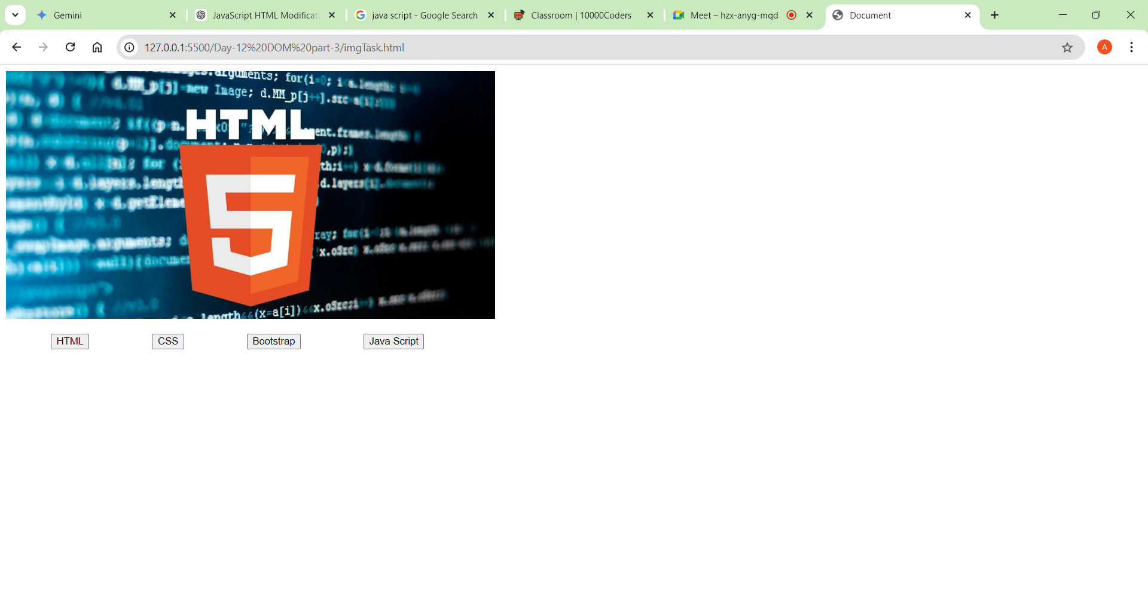 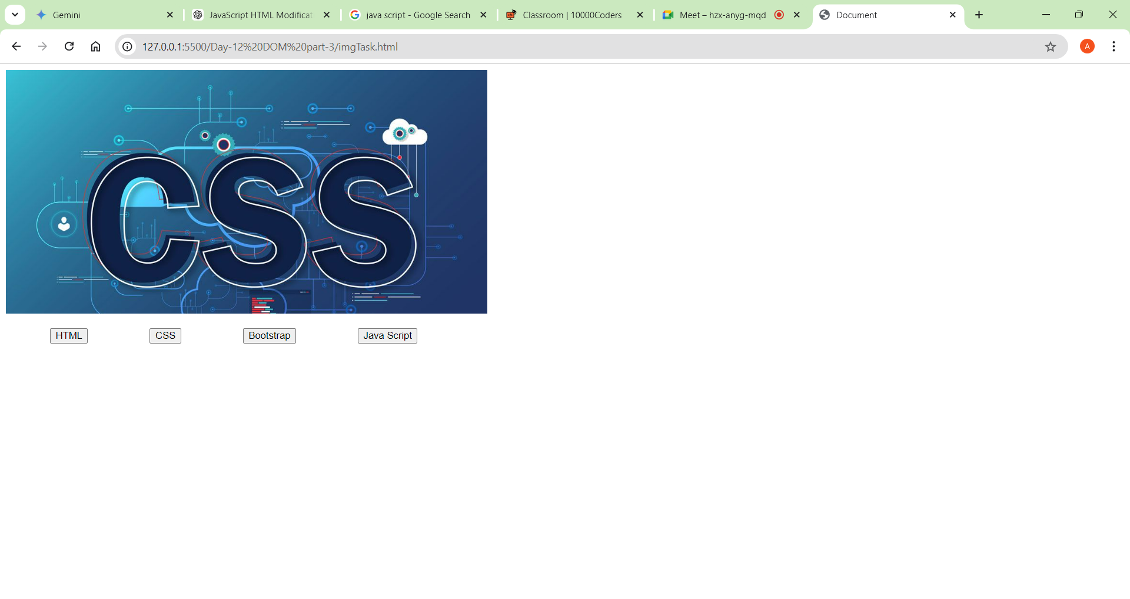

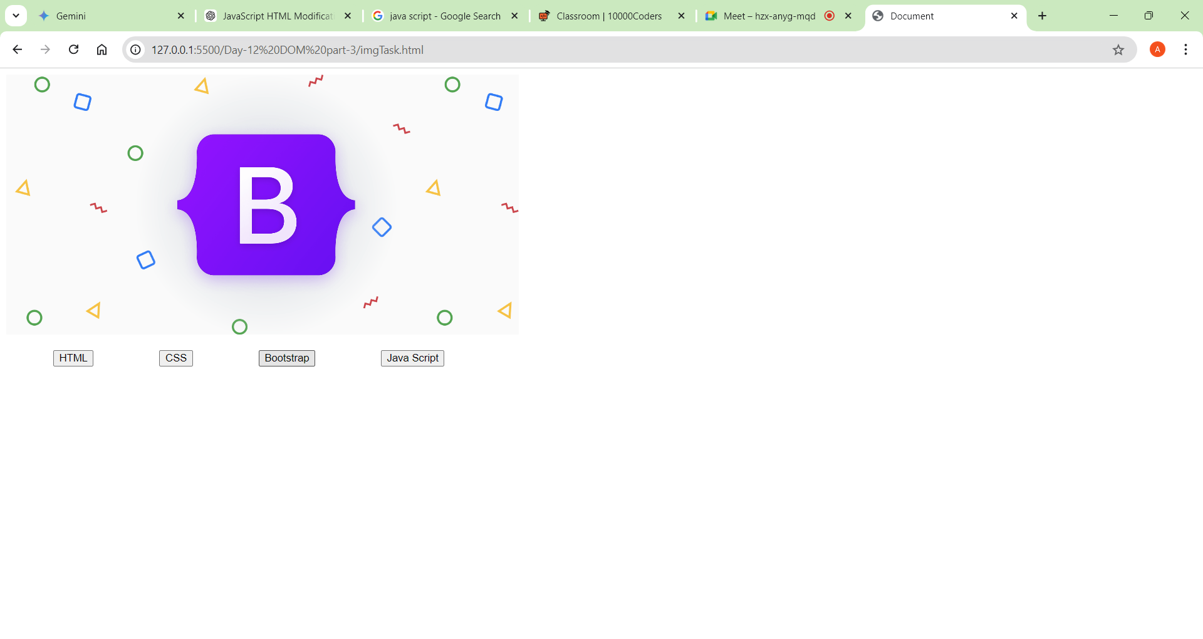 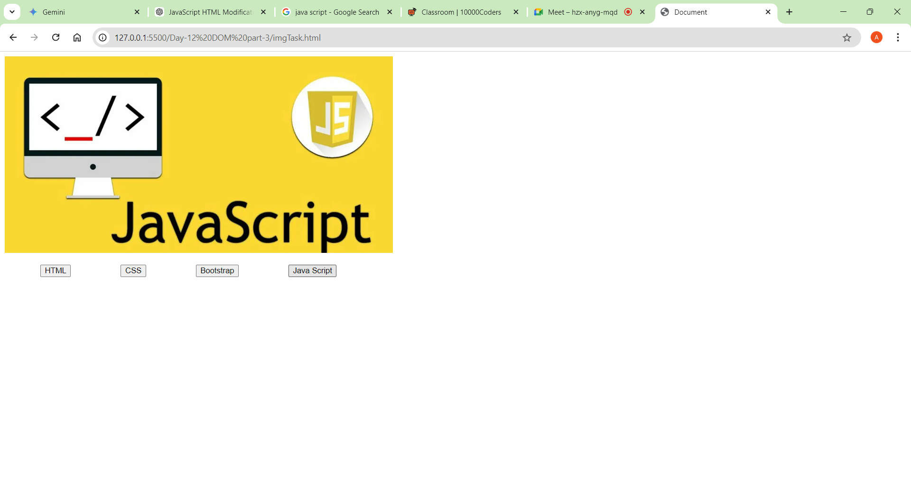

**Topic:  Dom forms** (Form Handling)

**1. Accessing Form Elements:**

    <form id="myForm">

        <input type="text" id="username">

        <input type="email" id="email">

        <button type="submit">Submit</button>

    </form>

    <script>

        const form = document.getElementById('myForm');

        const usernameInput = document.getElementById('username');

        const emailInput = document.getElementById('email');

    </script>

**2. Setting Input Values:**

You can set input values using the value property:

    usernameInput.value = "John Doe";

    emailInput.value = "john@example.com";

**3. Getting Form Data:**

You can get form data when the form is submitted:

    form.addEventListener('submit', function(event) {

    event.preventDefault(); // Prevent form submission

    const formData = new FormData(form);

    // Access form data

    const username = formData.get('username');

    const email = formData.get('email');

    // Do something with the data

   });

**4. Changing Input Field Values**

You can change the value of input fields dynamically based on user actions or other events:

<input type="text" id="myInput">

<button onclick="changeInputValue()">Change Value</button>

<script>

    function changeInputValue() {

        const input = document.getElementById('myInput');

        input.value = 'New Value';

    }

</script>

**5.Accessing through values**

    document.forms[0].addEventListener('submit', function(event){

    event.preventDefault(); // Prevent form submission

    console.log(event);//stores the lot of form info including child tags of form

    console.log(event.target[0].value);//prints the value of first child in the first form

    })

In above program document.forms[0] get the first form,

e.preventdefault prevents the form default submission

console.log(event)  prints a lot of form data and event.target gets the childrens of the form in collection format.

Examples:

<https://github.com/Abhinavsai-12/10kCoders_JavaScript/tree/main/Day-13%20DOM%20part-4/practice>

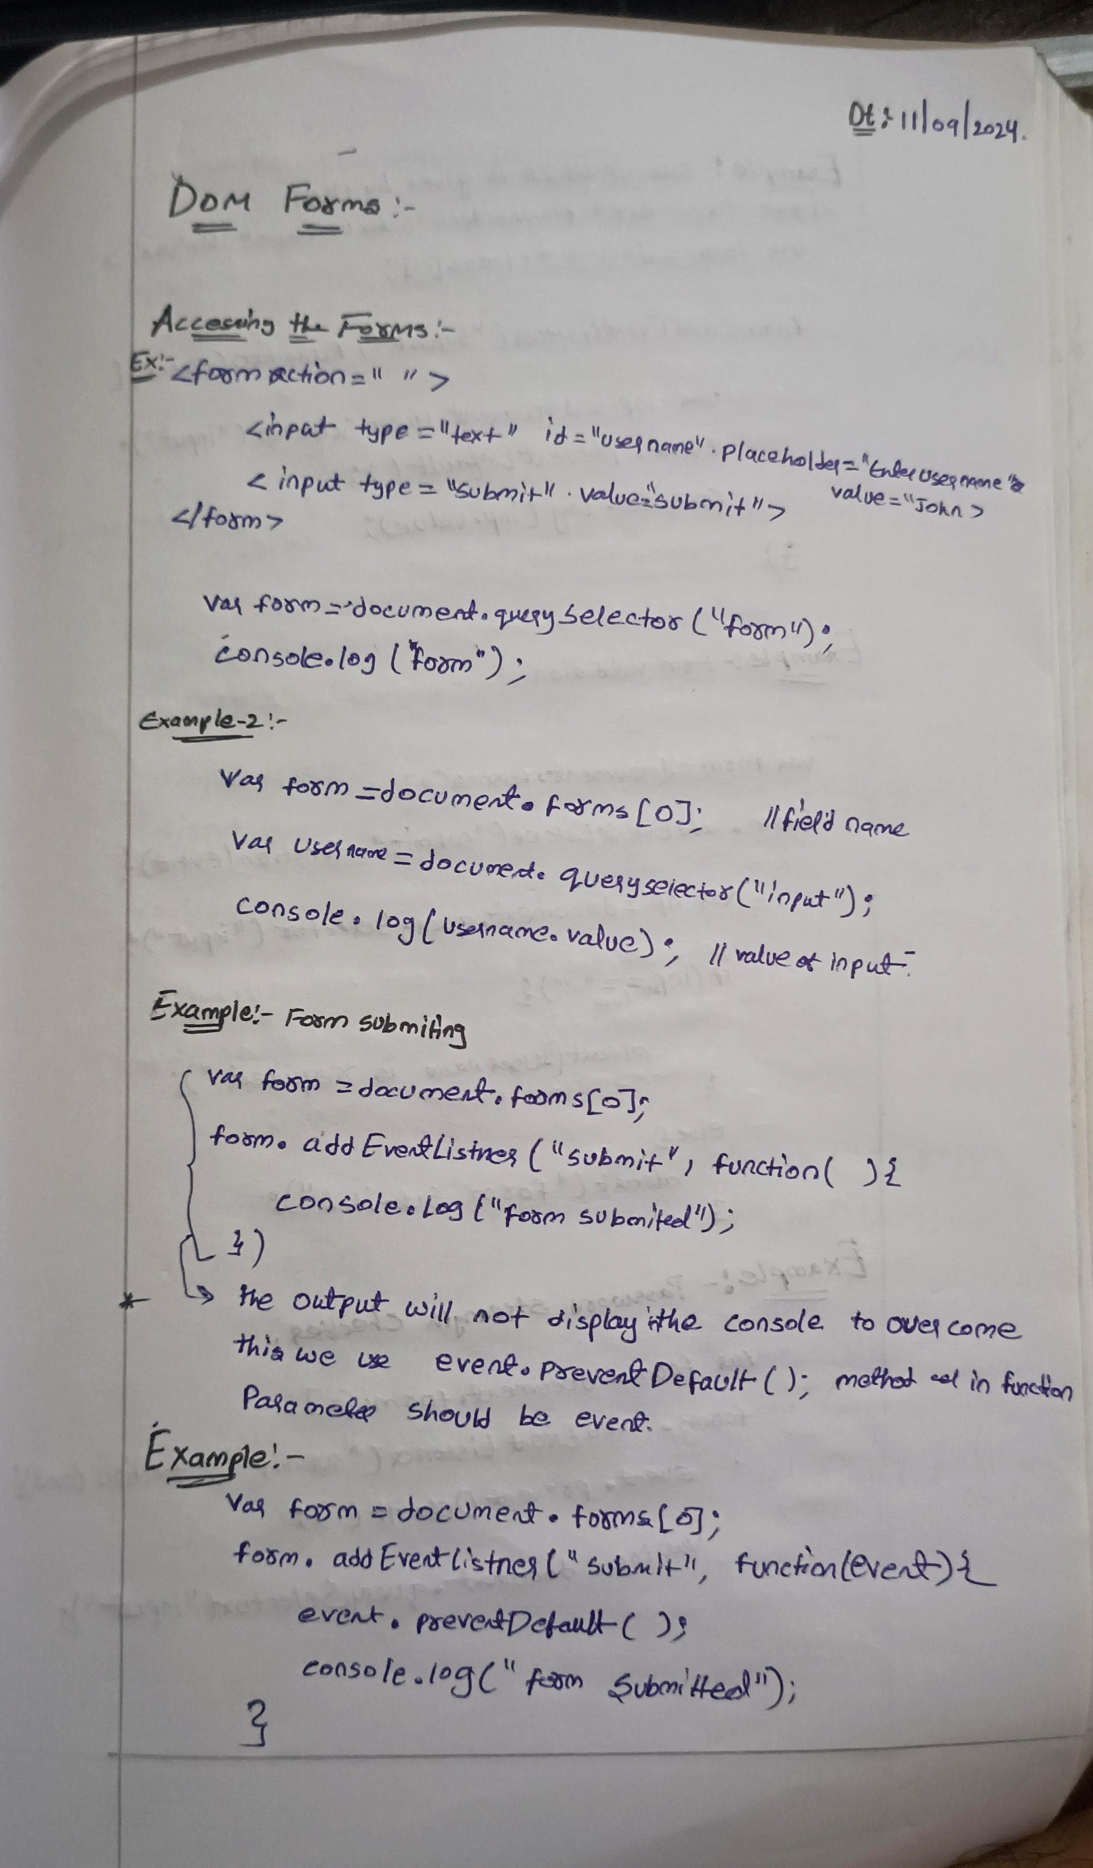

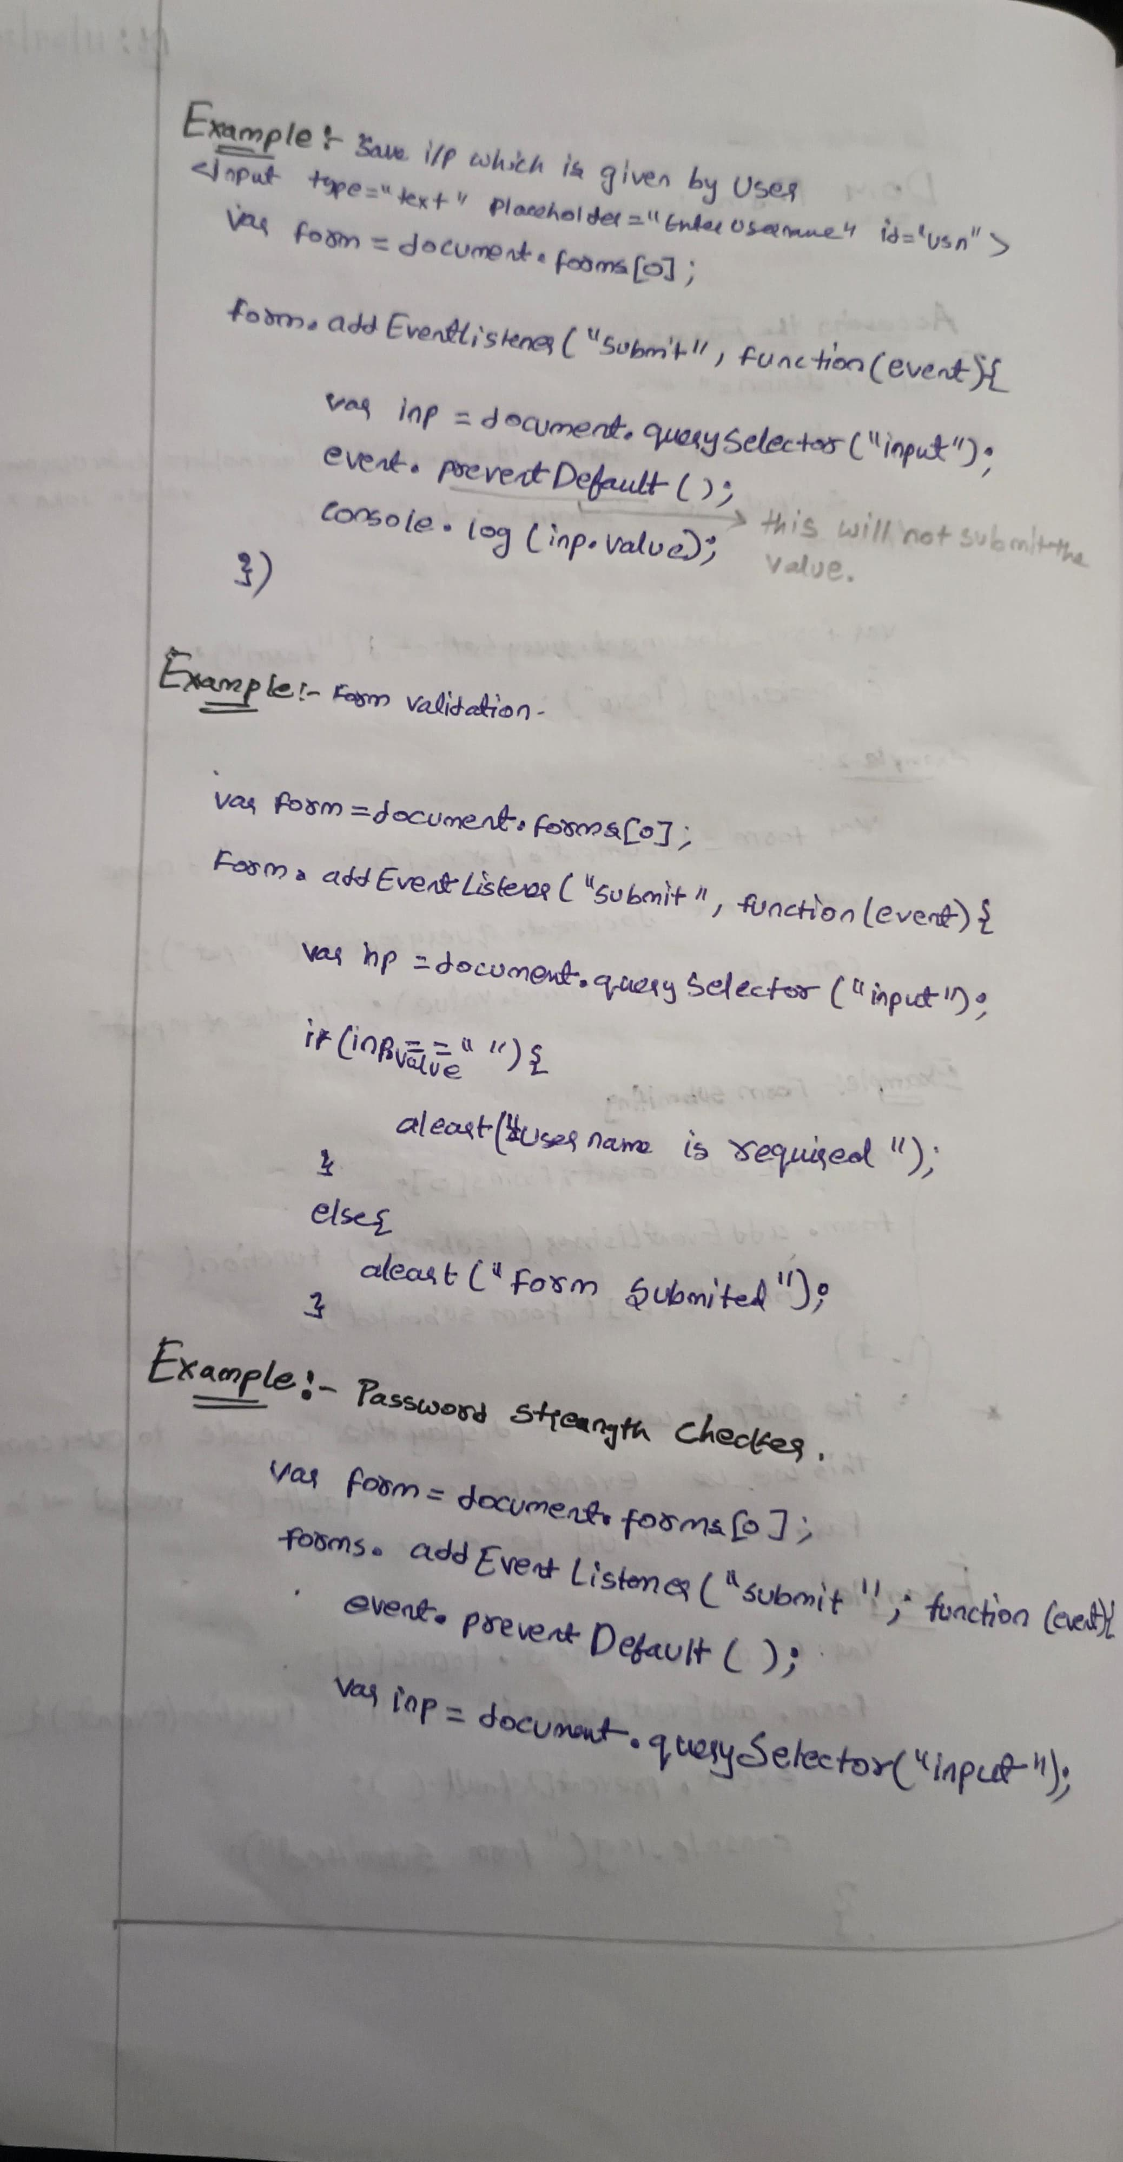

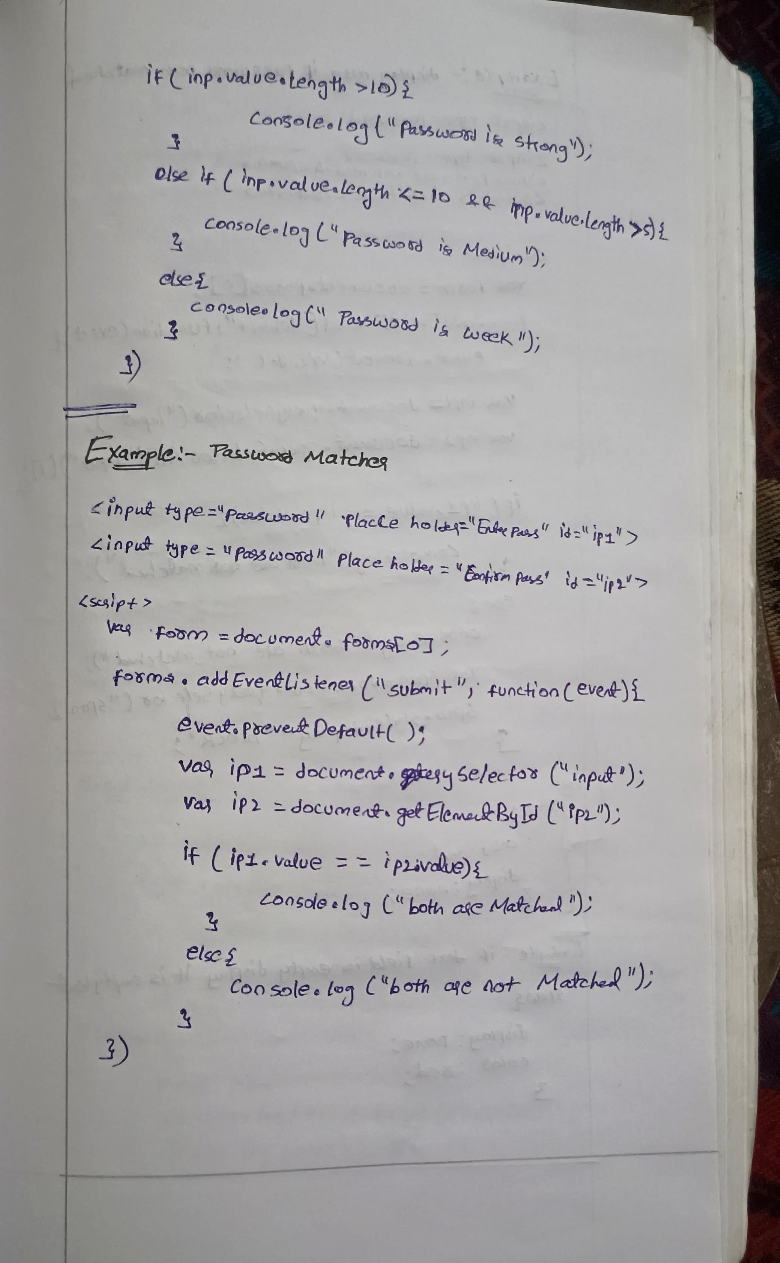

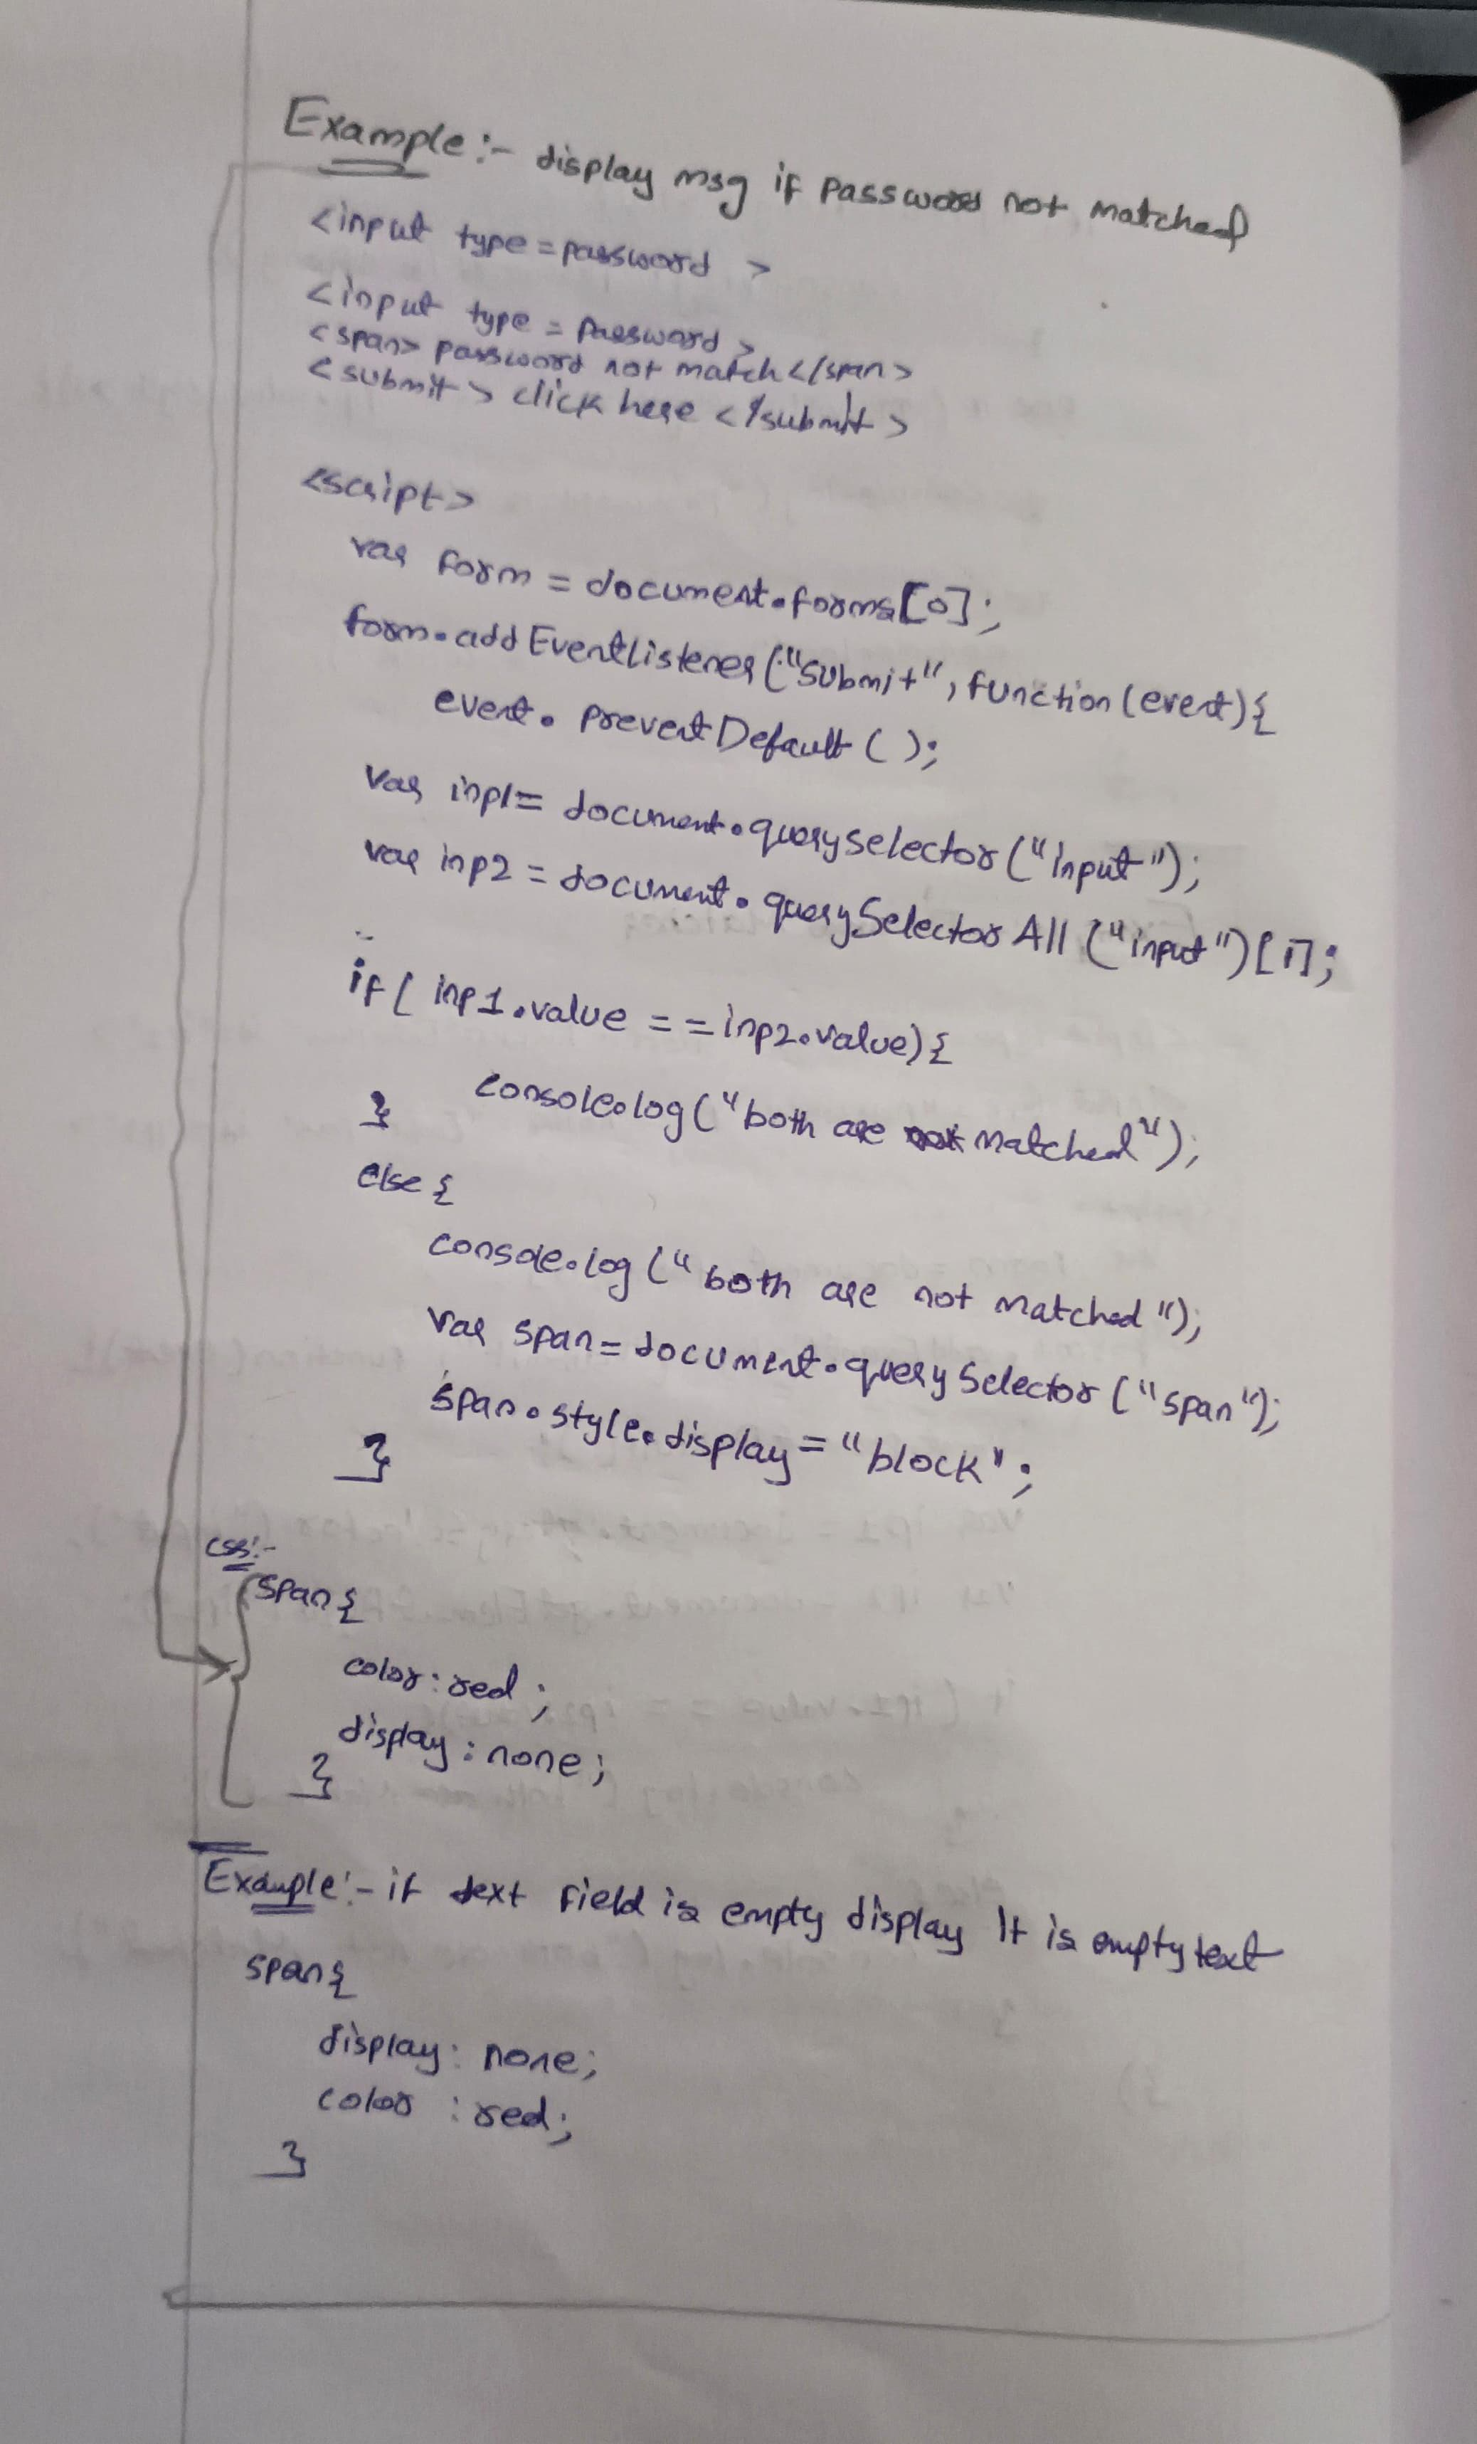

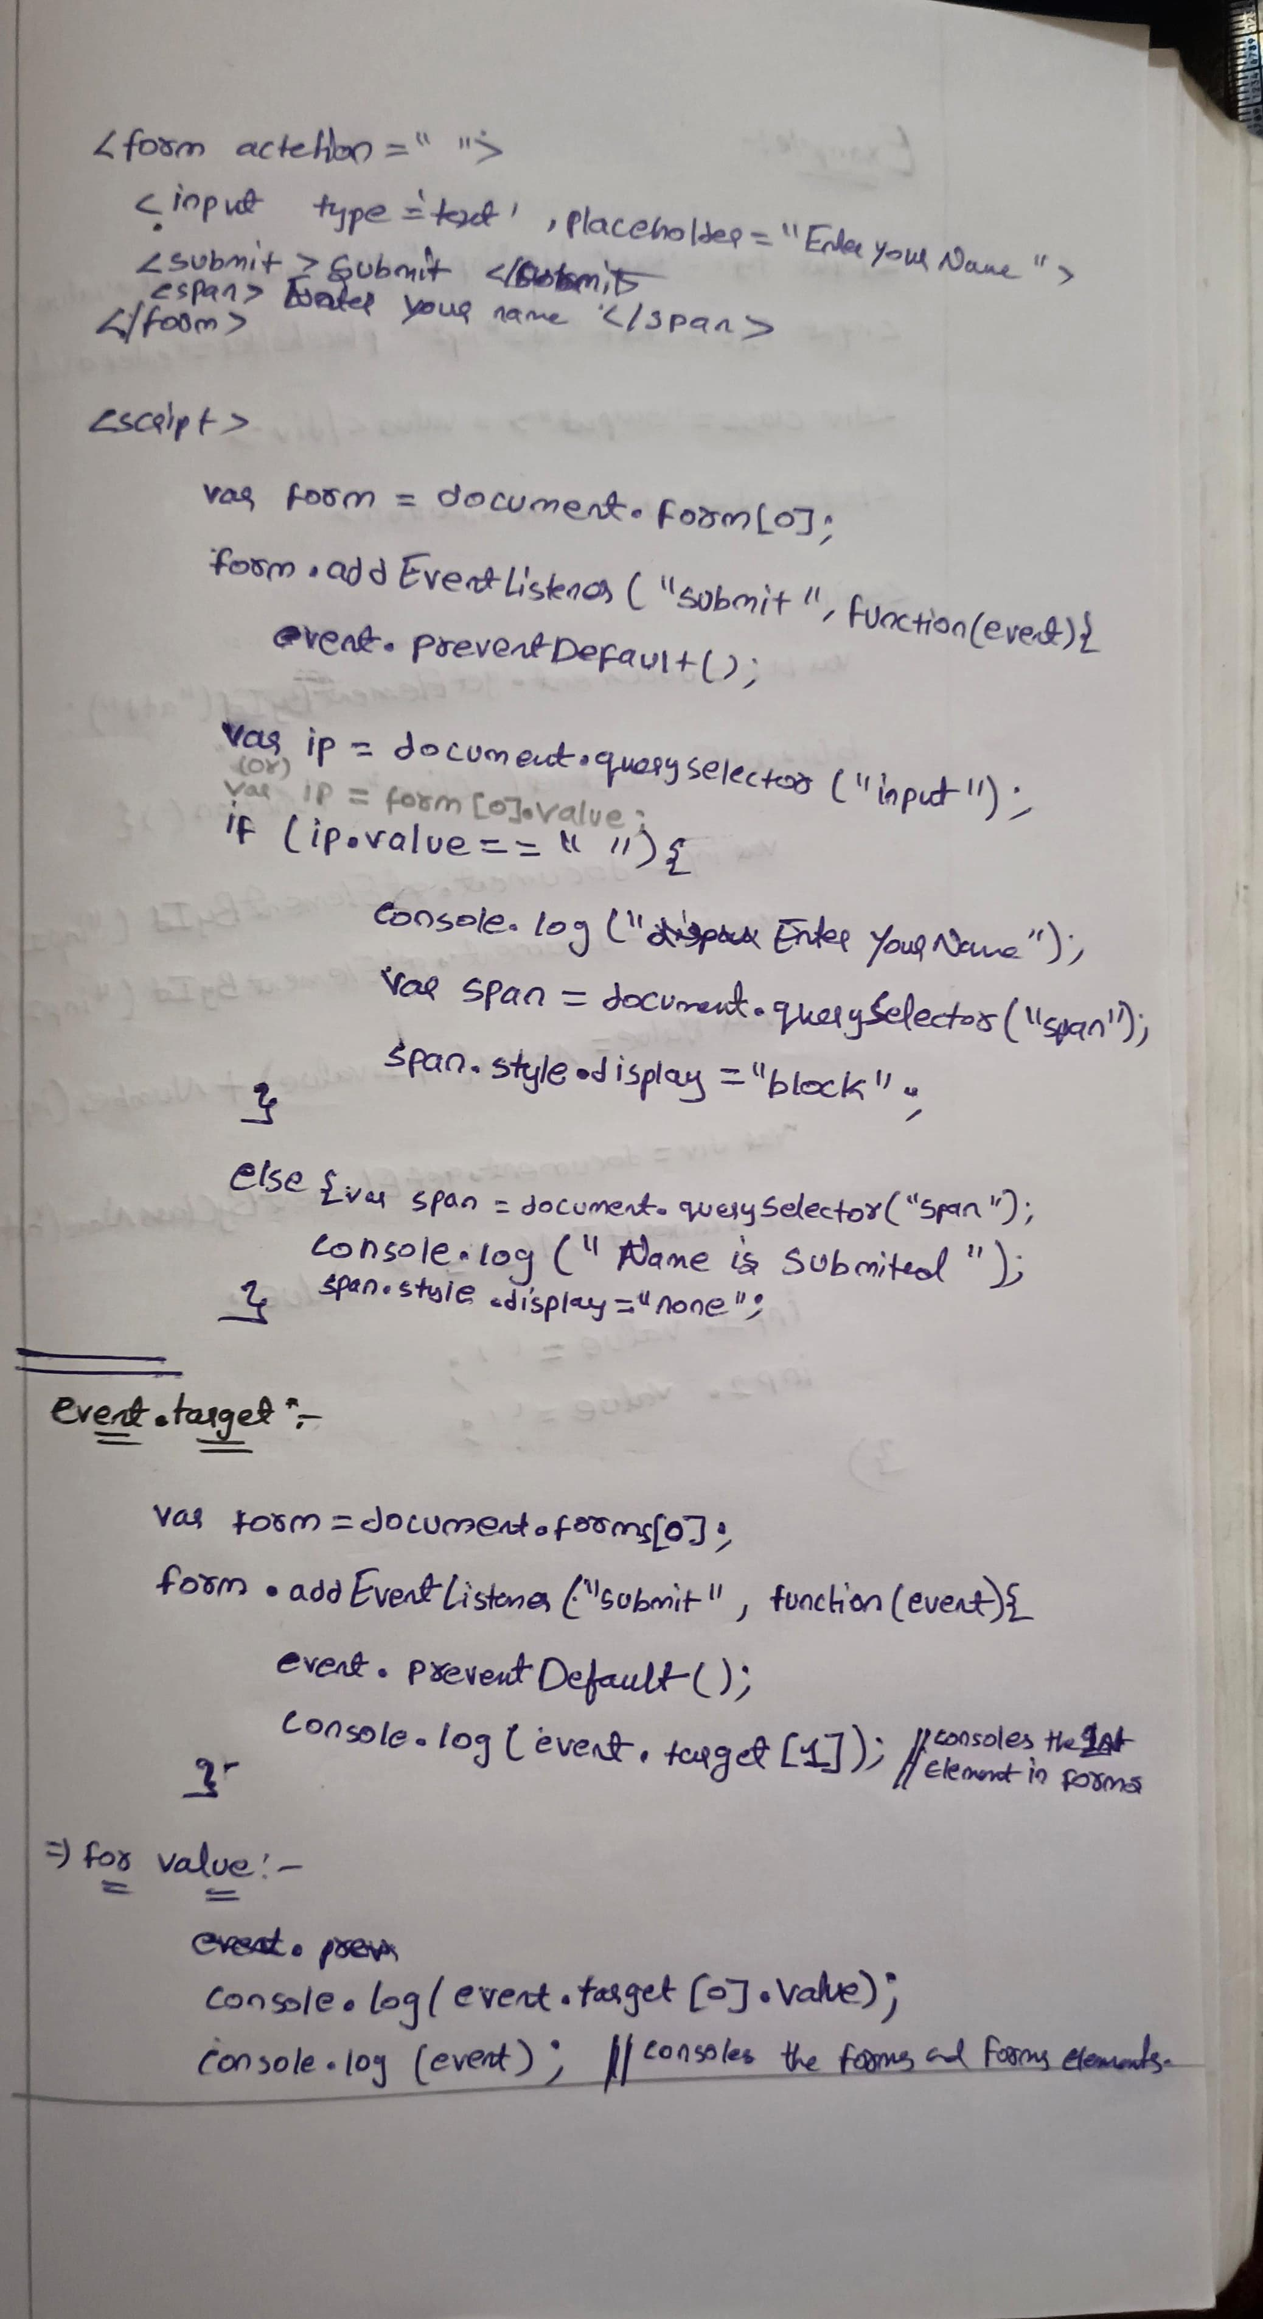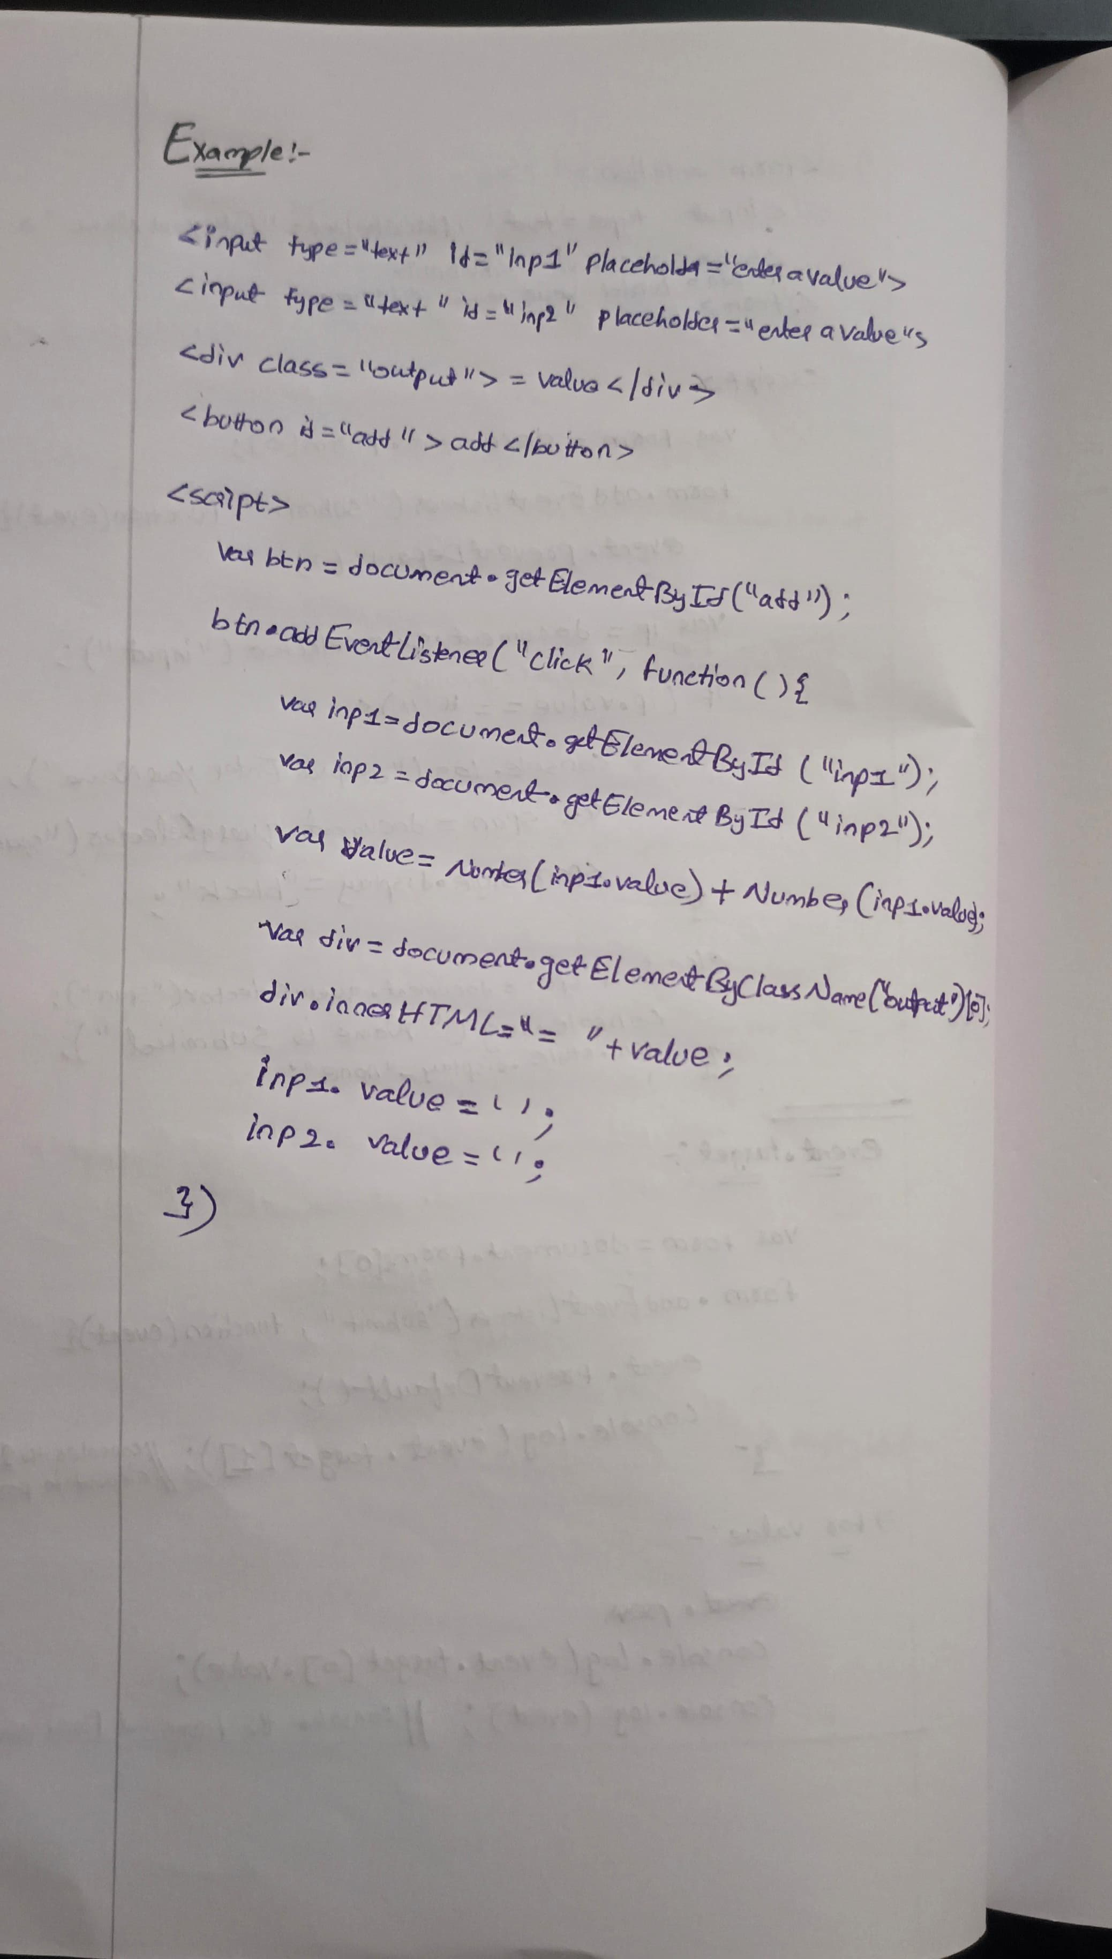

**TASKS:**

1) Password Strength Checker:

 Create an input field where a user types a password, and the script checks if the password is "Strong", "Medium", or "Weak" based on its length.

**Code:**

    <style>

        body{

            font-family: Arial, sans-serif;

            display: flex;

            justify-content: center;

            align-items: center;

            background-color: #c6e9e36f;

        }

        .container {

            background-color: #6cd5c965;

            padding: 20px;

            border-radius: 12px;

            box-shadow: 0 0 10px rgba(0, 0, 0, 0.1);

            width: 20%;

        }

        #fm{

            display: flex;

            flex-direction: column;

            justify-items:center;

            align-items: center;

        }

        input{

            width: 70%;

            padding: 5px;

            margin: 10px;

            border-radius:5px;

        }

        #sub{

            width: 20%;

            padding: 5px;

            margin: 10px;

            border-radius:10px;

        }

        span{

            font-size: 12px;

            font-weight:bold;

            display: none;

        }

        </style>

</head>

<body>

    <div class="container">

        <form action="" id="fm">

            <h3>Password Strength Checker</h3>

            <input type="password" id="pass" placeholder="Enter password">

            <span></span>

            <input type="submit" id="sub" value="submit">

        </form>

    </div>

    <script>

        var form=document.forms[0];

        form.addEventListener("submit",function(event){

            event.preventDefault();

            var inp=document.getElementById("pass");

            var span=document.querySelector("span");

            var span=document.getElementsByTagName("span")[0];

            if(inp.value.length>10){

                span.innerHTML="password is strong";

                span.style.display="block";

                span.style.color="green";

            }

            else if(inp.value.length<=10 && inp.value.length>5){

                span.innerHTML="password is medium";

                span.style.display="block";

                span.style.color="orange";

            }

            else{

                span.innerHTML="password is week";

                span.style.display="block";

                span.style.color="red";

            }

        })

    </script>

**Output**

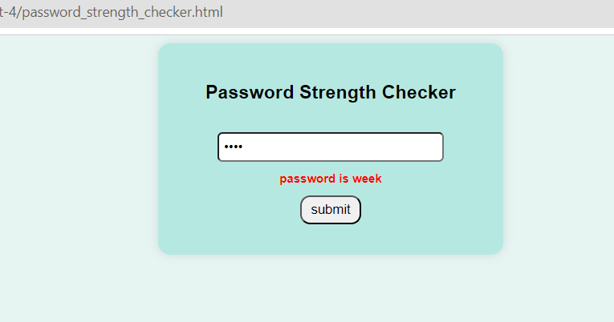 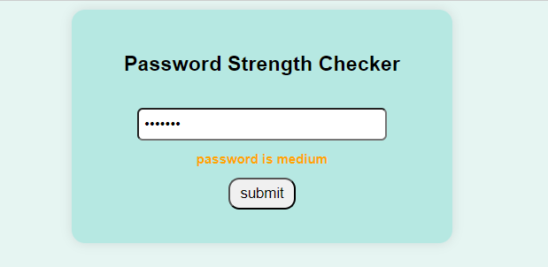

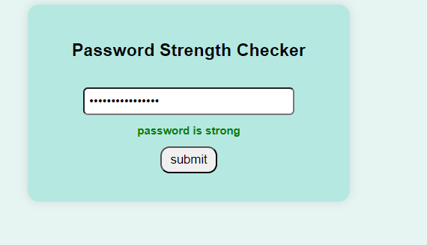

2) **password matcher**

**Code:**

<style>

        body{

            font-family: Arial, sans-serif;

            display: flex;

            justify-content: center;

            align-items: center;

            background-color: #e3f1dd6f;

        }

        .container {

            background-color: #83d56c65;

            padding: 20px;

            border-radius: 12px;

            box-shadow: 0 0 10px rgba(0, 0, 0, 0.1);

            width: 20%;

        }

        #fm{

            display: flex;

            flex-direction: column;

            justify-items:center;

            align-items: center;

        }

        input{

            width: 70%;

            padding: 5px;

            margin: 10px;

            border-radius:5px;

        }

        #sub{

            width: 20%;

            padding: 5px;

            margin: 10px;

            border-radius:10px;

        }

        span{

            color: red;

            font-weight:900;

            display: none;

        }

        </style>

</head>

<body>

    <div class="container">

        <form action="" id="fm">

            <h3>Password Matcher</h3>

            <input type="password" id="pass1" placeholder="Enter password">

            <input type="password" id="pass2" placeholder="Confirm password">

            <span>password not matched</span>

            <input type="submit" id="sub" value="submit">

        </form>

    </div>

    <script>

        var form=document.forms[0];

        form.addEventListener("submit",function(event){

            event.preventDefault();

            var pass1=document.getElementById("pass1");

            var pass2=document.getElementById("pass2");

            if(pass1.value==pass2.value){

                console.log("password is matched");

            }

            else{

                var span=document.getElementsByTagName("span")[0];

                span.style.display="block";

                console.log("password not matched");

            }

        })

    </script>

</body>

**Output**

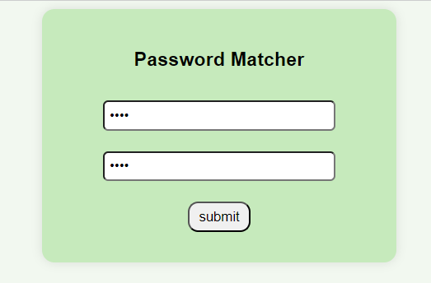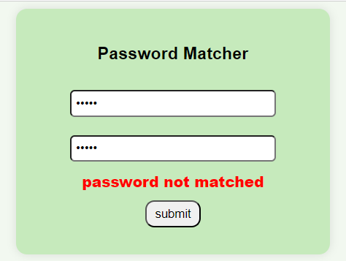

3) **simple calculator**

    <link rel="stylesheet" href="https://cdnjs.cloudflare.com/ajax/libs/font-awesome/6.0.0-beta3/css/all.min.css">

    <style>

        h1{

            text-align: center;

        }

        .container{

            width: 27%;

            height: 500px;

            margin: auto;

            border: 2px solid black;

            display: grid;

            grid-template-columns: auto auto auto auto;

            grid-template-rows: 70px;

            gap: 10px;

            padding: 10px;

            background-color: rgba(144, 215, 238, 0.571);

        }

        #result{

            grid-column: 1/4;

            height: 55px;

            text-align: right;

            padding-top: 10px;

            font-size: 24px;

            font-weight: 800;

            resize: none;

            scrollbar-width: none;

            background-color: rgb(180, 245, 248);

        }

        .button{

            font-size: 24px;

            font-weight: 500;

            background-color:rgba(4, 214, 251, 0.951) ;

        }

        .op{

            background-color: rgb(92, 131, 240);

        }

        .history{

            grid-column: 1/3;

            background-color: rgba(255, 0, 0, 0.682);

        }

        .clear{

            grid-column: 3/5;

            background-color: rgba(255, 0, 0, 0.682);

        }

    </style>

</head>

<body>

    <h1>Calculator</h1>

    <div class="container">

        <textarea id="result"></textarea>

        <button onclick="back()" class="button backspace" ><i class="fa-solid fa-delete-left"></i></button>

        <input type="button" onclick="dis('7')" value="7" class="button">

        <input type="button" onclick="dis('8')" value="8" class="button">

        <input type="button" onclick="dis('9')" value="9" class="button">

        <input type="button" onclick="dis('/')" value="/" class="button op">

        <input type="button" onclick="dis('4')" value="4" class="button">

        <input type="button" onclick="dis('5')" value="5" class="button">

        <input type="button" onclick="dis('6')" value="6" class="button">

        <input type="button" onclick="dis('*')" value="*" class="button op">

        <input type="button" onclick="dis('1')" value="1" class="button">

        <input type="button" onclick="dis('2')" value="2" class="button">

        <input type="button" onclick="dis('3')" value="3" class="button">

        <input type="button" onclick="dis('+')" value="+" class="button op">

        <input type="button" onclick="dis('.')" value="." class="button op">

        <input type="button" onclick="dis('0')" value="0" class="button">

        <input type="button" onclick="solve('')" value="=" class="button op">

        <input type="button" onclick="dis('-')" value="-" class="button op">

        <input type="button" onclick="hist()" value="History" class="button history">

        <input type="button" onclick="clr()" value="Clear" class="button clear">

    </div>

    <script>

        var his="";

        function dis(a){

            document.getElementById("result").value +=a;

            return a;

        }

        function back(){

            let x=document.getElementById("result").value;

            let y='';

            for(i=0;i<x.length-1;i++){

                y+=x[i];

            }

            document.getElementById("result").value=y;

        }

        function clr(){

            document.getElementById("result").value="";

        }

        function solve(){

            let x=document.getElementById("result").value;

            his +="->"+x+"\n";

            let y=eval(x);

            his +="="+y+"\n";

            document.getElementById("result").value=y;

            return y;

        }

        function hist(){

            document.getElementById("result").value=his;

        }

    </script>

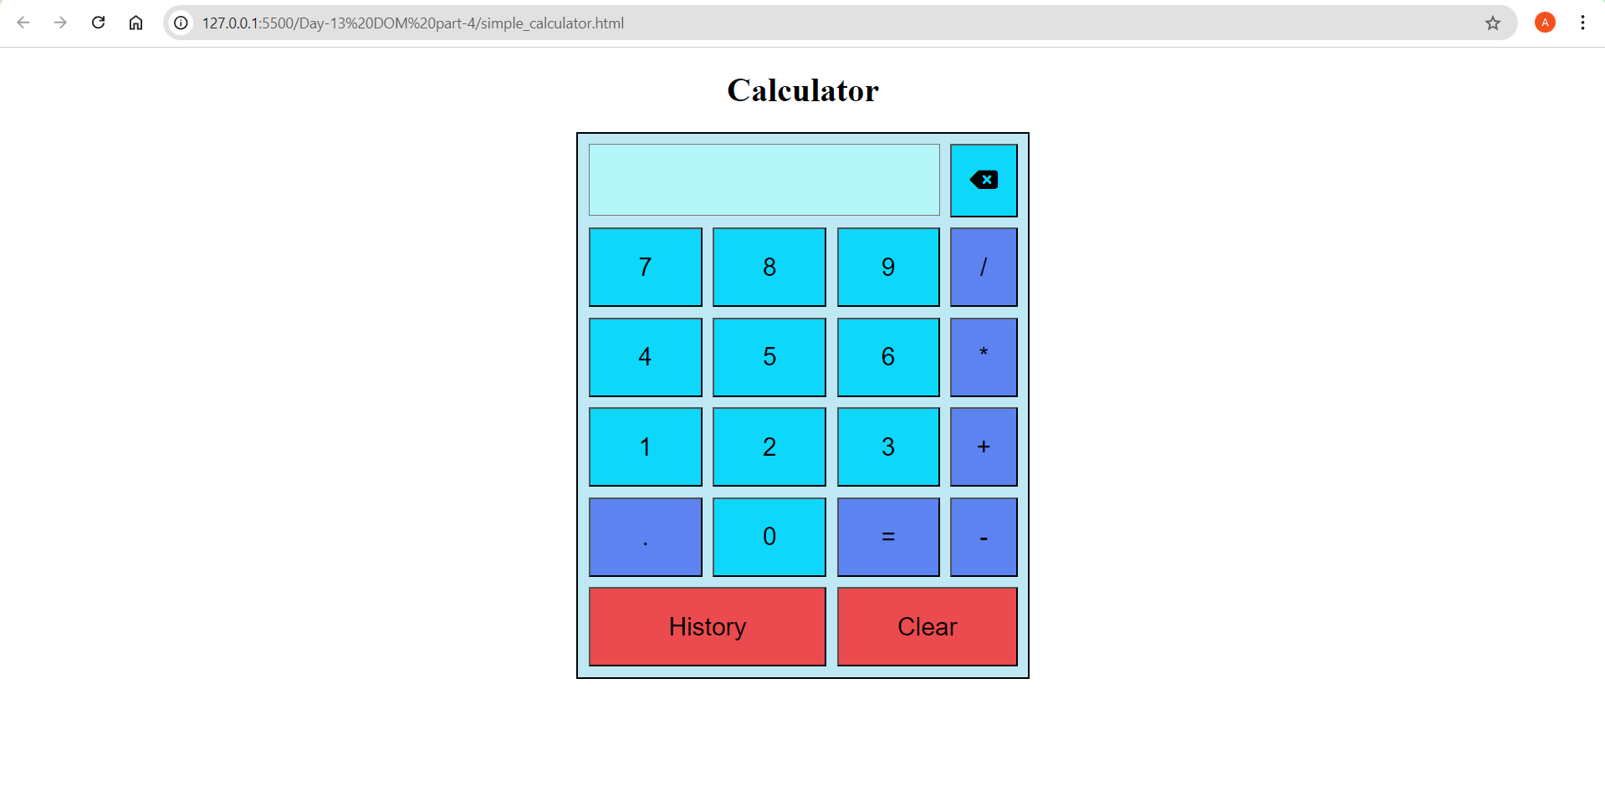

**Topic:  String methods**

**Strings**

collection of words or characters enclosed in a single or double quotes

Strings are immutable and can't be changed directly. We can get the values of string but we cant change.

     //iterate the string using for loop

      var a ="hello";

      for(i=0;i<5;i++){

        console.log(a[i]);

      }

**String.length**

It is a method used to find the length of a string

The .length property returns the number of characters in the string, including spaces, punctuation marks, and special characters.

let str = "Hello, world!";

console.log(str.length); // This will output 13

**charAt()**

The charAt() method is used to return the character at a specified index (position) within a string.

let str = "Hello";

console.log(str.charAt(0)); // Output: "H"

console.log(str.charAt(1)); // Output: "e"

console.log(str.charAt(4)); // Output: "o"

**at()**

The at() method allows you to directly access a character at a specific position within a string, similar to charAt() but also takes negative values.

let str = "Hello";

console.log(str.at(0)); // Output: "H"

console.log(str.at(1)); // Output: "e"

console.log(str.at(-1)); // Output: "o"

**charCodeAt()**

the charCodeAt() method returns the Unicode value (integer between 0 and 65535) of the character at a specified index in a string.

let str = "Hello";

console.log(str.charCodeAt(0)); // Output: 72

console.log(str.charCodeAt(1)); // Output: 101

console.log(str.charCodeAt(4)); // Output: 111

**slice(start,end)**

The slice() method is used to extract a section of a string and return it as a new string. It doesn't modify the original string. This method takes two parameters: the start index and the end index (optional).

let str = "Hello, world!";

console.log(str.slice(0, 5));    // Output: "Hello"

console.log(str.slice(7));     // Output: "world!"

console.log(str.slice(-6));    // Output: "world!"

console.log(str.slice(7, -1)); // Output: "world"

console.log(str.slice(0)); // Output: "Hello, world!"

console.log(str.slice(-1)); // Output: "!"

**substring(start, end)**

The substring() method is used to extract a portion of a string and return it as a new string. It is similar to the slice() method, but there are differences in how negative indices are handled because negative values are considered as zero

let str = "Hello, world!";

console.log(str.substring(0, 5)); // Output: "Hello"

console.log(str.substring(7)); // Output: "world!"

console.log(str.substring(7, 12)); // Output: "world"

console.log(str.substring(-6)); // Output: "Hello, world!"

console.log(str.substring(7, -1)); // Output: "Hello, world"

**substr()**

In JavaScript, the substr() method is used to extract a portion of a string, starting from a specified index and extending for a specified length of characters. This method is different from substring() in that the second parameter specifies the length of the extracted substring rather than the end index.

let str = "Hello, world!";

console.log(str.substr(0, 5)); // Output: "Hello"

console.log(str.substr(7)); // Output: "world!"

console.log(str.substr(7, 5)); // Output: "world"

console.log(str.substr(-6)); // Output: "world!"

console.log(str.substr(7, -1)); // Output: ""

**toUpperCase()**

The toUpperCase() method is used to convert all characters in a string to uppercase letters.

let str = "Hello, world!";

let a= str.toUpperCase();

console.log(a); // Output: "HELLO, WORLD!"

**toLowerCase()**

The toLowerCase() method is used to convert all characters in a string to lowercase letters.

let str = "Hello, WORLD!";

let a = str.toLowerCase();

console.log(a); // Output: "hello, world!"

**concat()**

The concat() method is used to concatenate two or more strings.

let str1 = "Hello";

let str2 = "world";

let str3 = "!";

let result = str1.concat(", ", str2, str3);

console.log(result); // Output: "Hello, world!"

**trim()**

The trim() method is used to remove whitespace from both ends of a string.

let str = "   Hello, world!   ";

let trimmedStr = str.trim();

console.log(trimmedStr); // Output: "Hello, world!"

**repeat()**

The repeat() method is used to construct and return a new string by concatenating the string on which it is called a certain number of times.

let str = "Hello";

let repeatedStr = str.repeat(3);

console.log(repeatedStr); // Output: "HelloHelloHello"

**Split()**

The split() method is used to split a string into an array.

let str = "Hello, world!";

let parts = str.split(", ");

console.log(parts); // Output: ["Hello", "world!"]

let characters = str.split("");

console.log(characters); // Output: ["H", "e", "l", "l", "o", ",", " ", "w", "o", "r", "l", "d", "!"]

**replace()**

replace() method used to replace the current occurrences of substring within a string with another string

syntax: string.replace(searchValue, replaceValue)

    let originalString = "Hello, world!,world";

    let newString = originalString.replace("world", "universe");

    console.log(newString); // Output: Hello, universe!,world

Above program replaces only the first match to replace all matches use a regular expression with /g flagset

let newString = originalString.replace(/world/g, "red fox");

    let originalString = "Hello, world!,world";

    let newString = originalString.replace(/world/g, "universe");

    console.log(newString); // Output: Hello, universe!,universe

Replace method is case sensitive writing World will not consider

To replace case insensitive, use a regular expression with an /i

    let originalString = "Hello, world!, World";

    let newString = originalString.replace(/world/ig, "universe");

    console.log(newString); // Output: Hello, universe!,universe

**replaceAll()**

it is a method to replace a substring with another sting but it doesn’t compatible in all browsers

**string search methods**

**indexOf() and lastIndexOf**

    let str= "Hellow, world!";

    let newString = str.indexOf("w")//output 5 because it checks from the starting

    let newString1= str.lastIndexOf("w")//output 8 because it checks from the ending

Both indexOf(), and lastIndexOf() return -1 if the text is not found

    let newString1= str.lastIndexOf("w",5)//output 8 because it checks from the ending

if the second parameter is 5, the search starts at position 5, and searches

**search()**

the search() method is used to search for a specified substring within a string. It returns the index of the first occurrence of the specified substring, or -1 if the substring is not found. It can take regular expressions also

let str = "Hello, world!";

let index = str.search("world");

console.log(index); // Output: 7

two methods, indexOf() and search(), are not equal because

search() method cannot take a second start position argument.

**match()**

The match() method in JavaScript is used to search a string for a specified pattern (regular expression), and returns an array containing the matches, or null if no matches are found.

It can take regular expression and it can print the values in an array

    let text = "The rain in SPAIN stays mainly in the plain";

    text.match(/ain/gi);    //4 [ain,AIN,ain,ain]

**includes()**

the includes() method returns true if a string contains a specified value.

let text = "Hello world, welcome to the universe.";

text.includes("world");//true

**Template literals**

Template literals allow you to embed expressions and variables directly within the string using ${}. This makes string interpolation more intuitive and readable.

    let a = 5;

    let b = 10;

    let result = `The sum of ${a} and ${b} is ${a + b}.`;

    // result is "The sum of 5 and 10 is 15.

**TASKS: Basic level**

**Task 1: take prompt and Convert to Uppercase**

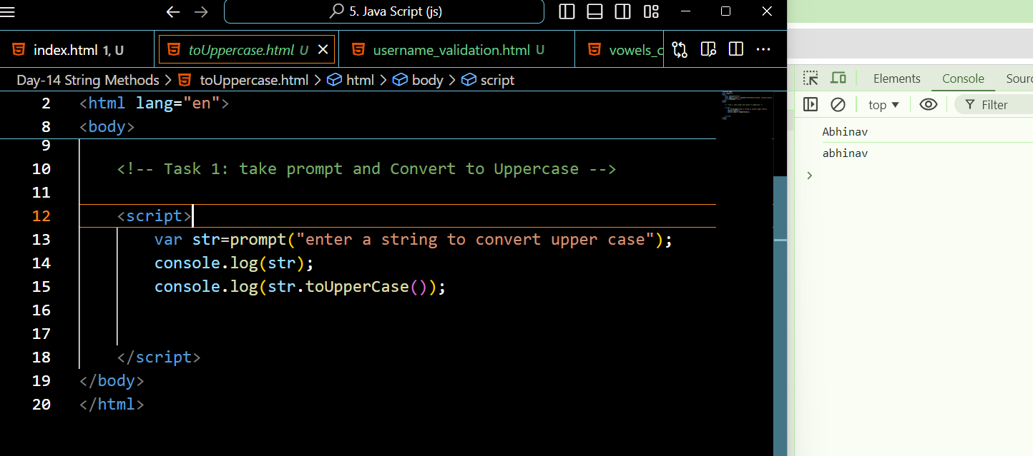

**Task 2: take prompt and Convert to Lowercase**

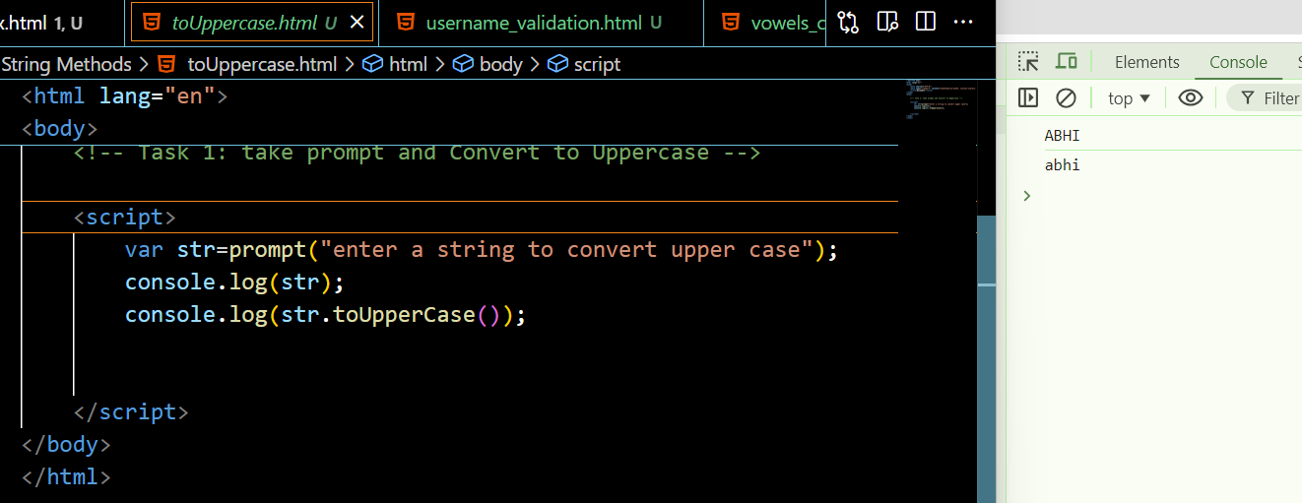

**Task 3: take prompt and Reverse a String**

**hints: use split and reverse and join method**

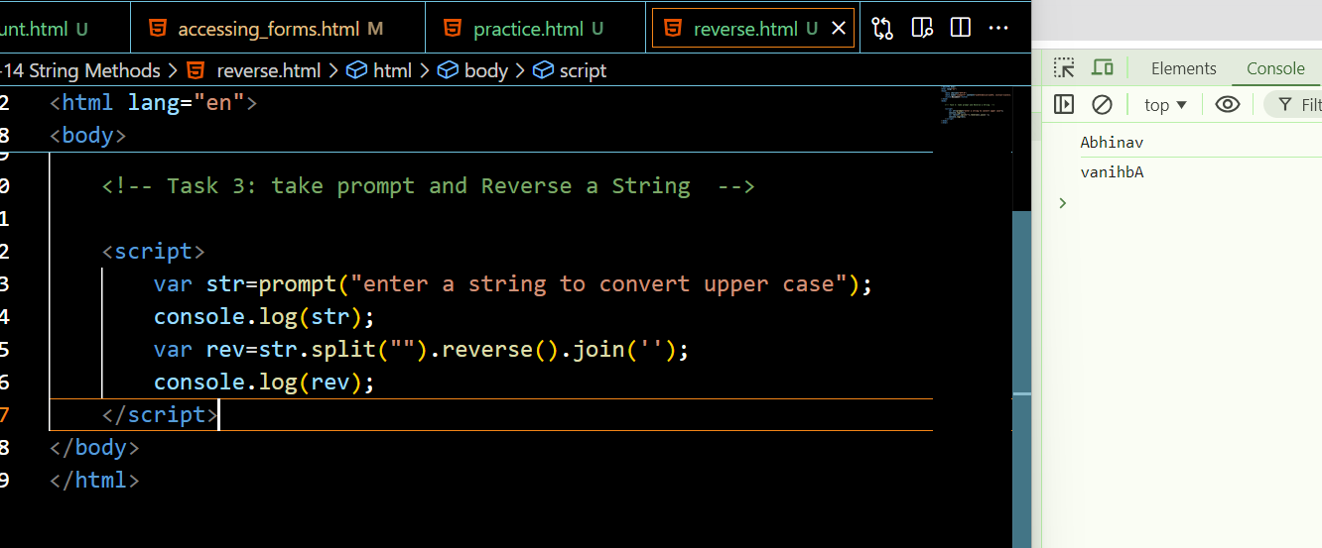

**Task 4: take prompt and Count the number of vowels in a string--**

**hints use match method**

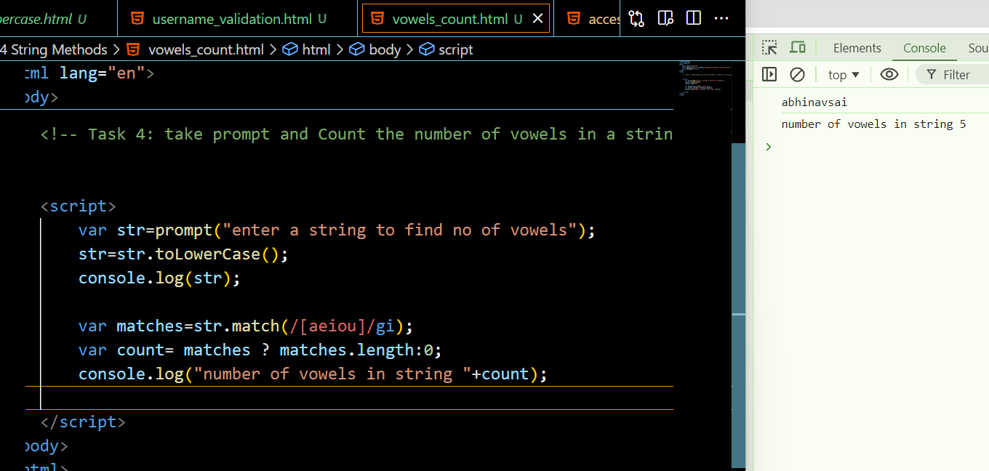

**Advanced**

**Task 1: Username Validation**

Scenario: Validate a username based on specific criteria. Task:

Prompt the user to enter a username.

Check if the username contains characters in between 5 to 15 long.

Display a message indicating whether the username is valid or not.

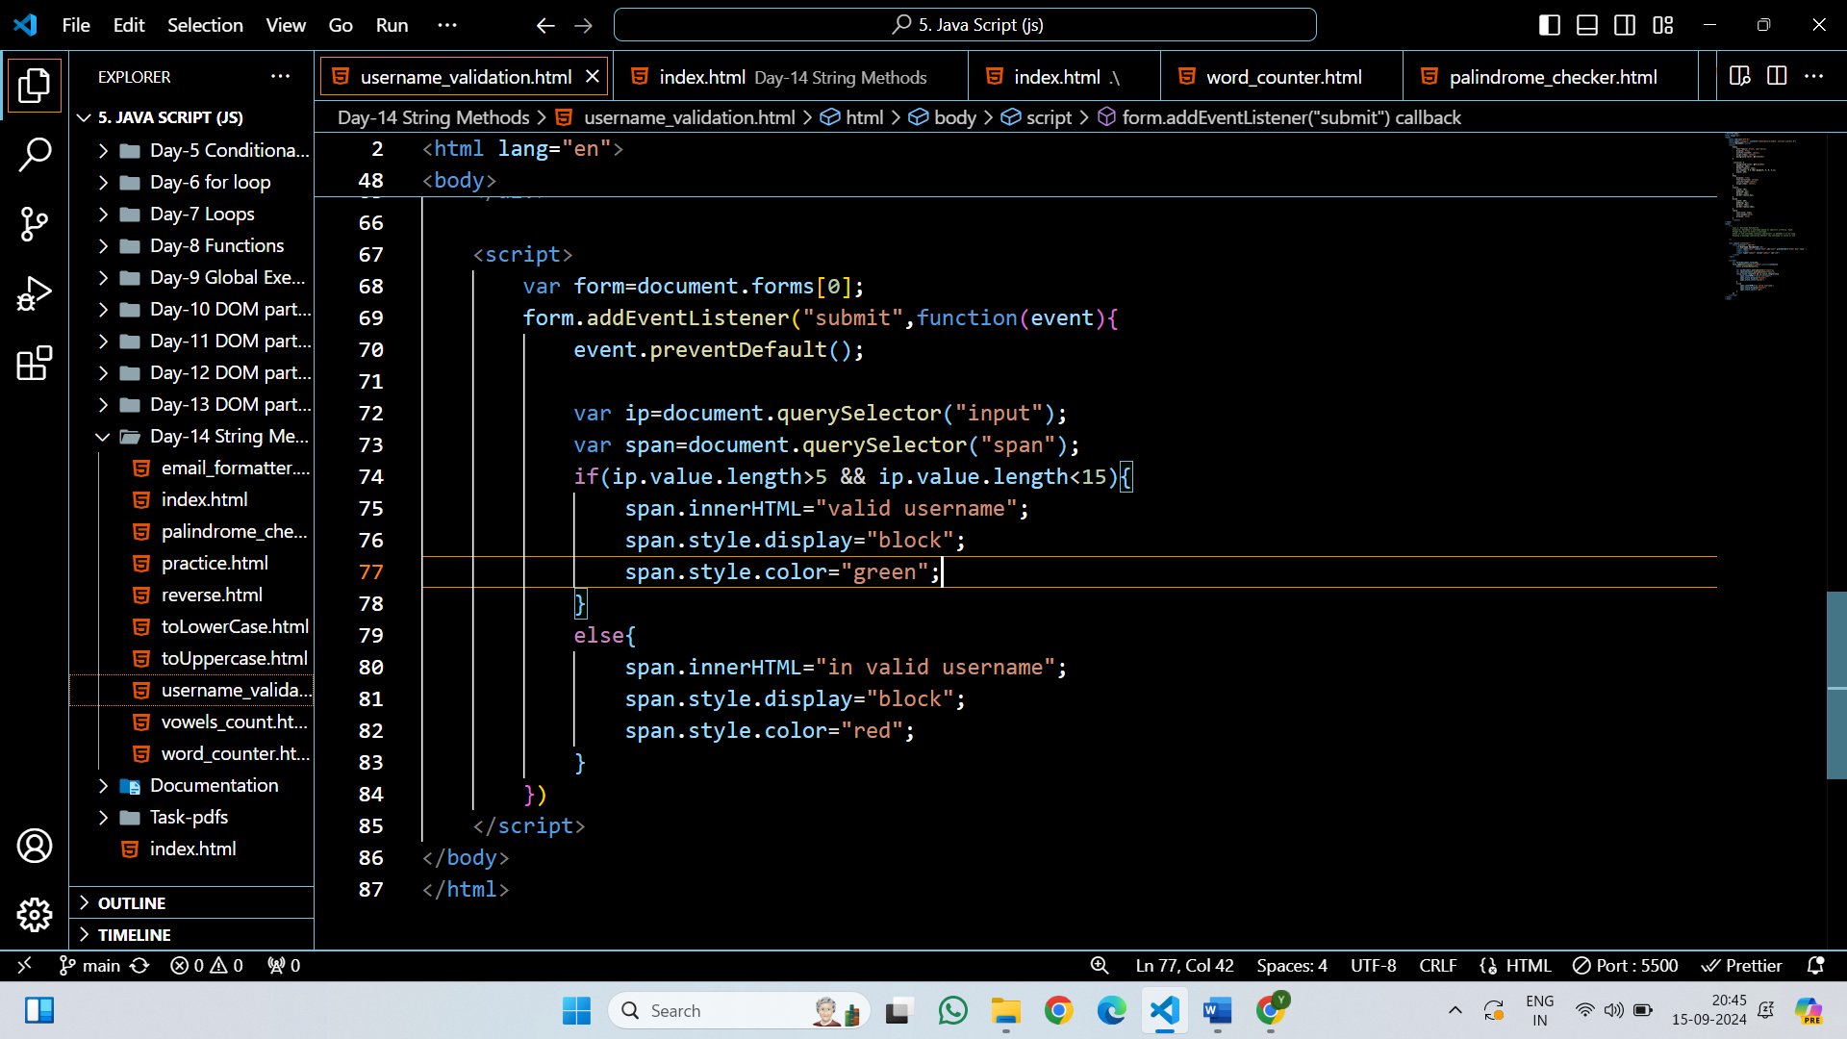

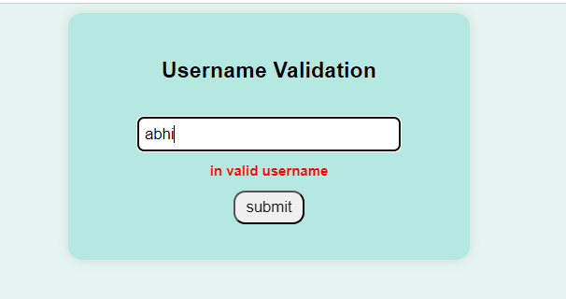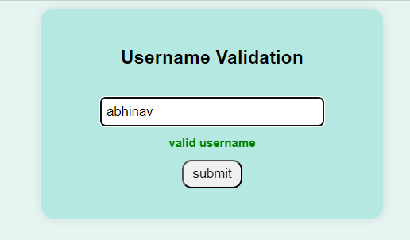

**Task 2: Email Formatter**

Scenario: Format an email address. Task:

Prompt the user to enter their first and last name.

Convert the names to lowercase and concatenate them with a dot in between.

concat “@gmail.com” to the result and display the formatted email address.

inp: jenny and joy

out: jenny.joy@gmail.com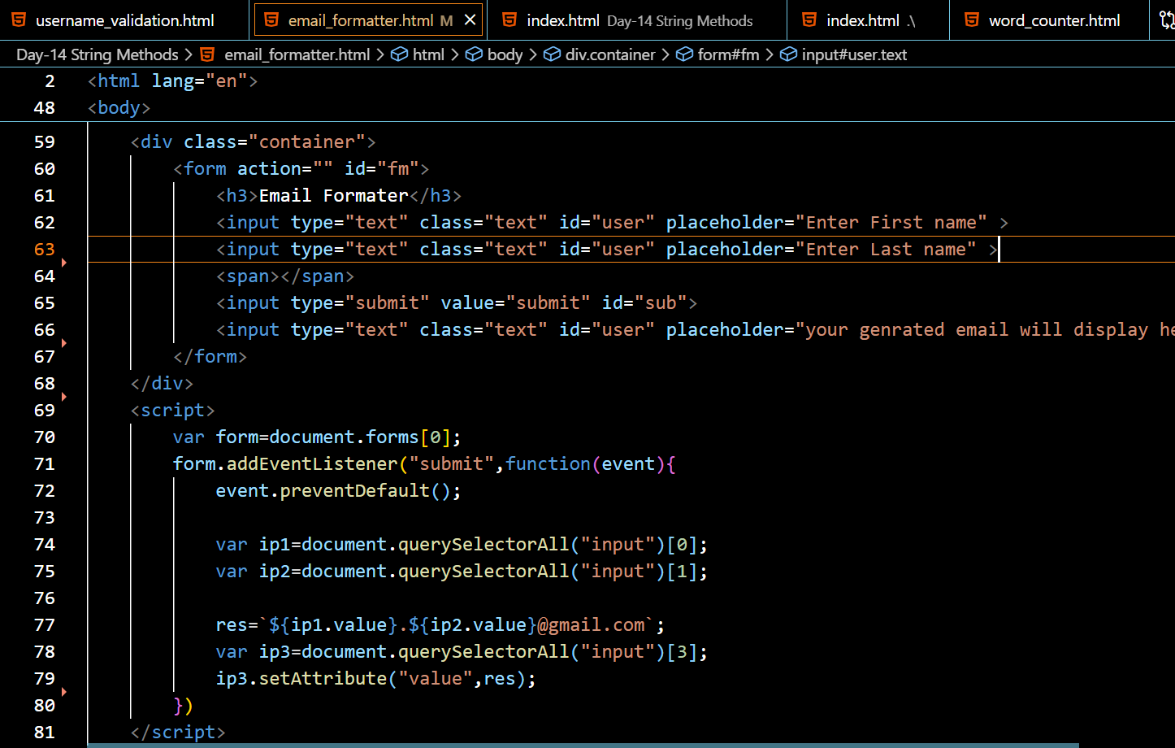

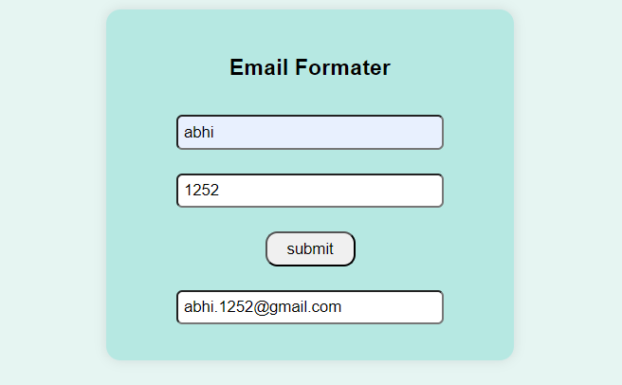

**Task 3: Word Counter**

Scenario: Count the number of words in a sentence. Task:

Prompt the user to enter a sentence.

Split the sentence into words and count them.

Display the word count.

Hint: use split and length method

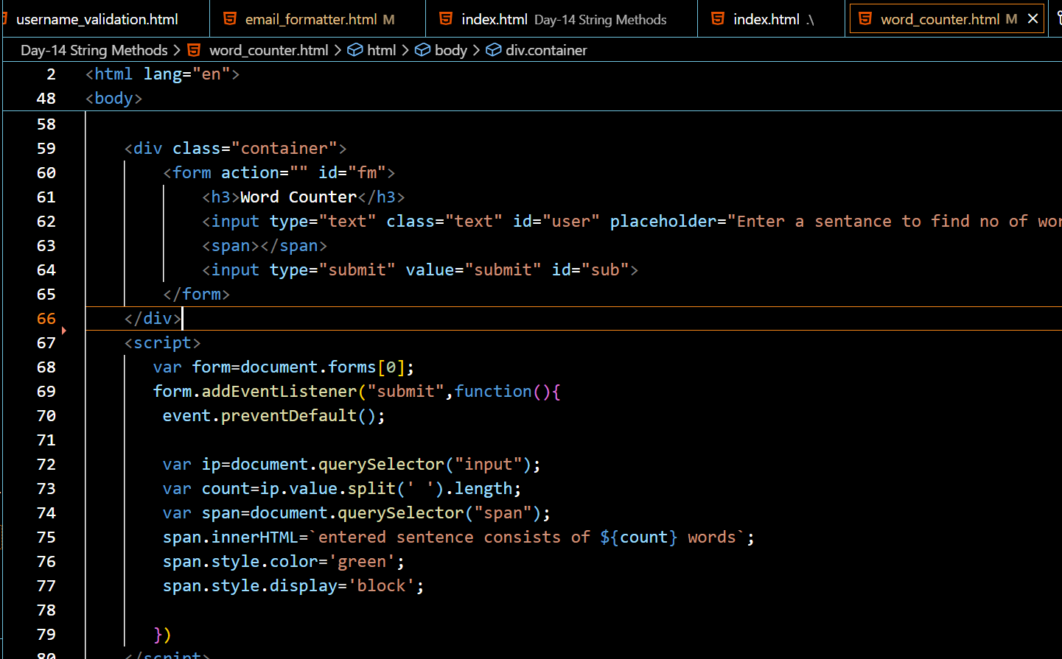

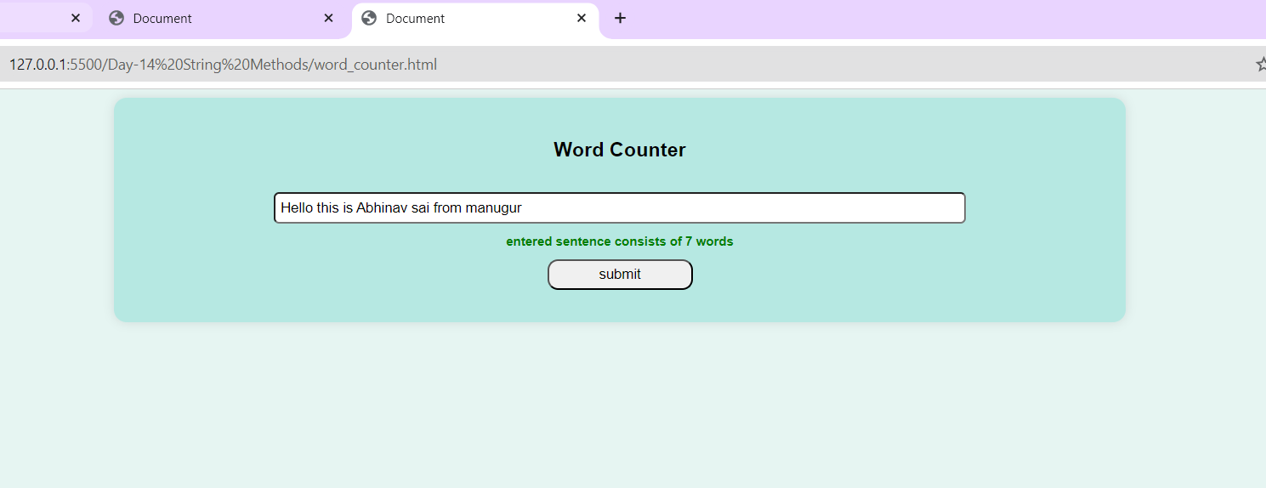

**Task 4: Palindrome Checker**

Scenario: Check if a given string is a palindrome. Task:

Prompt the user to enter a string.

Check if the string reads the same forwards and backwards.

Display a message indicating whether the string is a palindrome

Hints : use split,join, reverse method in arrays

inp:john

out: not a palandrome

inp:dad

out:it is a palandrome

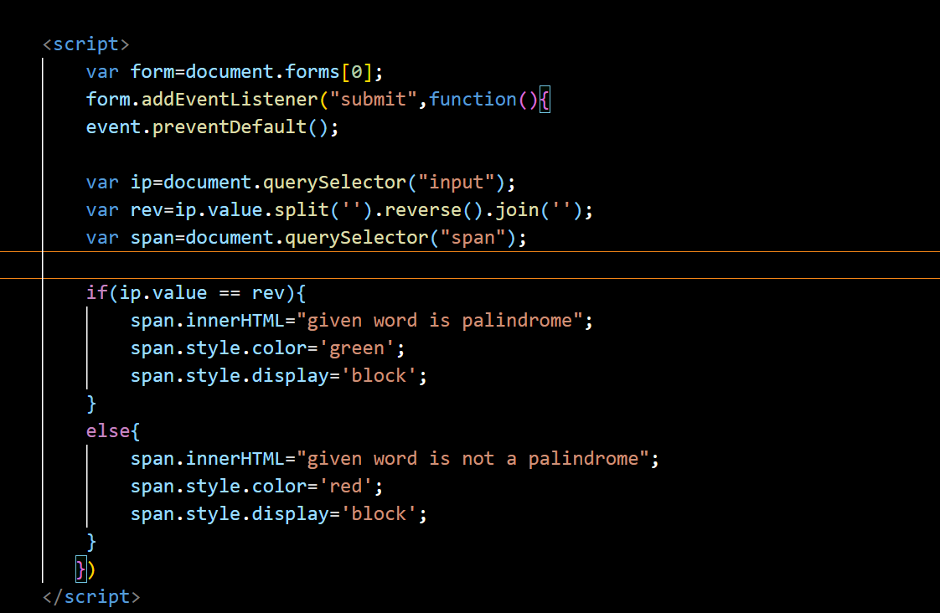

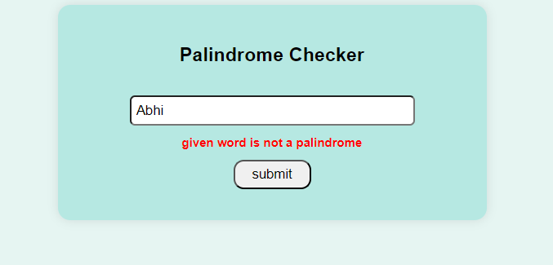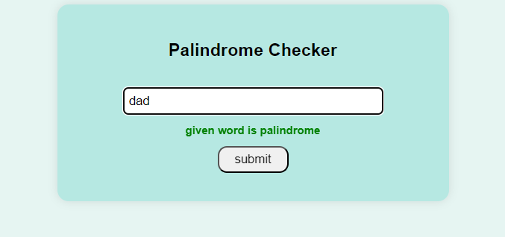

**Array Methods:**

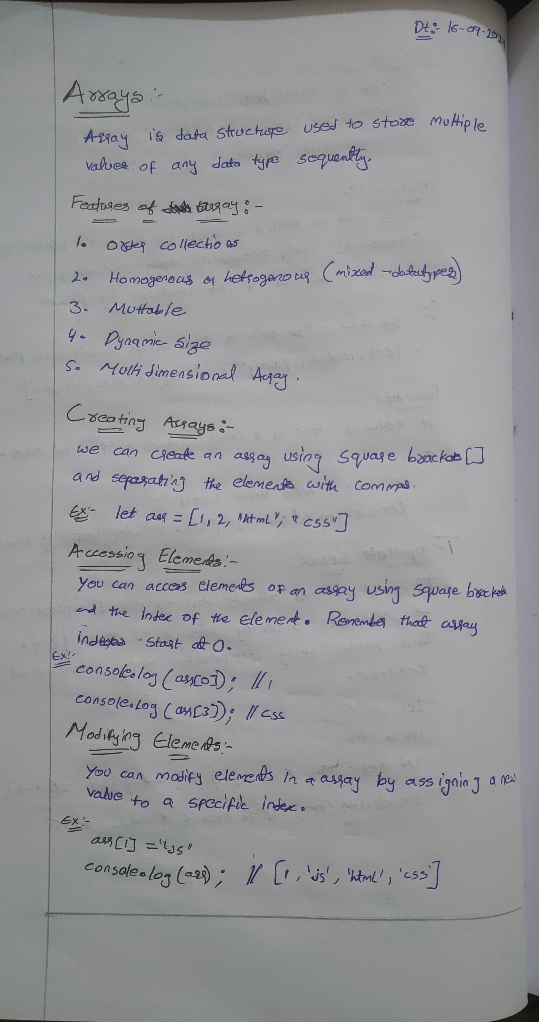

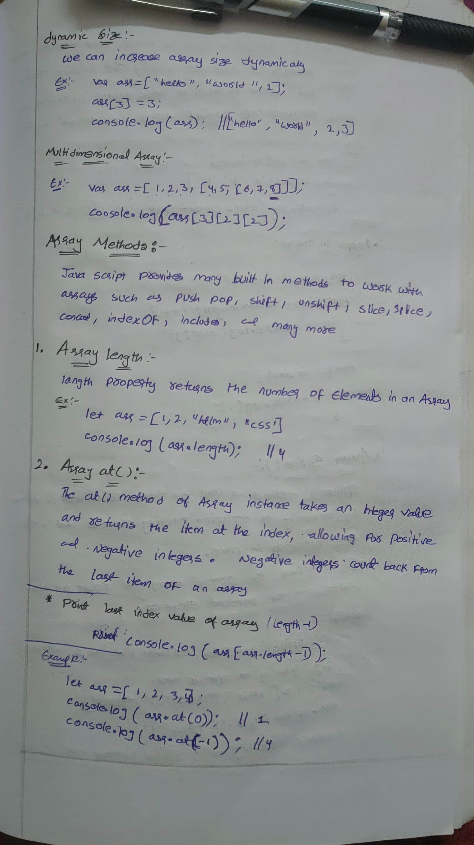

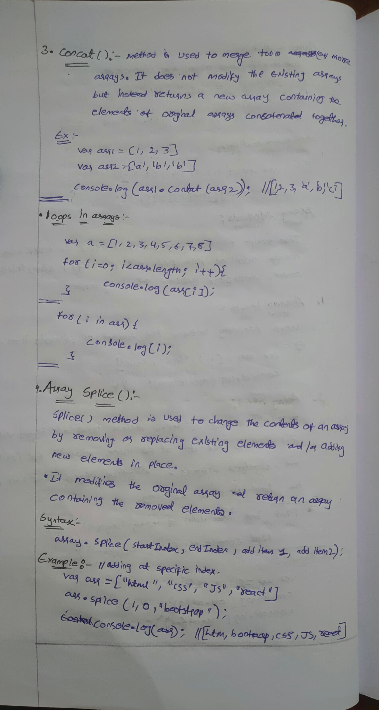

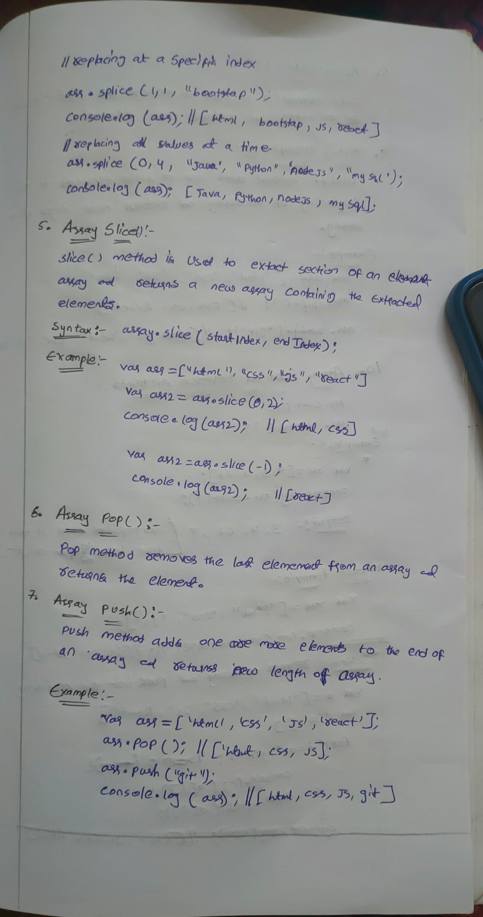

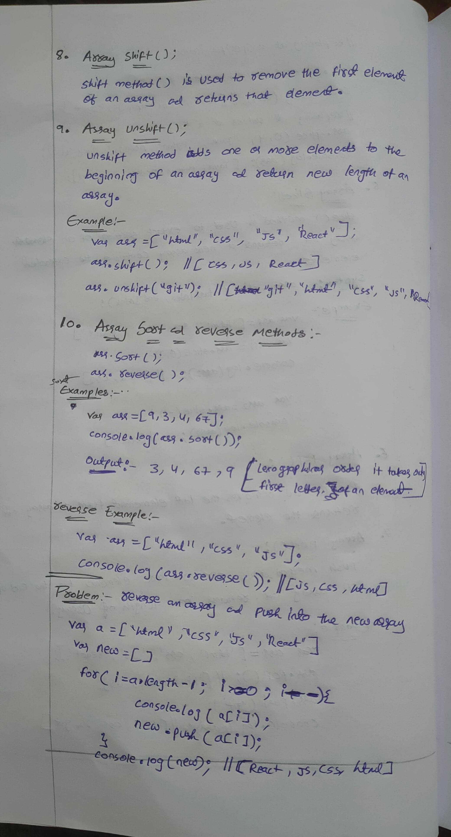

**TASKS:**

**1)Add elements to an array and iterate using for loop and for in loop and for of loop**

**Create an array of your favorite movies and iterate an array  to the console.**

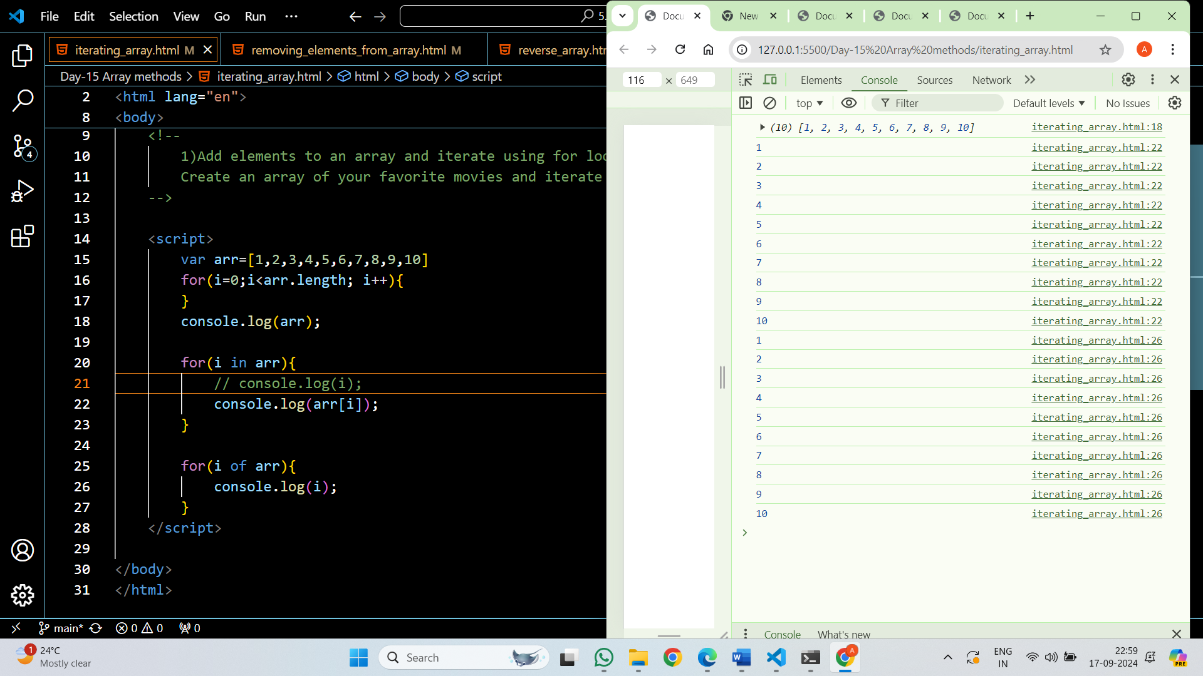

2)**Remove elements from an array**

**Remove the first and last elements from the array.**

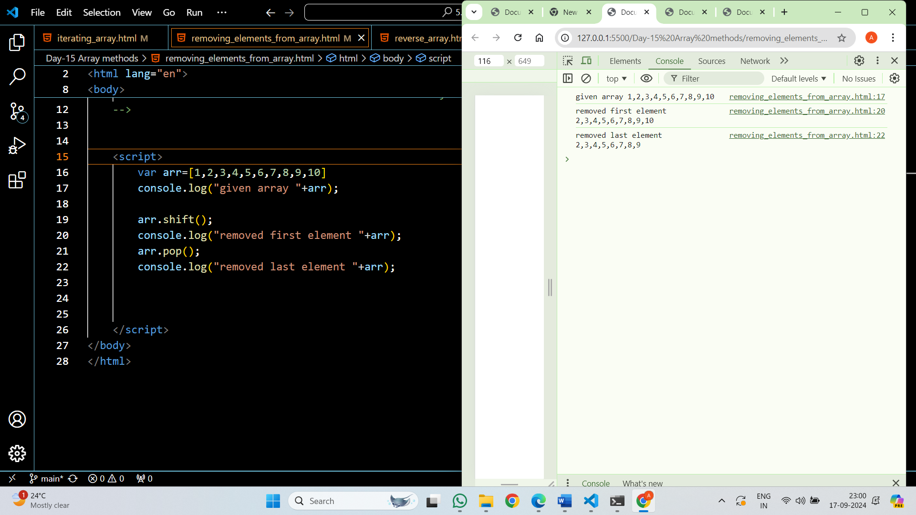

**3)Reverse an array using for loop**

**Hints: use push method**

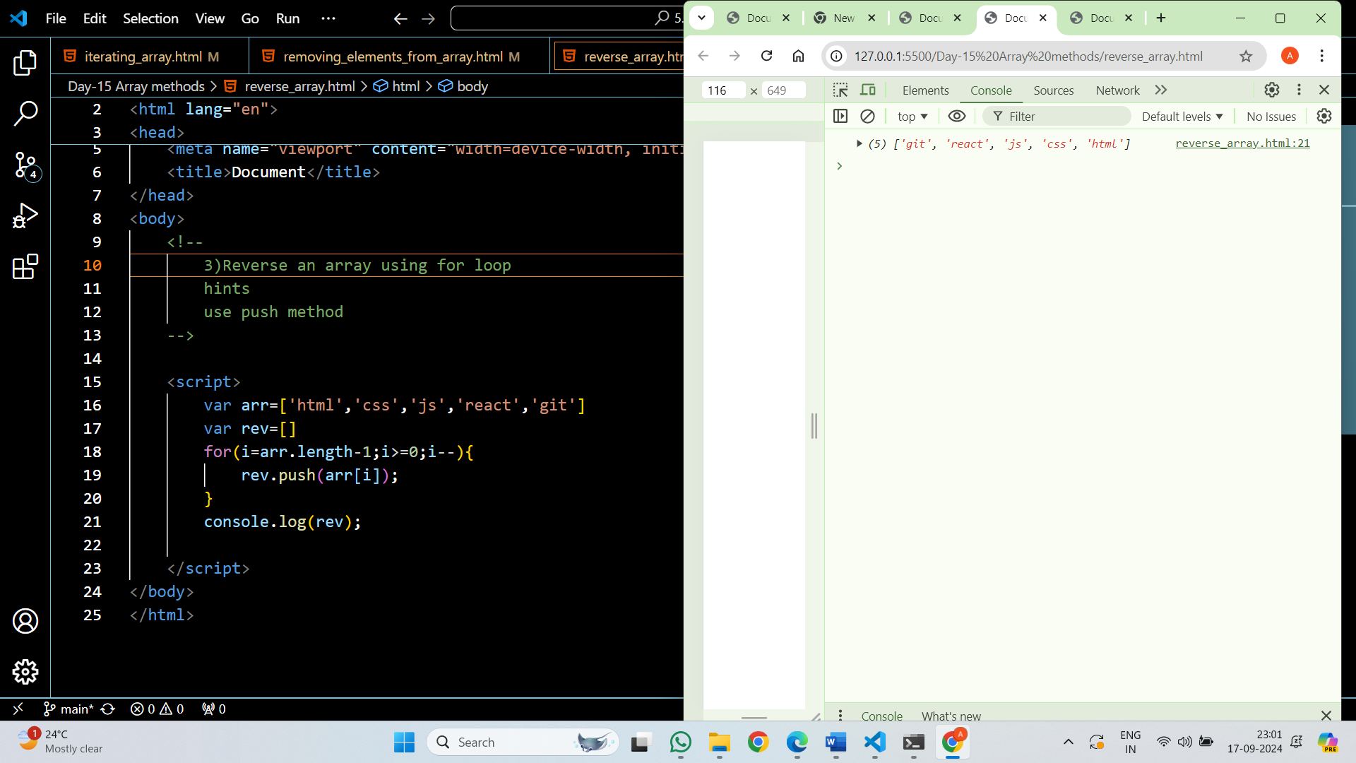

**4) find the even and odd numbers in an array [12,3,5,6,22,56,29]**

**and print the even numbers array and the sum of add and odd numbers array and the sum of even**

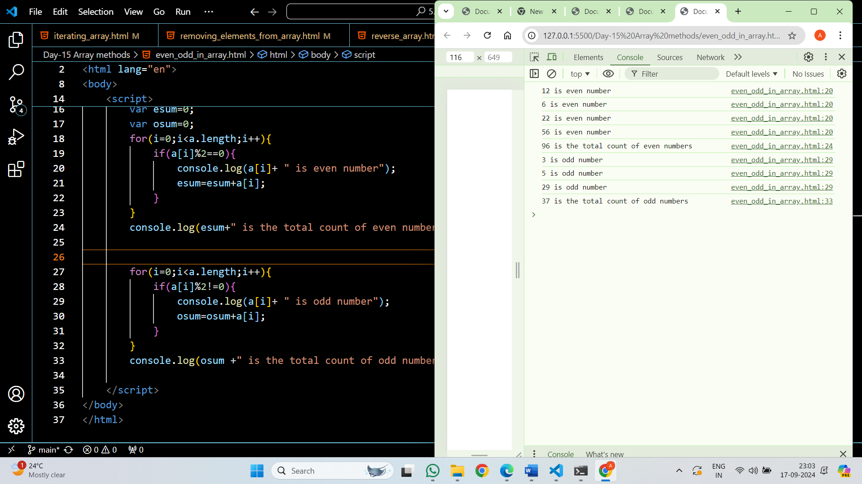

**5) Take a heterogeneous array and separate each data type into new array**

**hints : use loop, typeof and push method**

inp: let arr = ["apple", "banana", "mango", "banana", 3, 4, 5, 6, true, {name: "object"}];

out :

num=[3,4,5,6]

str=["apple","banana","mango","banana"]

bool=[true]

obj=[{name: "object"}]

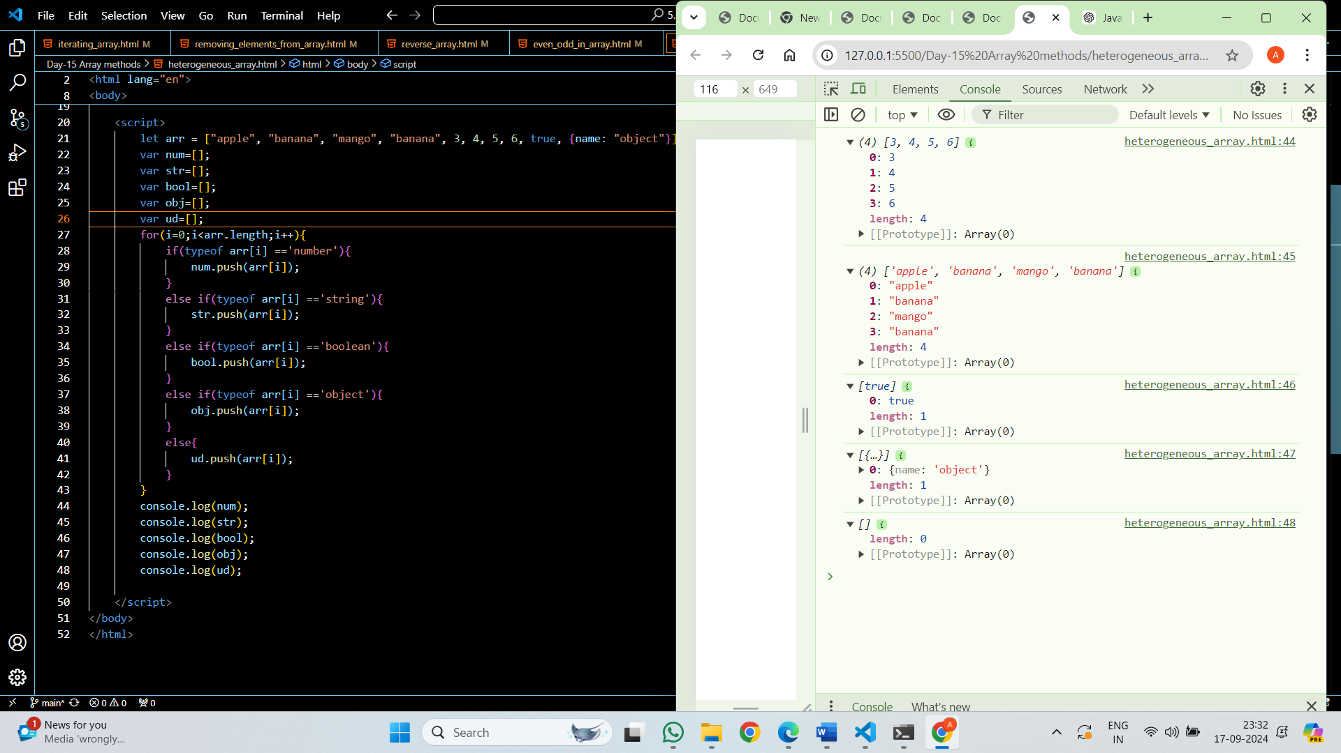

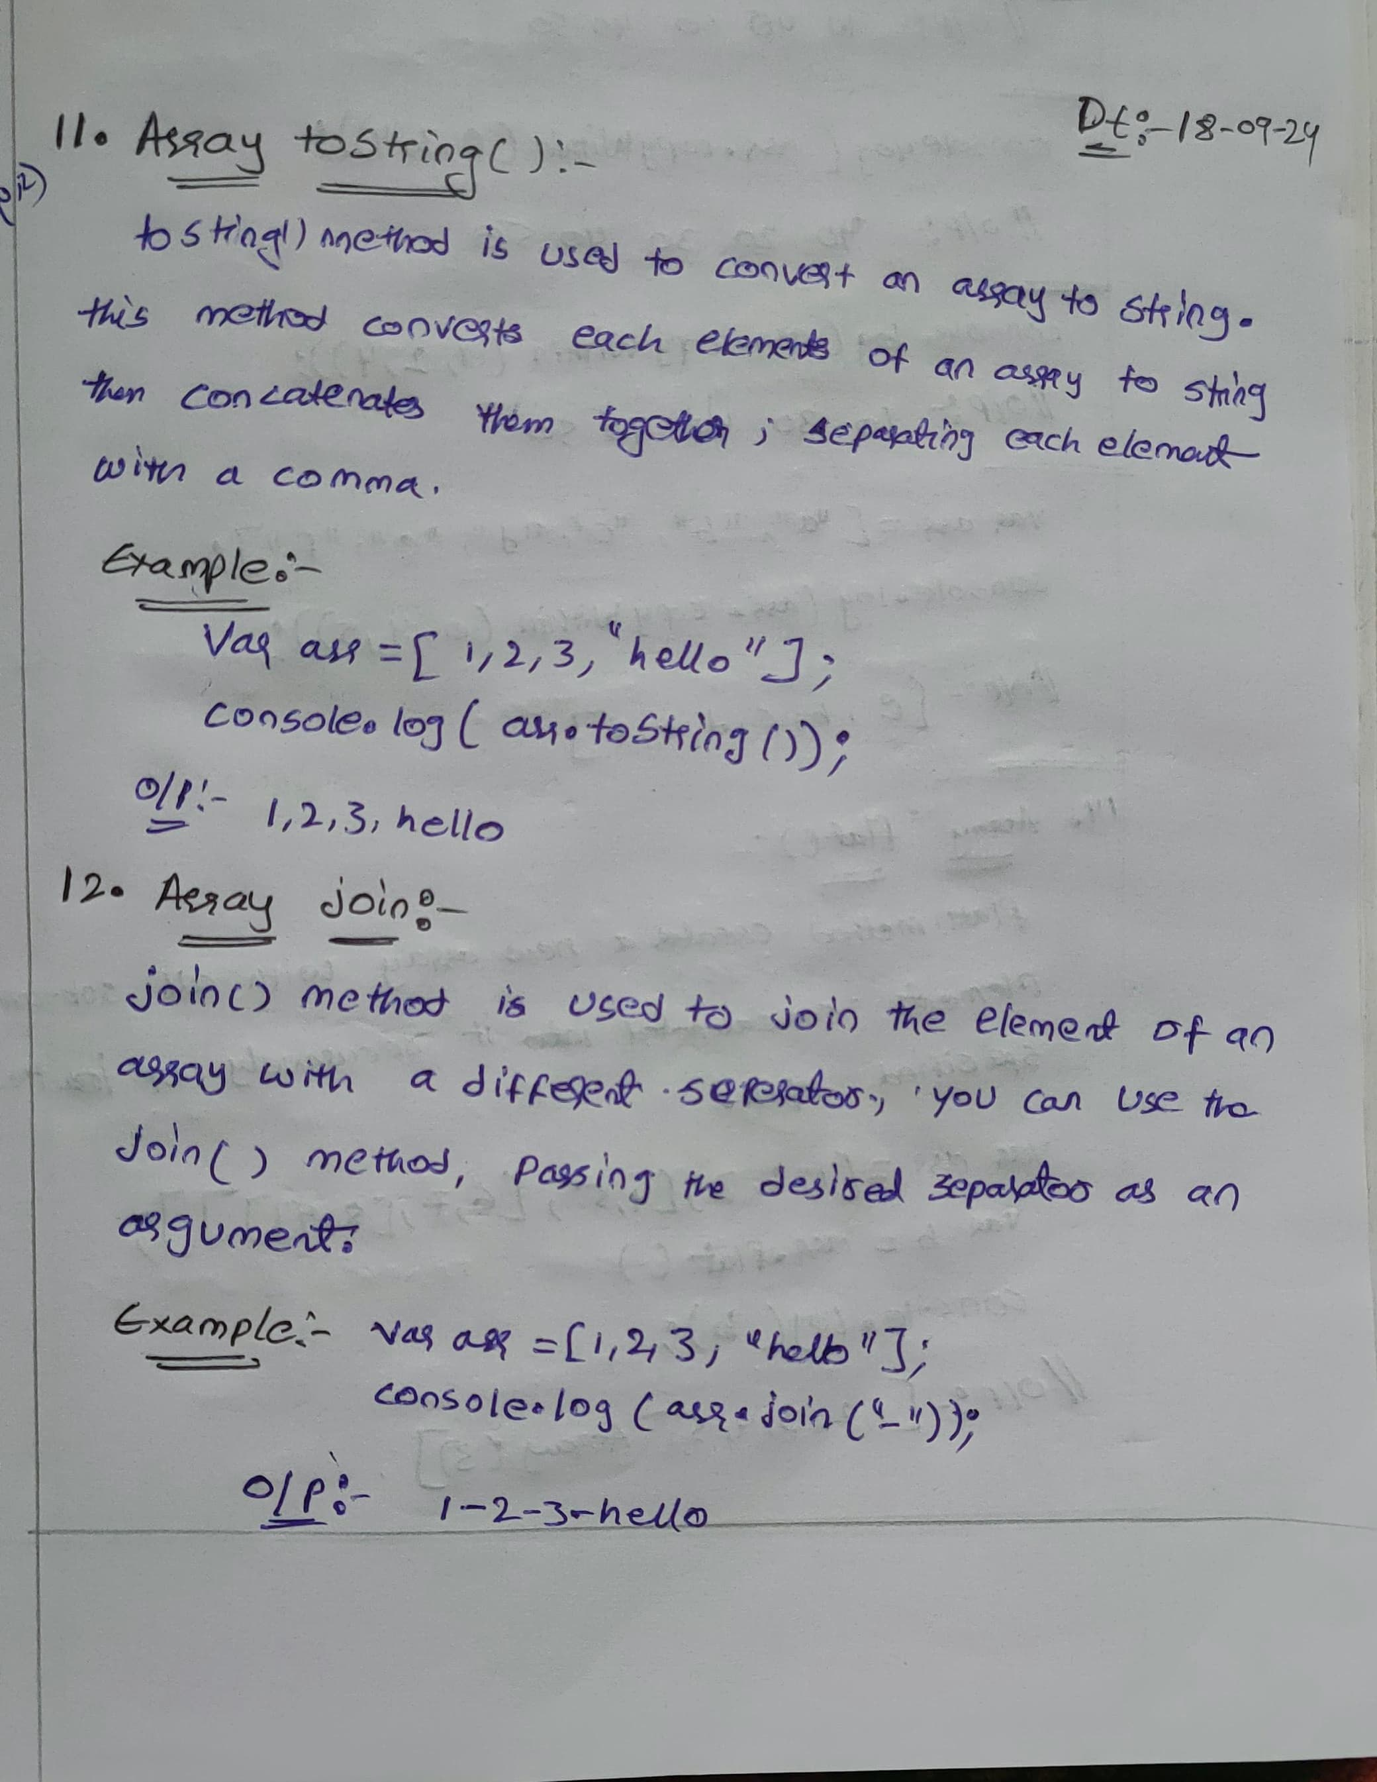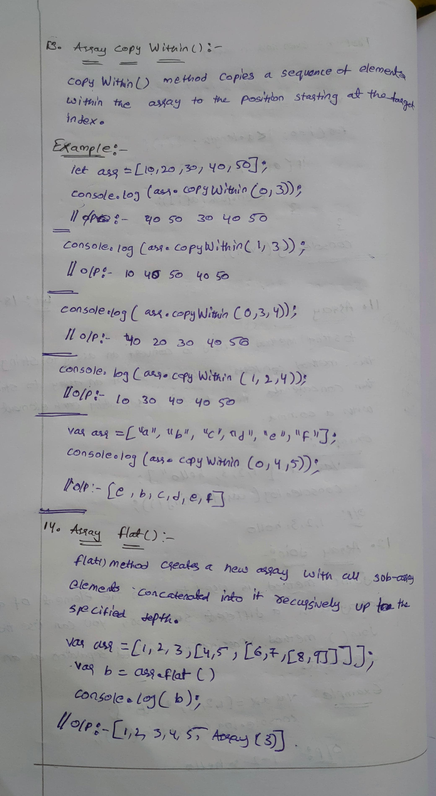

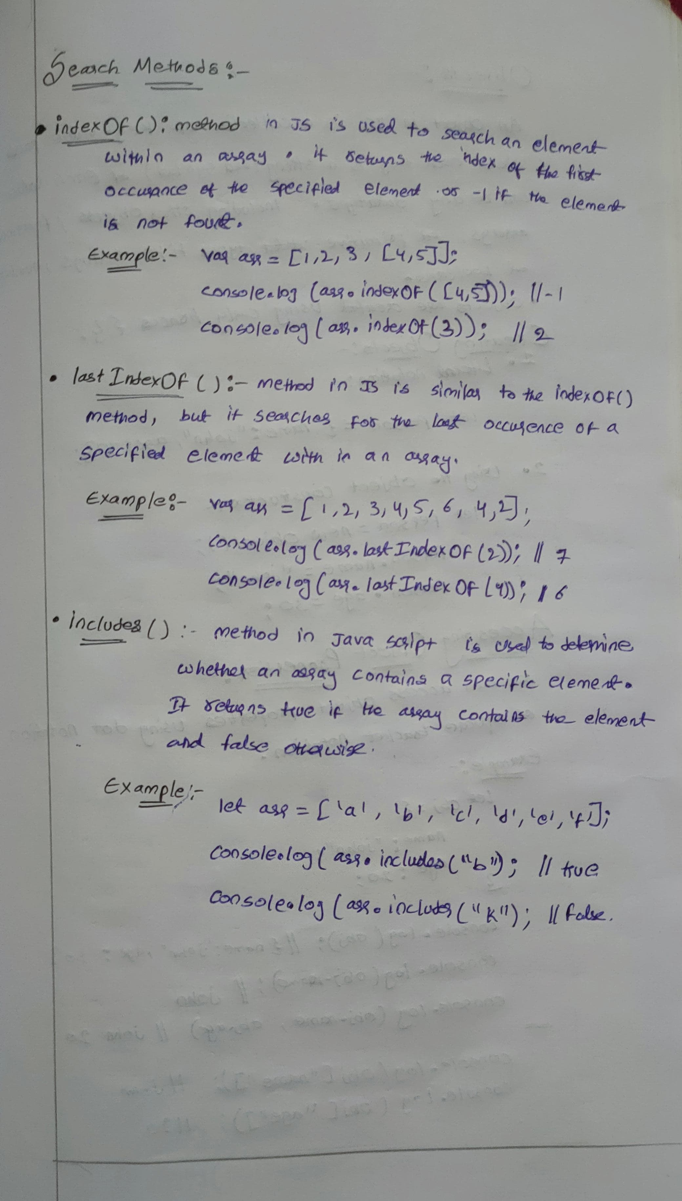

**TASKS:**

**Task 1: Using concat**

Objective: Merge two or more arrays.

Task: Create two arrays, one with your favorite sports and one with your favorite hobbies. Use the concat method to merge them into a single array.

Expected Output: Display the merged array.

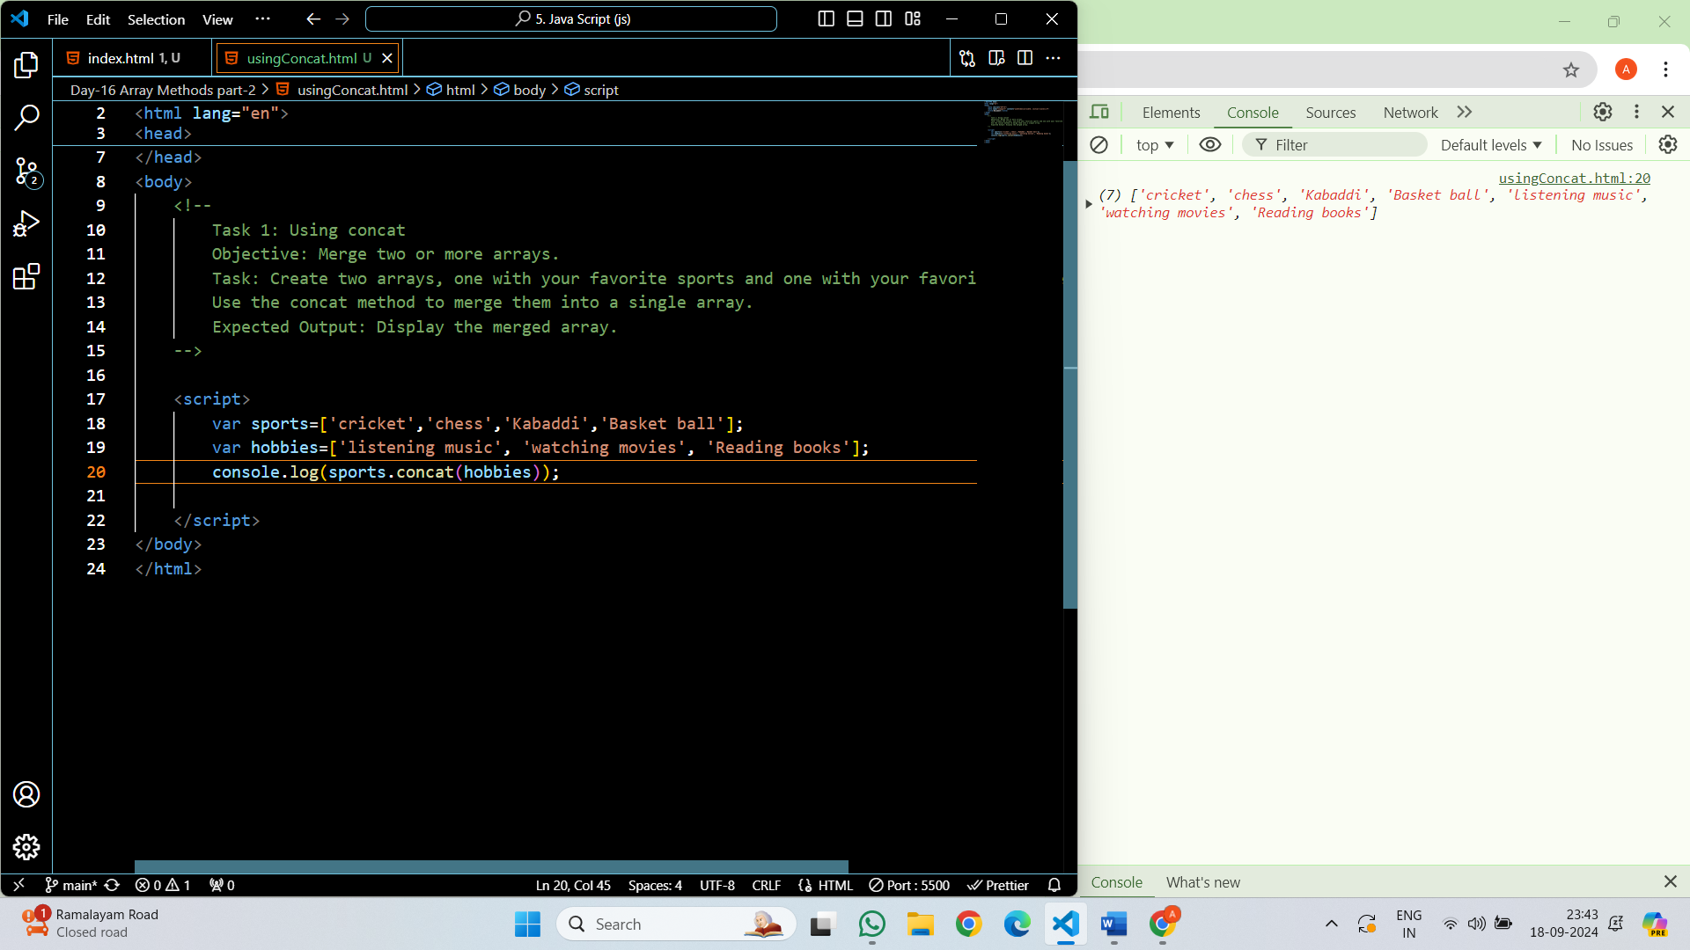

**Task 2: Using splice**

Objective: Modify an array by adding, removing, or replacing elements.

Task: Create an array of numbers from 1 to 10. Use the splice method to remove the numbers 4, 5, and 6, and replace them with the numbers 40, 50, and 60.

Expected Output: Display the array before and after the splice operation.

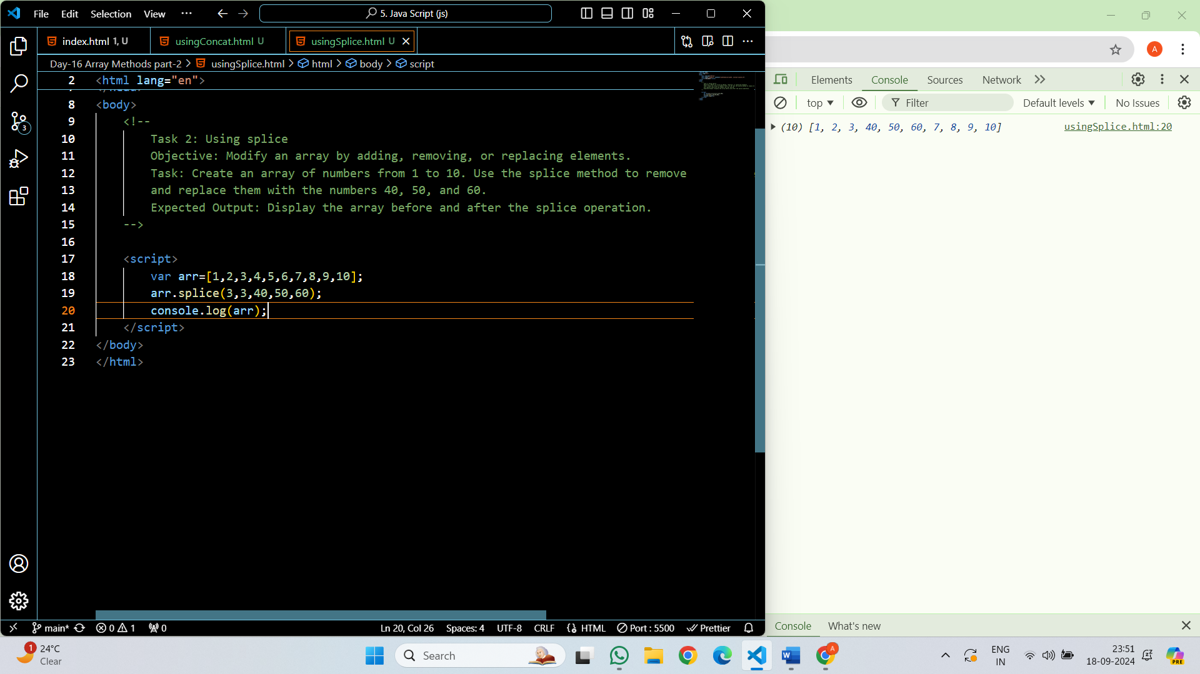

**Task 3: Using slice**

Objective: Extract a portion of an array without modifying the original array.

Task: Create an array of the days of the week. Use the slice method to create a new array that contains only the weekdays.

Expected Output: Display the original array and the new array.

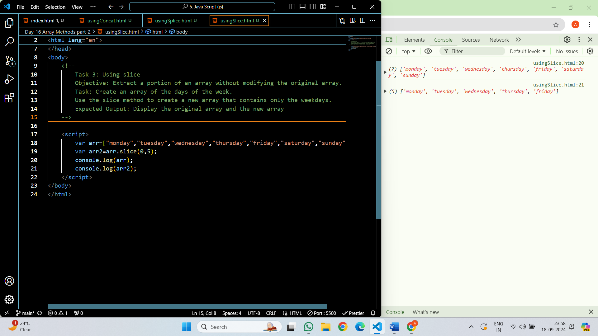

**Task 4: Using join**

Objective: Convert an array to a string.

Task: Create an array of words that form a sentence. Use the join method to combine them into a single string with spaces between each word.

Expected Output: Display the resulting sentence.

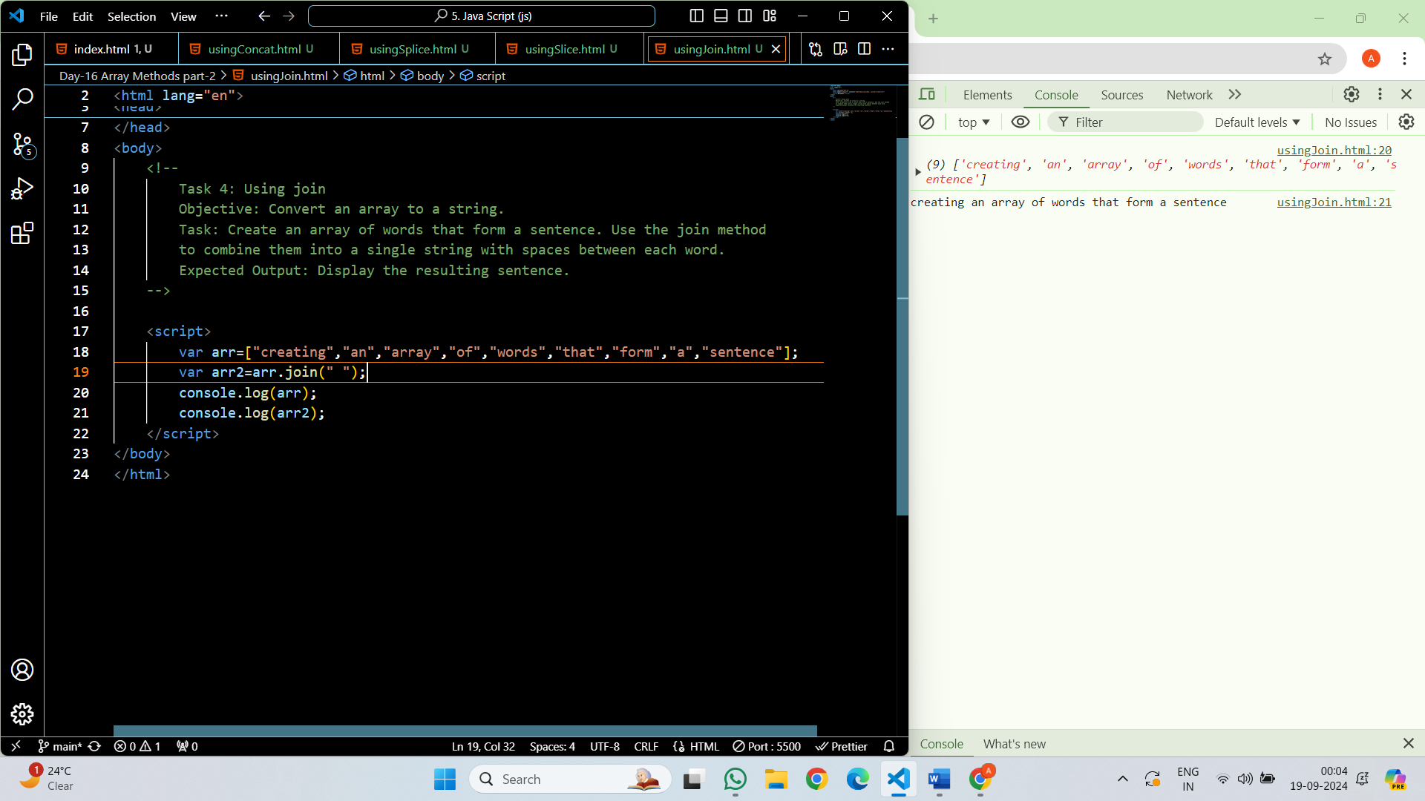

**Task 5: Using sort**

Objective: Sort the elements of an array.

Task: Create an array of random numbers. Use the sort method to sort the numbers in ascending order.

Expected Output: Display the sorted array.

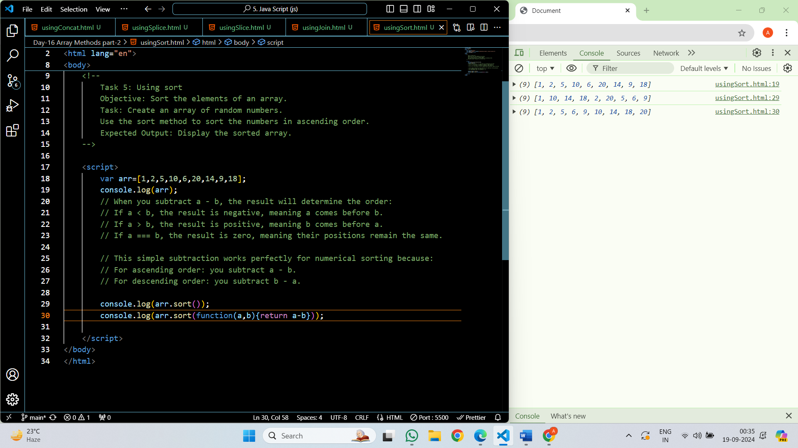

**Object Methods:**

**Objects**

An object in JavaScript is a collection of data in key-value pairs where each key is a string (or a Symbol) and each value can be of any data type, including other objects, functions, arrays, and primitive data types like strings, numbers, and booleans. Objects are created using curly braces {}.

**Creating Objects:**

**Literal notation:**

let person = { name: "John", age: 30 };

**Using the Object constructor:**

let person = new Object();

person.name = "John";

person.age = 30;

**Accessing Object Properties:**

You can access object properties using dot notation or square bracket notation:

console.log(person.name); // Dot notation

 console.log(person['age']); // Square bracket notation

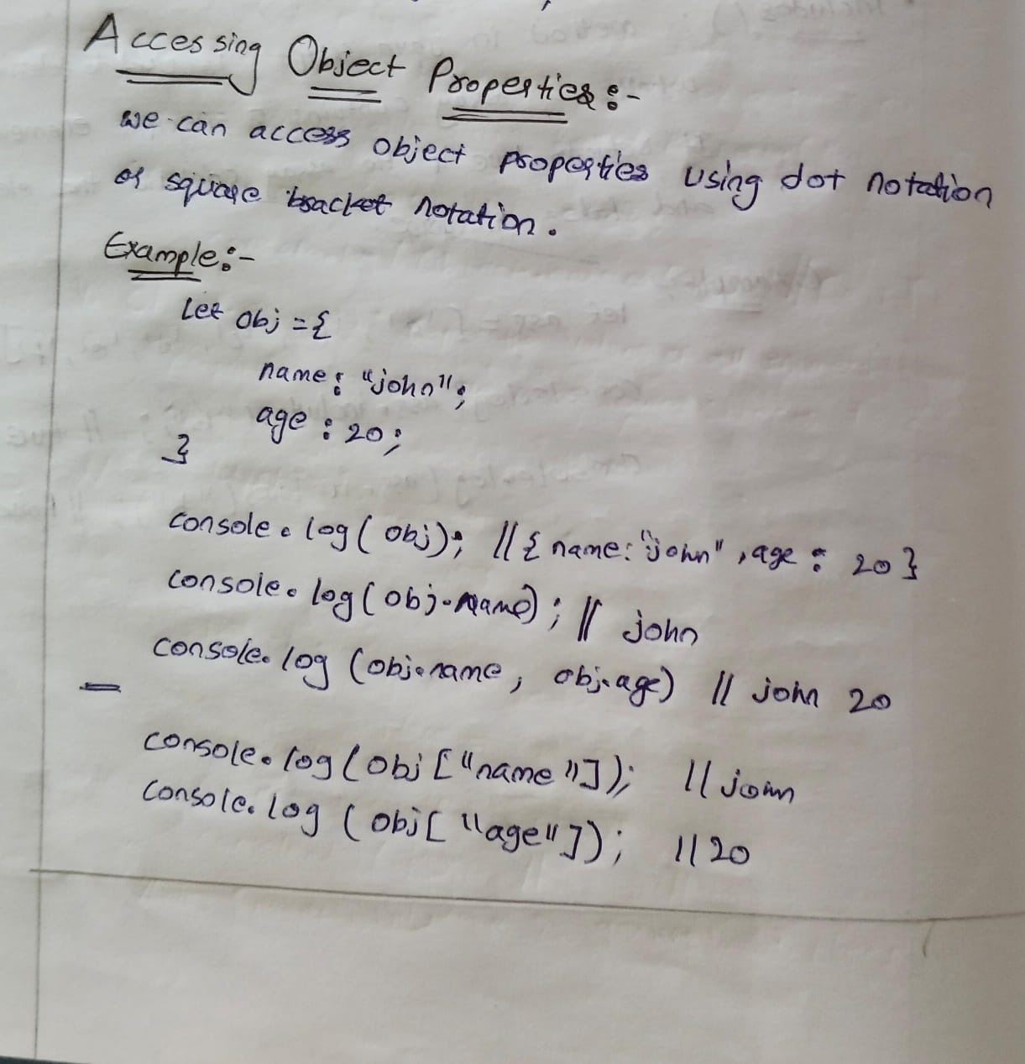

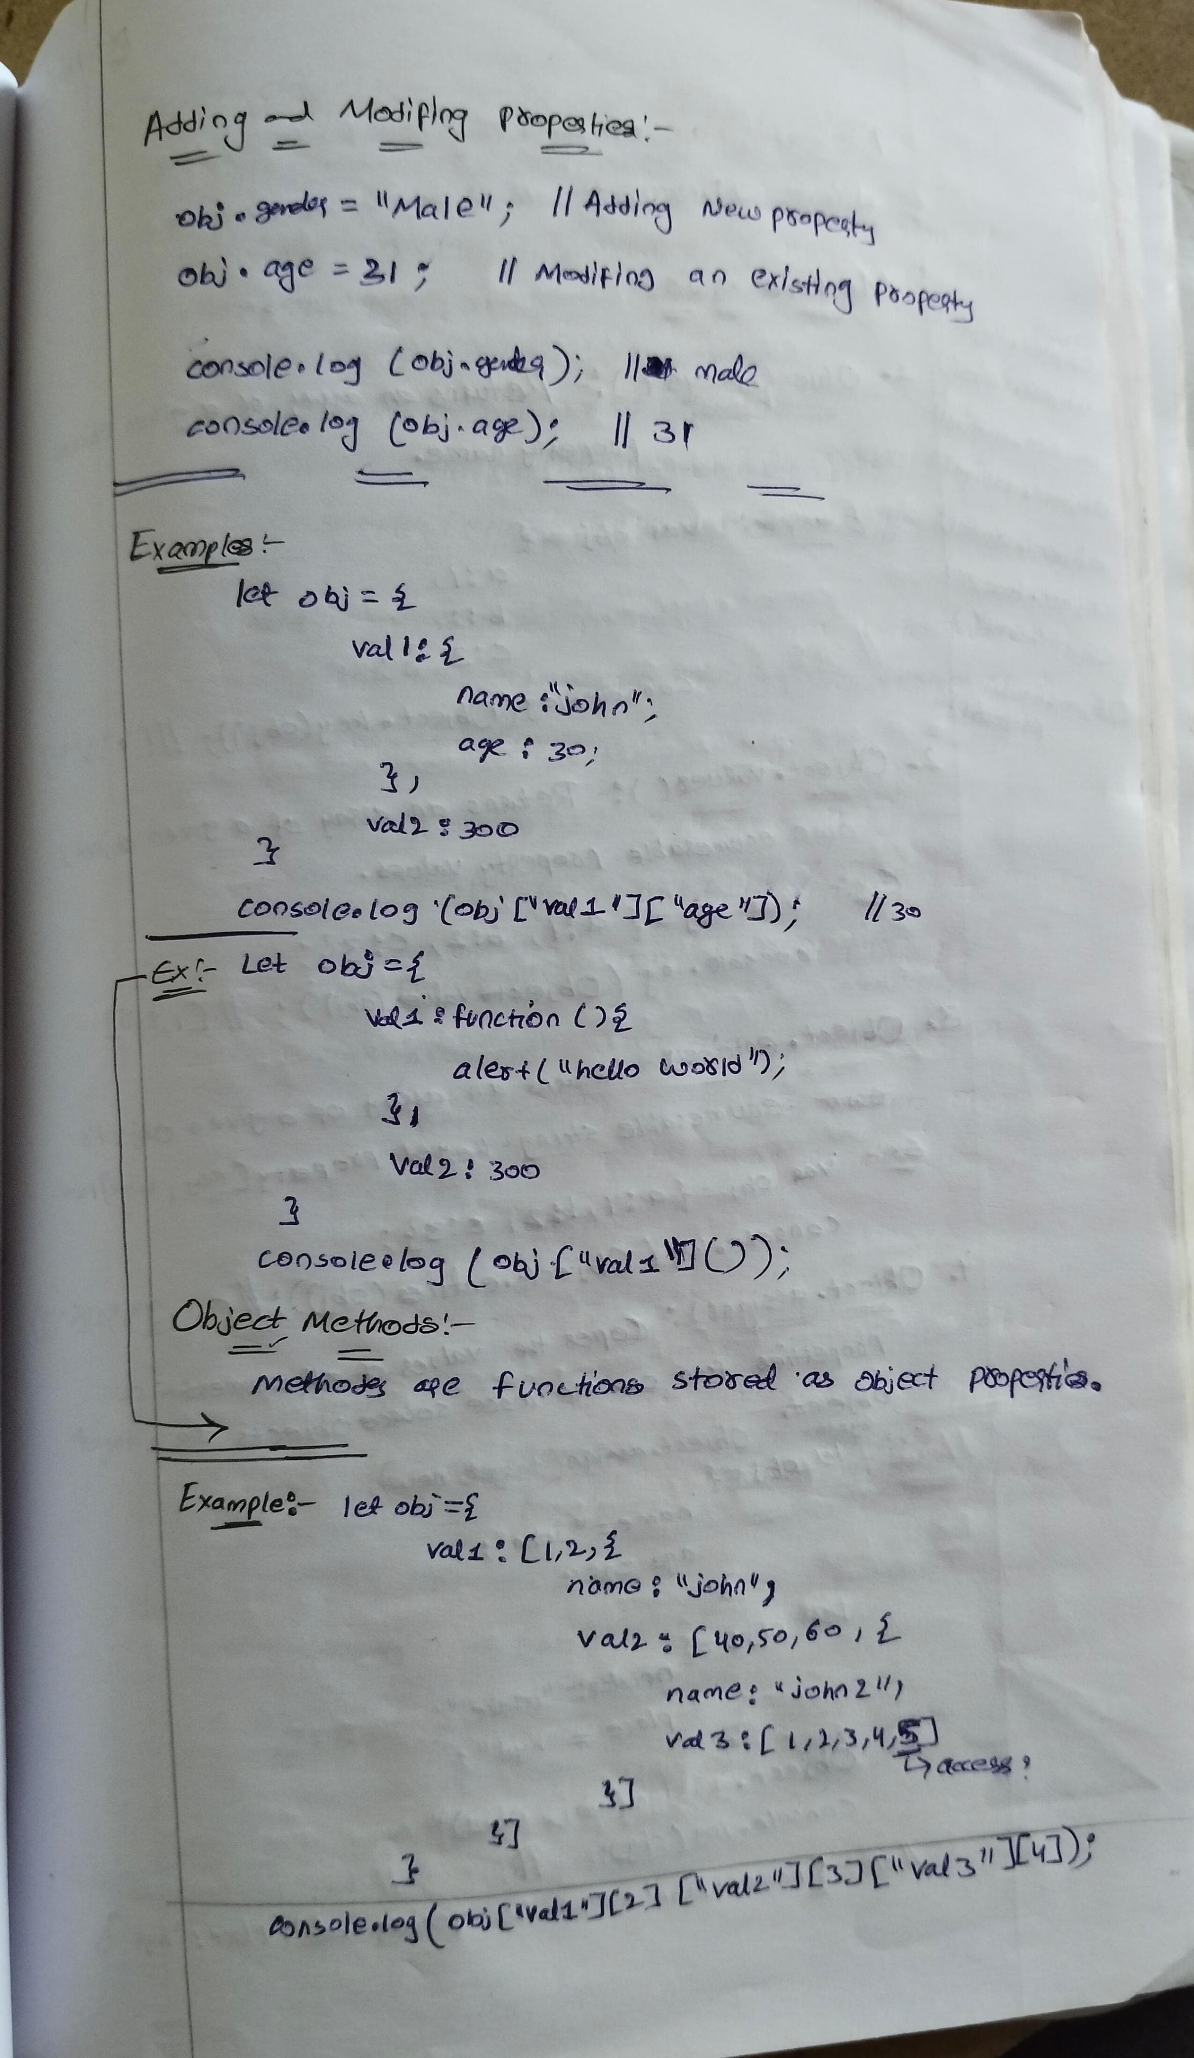

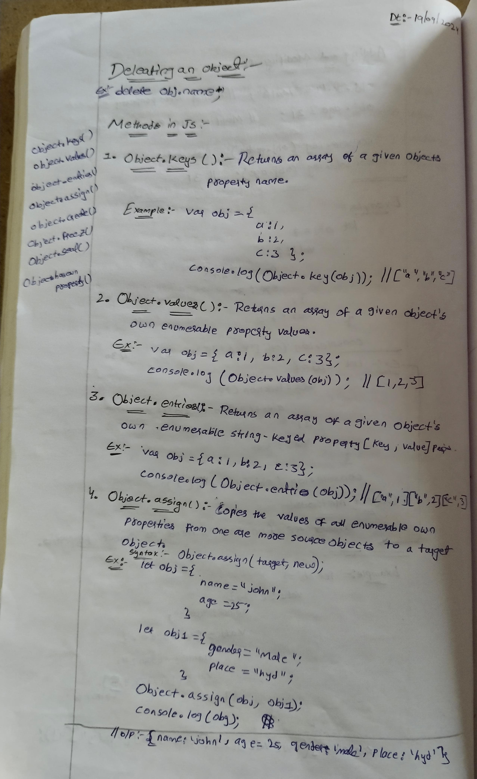

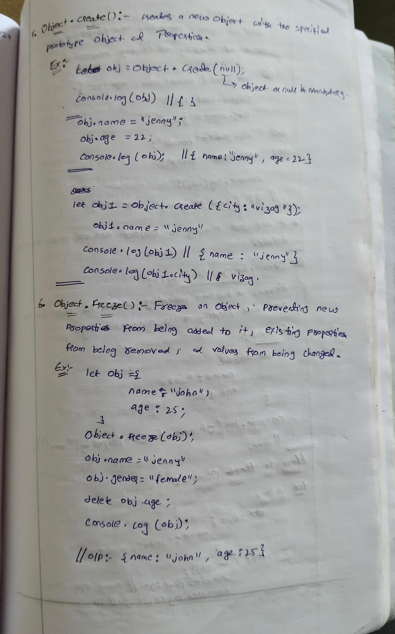

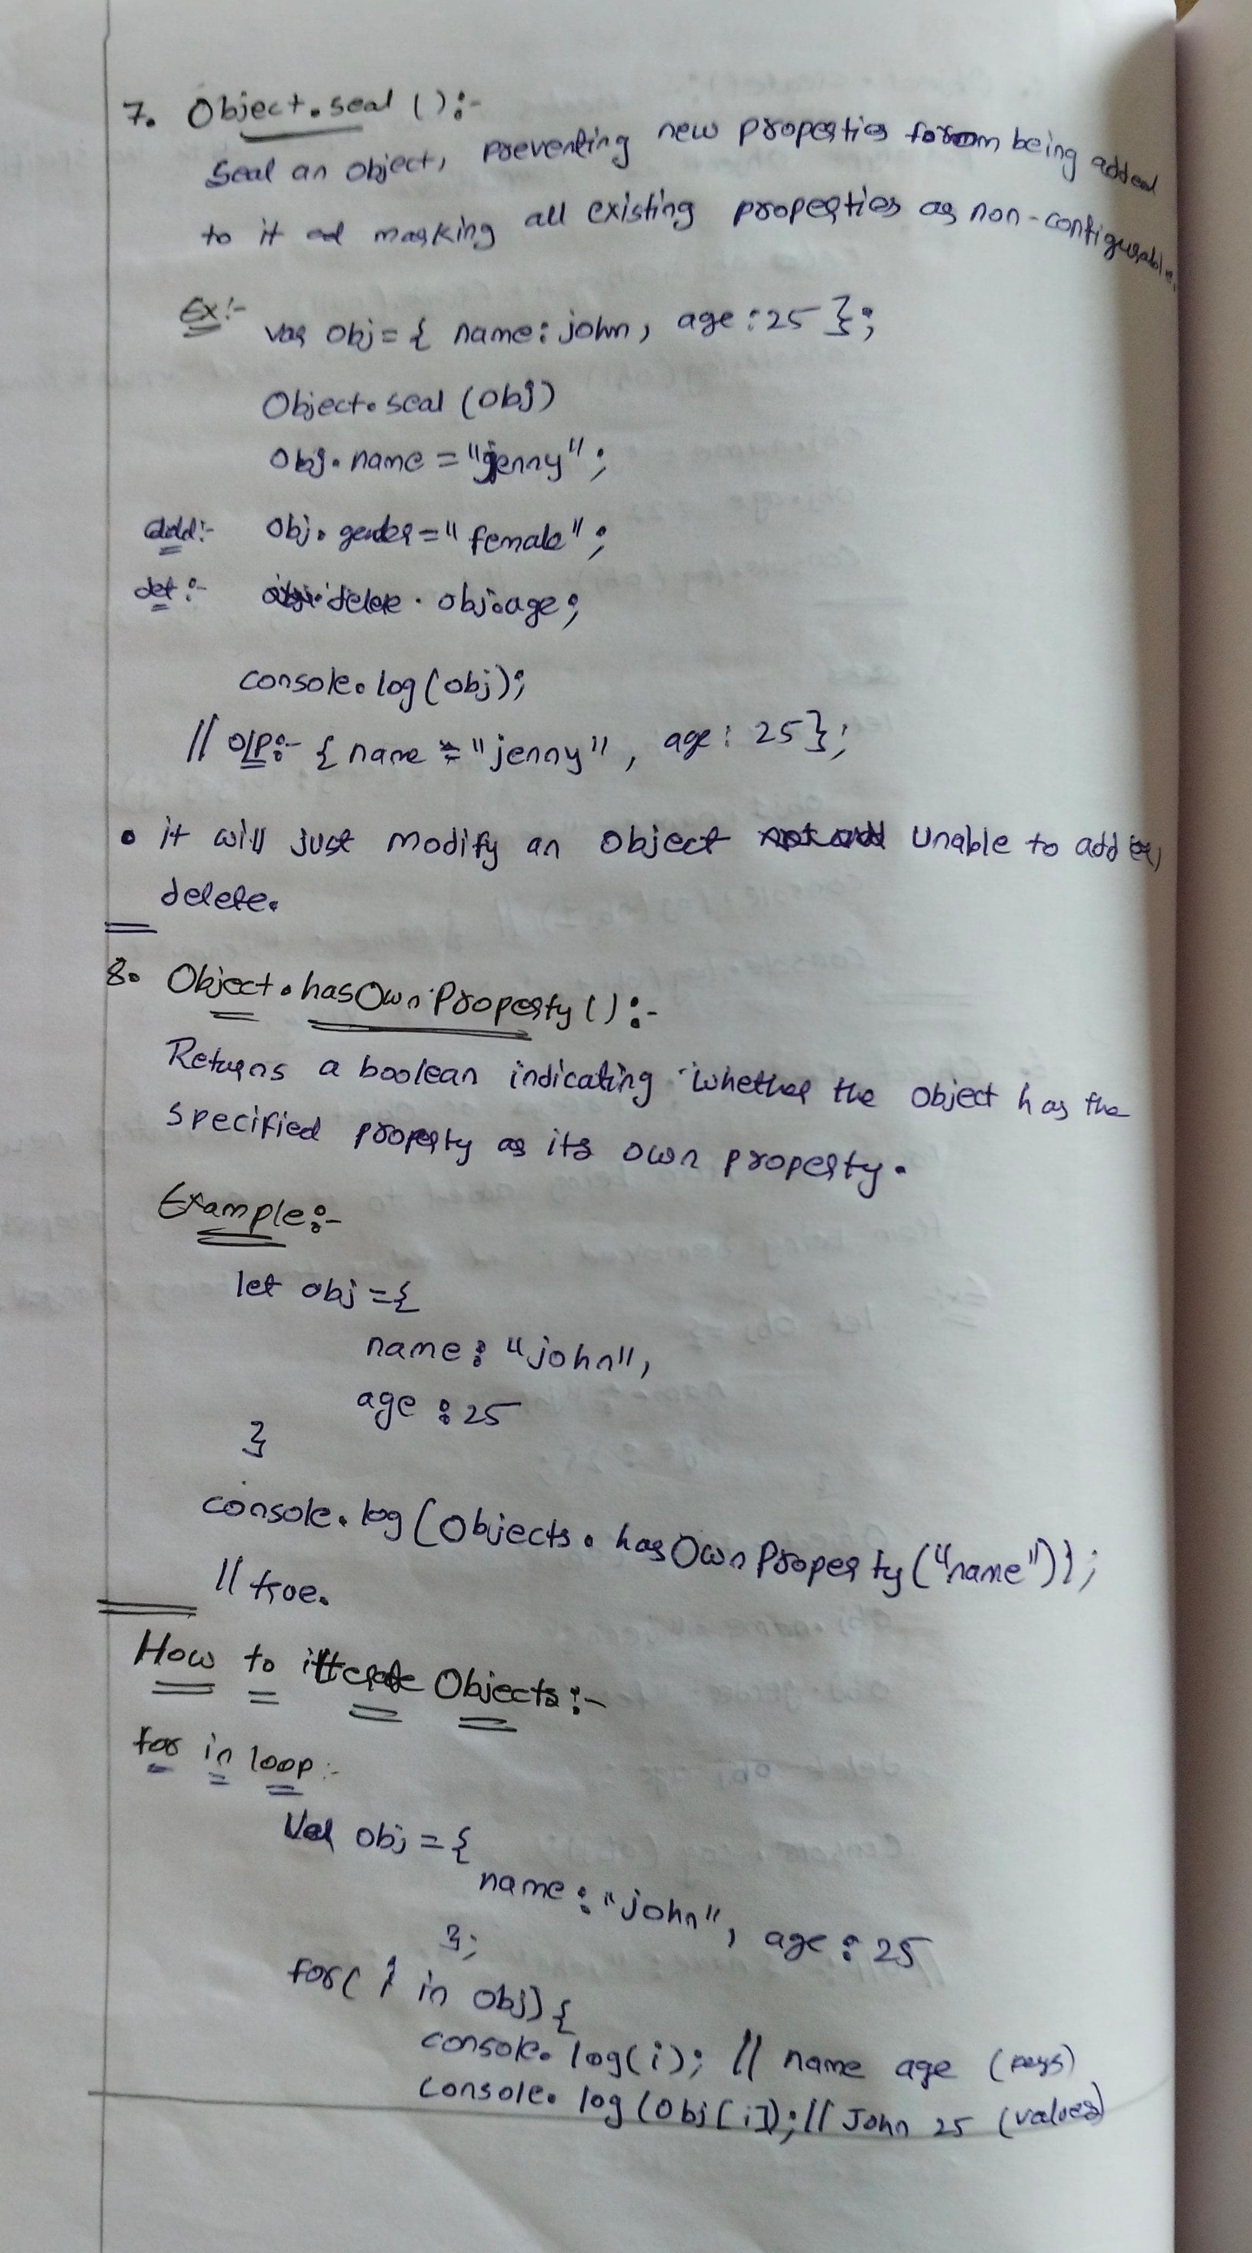

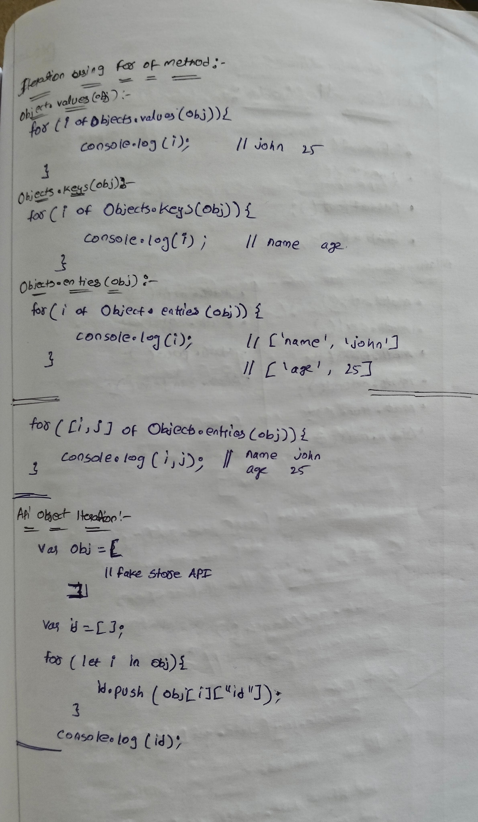

**Topic:  Number & Math methods**

**Number methods**

**toFixed()** method formats a number using fixed-point notation, which means it returns a string representation of the number with a specified number of decimal places. This is useful for rounding numbers to a certain number of decimal places.

let num = 123.45678;

console.log(num.toFixed(2)); // "123.46" - rounded to two decimal places

console.log(num.toFixed(3)); // "123.457" - rounded to three decimal places

console.log(num.toFixed(0)); // "123" - no decimal places, rounds to nearest integer

let num1 = 150;

console.log(num1.toFixed(2)); // "150.00" - Adds two decimal places with zeros

console.log(num1.toFixed(0)); // "150" - No change

**parseInt():** Parses a string argument and returns an integer.

let str = "123";

console.log(parseInt(str)); // Output: 123

**parseFloat():** Parses a string argument and returns a floating point number.

**// Example 1: Basic Parsing**

console.log(parseInt("42")); // 42 (simple integer parsing)

console.log(parseFloat("42")); // 42 (simple float parsing)

console.log(parseFloat("42.5")); // 42.5 (floating-point parsing)

**// Example 2: Handling Leading and Trailing Whitespaces**

console.log(parseInt("   123   ")); // 123 (leading/trailing spaces ignored)

console.log(parseFloat("   123.45   ")); // 123.45 (leading/trailing spaces ignored)

**// Example 3: Parsing with Non-Numeric Characters**

console.log(parseInt("123abc")); // 123 (parsing stops at "abc")

console.log(parseFloat("123.45abc")); // 123.45 (parsing stops at "abc")

**// Example 4: Strings Starting with Non-Numeric Characters**

console.log(parseInt("abc123")); // NaN (no leading numeric characters)

console.log(parseFloat("abc123.45")); // NaN (no leading numeric characters)

**// Example 5: Handling Float Strings in parseInt()**

console.log(parseInt("3.14")); // 3 (truncates the decimal part)

console.log(parseFloat("3.14")); // 3.14 (returns the full float)

**// Example 6: Parsing Strings with Exponential Notation**

console.log(parseInt("1e4")); // 1 (stops at "e")

console.log(parseFloat("1e4")); // 10000 (interpreted as 1 * 10^4)

**// Example 8: Large and Small Numbers**

console.log(parseInt("999999999999999999999")); // 1e+21 (very large integer)

console.log(parseFloat("999999999999999999999")); // 1e+21 (very large float)

console.log(parseInt("0.0001")); // 0 (fractional part ignored)

console.log(parseFloat("0.0001")); // 0.0001 (floating-point number)

**isNaN():** Checks if a value is NaN (Not-a-Number). If it is number it returns false if it is not a number it returns true.

NUMBER – False

Not a Number - True

console.log(isNaN("hello")); // true

Output: true console.log(isNaN(123)); // Output: false

**5. Number method:** The Number constructor converts a value to a number.

console.log(Number("123")); // 123

console.log(Number("123abc")); // NaN

console.log(Number(true)); // 1

console.log(Number(false)); // 0

console.log(Number(null)); // 0

console.log(Number(undefined)); // NaN

**Type Coercion:**

isNaN() first tries to convert the parameter to a number, and then tests if the resulting value is NaN.

isNaN(NaN); // true

isNaN(undefined); // true

isNaN({}); // true

isNaN(true); // false

isNaN(false);//false

isNaN(null); // false

isNaN(37); // false

**// Strings**

isNaN("37"); // false: "37" is converted to the number 37 which is not NaN

isNaN("37.37"); // false: "37.37" is converted to the number 37.37 which is not NaN

isNaN("37,5"); // true

isNaN("123ABC","jhkhk"); // true: Number("123ABC") is NaN

isNaN(""); // false: the empty string is converted to 0 which is not NaN

isNaN(" "); // false: a string with spaces is converted to 0 which is not NaN

**// Dates**

isNaN(new Date()); // false; Date objects can be converted to a number (timestamp)

isNaN(new Date().toString()); // true; the string representation of a Date object cannot be parsed as a number

**// Arrays**

isNaN([]); // false; the primitive representation is "", which coverts to the number 0

isNaN([1]); // false; the primitive representation is "1"

isNaN([1, 2]); // true; the primitive representation is "1,2", which cannot be parsed as number

**Math methods**

**1. Math.abs():** Returns the absolute value of a number.

        console.log(Math.abs(10)); // 10

        console.log(Math.abs(-10)); // 10

        console.log(Math.abs(0)); // 0

        console.log(Math.abs(-0)); // 0

        console.log(Math.abs("-42")); // 42 (string converted to number)

        console.log(Math.abs(null)); // 0 (null converted to 0)

        console.log(Math.abs("Hello")); // NaN (string that can't be converted to a number)

**2. Math.ceil():** Rounds a number up to the next largest integer.

        console.log(Math.ceil(4.2)); // 5

        console.log(Math.ceil(-4.2)); // -4

        console.log(Math.ceil(0)); // 0

        console.log(Math.ceil(7.004)); // 8

        console.log(Math.ceil(-7.004)); // -7

**3. Math.floor():** Rounds a number down to the previous largest integer.

        console.log(Math.floor(4.7)); // 4

        console.log(Math.floor(-4.7)); // -5

        console.log(Math.floor(0)); // 0

        console.log(Math.floor(7.999)); // 7

        console.log(Math.floor(-7.999)); // -8

**4. Math.round()**

Rounds a number to the nearest integer. If the fractional part is 0.5 or greater, the argument is rounded to the next higher integer.

        console.log(Math.round(4.5)); // 5

        console.log(Math.round(4.4)); // 4

        console.log(Math.round(-4.5)); // -4

        console.log(Math.round(-4.6)); // -5

        console.log(Math.round(7.999)); // 8

        console.log(Math.round(-7.999)); // -8

**5. Math.trunc()**

Returns the integer part of a number by removing any fractional digits.

    console.log(Math.trunc(4.9)); // 4

    console.log(Math.trunc(-4.9)); // -4

    console.log(Math.trunc(0)); // 0

    console.log(Math.trunc(7.004)); // 7

    console.log(Math.trunc(-7.004)); // -7

**6. Math.max()** Returns the largest of zero or more numbers

    console.log(Math.max(1, 2, 3)); // 3

    console.log(Math.max(-1, -2, -3)); // -1

    console.log(Math.max(1, 2, 3, 10, 20)); // 20

**7. Math.min():** Returns the smallest of zero or more numbers.

    console.log(Math.min(1, 2, 3)); // 1

    console.log(Math.min(-1, -2, -3)); // -3

    console.log(Math.min(1, 2, 3, 10, 20)); // 1

**8. Math.pow():** Returns the base raised to the power of the exponent.

    console.log(Math.pow(2, 3)); // 8 (2^3)

    console.log(Math.pow(5, 2)); // 25 (5^2)

    console.log(Math.pow(4, 0.5)); // 2 (square root of 4)

    console.log(Math.pow(-7, 2)); // 49 (negative base, even exponent)

**9. Math.sqrt():** Returns the square root of a number.

    console.log(Math.sqrt(16)); // 4

    console.log(Math.sqrt(9)); // 3

    console.log(Math.sqrt(0)); // 0

**10. Math.random():** Returns a pseudo-random number between 0 (inclusive) and 1 (exclusive).

    console.log(Math.random()); // Random number between 0 and 1

    console.log(Math.random() * 10); // Random number between 0 and 10

    console.log(Math.floor(Math.random() * 10)); // Random integer between 0 and 9

    console.log(Math.floor(Math.random() * 100) + 1); // Random integer between 1 and 100

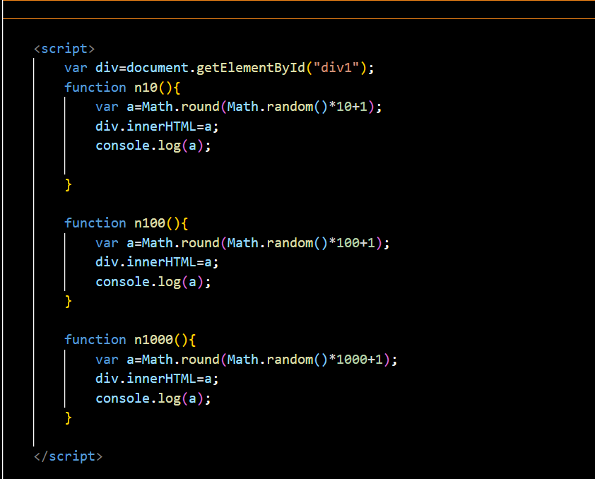

**Topic:  Date methods , callback, for each and map**

**Date Methods**

**Creating Dates**

Var now=new Date();

**Specific Date and Time**

let specificDate = new Date('2024-06-12T10:20:30Z');

**Getting Date Components**

let year = now.getFullYear();// year

let month = now.getMonth(); //0 -11

let day = now.getDate(); // 1-31

**Day of the Week**

let dayOfWeek = now.getDay(); // 0-6 (0 = Sunday, 6 = Saturday)

**Hours, Minutes, Seconds, Milliseconds**

let hours = now.getHours(); // 0-23

 let minutes = now.getMinutes(); // 0-59

let seconds = now.getSeconds(); // 0-59

let milliseconds = now.getMilliseconds(); // 0-999

**Setting Date Components**

now.setFullYear(2025);

now.setMonth(6); // July

 now.setDate(15);

**Set Hours, Minutes, Seconds, Milliseconds**

now.setHours(15);

now.setMinutes(30);

now.setSeconds(45);

now.setMilliseconds(500);

**Formatting Date and Time**

JavaScript provides methods to format dates as strings in different formats:

**toDateString()**

let dateStr = now.toDateString(); // e.g., "Wed Sep 22 2024"

**toTimeString()**

let timeStr = now.toTimeString(); // e.g., "15:30:45 GMT+0530 (India Standard Time)"

**toLocaleDateString()**

let localDateStr = now.toLocaleDateString(); // e.g., "9/22/2024" in US format

**toLocaleTimeString()**

let localTimeStr = now.toLocaleTimeString(); // e.g., "3:30:45 PM" in US format

These methods allow you to present dates in a human-readable or standardized format.

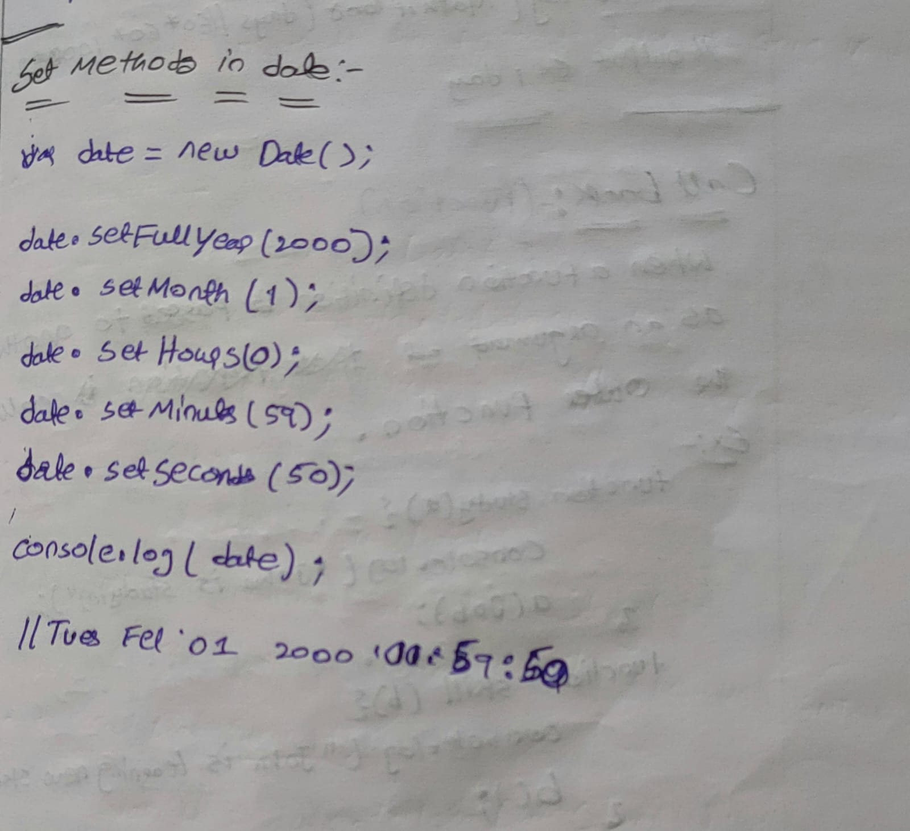

**Age calculator**

    <input type="date" id="el1" />

    <button onclick="fun()">clicke me</button>

    <script>

      function fun() {

        var d = document.getElementById("el1").value;

        var olddate = new Date(d);

        var newdate = new Date();

**var year = newdate.getFullYear() - olddate.getFullYear();**

**var milliseconds = newdate - olddate;**

**var days = Math.floor(milliseconds / (60 * 60 * 24 * 1000));**

        console.log(days);

        console.log(year);

      }

    </script>

**Callbacks**

callback is a function defintion is passed as an argument to another function and is executed after some operation has been completed. This is a powerful feature that allows for asynchronous programming, enabling tasks to run concurrently without blocking the main execution thread.

**Defining the Callback:**

      // Step 1: Define the callback function

      function myCallback() {

        console.log("Callback function executed!");

      }

**The callback function can be defined separately or inline.**

**// Defining separately**

      function myCallback() {

        console.log("Callback executed!");

      }

      doSomething(myCallback);

**// Defining inline**

      doSomething(function () {

        console.log("Callback executed!");

      });

**Step 1: Define a Function that Takes Another Function as a Parameter(HOF)**

**Step 2: Define a function that takes another function as a parameter**

**Step 3: Execute the callback function**

**Step 4: Pass the callback function as an argument**

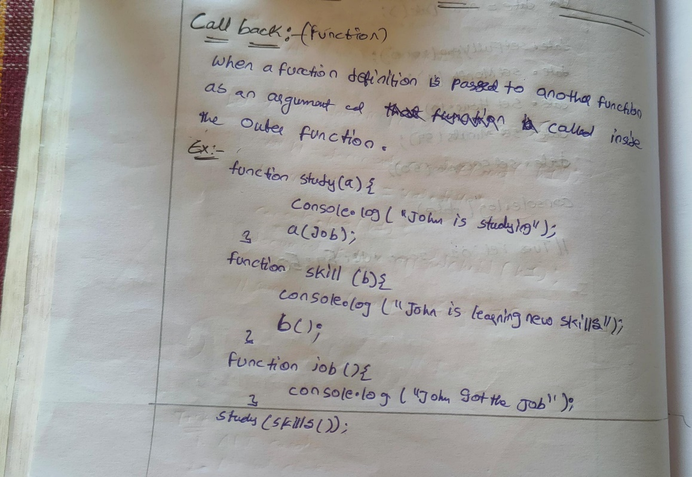

**Ex-1**

function myFirst() {

  console.log("Hello");

}

function mySecond(a) {

  console.log("Goodbye");

}

var a=myFirst();

mySecond(a);

//Hello

//Goodbye

**Ex-2**

function myFirst() {

  console.log("Hello");

}

function mySecond() {

    myFirst()

  console.log("Goodbye");

}

mySecond();

The problem with the first example above, is that you have to call two functions to display the result.

The problem with the second example, is that you cannot prevent the function from displaying the result when it invokes every time.

function myFirst() {

  console.log("Hello");

}

function mySecond(a) {

  console.log("Goodbye");

}

mySecond(myFirst());//can call two functions at a time

mySecond()//one function

**Usage of Callbacks**

Callbacks are commonly used in situations where you want to perform tasks asynchronously,

**such as:**

Event Handling

Array Methods

Higher-Order Functions

Asynchronous Operations

**Array Iteration and Transformation Methods:**

**Array for each**

Array.forEach() is a method in JavaScript used to iterate over elements in an array. It executes a provided function once for each array element

**Syntax:**

array.forEach(function(value, index, array) {

    // Your code here

});

**value**: The current item in a array.

**index (optional):** The index of the item in the array.

**array (optional):** The array that forEach()

const numbers = [1, 2, 3, 4, 5];

numbers.forEach(function(val, index) {

    console.log(`Element at index ${index} is ${val }`);

});

//output

// Element at index 0 is 1

// Element at index 1 is 2

// Element at index 2 is 3

// Element at index 3 is 4

// Element at index 4 is 5

**You can also use arrow functions for a more concise syntax:**

numbers.forEach((number, index) => {

    console.log(`Element at index ${index} is ${number}`);

});

One important thing to note about forEach() is that it doesn't return anything. It simply iterates over the array. If you need to transform the elements of the array and create a new array based on those transformations, you might want to use methods like map() instead.

array.forEach(function(element) {

    return element * 2; // This return statement has no effect

});

**Map method:**

The map() method in JavaScript is used to create a new array by calling a provided function on every element in the calling array. It doesn't change the original array; instead, it returns a new array with the results of applying the provided function to each element.

**Syntax:**

const newArray = array.map(function callback(currentValue, index, array) {

  // Return element for newArray

});

**value:** The current item in a array.

**index (optional):** The index of the item in the array.

**array (optional):** The array that forEach()

const numbers = [1, 2, 3, 4, 5];

const doubledNumbers = numbers.map(function(number) {

  return number * 2; // Return value determines the value

});

console.log(doubledNumbers); // Output: [2, 4, 6, 8, 10]

**You can also use arrow functions for more concise syntax:**

const numbers = [1, 2, 3, 4, 5];

const doubledNumbers = numbers.map(number => number * 2);

console.log(doubledNumbers); // Output: [2, 4, 6, 8, 10]

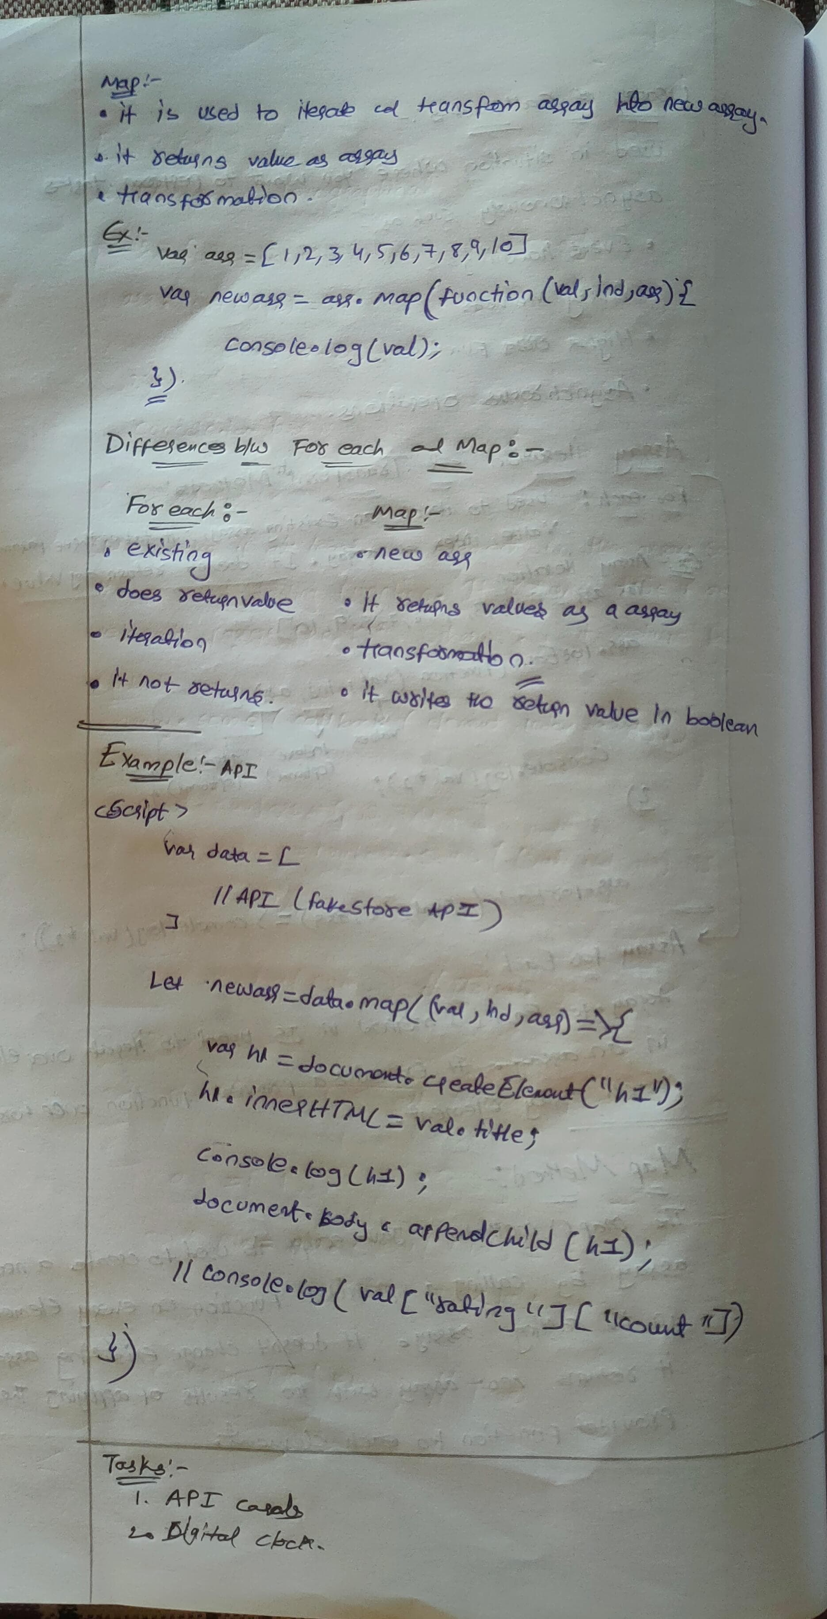

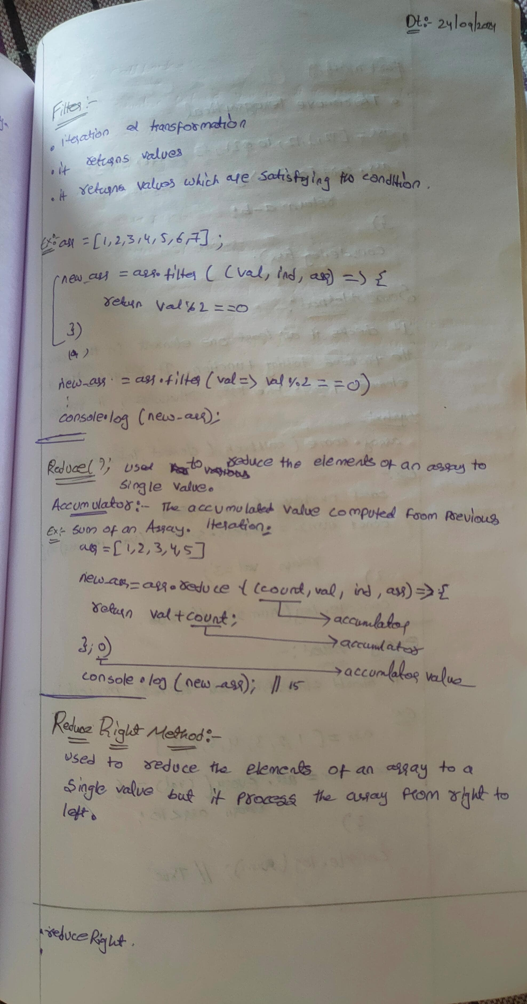

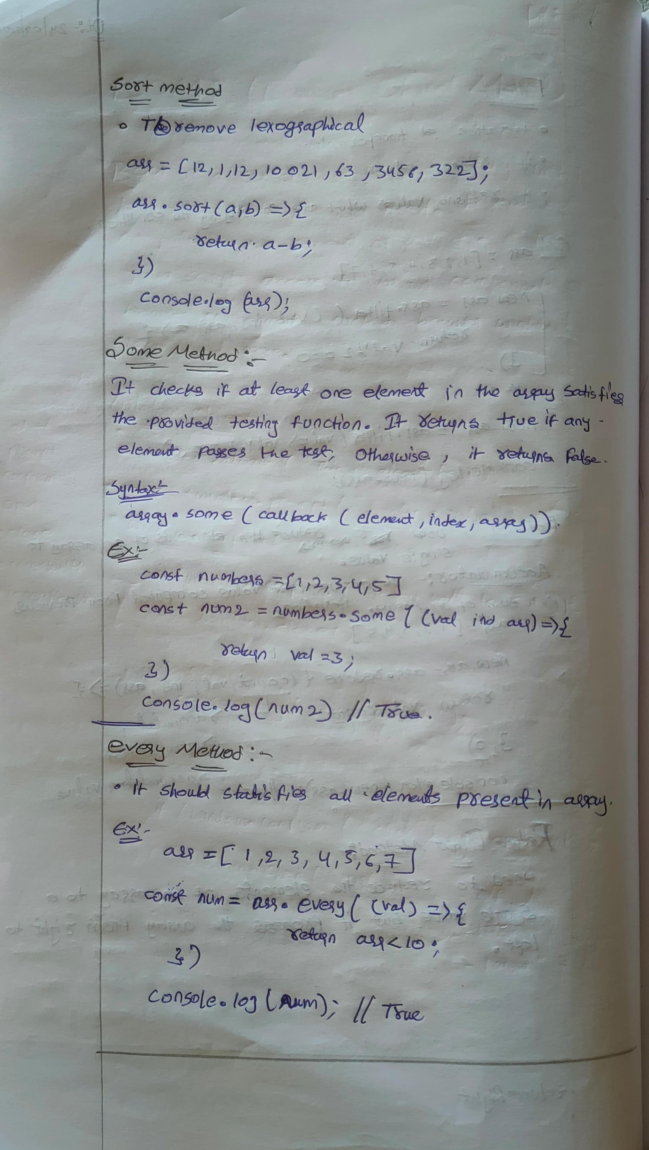

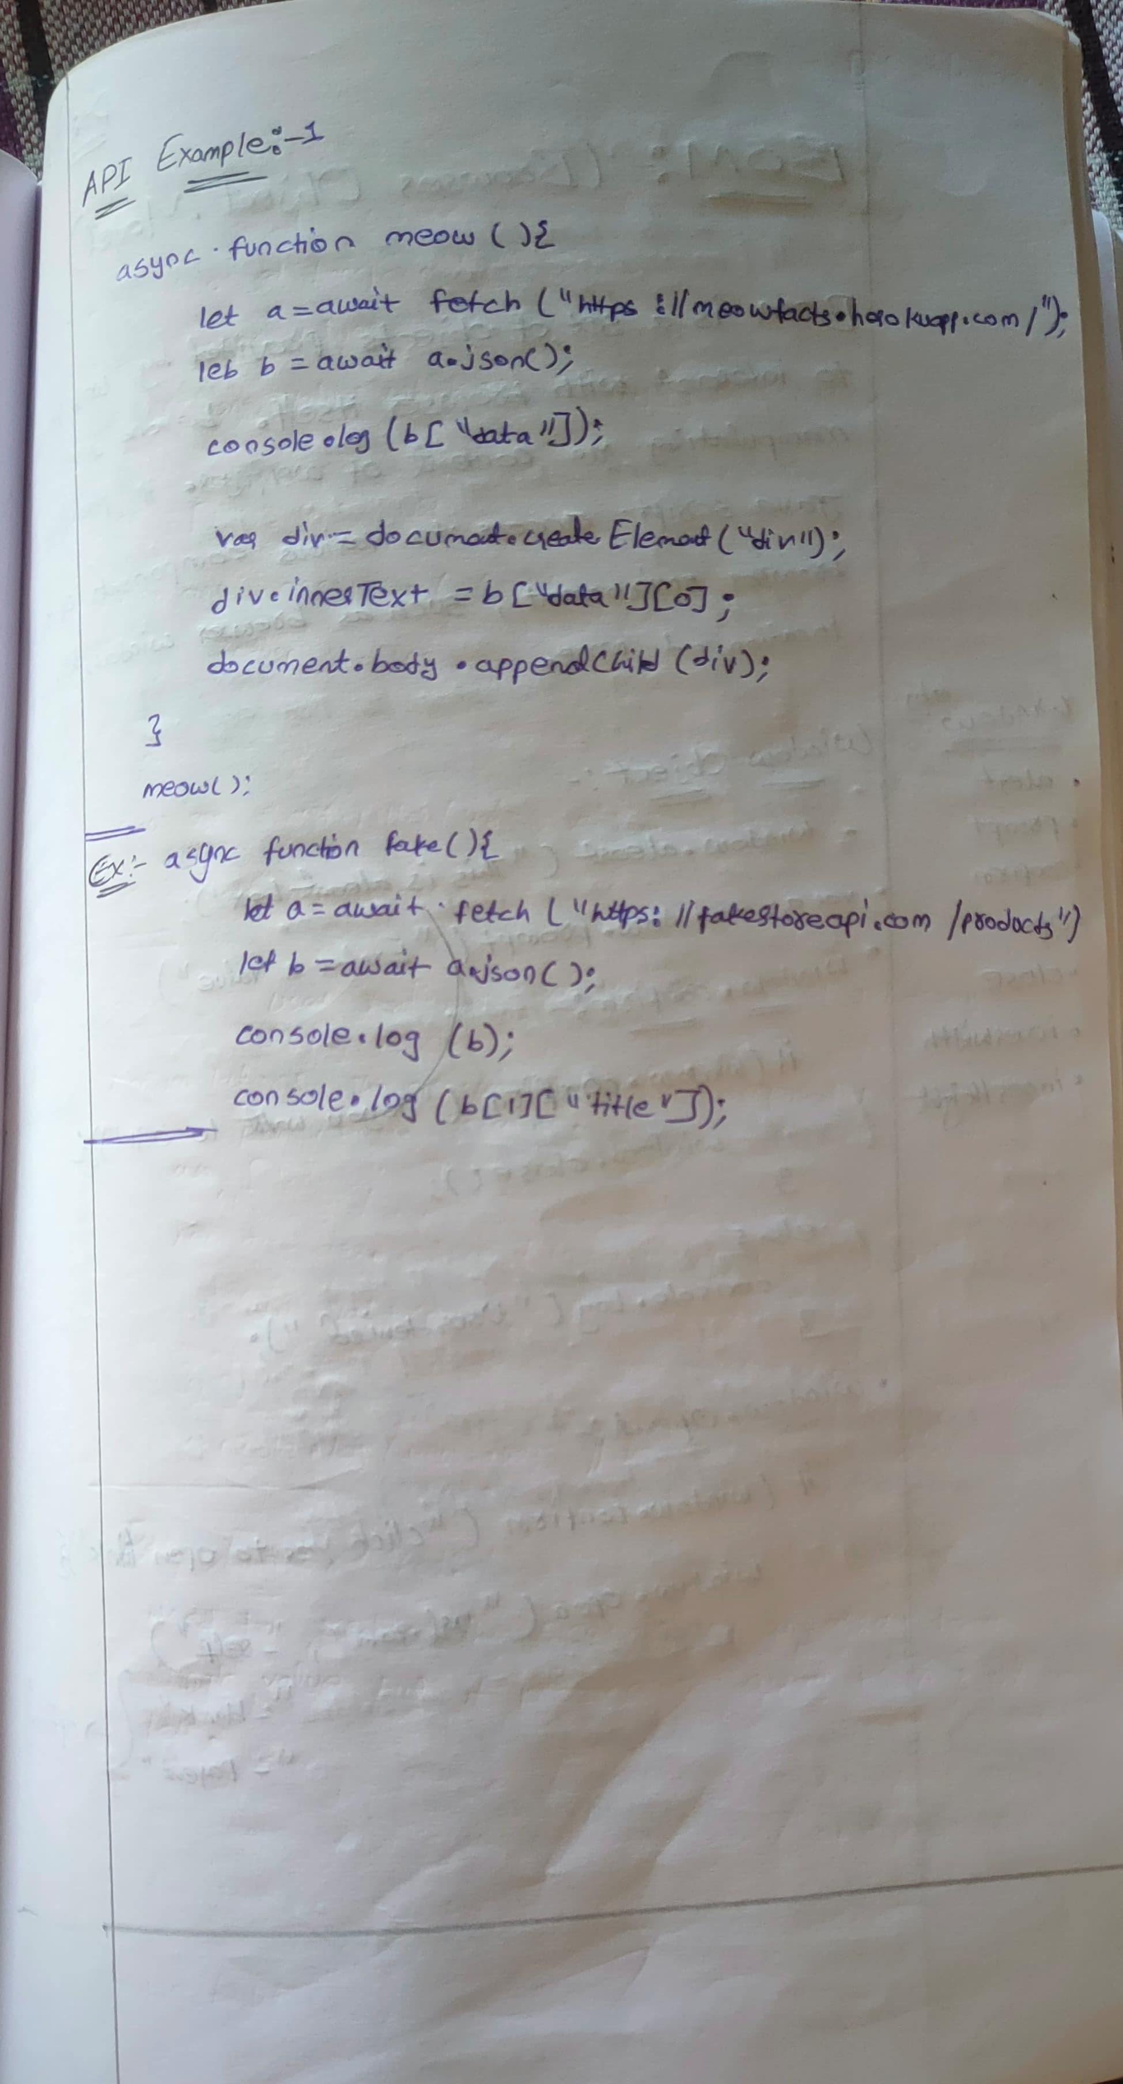

**Task:**

1. **Digital Clock**

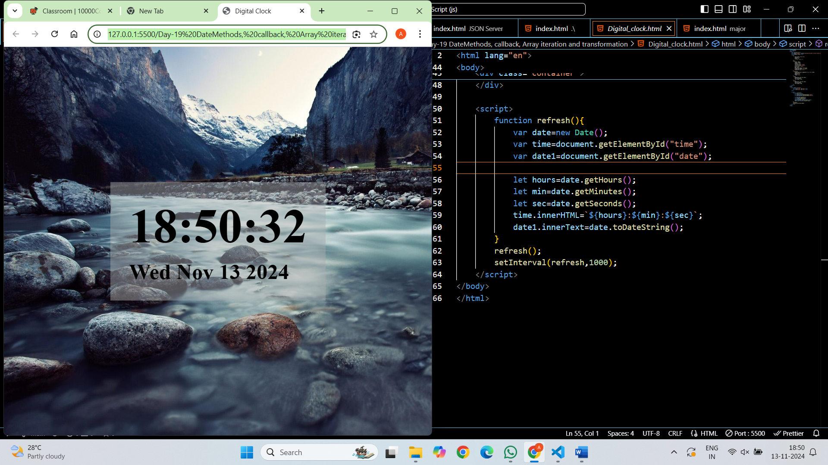

**2. API Cards**

const products = [

    //Fake Store API Data

  ]

const container = document.getElementById('card-container');

**// Function to create a card for each product**

function createProductCard(product) {

    const card = document.createElement('div');

    card.className = 'card';

    const image = document.createElement('img');

    image.src = product.image;

    const title = document.createElement('div');

    title.className = 'title';

    title.textContent = product.title;

    const description = document.createElement('div');

    description.className = 'description';

    description.textContent = product.description;

    const price = document.createElement('div');

    price.className = 'price';

    price.textContent = `$${product.price}`;

    const rating = document.createElement('div');

    rating.className = 'rating';

    rating.textContent = `Rating: ${product.rating.rate} (${product.rating.count} reviews)`;

    card.appendChild(image);

    card.appendChild(title);

    card.appendChild(description);

    card.appendChild(price);

    card.appendChild(rating);

    return card;

}

**// Loop through the products and create cards**

products.forEach(product => {

    const productCard = createProductCard(product);

    container.appendChild(productCard);

});



**3. Genrate Jokes Using API:**

<button onclick="jokes()">click here</button>

    <div class="container"></div>

    <script>

        async function jokes(){

            let a=await fetch("https://official-joke-api.appspot.com/random_joke");

            let b=await a.json();

            // console.log(b);

            // console.log(b["setup"]);

            var span=document.createElement("span");

            span.innerHTML="Type Of Joke:";

            var span1=document.createElement("span");

            span1.innerHTML=b["type"];

            span1.style.paddingBottom="15px";

            var div1=document.createElement("div");

            div1.innerHTML=b["setup"];

            var div2=document.createElement("div");

            div2.innerHTML="Punchline: "+b["punchline"];

            div2.style.fontSize="18px"

            var div=document.getElementsByClassName("container")[0];

            span.appendChild(span1);

            div.appendChild(span);

            div.appendChild(div1);

            div.appendChild(div2);

            // document.body.appendChild(div);

        }

        // jokes();

    </script>

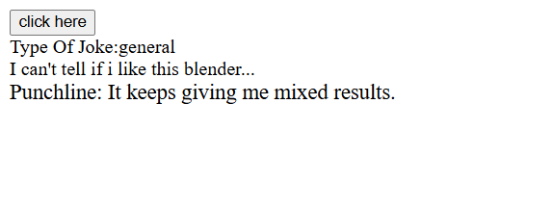

**4. Genrate Meow facts using API**

    <button onclick="me()">click here</button>

    <script>

        async function me(){

            let a=await fetch("https://meowfacts.herokuapp.com/");

            let b=await a.json();

            console.log(b["data"][0]);

            var div=document.createElement("div");

            div.innerHTML=b["data"][0];

            document.body.appendChild(div);

        }

        // me();

    </script>

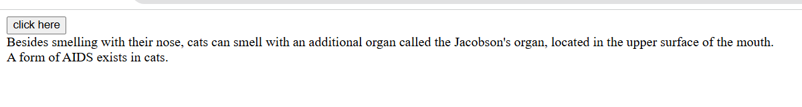

**Topic:  Browser Object Model (BOM)**

The **Browser Object Model (BOM)** is a set of objects provided by web browsers to interact with the browser itself, beyond just manipulating the content of a web page. It provides JavaScript access to various components of the browser environment, such as the browser window, history, location, and more.

**1. Window Object**

The window object represents the browser's window. All global JavaScript objects, functions, and variables automatically become members of the window object.

2. **Window Object**:

Get the width and height of the browser window

console.log(window.innerWidth);

console.log(window.innerHeight);

window.open("https://example.com", "_blank", "width=600,height=400");

**3. Navigator objects**

The Navigator object in JavaScript provides information about the browser's name, version, platform, and capabilities.

**4. Location objects**

It provides properties that allow you to access and manipulate different parts of the URL

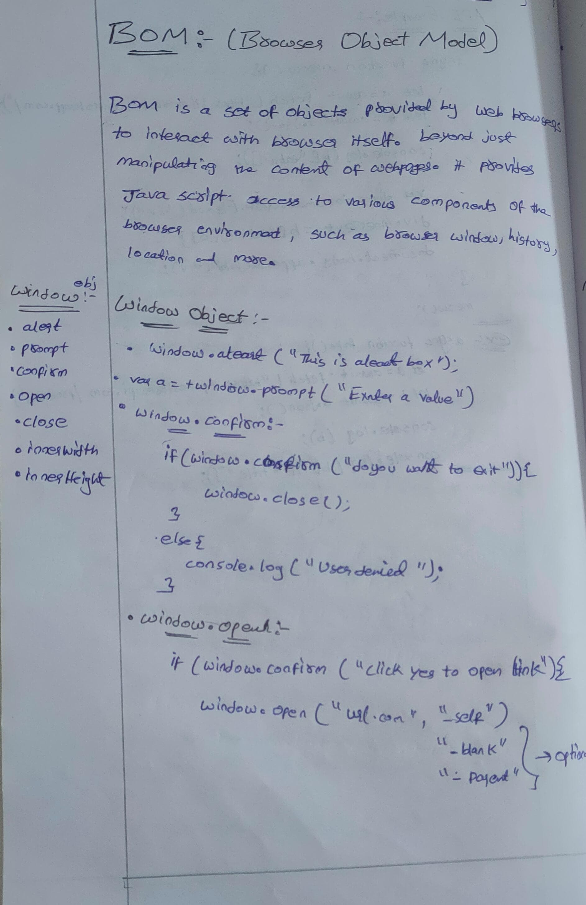

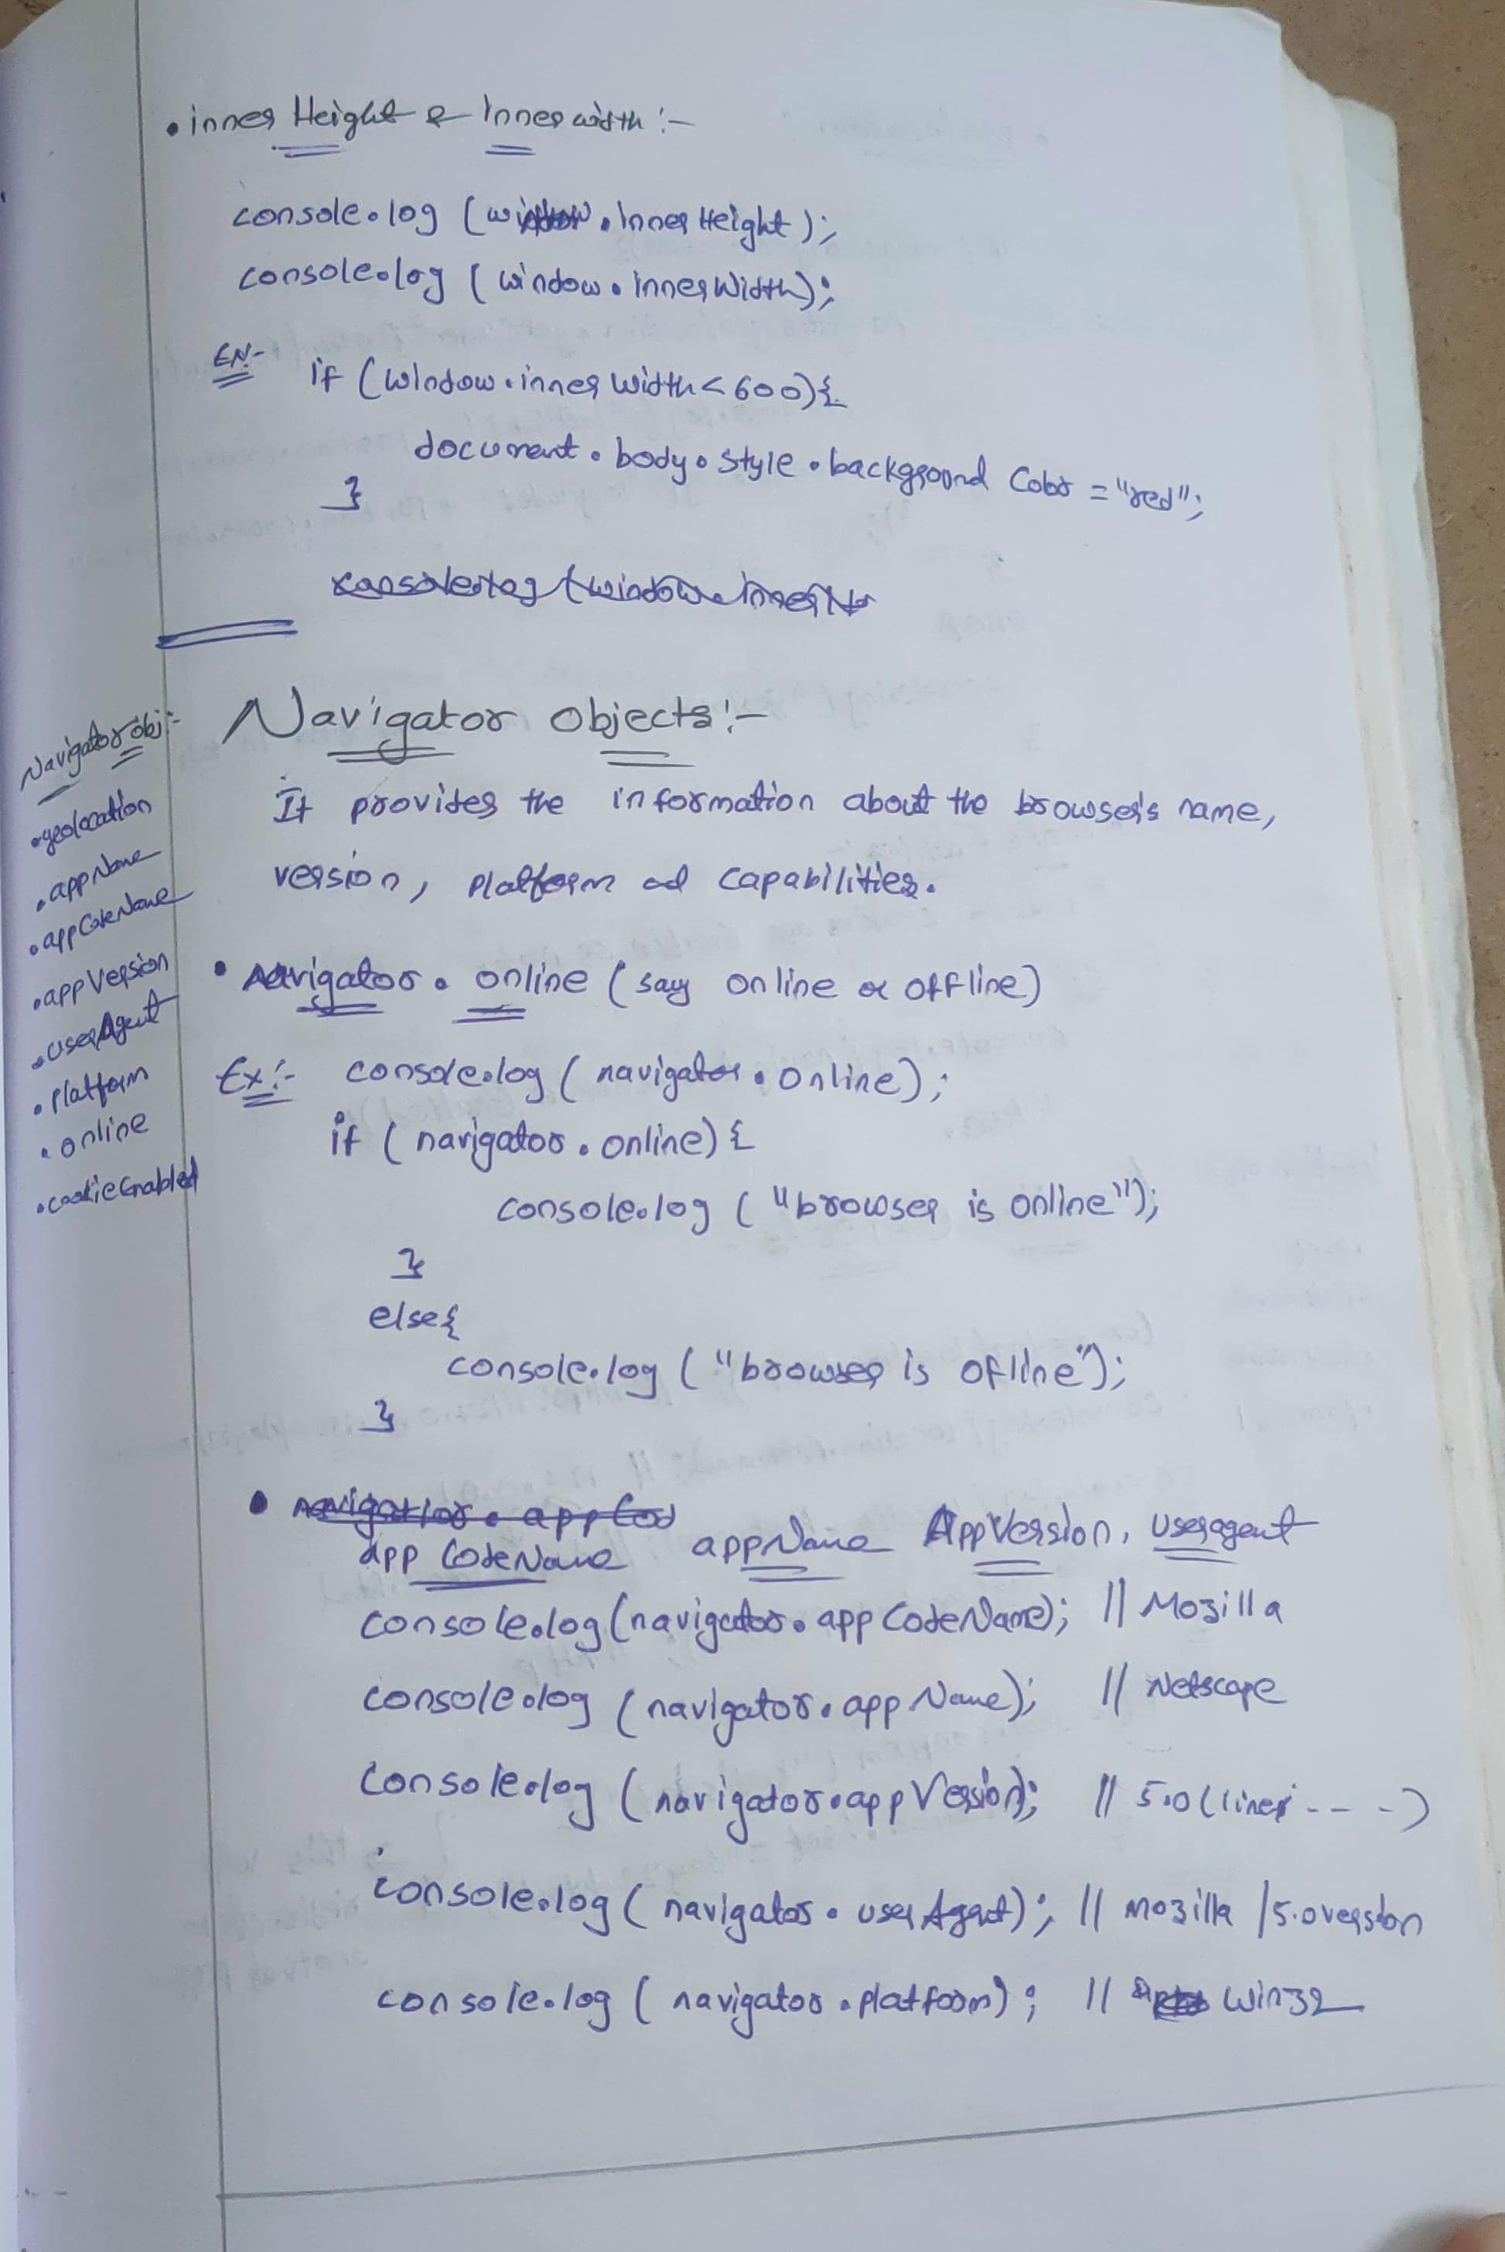

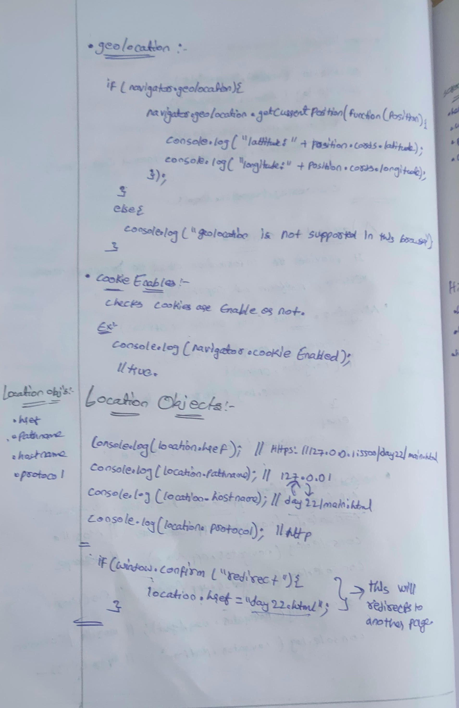

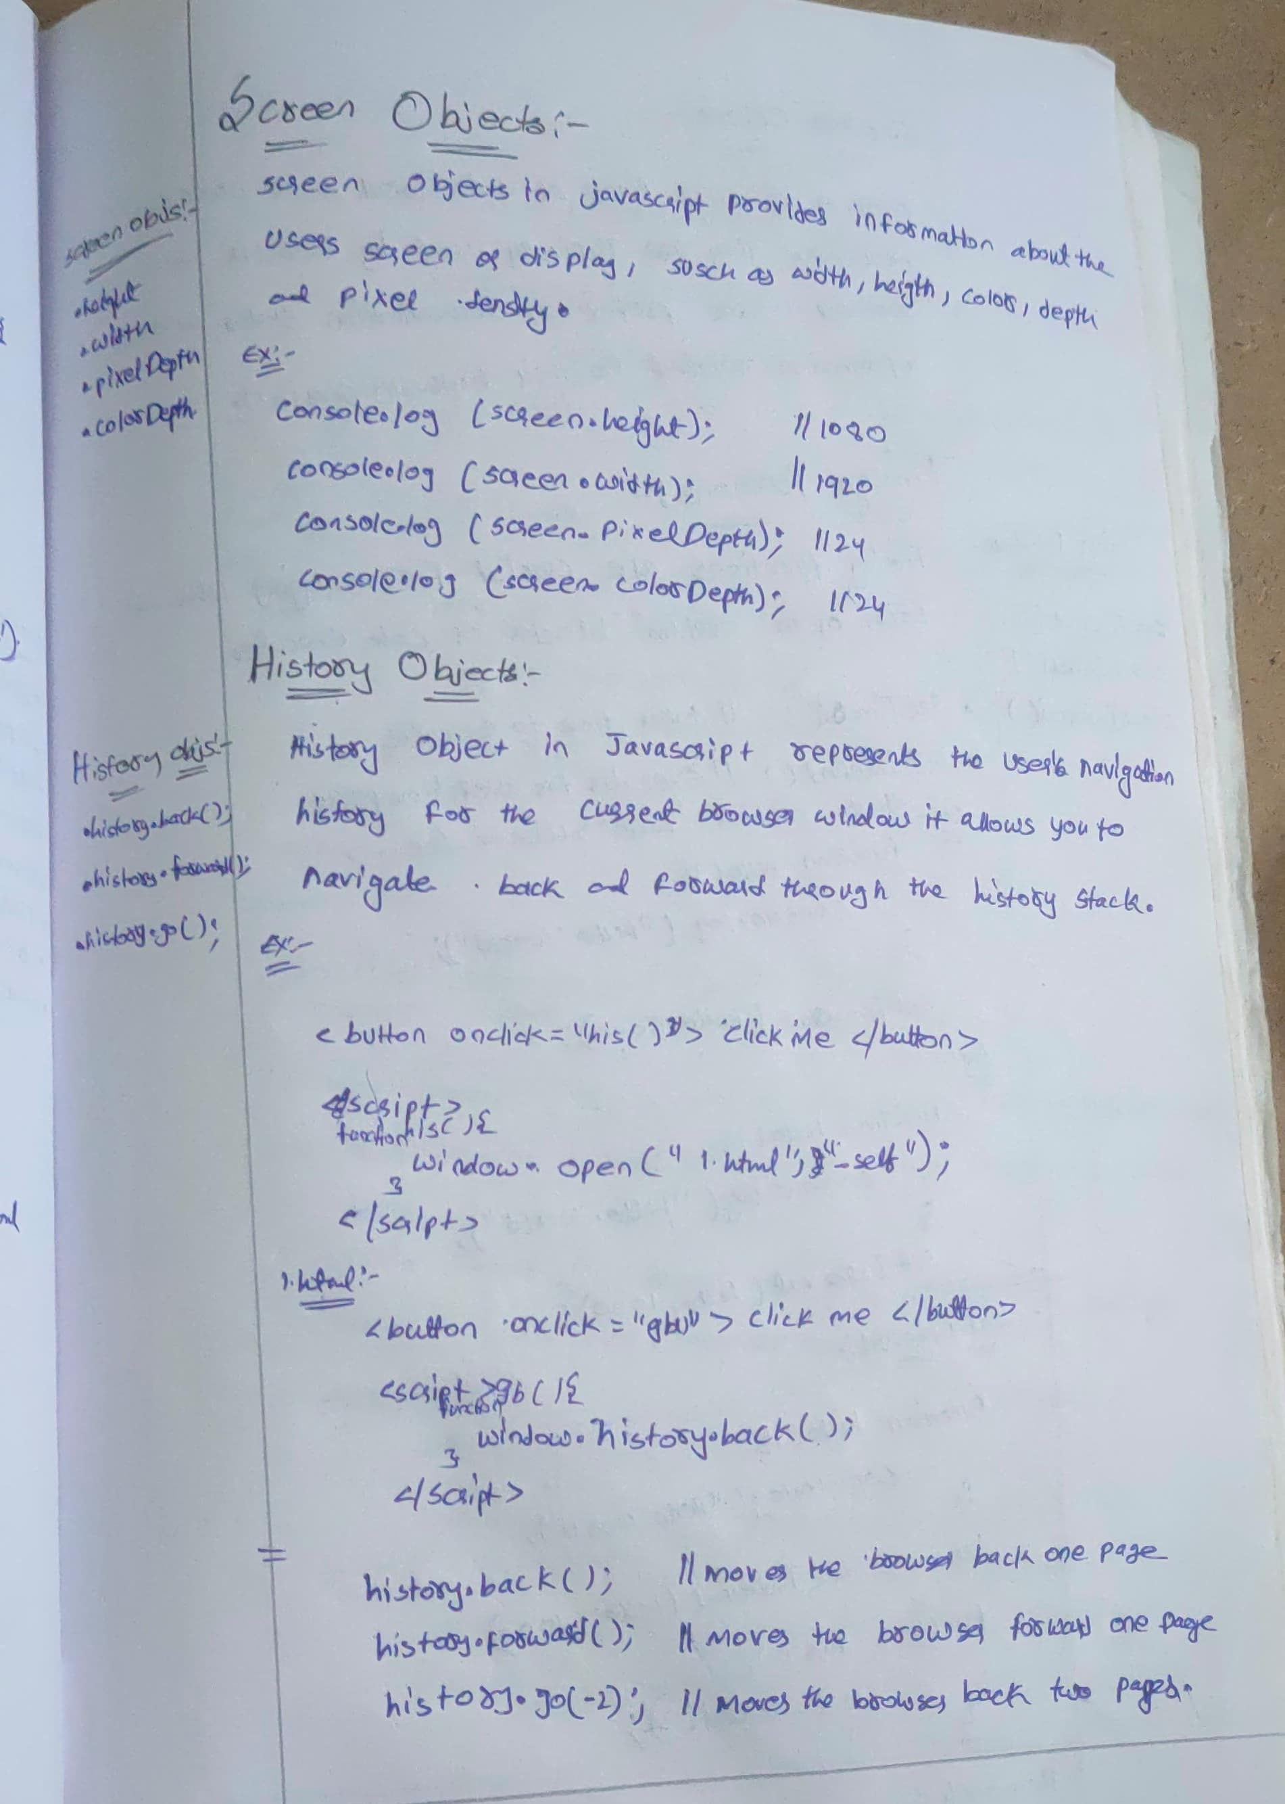

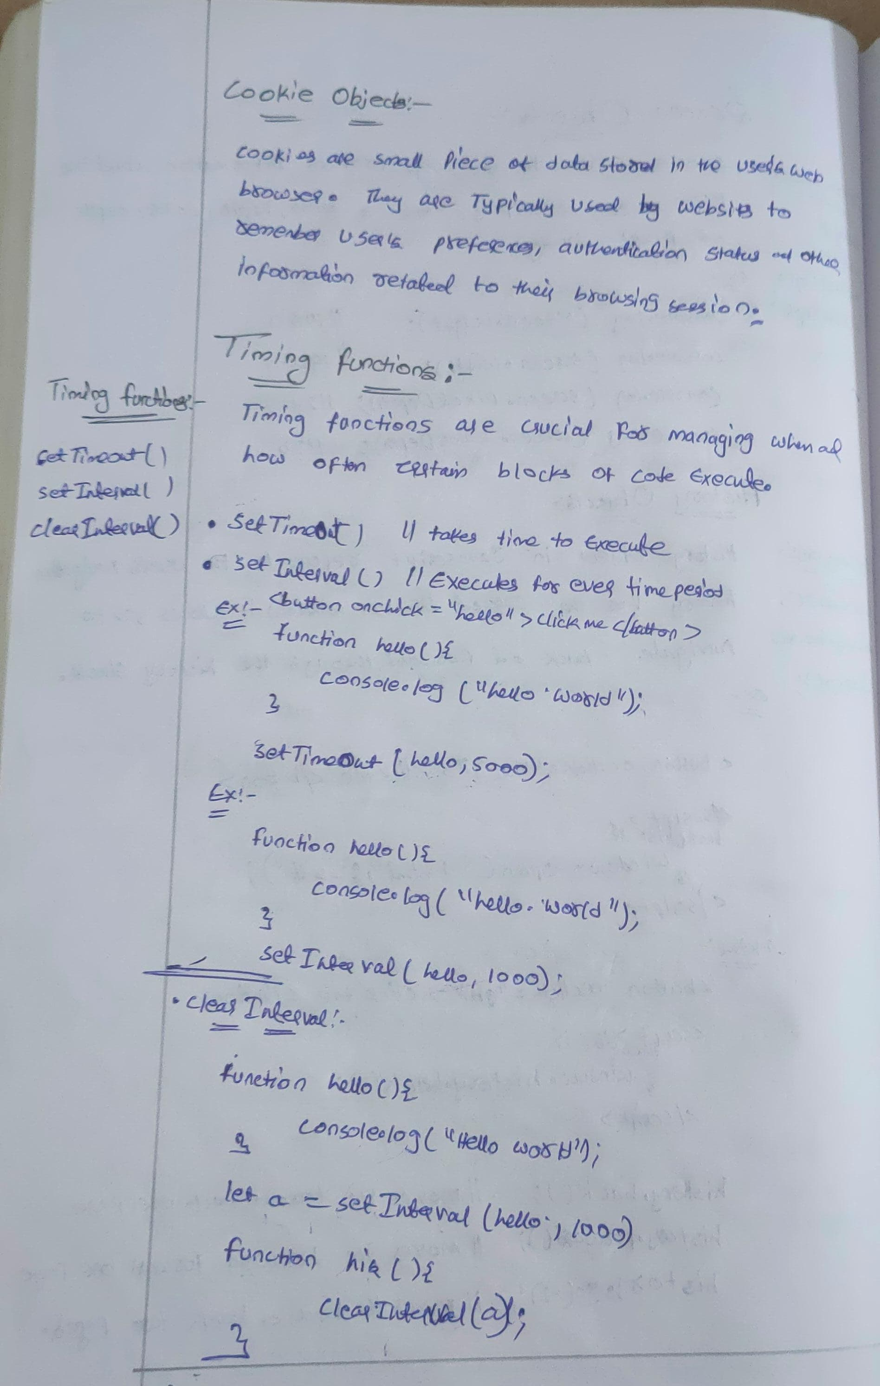

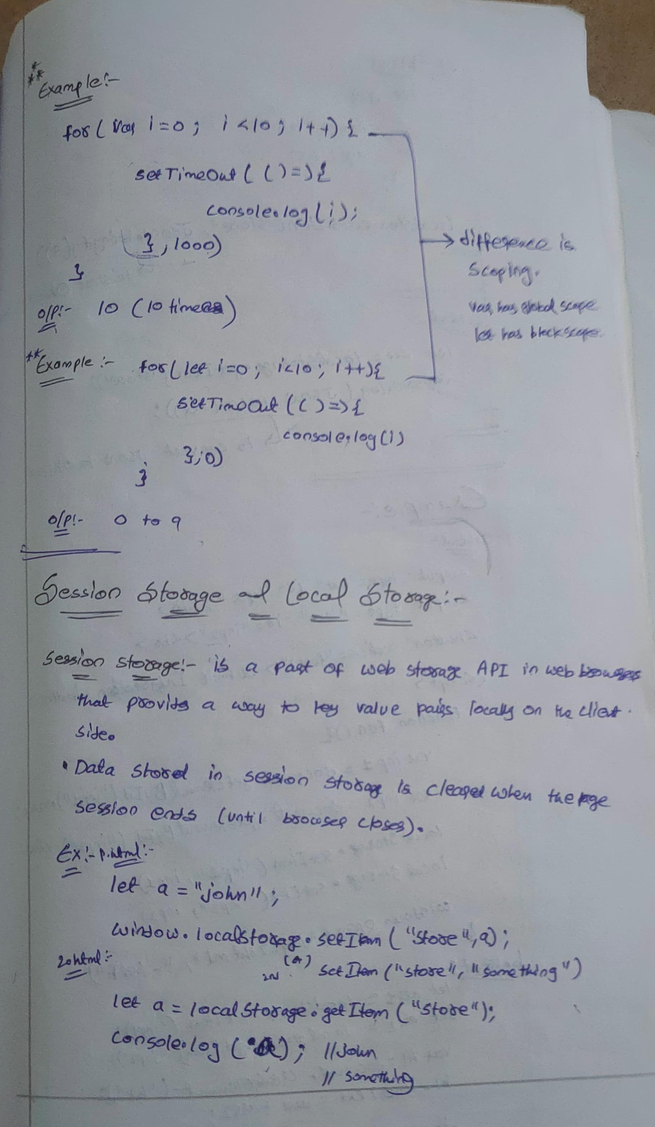

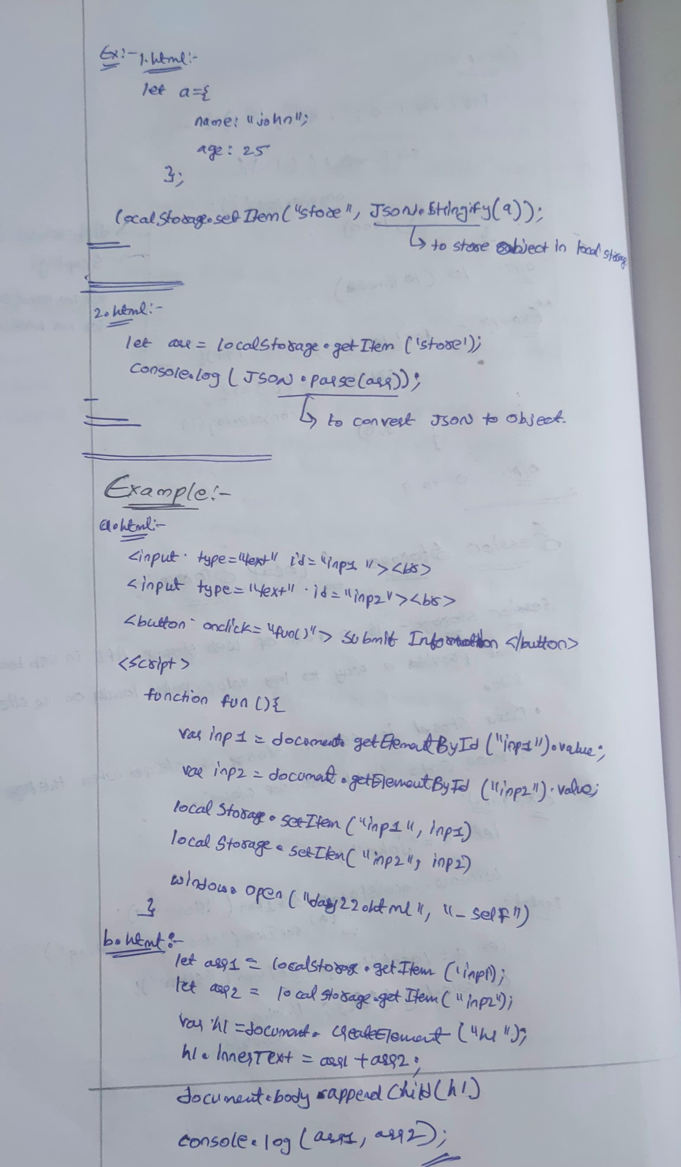

**Topic:  Bubbling, capturing, binding, local storage and session storage**

**Event Bubbling:**

   - Event bubbling is a mechanism where when an event is triggered on a nested element inside another element, the event 'bubbles up' through its ancestors.

   - By default, most events bubble.

   - You can stop the bubbling phase using `**event.stopPropagation()**`.

  <div id="parent">

        <button id="child">

            click me

        </button>

    </div>

    <script>

    let parent=document.getElementById("parent");

    let child=document.getElementById("child");

    child.addEventListener("click", function(event){

        event.stopPropagation()// this will prevent the bubbling to the parent

        console.log("child is clicked");

    })

    parent.addEventListener("click", function(){

        console.log("parent is clicked")

    })

    </script>

**Event Capturing:**

   - Event capturing is the opposite of event bubbling.

   - During the capturing phase, the event is first captured by the outermost element and then propagated to the innermost element.

   - You can listen to events during the capturing phase by passing `true` as the third parameter to `**addEventListener()`.**

  <div id="parent">

        <button id="child">

            click me

        </button>

    </div>

    <script>

    let parent=document.getElementById("parent");

    let child=document.getElementById("child");

**child.addEventListener**("click", function(event){

        console.log("child is clicked");

    })

**parent.addEventListener**("click", function(){

        console.log("parent is clicked")

    },true)

**Event Binding:**

   - Event binding refers to the **process of attaching event listeners to DOM elements**.

   - This is typically done using `**addEventListener()**` or by assigning event handler properties like `onclick`.

**Session storage and local storage**

**Session storage** is a part of the Web Storage API in web browsers that provides a way to store key-value pairs locally on the client-side.

* sessionStorage maintains a separate storage area for each given origin that's available for the duration of the page session (as long as the browser is open, including page reloads and restores).
* Data stored in sessionStorage is cleared when the page session ends.
* Data is only accessible within the window/tab that set it.

**// Storing data in sessionStorage**

sessionStorage.setItem('username', 'John');

**// Retrieving data from sessionStorage**

let username = sessionStorage.getItem('username');

console.log(username); // Output: John

**// Removing data from sessionStorage**

sessionStorage.removeItem('username');

**localStorage:**

localStorage is a feature of web browsers that allows web applications to store key-value pairs locally on the client-side. It provides a persistent storage mechanism, meaning that the data stored in localStorage remains available even after the browser is closed and reopened, and across browser sessions.

* localStorage does almost the same thing as sessionStorage, but it persists even when the browser is closed and reopened.
* Data stored in localStorage has no expiration time.
* Data is accessible across windows and tabs within the same origin.

**// Storing data in localStorage**

localStorage.setItem('email', 'example@example.com');

**// Retrieving data from localStorage**

let email = localStorage.getItem('email');

console.log(email); // Output: example@example.com

**// Removing data from localStorage**

localStorage.removeItem('email');

**how to display some data from one page to another page using local storage**

local storage limited to handle only string key/value pairs you can do like below using **JSON.stringify** and while getting value **JSON.parse**

var testObject ={name:"test", time:"Date 2017-02-03T08:38:04.449Z"};

**Put the object into storage:**

localStorage.setItem('testObject', JSON.stringify(testObject));

**Retrieve the object from storage:**

var retrievedObject = localStorage.getItem('testObject');

console.log('retrievedObject: ', JSON.parse(retrievedObject));

**Example: Add to cart functionality**

**//first file**

<!DOCTYPE html>

<html lang="en">

  <head>

    <meta charset="UTF-8" />

    <meta name="viewport" content="width=device-width, initial-scale=1.0" />

    <title>Document</title>

    <style>

      .container {

        display: grid;

        grid-template-columns: auto auto auto;

        gap: 20px;

      }

      .container > div {

        padding: 20px;

        border: 1px solid red;

      }

      .container > div > div,

      h1 {

        padding: 10px;

        border: 2px solid blue;

      }

    </style>

  </head>

  <body>

    <h1>

      <button onclick="cart()">cart</button>

    </h1>

    <div id="row" class="container"></div>

    <script>

      async function apicall() {

        var newarr = [];

        var result = await fetch("https://fakestoreapi.com/products");

        var apidata = await result.json();

        console.log(apidata);

        var iterated = apidata.map((val) => {

          // console.log(val);

          var row = document.getElementById("row");

          var main = document.createElement("div");

          var child1 = document.createElement("h1");

          var child2 = document.createElement("div");

          var child3 = document.createElement("div");

          var child4 = document.createElement("div");

          child1.innerHTML = val.id + " <br>";

          child2.innerHTML = val.title + " <br>";

          child3.innerHTML = val.description + " <br>";

          child4.innerHTML = val.price + " <br>";

          var btn = document.createElement("button");

          btn.innerHTML = "click";

          btn.addEventListener("click", function () {

            newarr.push(val);

            sessionStorage.setItem("arr", JSON.stringify(newarr));

          });

          main.append(child1, child2, child3, child4, btn);

          row.appendChild(main);

        });

      }

      apicall();

      function cart() {

        window.open("sub.html", "_self");

      }

    </script>

  </body>

</html>

**//second file**

<!DOCTYPE html>

<html lang="en">

  <head>

    <meta charset="UTF-8" />

    <meta name="viewport" content="width=device-width, initial-scale=1.0" />

    <title>Document</title>

  </head>

  <body>

    <div id="row"></div>

    <script>

      var newarrdata = JSON.parse(sessionStorage.getItem("arr"));

      console.log(newarrdata);

      var iterated = newarrdata.map((val) => {

        // console.log(val);

        var row = document.getElementById("row");

        var main = document.createElement("div");

        var child1 = document.createElement("h1");

        var child2 = document.createElement("div");

        var child3 = document.createElement("div");

        var child4 = document.createElement("div");

        child1.innerHTML = val.id + " <br>";

        child2.innerHTML = val.title + " <br>";

        child3.innerHTML = val.description + " <br>";

        child4.innerHTML = val.price + " <br>";

        var btn = document.createElement("button");

        btn.innerHTML = "click";

        btn.addEventListener("click", function () {

          main.style.display = "none";

        });

        main.append(child1, child2, child3, child4, btn);

        row.appendChild(main);

      });

    </script>

  </body>

</html>

**Topic: regex, synchronous and asynchronous**

**Regular Expressions (Regex)**

A regular expression is a sequence of characters that helps to create a search pattern, often used for string matching and manipulation.

**Ways to Create Regular Expressions**

Literal Notation: Uses slashes to define the pattern.

Syntax: /pattern/flags

**Example:**

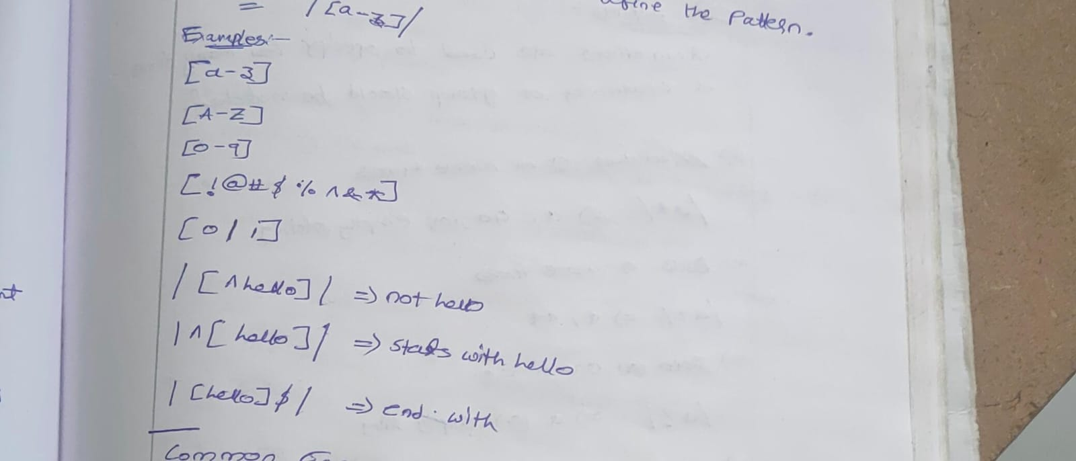

/hello/ matches the string "hello".

/^[0-9]{10}$/ matches a 10-digit number (starts with a digit, ends with a digit).

/[0|1]/ matches either "0" or "1".

**Bracket Expressions:**

[ ] Matches any character inside the brackets.

Example: [a-z] matches any lowercase letter between 'a' and 'z'.

[^ ] Matches any character not in the brackets.

Example: [^a-z] matches any character except lowercase letters.

[0-9] Matches any digit between '0' and '9'.

[A-Z] Matches any uppercase letter between 'A' and 'Z'.

**Common Escape Sequences**

\d Matches any **digit** (equivalent to [0-9]).

\D Matches any **non-digit character** (equivalent to [^0-9]).

\w Matches **alphanumeric characters and underscores** (equivalent to [A-Za-z0-9_]).

\W Matches any **non-alphanumeric character**.

\. Matches a **literal period** (dot).

**Methods for Using Regular Expressions**

test(): Checks if the pattern exists in a string and returns true or false.

const regex = /\d+/;

console.log(regex.test("123"));  // true

console.log(regex.test("abc"));  // false

**Quantifiers**

Quantifiers are used to **specify how many times a character or group should be matched**:

* Matches **zero or more times**.
* **Example:** /a*/ matches "a", "aa", or an empty string.
* + Matches **one or more times**.
* **Example:** /a+/ matches "a", "aa", but not an empty string.
* ? Matches **zero or one time**.
* **Example:** /a?/ matches "a" or an empty string.
* {n}: Matches exactly **n occurrences** of the preceding element.
* **Example:** /a{3}/ matches exactly three "a" characters in a row ("aaa").
* "aaa" matches, "aa" does not match.
* {n,}: **Matches n or more occurrences** of the preceding element.
* **Example:** /a{3,}/ matches three or more "a" characters.
* aaa", "aaaa", and "aaaaa" match, but "aa" does not.
* {n,m}: **Matches between n and m occurrences** of the preceding element.
* **Example:** /a{3,5}/ matches between 3 to 5 "a" characters.
* "aaa", "aaaa", and "aaaaa" match, but "aa" and "aaaaaa" do not.

**Examples of Regex**

**Phone Number Validation:**

**Regex**: /^[0-9]{10}$/

Explanation: Matches exactly 10 digits from 0-9, used for validating phone numbers.

**Binary Values (0 or 1):**

**Regex:** /[0|1]/

**Explanation:** Matches either 0 or 1.

**Simple Email Validation:**

**Regex:** /^[a-zA-Z0-9._%+-]+@[a-zA-Z0-9.-]+\.[a-zA-Z]{2,}$/

**Explanation:** Matches a basic email format.

**Examples**

**1. Validate an Email Address**

**Pattern:** /^[a-zA-Z0-9._%+-]+@[a-zA-Z0-9.-]+\.[a-zA-Z]{2,}$/

**Explanation:**

^[a-zA-Z0-9._%+-]+ - Matches the username (alphanumeric characters and special symbols like ._%+-).

@ - Requires the "@" symbol.

[a-zA-Z0-9.-]+ - Matches the domain name.

\.[a-zA-Z]{2,} - Ensures a valid top-level domain (TLD), like .com or .net.

**2. Validate a Phone Number (10 digits)**

**Pattern:** /^[0-9]{10}$/

**Explanation:** ^[0-9]{10}$ - Ensures exactly 10 digits between 0 and 9.

**3. Validate a URL**

**Pattern:** /^(https?:\/\/)?(www\.)?[a-zA-Z0-9.-]+\.[a-zA-Z]{2,}(\/\S*)?$/

**Explanation:**

https?:\/\/ - Matches "http" or "https".

(www\.)? - Optional "www.".

[a-zA-Z0-9.-]+ - Matches the domain name.

\.[a-zA-Z]{2,} - Ensures a valid TLD.

(\/\S*)? - Optionally allows a path after the domain.

**4. Validate a Credit Card Number**

**Pattern:** /^(?:\d{4}-?){3}\d{4}$/

**Explanation:**

(?:\d{4}-?){3} - Matches three groups of 4 digits, optionally separated by hyphens.

\d{4} - Matches the final group of 4 digits.

**5. Validate a ZIP Code (US, 5 digits)**

**Pattern**: /^\d{5}(-\d{4})?$/

**Explanation**:

^\d{5} - Matches exactly 5 digits.

(-\d{4})? - Optionally matches a hyphen followed by 4 digits for ZIP+4 codes.

**6. Match a Date (MM/DD/YYYY)**

⦁ **Pattern:** /^(0[1-9]|1[0-2])\/(0[1-9]|[12][0-9]|3[01])\/\d{4}$/

⦁ **Explanation:**

⦁ (0[1-9]|1[0-2]) - Matches months from 01 to 12.

⦁ (0[1-9]|[12][0-9]|3[01]) - Matches days from 01 to 31.

⦁ \d{4} - Matches exactly 4 digits for the year.

**7. Match a Time (24-hour format)**

⦁ **Pattern**: /^([01][0-9]|2[0-3]):[0-5][0-9]$/

⦁ **Explanation**:

⦁ ([01][0-9]|2[0-3]) - Matches hours from 00 to 23.

⦁ :[0-5][0-9] - Matches minutes from 00 to 59.

**8. Match Only Numbers**

**Pattern**: /^\d+$/

**Explanation:**

^\d+$ - Matches any sequence of one or more digits (whole numbers only).

**9. Match Only Alphanumeric Characters**

**Pattern:** /^[a-zA-Z0-9]+$/

**Explanation:** ^[a-zA-Z0-9]+$ - Matches any sequence of alphanumeric characters.

**10. Match Hexadecimal Colors**

**Pattern:** /^#?([a-fA-F0-9]{6}|[a-fA-F0-9]{3})$/

**Explanation**:

#? - The # symbol is optional.

([a-fA-F0-9]{6}|[a-fA-F0-9]{3}) - Matches either a 6-character or 3-character hex color.

**11. Strip Whitespace from the Beginning and End of a String**

**Pattern**: /^\s+|\s+$/g

**Explanation**:

^\s+ - Matches one or more whitespace characters at the start.

\s+$ - Matches one or more whitespace characters at the end.

g flag - Global search for all matches.

**12. Match a Word Boundary**

**Pattern**: /\bword\b/

**Explanation**:

\b - Ensures the pattern matches at word boundaries.

word - The specific word to match.

**13. Match a Floating-Point Number**

**Pattern**: /^[+-]?([0-9]*[.])?[0-9]+$/

**Explanation**:

[+-]? - Allows an optional "+" or "-" sign.

([0-9]*[.])? - Optionally matches digits before and after a decimal point.

[0-9]+ - Requires at least one digit.

**14. Validate a Strong Password**

**Pattern**: /^(?=.*[a-z])(?=.*[A-Z])(?=.*\d)(?=.*[@$!%*?&])[A-Za-z\d@$!%*?&]{8,}$/

**Explanation**:

(?=.*[a-z]) - Requires at least one lowercase letter.

(?=.*[A-Z]) - Requires at least one uppercase letter.

(?=.*\d) - Requires at least one digit.

(?=.*[@$!%*?&]) - Requires at least one special character.

{8,} - Must be at least 8 characters long.

**15. Match a Repeated Character**

**Pattern**: /(\w)\1+/

**Explanation**:

(\w) - Captures any alphanumeric character.

\1+ - Matches one or more occurrences of the same captured character.

**16. Match an IP Address (IPv4)**

**Pattern**: /^(25[0-5]|2[0-4][0-9]|[01]?[0-9][0-9]?)\.(25[0-5]|2[0-4][0-9]|[01]?[0-9][0-9]?)\.(25[0-5]|2[0-4][0-9]|[01]?[0-9][0-9]?)\.(25[0-5]|2[0-4][0-9]|[01]?[0-9][0-9]?)$/

**Explanation**:

Each part of the IP is matched using (25[0-5]|2[0-4][0-9]|[01]?[0-9][0-9]?) which ensures a valid number between 0 and 255.

**17. Match HTML Tags**

**Pattern**: /^<\/?[\w\s"'-=]+>$/

**Explanation**:

<\/? - Matches an opening or closing tag.

[\w\s"'-=]+ - Matches tag content (attributes, values).

> - Matches the closing bracket.

**18. Match Leading Zeroes**

**Pattern:** /^0+(?=\d)/

**Explanation**:

^0+ - Matches one or more leading zeroes.

(?=\d) - Ensures a digit follows.

**19. Validate a Username**

**Pattern**: /^[a-zA-Z0-9_]{3,16}$/

**Explanation**:

^[a-zA-Z0-9_]{3,16}$ - Matches a username that is 3-16 characters long, only allowing alphanumeric characters and underscores.

**20. Match a Word with Only Letters**

**Pattern**: /^[A-Za-z]+$/

**Explanation**:

^[A-Za-z]+$ - Matches a word containing only letters (upper or lowercase).

**Synchronous and asynchronous**

**Synchronous:** In synchronous operations, code is executed sequentially, one line at a time. Each line must wait for the previous one to finish executing before it can start. This can sometimes lead to blocking behavior, where one task prevents another from executing until it's complete.

    console.log("Start");

    console.log("Middle");

    console.log("End");

    // start

    // middle

    // end

In this synchronous code, "Start" will be logged first, followed by "Middle", and then "End".

**Asynchronous:** Asynchronous operations allow code to execute independently from the main program flow. This means that while one operation is being processed, the program can continue to execute other tasks. Asynchronous operations are typically used for tasks that may take some time to complete, such as fetching data from a server or reading a file. In JavaScript, common asynchronous operations are handled using callbacks, promises, or async/await syntax.

    console.log("Start");

    setTimeout(()=>{

       console.log("middle")

    }),2000;

    console.log("End");

    // start

    // end

    // middle

In this example, "Start" is logged first, then after a delay of 2000 milliseconds, "End" is logged, followed by " Middle ".

**How js works**

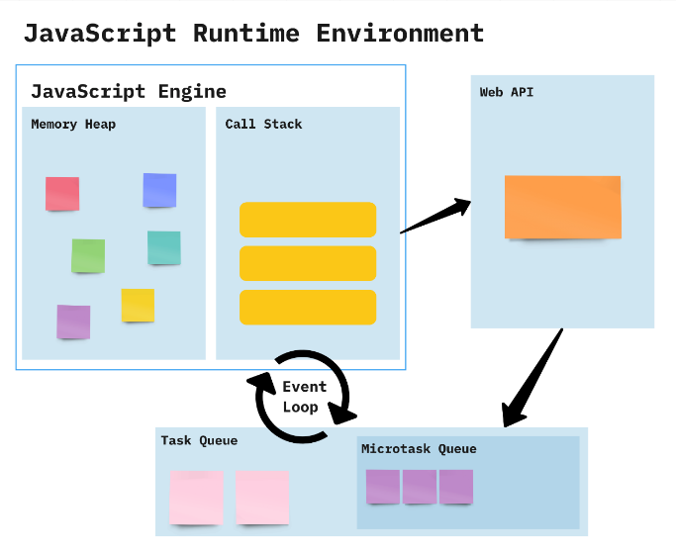

JavaScript works on a environment called **JavaScript Runtime Environment**. To use JavaScript you basically install this environment and than you can simply use JavaScript.

So in order to use JavaScript you install a **Browser** or **NodeJS** both of which are JavaScript Runtime Environment.

**call stack:**

The call stack is used to store information about function calls, including local variables, parameters, and the point of execution.

**Heap:**

The heap is a region of memory used for dynamic memory allocation. It stores objects, arrays, and other complex data structures that are created and managed at runtime.

**Web API:**

A Web API (Application Programming Interface) is a set of rules and tools that allows different software applications to communicate with each other over the web. It acts as an intermediary, enabling one application to interact with another application's data or functionality using standard web protocols, usually HTTP.

**Event loop:**

The event loop is a fundamental concept in asynchronous programming, especially in environments like JavaScript. It enables non-blocking operations, allowing code to execute asynchronously while ensuring that tasks are handled in an orderly manner. Here's a closer look at how synchronous and asynchronous operations interact with the event loop:

**Synchronous vs. Asynchronous**

**Synchronous:**

Synchronous operations are executed sequentially, one after the other. Each operation must complete before the next one begins.

**Asynchronous:**

Asynchronous operations allow code to execute without waiting for previous operations to complete. This is useful for tasks that involve waiting, such as network requests or timers.

**CallStack Overflow**: If the call stack grows too large, typically due to infinite recursion or excessive nested function calls, it can exceed the available memory allocated for the stack. This results in a "stack overflow" error and crashes the program.

**How it Works:**

* Constantly checks whether or not the call stack is empty
* When the call stack is empty, all queued up Microtasks from Microtask Queue are popped onto the callstack
* If both the call stack and Microtask Queue are empty, the event loop dequeues tasks from the Task Queue and calls them
* Starved event loop

**1. Basic Synchronous Code**

console.log("Task 1: Start");

console.log("Task 2: Middle");

console.log("Task 3: End");

// start

// middle

// end

**2 Asynchronous with setTimeout (Event Loop in Action)**

console.log("Task 1: Start");

setTimeout(() => {

    console.log("Task 2: Asynchronous Task (After 2 seconds)");

}, 2000);

console.log("Task 3: End");

start

// end

// asynchronous task

**3. Asynchronous Code with a Promise**

console.log("Task 1: Start");

const promise = new Promise((resolve, reject) => {

    setTimeout(() => {

        resolve("Task 2: Promise Resolved (After 1 second)");

    }, 1000);

});

promise.then((message) => {

    console.log(message);

});

console.log("Task 3: End");

// Task 1: Start

// Task 3: End

// Task 2: Promise Resolved (After 1 second)

**4. Multiple Asynchronous Tasks**

   console.log("Task 1: Start");

    setTimeout(() => {

        console.log("Task 2: Asynchronous Task 1 (After 2 seconds)");

    }, 2000);

    setTimeout(() => {

        console.log("Task 3: Asynchronous Task 2 (After 0 seconds)");

    }, 0);

    console.log("Task 4: End");

    // Task 1: Start

    // Task 4: End

    // Task 3: Asynchronous Task 2 (After 0 seconds)

    // Task 2: Asynchronous Task 1 (After 2 seconds)

**5. setTimeout and Promise Together**

console.log("Task 1: Start");

setTimeout(() => {

    console.log("Task 2: Asynchronous Task (setTimeout)");

}, 0);

Promise.resolve().then(() => {

    console.log("Task 3: Promise Resolved");

});

console.log("Task 4: End");

// Task 1: Start

// Task 4: End

// Task 3: Promise Resolved

// Task 2: Asynchronous Task (setTimeout)

**6. Using async/await**

async/await is a syntactic sugar for working with promises. It behaves synchronously within an async function until an await keyword is encountered, at which point it returns to the event loop to handle other tasks.

console.log(“Task 1: Start");

    async function asyncTask() {

        console.log("Task 2: Inside asyncTask");

        await new Promise(resolve => setTimeout(resolve, 1000)); // Wait for 1 second

        console.log("Task 3: After 1 second wait in asyncTask");

    }

    asyncTask();

    console.log("Task 4: End");

//    Task 1: Start

//     Task 2: Inside asyncTask

//     Task 4: End

//     Task 3: After 1 second wait in asyncTask

**7) setTimeout with Different Delays**

   console.log("Task 1: Start");

    setTimeout(() => {

        console.log("Task 2: 2 seconds delay");

    }, 2000);

    setTimeout(() => {

        console.log("Task 3: 1 second delay");

    }, 1000);

    setTimeout(() => {

        console.log("Task 4: 0 seconds delay");

    }, 0);

    console.log("Task 5: End");

    // Task 1: Start

    // Task 5: End

    // Task 4: 0 seconds delay

    // Task 3: 1 second delay

    // Task 2: 2 seconds delay

**Topic: callback hell and promises**

**Callback hell**

Callback hell, also known as "**Pyramid of Doom,**" is a term used in JavaScript programming to describe a situation where multiple nested callbacks make the code difficult to read, understand, and maintain. This usually happens when dealing with asynchronous operations, such as making API requests or reading files.

**Syntax:**

step1(function() {

    step2(function() {

        step3(function() {

            console.log("All steps completed");

        });

    });

});

**Example:1**

      function first(callback) {

        console.log("first");

        callback();

      }

      function second(callback) {

        console.log("second");

        callback();

      }

      function third(callback) {

        console.log("third");

        callback();

      }

      function fourth(callback) {

        console.log("fourth");

      }

      first(() => {

        second(() => {

          third(() => {

            fourth();

          });

        });

      });

**Example:2**

      function add(val, callback) {

        callback(val + 10);

      }

      function sub(val, callback) {

        callback(val - 5);

      }

      function mul(val, callback) {

        callback(val * 2);

      }

      function div(val, callback) {

        callback(val / 5);

      }

      add(10, (address) => {

        sub(addres, (subres) => {

          mul(subres, (mulres) => {

            div(mulres, (finalres) => {

               console.log(finalres);

            });

          });

        });

      });

**Example:3**

function wakeUp(callback) {

    setTimeout(() => {

        console.log("1. Woke up");

        callback();

    }, 1000);

}

function eatBreakfast(callback) {

    setTimeout(() => {

        console.log("2. Ate breakfast");

        callback();

    }, 1000);

}

function study(callback) {

    setTimeout(() => {

        console.log("3. Studied");

        callback();

    }, 1000);

}

function goToSleep(callback) {

    setTimeout(() => {

        console.log("4. Went to sleep");

        callback();

    }, 1000);

}

// The callback hell part starts here

wakeUp(() => {

    eatBreakfast(() => {

        study(() => {

            goToSleep(() => {

                console.log("Finished all tasks!");

            });

        });

    });

});

To mitigate callback hell, several approaches have been developed:

Named functions

Promises

Async/await

**Promises**

Promises in JavaScript provide a cleaner and more structured way to handle asynchronous operations compared to traditional callbacks.It has three states: pending, fulfilled, or rejected.

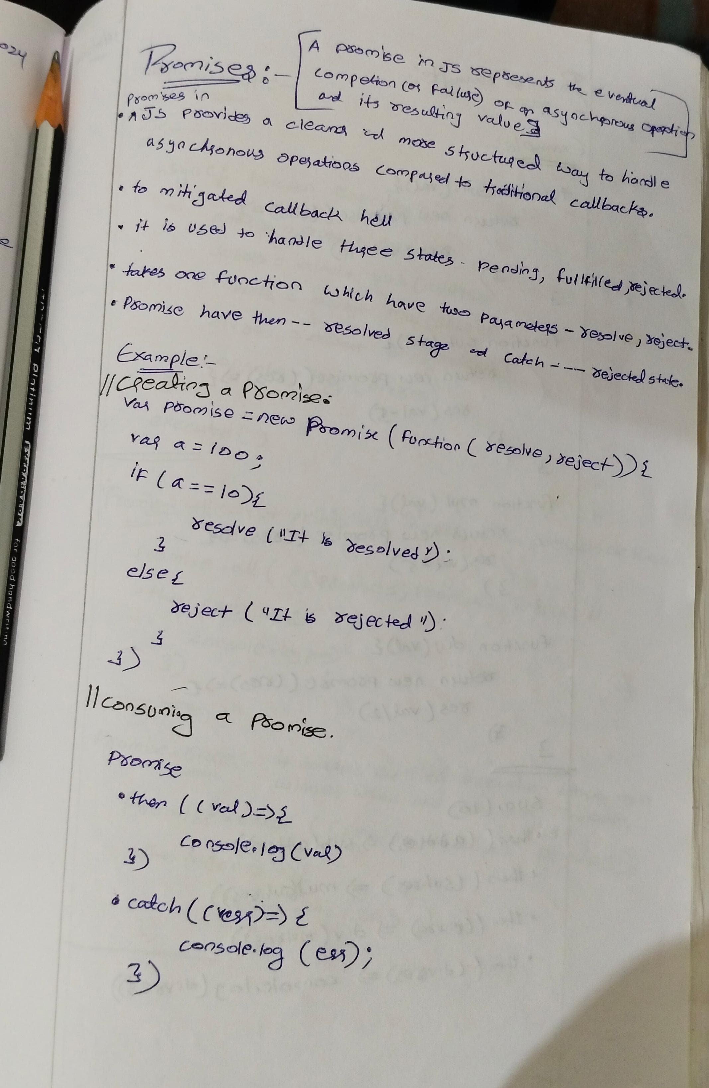

**Creating a Promise(producing)** : You create a new Promise object using the Promise constructor. This constructor takes a function as an argument, which in turn takes two parameters: resolve and reject. Inside this function, you perform your asynchronous operation, and when it's completed, you call resolve with the result or reject with an error if it fails.

      //promises creation

      var promises=new Promise(function (resolve,reject){

      var a=100;

      if(a==10){

      resolve("a is 10")

      }

      else{

      reject("a is not 10")

      }

      });

**Consuming a Promise:** You consume a promise using the then method, which takes two optional parameters: a callback function to handle the resolved value, and a callback function to handle any errors.

      //print the response

      promises.then((val)=>{

      console.log(val)

      }).catch((err)=>{

      console.log(err)

      })

Promises also forming chain method which inturns make code readability  difficult in order to avoid this

      let add = (val) =>

        new Promise((resolve, reject) => {

          resolve(val + 10);

        });

      let sub = (val) =>

        new Promise((resolve, reject) => {

          resolve(val - 10);

        });

      let mul = (val) =>

        new Promise((resolve, reject) => {

          resolve(val * 5);

        });

      let div = (val) =>

        new Promise((resolve, reject) => {

          resolve(val / 2);

        });

      add(10)

        .then((addres) => sub(addres))

        .then((subres) => mul(subres))

        .then((mulres) => div(mulres))

        .then((divres) => console.log(divres))

        .catch((error) => console.error(error));

**Promises aysnchronous**

        let promise1= new Promise((resolve,reject)=>{

          console.log("promise 1");

          setTimeout(resolve, 2000, "promise 1 success")

        })

        let promise2= new Promise((resolve,reject)=>{

          console.log("promise 2");

          setTimeout(resolve, 1500, "promise 2 success")

        })

        let promise3= new Promise((resolve,reject)=>{

          console.log("promise 3");

          setTimeout(resolve, 1800, "promise 3 success")

        })

        let promise4= new Promise((resolve,reject)=>{

          console.log("promise 4");

          setTimeout(resolve, 500, "promise 4 success")

        })

        promise1.then((resolve)=>{console.log(resolve)})

        promise2.then((resolve)=>{console.log(resolve)})

        promise3.then((resolve)=>{console.log(resolve)})

        promise4.then((resolve)=>{console.log(resolve)})

//convert synchronous to aynchronous

      promise1

        .then((result) => {

          console.log(result);

          return promise2;

        })

        .then((result) => {

          console.log(result);

          return promise3;

        })

        .then((result) => {

          console.log(result);

          return promise4;

        })

        .then((result) => {

          console.log(result);

        });

**Async/Await**  
Async/await is a modern feature in JavaScript that simplifies working with asynchronous code, especially when dealing with Promises. It allows you to write asynchronous code in a synchronous-like manner, making it easier to read, write, and maintain.

1. **Async Functions**: An async function is a function that operates asynchronously via the event loop. You declare an async function by prefixing the function declaration with the **async** keyword.

      async function myAsyncFunction() {

        // Asynchronous code here

      }

1. **Await Keyword:** The await keyword is used inside an async function to pause the execution of the function until a Promise is settled (resolved or rejected). It allows you to write code that looks synchronous but behaves asynchronously.

      async function myAsyncFunction() {

        const result = await somePromise;

        // Code here executes after somePromise is resolved

      }

Example

//promise is created

      function apromise() {

        return new Promise(function (res, rej) {

          var a = 20;

          if (a % 2 == 0) {

            res("num is even");

          } else {

            rej("num is odd");

          }

        });

      }

//resolving the promise value using async/await

      async function asyncfun() {

        var v = await apromise();

        console.log(v);

      }

      asyncfun();

//callback hell

        async function executor(){

          var addres=await add(10);

          var subres=await sub(addres);

          var mulres=await mul(subres);

          var divres=await div(mulres);

          console.log(divres);

        }

        executor()

//asynchronous

      async function executor() {

        let result1 = await promise1;

        console.log(result1);

        let result2 = await promise2;

        console.log(result2);

        let result3 = await promise3;

        console.log(result3);

        let result4 = await promise4;

        console.log(result4);

      }

      executor();

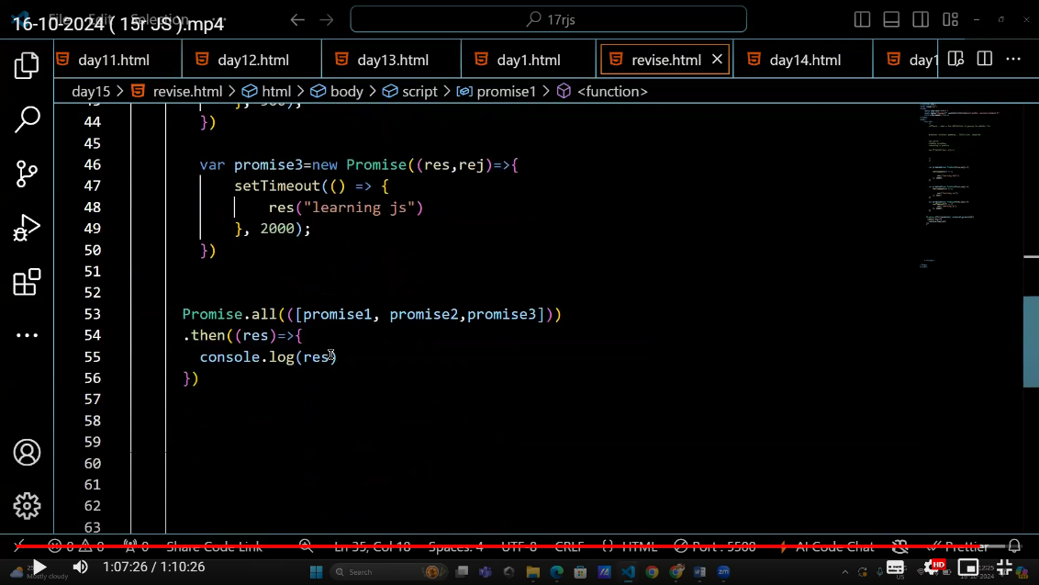

// promise.all --> print all

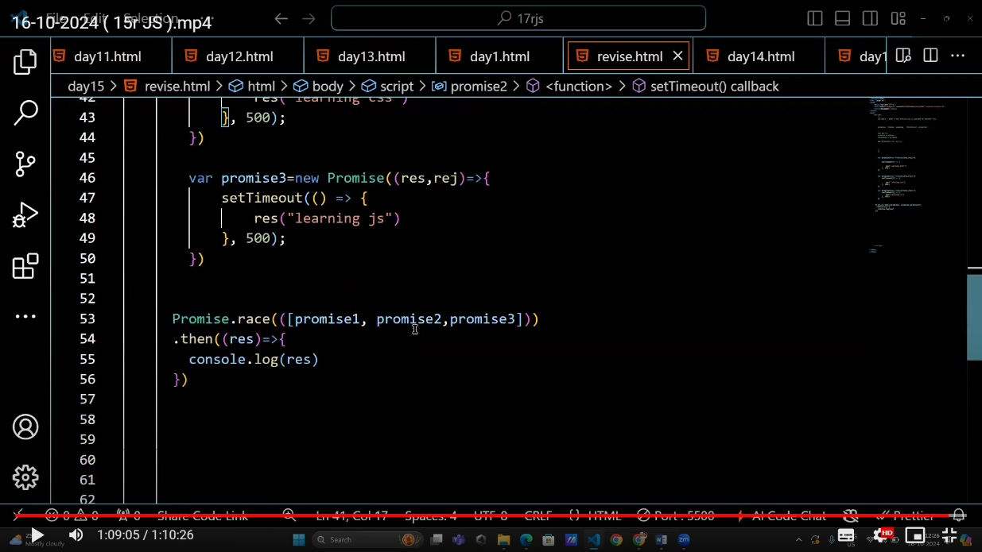

//race – it declares the winner

**Topic: Fetch, json, status codes and methods**

**Fetch**

The **fetch()** API is a modern way to make network requests and handle responses. It is widely used to interact with web APIs, allowing to request and send data to servers. It returns a Promise that resolves to the Response object representing the response to the request.

fetch(url, options)

*  **url**: The endpoint from which the resource is to be fetched.

* **options** (optional): An object containing additional settings such as HTTP method, headers, body, etc.

**Example using fetch() API with Promises:**

**When Data fetched successfuly**

  fetch("https://fakestoreapi.com/products/1")

  .then(res=>res.json())

  .then(data=>console.log(data))

  .catch(err=>console.log("there was a problem"))

**When there is a error**

  fetch("https://fakestoreai.com/products/1")

  .then(res=>res.json())

  .then(data=>console.log(data))

  .catch(err=>console.log("there was a problem"))

**Explanation:**

* fetch() returns a promise that resolves with the response object once the data is available.
* The .then() method is used to handle the fulfilled promise.
* If something goes wrong, we can use .catch() to handle the rejection.

**. Async/Await**

The async and await keywords simplify working with promises, allowing us to write asynchronous code that looks synchronous.

* async: Marks a function as asynchronous. This means it always returns a promise.
* await: Pauses the execution of the function until the promise is resolved or rejected.

**Example using fetch() API with async/await:**

        async function executor(){

            var res= await fetch("https://fakestoreapi.com/products/1");

            var data = await res.json();

            console.log(data);

        }

        executor()

**async with try and catch**

      async function executor() {

        try {

          var res = await fetch("https://fakestoreapi.com/products/1");

          var data = await res.json();

          console.log(data);

        } catch (err) {

          console.log("data not loading");

        }

      }

      executor();

**Explanation:**

* The executor function is marked as async, which means it can use await.
* Inside the function, await fetch() pauses the execution until the fetch() promise is resolved.
* Once resolved, the response is checked and the JSON data is awaited.
* If there's an error (e.g., network failure), it is caught by the try...catch block.

**Differences Between Promises and Async/Await:**

* Readability: Async/await makes asynchronous code look synchronous, which improves readability, especially in complex scenarios with many chained .then() blocks.
* Error Handling: Async/await uses try...catch, which is often more intuitive for handling errors compared to .catch() in promises.

**JSON- javascript object notation**

**Ajax**

Ajax, which stands for "Asynchronous JavaScript and XML," is a web development technique used to create interactive web applications. It allows for the asynchronous exchange of data between the browser and the server

**JSON**

JSON, or **JavaScript Object Notation**, is a **lightweight data interchange format** widely used in web development and other software applications. Its **syntax is derived from JavaScript object notation, but it is language independent** making it easy to read and write for humans. JSON is commonly used for transmitting data between a server and a web application due to its simplicity, universality, and support for complex data structures like nested objects and arrays. It is supported by virtually all modern programming languages and is **commonly used in web APIs** for its lightweight nature and ease of parsing. Overall, JSON's simplicity, readability, and wide support make it a popular choice for **data interchange in various software applications**.

**Why json**

B2b

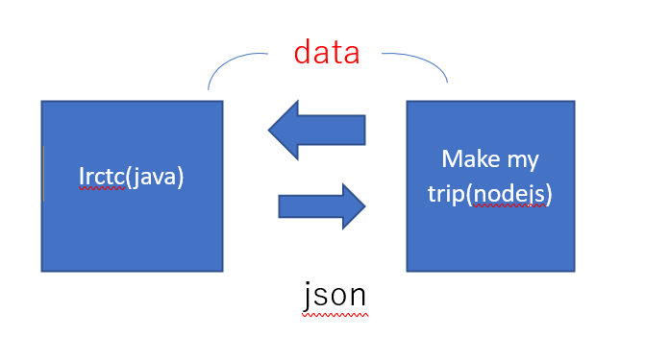

**JSON.stringify()**:

**JSON.stringify()** is a built-in JavaScript method used to convert a JavaScript object into a JSON string.

**JSON.parse()**:

**JSON.parse()** is a built-in JavaScript method used to parse a JSON-formatted string and convert it into a JavaScript object.

**Http status codes**

HTTP status codes are standard response codes returned by web servers to indicate the outcome of a client's request.

Important HTTP status codes along with their meanings:

1. **200 OK**: This status code indicates that the **request was successful**, and the server has returned the requested resource.
2. **201 Created**: Indicates that the **request was successful, and a new resource has been created as a result.**
3. **204 No Content**: The server successfully processed the request, but there is **no content to return**.
4. **400 Bad Request**: This status code is returned when the **server cannot process the request** due to a client error, such as malformed syntax or invalid parameters.
5. **401 Unauthorized**: Indicates that the **client needs to authenticate itself to access the requested resource.**
6. **403 Forbidden**: The server understood the request, but the client is not allowed to access the requested resource.

**Http methods**

HTTP methods, also known as HTTP request methods, are actions that indicate the desired operation to be performed on a resource identified by a URI (Uniform Resource Identifier).

1. **GET**: The GET method requests a representation of the specified resource. It is primarily used for retrieving data from the server. GET requests should only **retrieve data and should not have any other effect on the server**.
2. **POST**: The POST method submits data to be processed to a specified resource. It is commonly used for **creating new resources on the server or submitting form data**.
3. **PUT**: The PUT method replaces all current representations of the target resource with the request payload. It is typically **used to update or create a resource with a specific identifier**.
4. **PATCH**: The PATCH method is **used to apply partial modifications** to a resource. It is similar to the PUT method but only updates the parts of the resource specified in the request.
5. **DELETE**: The DELETE method **requests the removal of the specified resource**. It is used to delete resources identified by the URI from the server.

**How to call api using fetch by then method**

      fetch("https://fakestoreapi.com/products")

        .then((val) => {

          return val.json();

        })

        .then((val) => {

          console.log(val);

        });

1. **fetch("https://fakestoreapi.com/products")**: This line initiates a request to the specified URL, which returns a Promise representing the response to that request.
2. **.then((response) => { return response.json(); })**: Once the request is complete, this line chains a **.then()** method to the Promise returned by **fetch()**. Inside this **.then()** method, it takes the response object, and the **json()** method is called on it. This method returns a Promise that resolves to the JSON representation of the response body.
3. **.then((data) => { console.log(data); })**: After parsing the JSON response, this line chains another **.then()** method to the Promise returned by **response.json()**. Inside this **.then()** method, it receives the parsed JSON data as a JavaScript object. In this example, it logs the retrieved data to the console using **console.log()**

Some apis

**Food api:** [**https://api.edamam.com/search?q=biriyani&app_id=a52b4d43&app_key=e0e5c667605f5e91d8275c973531b80a**](https://api.edamam.com/search?q=biriyani&app_id=a52b4d43&app_key=e0e5c667605f5e91d8275c973531b80a)

**Weather api -** [https://api.openweathermap.org/data/2.5/weather?q=**hyderabad**&units=metric&appid=466ddaa21a8de191e9f608bd11a56acb](https://api.openweathermap.org/data/2.5/weather?q=hyderabad&units=metric&appid=466ddaa21a8de191e9f608bd11a56acb)

**Quotes api:** <https://api.quotable.io/random>

**Random joke:** [**https://v2.jokeapi.dev/joke/Programming?blacklistFlags=nsfw,religious,political,racist,explicit&type=single**](https://v2.jokeapi.dev/joke/Programming?blacklistFlags=nsfw,religious,political,racist,explicit&type=single)

**Movies info:-** [https://www.omdbapi.com/?t=**titanic**&apikey=76d079f0](https://www.omdbapi.com/?t=titanic&apikey=76d079f0)

**Random joke**

async function getRandomJoke() {

  const rawRes = await fetch('https://icanhazdadjoke.com/', {

    headers: {

      Accept: 'application/json'

    }

  });

  const res = await rawRes.json();

  console.log(res.joke);

}

getRandomJoke()

<https://github.com/saiteja-yernagula/javascript-mini-projects>

**Topic: JSON Server**

**How to create a local json server**

1. Download and Install Node js
2. Check whether it is installed or not by using below commands

**node –version**

**npm –version**

**Open powershell run as administrator and run the commands**

**Get-ExecutionPolicy**

**Set-ExecutionPolicy RemoteSigned**

**Y (for yes)**

**Get-ExecutionPolicy**

1. Select the folder in your local , open in vs code terminal and use below command

**npm init –y**

You will find json packages then you can install any libraries

1. Install json server for api creation in local server

**npm install -g json-server@0**

1. After installation watch the server using below command if it throws error follow the next step for script enabalation.

**json-server --watch db.json –port num**

1. Adjust the version by reinstalling using below command

**npm install -g json-server@0**

**json-server --watch db.json –port 6000**

**Stepwise All Methods**

**Step 1 – create db.json file**

**Step 2 – add the data**

{

    "data":[{

    "name":"teja",

    "id":"4"

},

{

    "name":"sai",

    "id":"2"

},

{

    "name":"hemanth",

    "id":"3"

},

{

    "name":"chaitanya",

    "id":"1"

}

]}

**Step 3 – json-server --watch db.json –port 6000**

**Step 4 - open js file paste the below program in it**

    //  get method - used to get data from the server

            fetch("http://localhost:3000/data")

            .then(val=>val.json())

            .then(data=>console.log(data))

            .catch(err=>console.log("data not found"))

**How to use post or patch in fetch**

Index.html

<button onclick="getdata()">get data</button>

    <button onclick="setdata()">set data</button>

Script.js:

    <script>

        function getdata(){

            //  get method - used to get data from the server

            fetch("http://localhost:3000/data")

            .then(val=>val.json())

            .then(data=>console.log(data))

            .catch(err=>console.log("data not found"))

        }

        let obj={

            name:"Raju",

            id:5

        };

        function setdata(){

            //  set method - used to set   data to the server

            fetch("http://localhost:3000/data", {

                method: "POST",

                headers: {

                    "Content-Type":"application/json"

                },

                body: JSON.stringify(obj)

            })

            .then(val=>val.json())

            .then(data=>console.log(data))

            .catch(err=>console.log("data not found"))

        }

    </script>

Db.json:

{

  "data": [

    {

      "name": "Abhi",

      "id": "1"

    },

    {

      "name": "sai",

      "id": "2"

    },

    {

      "name": "hemanth",

      "id": "3"

    },

    {

      "name": "manoj",

      "id": "4"

    }

  ]

}

**Json server**

HTTP methods (GET, POST, PUT, PATCH, DELETE) using fetch() and interacting with a JSON Server. JSON Server is a simple API tool that allows you to simulate a REST API with basic HTTP methods

Assume your JSON server is running at http://localhost:3000 with the following db.json:

{

    "data":[{

    "name":"teja",

    "id":"4"

}

,

{

    "name":"sai",

    "id":"2"

},

{

    "name":"hemanth",

    "id":"3"

},

{

    "name":"chaitanya",

    "id":"1"

}

]}

**1. GET Request: Fetching Data from the Server**

fetch('http://localhost:3000/posts')

  .then(response => response.json())  // Parse the JSON response

  .then(data => console.log(data))    // Handle the received data

  .catch(error => console.error('Error:', error));  // Handle errors

If you want to add queries params

By name

 fetch("http://localhost:3000/data?name=teja")

By id

 fetch("http://localhost:3000/data?id =2")

By both

 fetch("http://localhost:3000/data?id =2&name=teja")

By limit- used for pagination

 fetch("http://localhost:3000/data?_limit=2 ")

By _sort

 fetch("http://localhost:3000/data?_sort=-id")

**2. POST Request: Sending Data to the Server**

fetch('http://localhost:3000/posts', {

  method: 'POST',

  headers: {

    'Content-Type': 'application/json'  // Indicate we are sending JSON

  },

  body: JSON.stringify({                // Data to be added

    title: 'New post',

    author: 'Sam'

  })

})

  .then(response => response.json())    // Parse the JSON response

  .then(data => console.log('Post added:', data))  // Handle the response

  .catch(error => console.error('Error:', error));  // Handle errors

. Explanation: This adds a new post with the title "New post" and author "Sam" to the posts endpoint.

**3. PUT Request: Replacing Existing Data on the Server**

  fetch('http://localhost:3000/posts/1', {

  method: 'PUT',

  headers: {

    'Content-Type': 'application/json'

  },

  body: JSON.stringify({

    id: 1,            // `PUT` requires the `id`

    title: 'Updated first post',

    author: 'John Doe'

  })

})

  .then(response => response.json())

  .then(data => console.log('Post updated:', data))

  .catch(error => console.error('Error:', error));

Explanation: This updates the post with id: 1, changing its title and author.

**4. PATCH Request: Partially Updating Data on the Server**

  fetch('http://localhost:3000/posts/2', {

  method: 'PATCH',

  headers: {

    'Content-Type': 'application/json'

  },

  body: JSON.stringify({

    author: 'Jane Smith'  // Only update the author field

  })

})

  .then(response => response.json())

  .then(data => console.log('Post partially updated:', data))

  .catch(error => console.error('Error:', error));

Explanation: This updates only the author field of the post with id: 2.

**5. DELETE Request: Removing Data from the Server**

  fetch('http://localhost:3000/posts/1', {

  method: 'DELETE'

  })

  .then(() => console.log('Post deleted'))  // Handle deletion success

  .catch(error => console.error('Error:', error));

**Topic:  Apis, Exeception handling, this call apply bind and constructor function**

**API- application programming interface**

API stands for Application Programming Interface

It is a collection of communication protocols and subroutines used by various programs to form the communication between them.

In simple words It allows communication between two different software systems.

**How api works**

Client initiates the request via the api uri (uniform resource identifier)

The api makes a call to the server after receiving the request

Then the server sends the response back to API with the information

Finally, the API transfers data to the client

**Types of apis**

* **Browser APIs**: Interact with browser and web page elements (dom api), storage api
* **Server Apis:** Provide data and services from a server (restfull api)
* **Third-party Apis:** Offered by external services (social media apis)
* **Rest apis:** REST APIs are designed to make server-side data readily available by representing it in simple formats such as JSON and XML.
* **Soap apis(Simple Object Access Protocol):** SOAP uses XML exclusively to format data, making it more verbose and complex compared to REST.
* **GraphQL:** Allows clients to request exactly the data they need, great for complex data relationships. The client controls what data to retrieve, reducing over-fetching or under-fetching of data.
* **gRPC (Google Remote Procedure Call):** gRPC is a modern, high-performance, open-source RPC (Remote Procedure Call) framework developed by Google suitable for microservices and performance-critical systems.
* **WebSockets:** WebSocket is a protocol that allows for real-time, two-way communication between the client and server over a single TCP connection. WebSocket can send data in JSON, XML, or any other format, but the communication is typically binary, Real-time, bi-directional communication for applications like chat and gaming.

**Error handling methods is js**

In JavaScript, try...catch statements are used to handle exceptions (errors) that occur in your code. By using these statements, you can ensure that your code continues to run even if an error occurs.

**Error** – It is an object that is created to represent a problem that occurs offten with userinput or establishing a connection.

Why we need try catch

**// case -1** ------> both statements will execute

console.log("hi hello");

console.log("you have reached the end");

**// case -2** ------>It interupts the program from 163 line to end because console.lag is not a method it

console.lag("hi hello");

console.log("you have reached the end");

To overcome this we need **try catch methods**

**Syntax:**

**try** {

  // Code that may throw an error

} **catch** (err) {

  // Code to handle the error

} **finally** {

  // Code that will always run, regardless of error

}

**Explanation**

**try block:** Contains the code that may throw an error. If no errors occur, the code inside the catch block is skipped.

**catch block:** Contains code that will execute if an error occurs in the try block. The err parameter contains the error object.

**finally block (optional):** Contains code that will run after the try and catch blocks, regardless of whether an error was thrown or not.

//try block contains error catch block takes one parameter err means error it will store the error caused by try

**Ex-1:**

**try**{

    console.lag("hi hello");

}

**catch**(err){

    console.log(err);

}

We can also use

**console.error(err)**

**Ex-2**

**try**{

    console.lag("hi hello");

}

**catch**(err){

**console.error(err);**

}

**finally**{

**console.log("this will always run");**

}

console.log("you have reached the end");

**Ex-3: (if we use finally)**

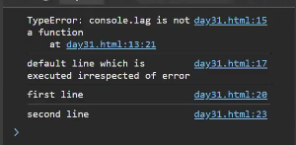

**Throw statement in js**

The throw statement is used to raise an exception in JavaScript. When an exception is thrown, the **normal flow of code execution is stopped**, and **control is passed to the nearest enclosing catch block.** If no catch block is found, the script will terminate.

Example:

      num = prompt("entry");

      try {

        if (num <= 0) {

          throw new Error("The number must be positive.");

        }

      }

catch (err) {

        console.error(err);

      }

      console.log("you have reached the end");

This program prompts the user to enter a number, checks if the number is positive, and handles errors if the number is not positive. It uses a try...catch block to manage potential exceptions and ensures that a final message is logged to indicate the end of the program.

**Try Block:**

if (num <= 0) { throw new Error("The number must be positive."); }

**Condition**: Checks if the input num is less than or equal to 0.

**Error Handling:** If the condition is true, an error is thrown with the message "The number must be positive."

**Catch Block:**

catch (err) { console.error(err); }

**Function**: Catches the error thrown in the try block.

**Error Logging:** Uses console.error(err) to log the error object to the console, which includes the error message and stack trace.

**Final Log Statement:**

console.log("you have reached the end");

**Purpose:** To indicate that the program has reached its end, regardless of whether an error occurred.

**Types of errors**

1. **Syntax Errors**

Description: Occur when the code contains **invalid syntax**, which prevents the script from being parsed correctly.

if (true {

  console.log("This is a syntax error");

}

**2. Reference Errors**

Description: Occur when trying to reference a **variable that is not declared**.

console.log(nonExistentVariable);

**3. Type Errors**

Description: Occur when an operation is performed on a **value of an inappropriate type**

let num = 5;

num.toUpperCase(); // TypeError: num.toUpperCase is not a function

**4. Range Errors**

Description: Occur when a numeric variable or parameter is **outside its valid range**

  let arr = new Array(-1);

function createArray(size) {

  if (size > 100) {

    throw new RangeError("Array size is too large");

  }

  return new Array(size);

}

createArray(101);

**5. Eval Errors**

Description: Occur due to improper use of the **eval() function**. This error type is **rarely encountered** and is primarily included for **backward compatibility**.

eval("alert('Hello)");// This example won't necessarily throw an EvalError in modern browsers but shows misuse of eval.

**6. URI Errors**

Description: Occur when global **URI handling functions are used incorrectly**, such as encodeURI(), decodeURI(), encodeURIComponent(), and decodeURIComponent().

decodeURIComponent("%");

**This keyword**

`this` is a keyword that refers to the **current calling object** or context in which it is used. It is used to access the properties and methods of the current object.

**1.Global Context:** When this is used in the global scope (outside of any function), it refers to the global object. In a web browser environment, the global object is window.

  console.log(this === window); // true

**Function Context:** When this is used within a function that is not a method of an object, its value depends on how the function is called. If the function is called as a standalone function, this will typically refer to the global object (or undefined in strict mode).

  function sayHello() {

    console.log(this);

}

sayHello(); // In a browser, this would log the window object

**3.Method Context:** When this is used within a method of an object, it refers to the object that the method is called on.

//here this refers to the person means object name

  const person = {

    name: 'John',

    greet: function() {

        console.log('Hello, my name is ' + this.name);

    }

};

person.greet(); // Logs "Hello, my name is John"

This in arrow function

**Ex-1:**

        let obj={

            name:"John",

            age:30,

            sayHello:()=>{

                console.log(this.age) //undefined

            }

        }

        obj.sayHello()

**Ex-2:**

        let obj={

            name:"John",

            age:30,

            sayHello:()=>{

                console.log(this)// window

            }

        }

        obj.sayHello()

Understanding this in Arrow Functions

Arrow functions (() => { }) in JavaScript behave differently with respect to this compared to regular functions.

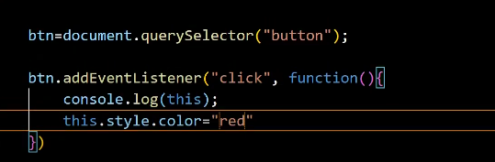

**Here are the key points to note:**

**Lexical Scope**: Arrow functions do not have their own this context. Instead, they inherit this from the surrounding (lexical) scope where they are defined.

**Global Object:** In most cases where obj is defined at the top level (not inside another function or block), this refers to the global object (window in browsers).

**4.This refers to the particular event in evenhandlers**

  document.getElementById('myButton').onclick = function() {

  console.log(this); // Refers to the button element with the ID 'myButton'

    };

**Changing this with call, apply, and bind**

call and apply immediately invoke the function with a specified this value and arguments.

      function showThis() {

        console.log(this);

      }

      const obj = { name: "John" };

      showThis()// window

      showThis.call(obj); // obj

      showThis.apply(obj); // obj

**bind**

bind returns a new function with a specified this value, without immediately invoking the function.

      const boundFunction = showThis.bind(obj);

      boundFunction(); // obj

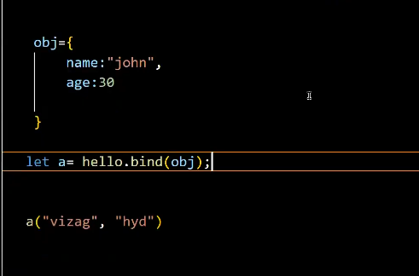

**call with parameters**

      function hello(city, profession) {

console.log("hello my name is " + this.name + " iam from " + city + " my profesion is " + profession);

      }

      obj = {

        name: "john",

      };

      obj2 = {

        name: "peter",

      };

      hello.call(obj, " vizag", " senior trainer");

      hello.call(obj2, "hyd", " developer ");

**apply**

      function hello(city, profession) {

        console.log( "hello my name is " + this.name + " iam from " + city + " my profesion is " + profession);

      }

      obj = {

        name: "john",

      };

      obj2 = {

        name: "peter",

      };

      hello.apply(obj, [" vizag", " senior trainer"]);

      hello.apply(obj2, ["hyd", " developer "]);

**bind**

      function hello(city, profession) {

        console.log( "hello my name is " + this.name + " iam from " + city + " my profesion is " + profession );

      }

      obj = {

        name: "john",

      };

      var bind1 = hello.bind(obj);

      bind1(" vizag", " senior trainer");

**Key Differences and Use Cases**

**call vs apply**: The primary difference between call and apply is how arguments are passed:

call passes arguments individually.

apply expects an array of arguments.

Use call when you know the exact arguments to  pass, and use apply when you have arguments in an array or array-like object.

**bind:** Unlike call and apply, bind does not immediately invoke the function. Instead, it creates a new function with the bound this value and optionally prepended arguments. This is useful when you want to create a function with a fixed this value that you can later execute.

**Constructor function**

**It is a old way to create objects**

Single same objects

 function Person(){

        this.name = "john";

        this.age = 30;

    }

    let person1=new Person();

    console.log(person1);

    let person2=new Person();

    console.log(person2);-

**Multi objects**

  // constructor function - it is a old way to create objects in js

    function Person(name, age){

        this.name = name;

        this.age = age;

    }

    let person1=new Person("Hemanth", "26");

    console.log(person1);

    let person2=new Person("teja", "25");

    console.log(person2);

**Prototype**

    function Person(){

        this.name = "john";

        this.age = 30;

    }

    Person.prototype.course="trainers"

    let person1=new Person();

    console.log(person1.course);

    let person2=new Person();

    console.log(person2.course)  
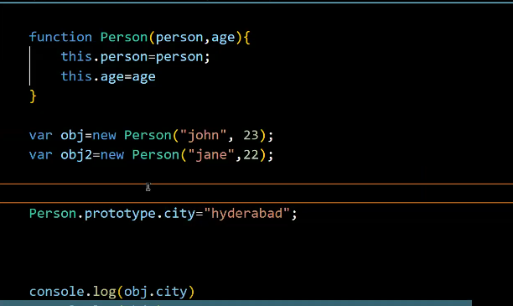

function Person(name, age) {

  this.name = name;

  this.age = age;

}

function Student(name, age, grade) {

  // Using call to inherit the properties from Person

  Person.call(this, name, age);

  this.grade = grade;

}

const student1 = new Student('John', 20, 'A');

console.log(student1); // Output: { name: 'John', age: 20, grade: 'A' }

**Javascript classes**

 The old way to create objects was using constructor functions.

     // constructor function

     function Person () {

       this.name = "John",

       this.age = 23

      }

     // create an object

     const person = new Person();

**Topic: Oops (Object Oriented Programming Structure)**

**Oops in js**

OOP in JavaScript provides a **way to structure and organize code** in a more modular and **reusable** manner. By utilizing objects, classes, inheritance, encapsulation, and polymorphism

1.class

2.object

3.encapsulatiion

4.inheritance

5.polymorphism

6.abstraction

**Constructor class**

Construtor class is a way to define a template for creating object

class was introduced recently in [ES6](https://www.programiz.com/javascript/ES6)

class is a collection of properties and methods(static/intance)

**syntax :**

         class Classname{

}

**obj syntax :**

new Classname(arguments)

constructor should be one

**Class Definition**

* **Class**: A class is a template for creating objects. It encapsulates data and functions that operate on that data.
* **Properties (state)**: Variables that belong to the class.
* **Methods (behaviour)**: Functions that belong to the class.

**Ex:- Marker Class**

The **Marker** class has three properties: **color, lid**, and **type**. It also has a constructor to initialize these properties.

      class Marker {

        color; // property to hold the color of the marker

        lid; // property to hold the type of lid of the marker

        type; // property to hold the type of the marker

        // Constructor to initialize the properties

        constructor(color,lid, type) {

          this.color = color; // initializes the color property

          this.lid = lid; // initializes the lid property

          this.type = type; // initializes the type property

        }

        // method initialisation - it is a behaviour of object

        write() {

            console.log("Writing with " + this.color + " marker");

        }

      }

**Creating Objects**

Objects are instances of a class. The new keyword is used to create an object from a class.

      var marker1 = new Marker("red", "square", "permanent");

      var marker2 = new Marker("black", "circle", "temporary");

**Logging the object**

     //logging the objects

     console.log(marker1);

     console.log(marker2);

**Calling the method**

    //calling the methods

    marker1.write();

**Key Points**

* **Class Definition**: Defines the state and behavior of objects.
* **Properties**: Variables within a class that hold data.
* **Methods** : function that holds the behaviour
* **Constructor**: Special method to initialize properties when an object is created.
* **this Keyword**: Refers to the current instance of the class.
* **Creating Objects**: Use new keyword followed by class name and arguments to create objects.

use the class keyword to create a JavaScript class.

// create a class

class Person{

// body of class

};

**To use the class constructor we must need to assign object to it**

    class Person{

        constructor (name,age){

            this.name=name;

            this.age =age;

        }

        hi(a,b){

            return "my name is "+ this.name+ " age is " + this.age;

        }

     }

     var b=new Person("teja",25);

    console.log(b);//{name:teja; age:25}

    console.log(b.age);//25

    console.log(b.hi());//my name is teja age is 25

**by using prototypes we can add properties directly**

**Person.prototype.fullName = “sai teja”.**

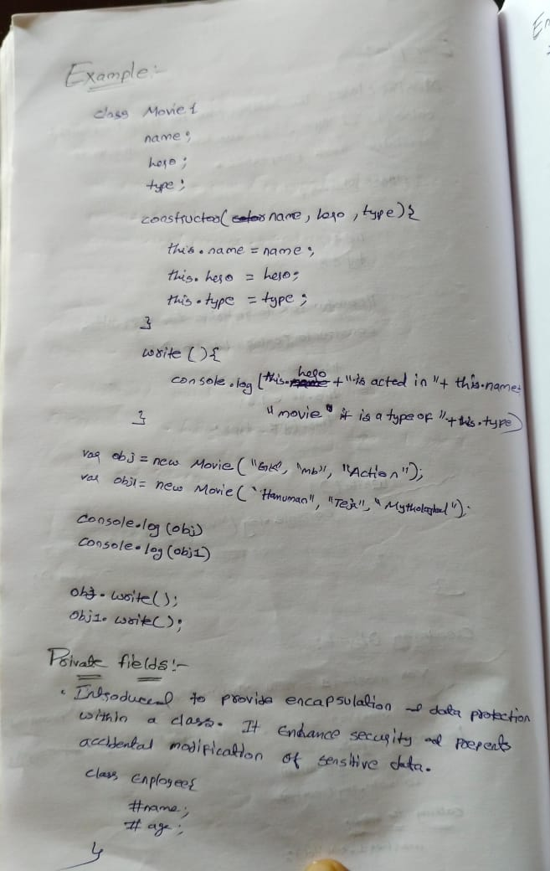

**Java script classes with private fields**

**Class Definition**

* **Class**: Employee
  + **Private Fields**: #name, #age, #salary (indicated by # prefix)
  + Introduced to provide encapsulation and data protection within a class.
  + Enhances security and prevents accidental modification of sensitive data.

    class Employee {

    #name;

    #age;

    #salary;

    constructor(name, age, salary) {

        this.#name = "John";    // Private field initialization

        this.#age = 30;         // Private field initialization

        this.#salary = 50000;   // Private field initialization

    }

//private fields can only accessed inside the class

  hello(){

        console.log("Hello, my name is " + this.# )

}

   }

**Private Fields**

* **Definition**: Private fields are declared using the # symbol before the field name (#name, #age, #salary).
* **Access Control**: Private fields can only be accessed and modified from inside the class where they are defined.

Accessing object will thrown an error because we cannot able to access them in outside

    var person1=new Employee("john", 25, 50000);

    console.log(person1.name)// error - private property cannot be accessed directly

method will print the output because properties can be accessed inside a class

    person1.hello();

**Encapsulation**

Encapsulation in JavaScript refers to the **bundling of data (attributes) and methods (functions) that operate on the data into a single unit**, typically known as an object. This concept helps in hiding the internal state of an object and only exposing the necessary functionalities to interact with that state.

**Access the values using getter**

Syntax:

    // we can giving access

    get methodname(){

      return this.#name;

    }

    // we can giving access

    get accessname(){

      return this.#name;

    }

    class Employee {

    #name;

    #age;

    #salary;

    constructor(name, age, salary) {

        this.#name = name;    // Private field initialization

        this.#age = age;         // Private field initialization

        this.#salary = salary;   // Private field initialization

    }

    hello(){

        console.log("Hello, my name is " + this.#name + " and I am a " )

    }

    // Getter for accessing private field #name

    get accessname(){

      return this.#name;

    }

   }

    var person1=new Employee("john", 25, 50000);

//we can able to access now because of encapsulation

    console.log(person1.accessname)// john - will not thrown an error

**Modify the values using setter**

    // Setter for modifying private field #salary

    set setsalary(sal){

      this.#salary=sal;

    }

// Getter for accessing private field #salary

    get getsalary(){

      return this.#salary;

    }

   //creating a object

    var person1=new Employee("john", 25, 50000);

    //setting the values

    person1.setsalary=99500;

    //accessing the updated values

    console.log(person1.getsalary);

**//complete program**

    class Employee {

    #name;

    #age;

    #salary;

    constructor(name, age, salary) {

        this.#name = name;    // Private field initialization

        this.#age = age;         // Private field initialization

        this.#salary = salary;   // Private field initialization

    }

    hello(){

        console.log("Hello, my name is " + this.#name + " and I am a " )

    }

    // we can giving access

    get accessname(){

      return this.#name;

    }

    //giving the access to change the values

    set setsalary(sal){

      this.#salary=sal;

    }

    get getsalary(){

      return this.#salary;

    }

   }

   //creating a object

    var person1=new Employee("john", 25, 50000);

    //setting the values

    person1.setsalary=99500;

    //accessing the updated values

    console.log(person1.getsalary);

Certainly! Let's break down the concept of inheritance in JavaScript using the provided code as an example and create detailed notes.

**Topic: OOPS (Inheritance, Polymorphism and abstraction)**

**JavaScript Inheritance**

**What is Inheritance?**

* **Inheritance**: A feature in object-oriented programming that allows one class (subclass or derived class) to inherit properties and methods from another class (superclass or base class).
* **Purpose**: Promotes code reusability and establishes a natural hierarchy between classes.

**Base Class: Animal**

The Animal class serves as the base class with common properties and methods that can be inherited by other classes.

    class Animal{

      weight;

      height;

      voice;

      constructor(weight, height, voice){

        this.weight = weight;

        this.height = height;

        this.voice = voice;

      }

      eating(){

        console.log("Eating...");

      }

    }

**Subclass: Dog**

The Dog class extends the Animal class, inheriting its properties and methods while adding its own specific properties.

    class Dog extends Animal {

    breed;

    food;

    constructor(weight, height, voice, breed, food) {

        super(weight, height, voice); // Calls the constructor of the Animal class

        this.breed = breed;

        this.food = food;

    }

}

**Properties**:

* Inherited: weight, height, voice
* Specific: breed, food

**Constructor**:

* Calls super(weight, height, voice) to initialize inherited properties.
* Initializes breed and food properties.

**Creating Objects and Using Methods**

      var dog1 = new Dog("15kgs", "2feet", "bow bow", "indie", "nonveg");

      console.log(dog1); // Outputs: Dog { weight: '15kgs', height: '2feet', voice: 'bow bow', breed: 'indie', food: 'nonveg' }

      dog1.eating(); // Outputs: Eating...

**Notes**

1. **Inheritance in JavaScript**:
   * **Base Class**: Defines common properties and methods.
   * **Subclass**: Inherits from the base class and can add or override properties and methods.
2. **super Keyword**:
   * Used in the constructor of the subclass to call the constructor of the base class.
   * Ensures inherited properties are properly initialized before accessing subclass-specific properties.
3. **Constructor Rules**:
   * In a subclass constructor, super must be called before accessing this.
   * Ensures proper initialization of the inherited fields.
4. **Method Inheritance**:
   * Subclasses inherit all methods from the base class.
   * Methods can be overridden in the subclass if needed.
5. **Code Reusability**:
   * Inheritance promotes code reusability by allowing subclasses to use and extend the functionality of base classes.
   * Reduces redundancy and simplifies maintenance.
6. **Example Scenario**:
   * **Base Class**: Animal with common properties (weight, height, voice) and methods (eating).
   * **Subclasses**: Dog and Cat with additional specific properties (breed, food for Dog, and color for Cat).

**What is Polymorphism?**

* **Polymorphism**: A core concept in object-oriented programming that allows objects of different classes to be treated as objects of a common superclass. It enables methods to perform different tasks based on the object they are called on.
* **Purpose**: Enhances flexibility, reusability, and maintainability of code by allowing a single interface to represent different underlying forms (data types).

**Example: Polymorphism in Action**

Using the provided code as an example, we can see how polymorphism works in JavaScript

**Base Class: Animal**

The Animal class serves as the base class with common properties and methods that can be inherited by other classes.

      class Animal {

        weight;

        height;

        voice;

        constructor(weight, height, voice) {

          this.weight = weight;

          this.height = height;

          this.voice = voice;

        }

        eating() {

          console.log("Eating...");

        }

      }

**Properties**: weight, height, voice

**Methods**:

* eating(): Prints "Eating..." to the console.

**Subclass: Dog**

The Dog class extends the Animal class, inheriting its properties and methods but also overriding the eating method.

      class Dog extends Animal {

        breed;

        food;

        constructor(weight, height, voice, breed, food) {

          // we cannot write anything above the super

          super(weight, height, voice);

          this.breed = breed;

          this.food = food;

        }

        eating() {

          console.log("Dog is eating " + this.food);

        }

      }

**Properties**:

* Inherited: weight, height, voice
* Specific: breed, food

**Methods**:

* Overridden: eating(): Prints "Dog is eating " followed by the type of food the dog eats.

**Object Creation and Method Overriding**

      var dog1 = new Dog("15kgs", "2feet", "bow bow", "indie", "nonveg");

      console.log(dog1);

      // Outputs: Dog { weight: '15kgs', height: '2feet', voice: 'bow bow', breed: 'indie', food: 'nonveg' }

      dog1.eating();

      // Outputs: Dog is eating nonveg

**Object Creation**: dog1 is created as an instance of the Dog class.

**Method Overriding**: The eating method in the Dog class overrides the eating method in the Animal class.

**Polymorphism**

Polymorphism, in the context of object-oriented programming, refers to the ability of **different objects to respond to the same message or method invocation** in different ways. It allows objects of different classes to be treated as objects of a common superclass, providing a unified interface for different classes.

**Abstraction**

Abstraction in JavaScript refers to the concept of hiding complex implementation details and showing only the necessary features of an object or function. It allows developers to work with high-level representations without needing to understand all the underlying complexities.